Exhibition by the Czech illustrator Renáta Fučíková in Ringsted

On Wednesday 10 November 2010 the exhibition of Chinese fairy tales illustrations and illustrations to fairy tales by H. C. Andersen by the Czech illustrator and writer Renáta Fučíková was opened at the Ringsted Public Library. Ringsted is one of the places in Denmark where the visitors have the opportunity to see this nice exposition. Afterwards the pictures will be presented in other Danish towns.

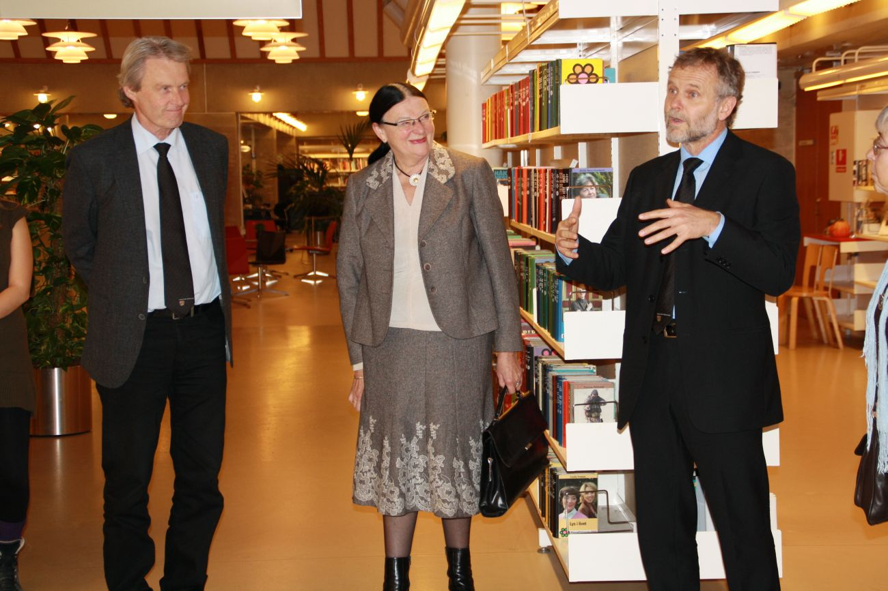
From the left: Town Mayor Niels Ulrich Hermansen, Annie Bøge Jørgensen, the chairman of the Library Board of Ringsted Municipality, Czech Ambassador Zdeněk Lyčka

The exhibition was opened by Czech Ambassador Zdeněk Lyčka in the presence of Town Mayor Niels Ulrich Hermansen, Annie Bøge Jørgensen, the chairman of the Library Board of Ringsted Municipality, and Library Director Jens-Erik Korntved. Inge Bro Jørgensen, Gratias Agit Award laureate 2000, was also among the specially invited guests.

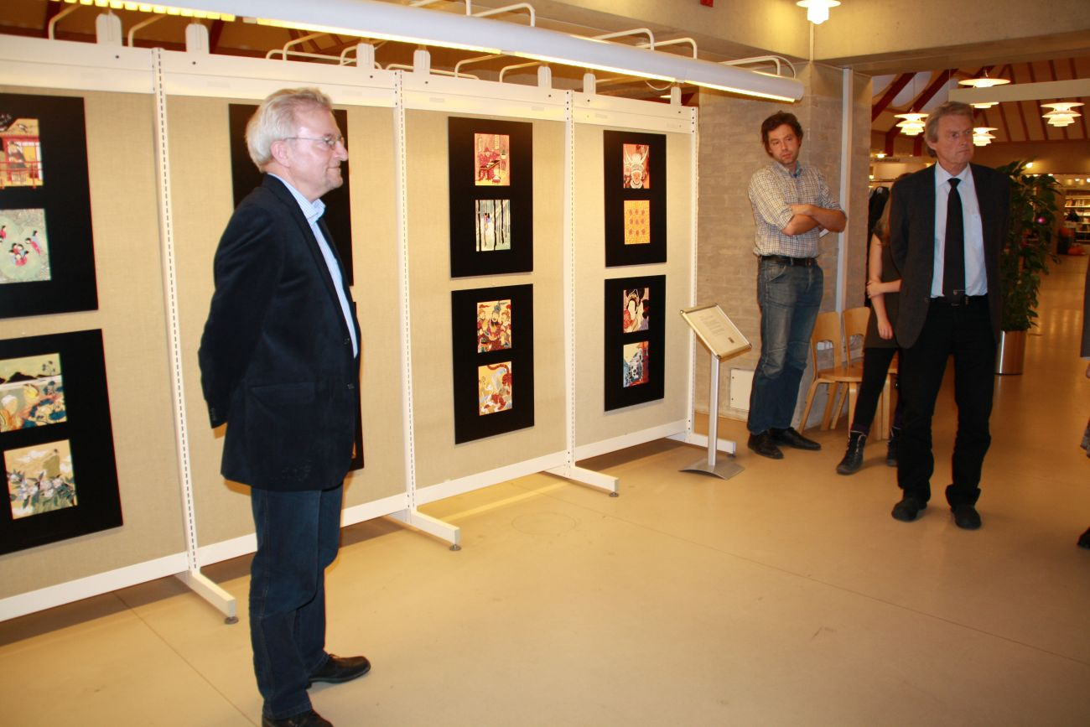
Library Director Jens-Erik Korntved

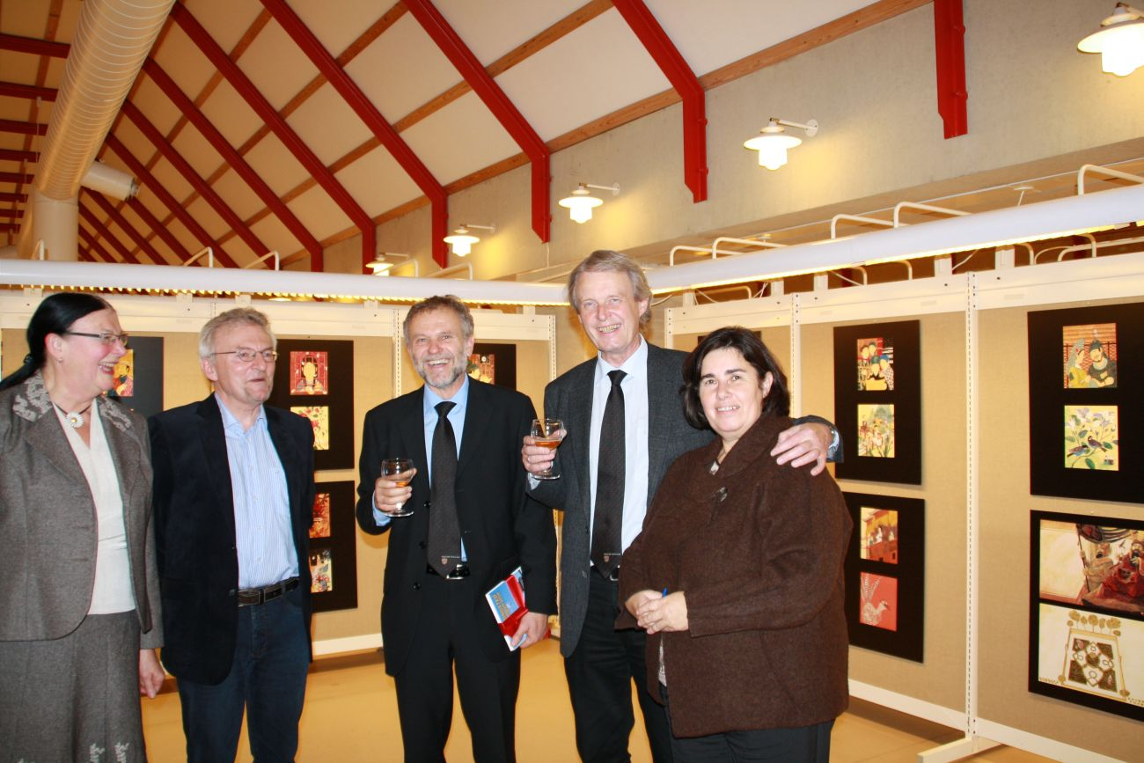
From the left: Annie Bøge Jørgensen, Jens-Erik Korntved, Zdeněk Lyčka, Niels Ulrich Hermansen and Czech consulBarbora Stejskalová

Together with the opening the library presented books by Czech authors in Danish translation and books about the Czech Republic. Thanks to the cooperation with the Czech publishing house PRÁH it was also possible to buy books illustrated by Renáta Fučíková.

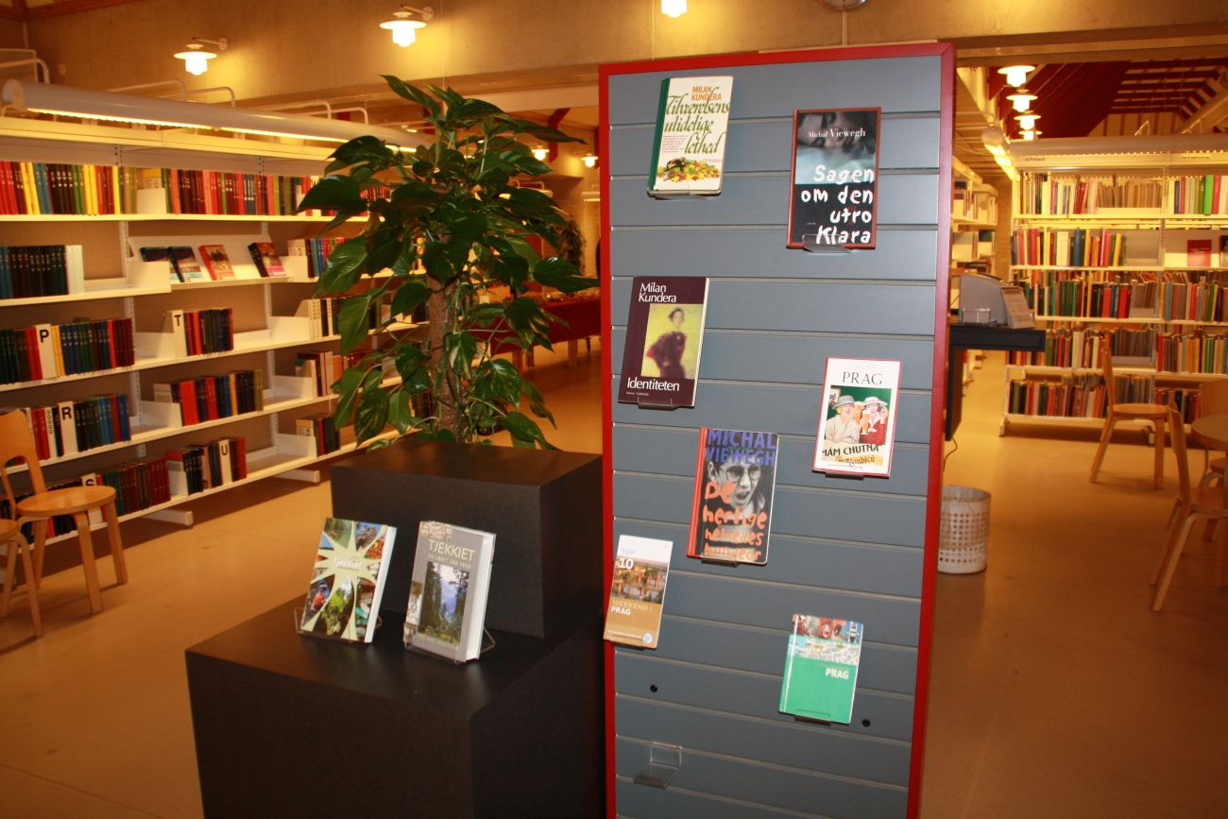
Presentation of books by Czech authors in Danish translation and books about the Czech Republic

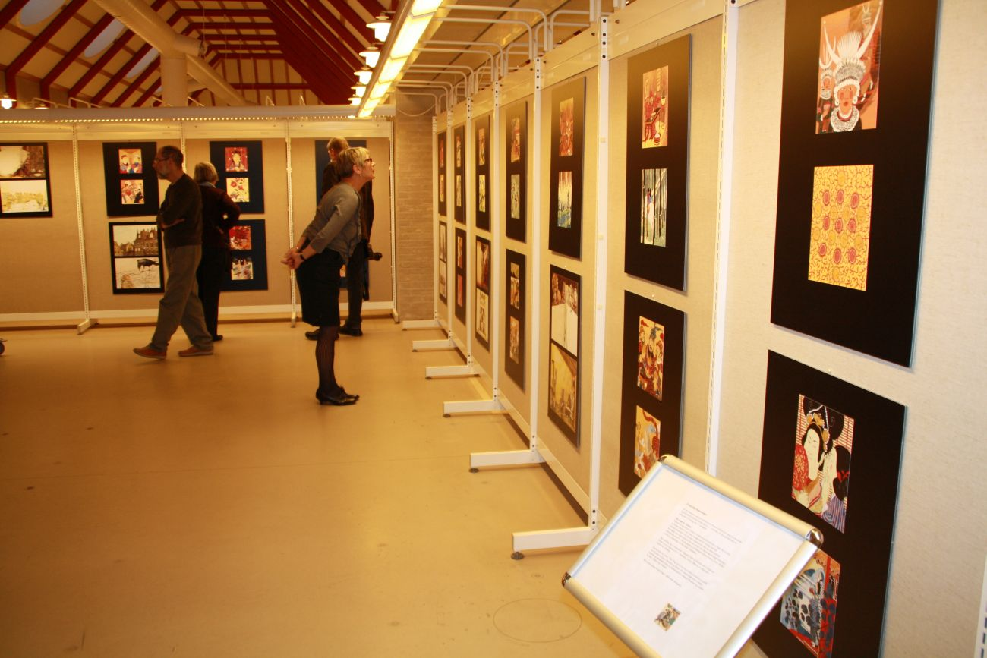
The exhibition of Chinese fairy tales illustrations and illustrations to fairy tales by H. C. Andersen by the Czech illustrator and writer Renáta Fučíková

The illustrations will be shown at the Ringsted Public Library until 27 November 2010.

