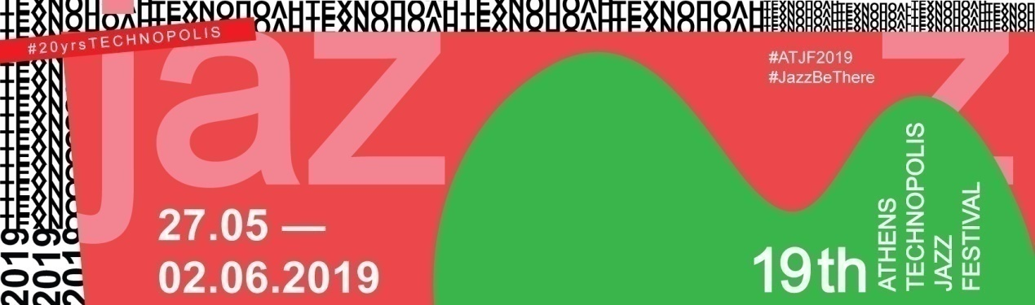

# 19th Athens Technopolis Jazz Festival

# 27th May to 2nd June 2019

**#ATJF19: the most surprising jazz line-up of the city**

**1 festival | 19 years | 7 days | 21 bands   
side events & unexpected happenings**

**#JazzBeThere**

**[Athens Technopolis Jazz Festival](https://www.technopolisjazzfestival.com)** is coming back for another year and fills our spring nights with the best jazz music in the city! **From the 27th May to 2nd June**, **[Technopolis City of Athens](http://www.technopolis-athens.com/web/guest/home)** is celebrating the 19th jazz event and welcomes rising and already noted international music ensembles, original sounds and many side jazz events! All this, of course, on free entry!

**Jazz days ‘n’ nights are coming!**

The first day of the festival, on Monday 27th May, is dedicated to contemporary Greek jazz scene. Athens Technopolis Jazz Festival is bringing out the local jazz trends, supporting the Greek jazz bands and presenting some of the most innovative and creative Greek jazz groups. So, we welcome **[Yako Trio](http://yakotrio.com/)**-Festival’s Pick- who will present music based on the work of the musician Yannis Konstantinidis. They will be followed by the experimental sounds of **[Grey Paris](https://greyparis.eu/)**, who are this year’s festival suggestion, whereas some time later **[Petros Klampanis Trio](https://www.petrosklampanis.com/)** will bring the air of the American metropolis in Athens.

On Tuesday 28th May, we expect the special group of **Wajdi Riahi** (Tunisia), the **[M. Messios Symmetry Band](https://www.facebook.com/Michael-Messios-Symmetry-band-1568724243402179/)** (Cyprus) and **[Gaspar Karoly Trio](https://www.facebook.com/gasparkarolyjazz/?__tn__=K-R&eid=ARB56X3Hb_Lzm9FzhJuaTDdi1Tpd3ShBBzZ52R9j20tvCTUSA-oMxzQK1HzCNKc4uqRKz-o3IhrxQVbn&fref=mentions) feat. Krisztina Pocsai** (Hungary), while on Wednesday 29th May the central stage of Technopolis is taken by **Clara Peya & Vic Moliner** (Spain), **[Richard Koch Quartett](https://richardkochquartett.bandcamp.com/?fbclid=IwAR23cB0hDxyPJoZWhU99Et8FPO9XT3KniQC2uBWnbjFgUXMEHAVIfna_CCw)** (Germany) and the highly-anticipated New York-based composer, drummer, academic and activist **[Jaimeo Brown](https://www.jaimeobrown.com/?fbclid=IwAR3GNsY7n-sfhosrs9Na-e5g6GeH8lpIcXVKmbdgbyue1phZ6juR1z-ZkHc)** (USA), who will present his project “Transcedence with Chris Sholar and Jaleel Shaw.

On Thursday 30th May we welcome the **[Filip Jers](http://www.filipjers.com/)** Quartet (Sweden), **[Month of Sundays](https://www.facebook.com/monthofsundaysmusic/)** (Austria) and **[Septeto Internacional](http://www.septeto.net/)** (Switzerland). On the next day-and night- Friday 31st May we are travelling with the jazz sound of the **Things I Can’t Control** (Netherlands), **[Alfa Collective](https://www.facebook.com/alfacollective/)** (Estonia) and **[Wojtek Mazolewski Quintet](https://www.facebook.com/wojtekmazolewskiquintet/)** (Poland).

When the weekend arrives, our mood is high and we can’t wait to enjoy the **[Helge Lien Trio](http://helgelientrio.com/)** (Norway) and the **[Dainius Pulauskas Group](https://www.facebook.com/dainiuspulauskasgroup/?__tn__=K-R&eid=ARBO9R7aLTIIdYYKvJNs0N347hWL-szP1iPIt74L5ypSGgkRl8hlTGOQ0Ni2jkEqKHeJsFQUn9611BH_&fref=mentions)** (Lithuania). They will be joined by the beloved **[Mammal Hands](http://mammalhands.com/)** (UK) who will present their enchanting and rhythmic minimal melodies on the jazziest stage of the city on Saturday 1st June.

The last day of the festival, Sunday 2nd June, belongs to **[Ondrej Havelka and his Melody Makers](https://www.facebook.com/OndrejHavelkaAndHisMelodyMakers/)** (Czech Republic), **[Ernie Hammes](https://www.erniehammes.com/)** (Luxembourg) and **[Girls in Airports](http://girlsinairports.net/)** (Denmark) who mark the ending of this fascinating jazz experience.

A jazzy Meet Market, special exhibitions as well a plethora of other side events accompany the biggest Jazz Festival in the country. This year as well, **[METAPolis](https://www.metapolis.gr/)** are presenting two original photo exhibitions based on the city surrounding us. Celebrating 10 years since METAPolis’ foundation, the exhibition “Urban” examines and renegotiates the identity of urban photography, while the group exhibition of 145 members of METAPolis expresses their love for travel photography.

Naturally,19th Athens Technopolis Jazz Festival wouldn’t be the same without the jazziest **[Meet Market](https://www.themeetmarket.gr/el/)** of the year! For seven days -and nights- we will host more than 120 stalls and many exciting activities for young and adults!

It’s true: 20 years of Technopolis and 19 years of Athens Technopolis Jazz Festival!

Seven days of celebration, music and unexpected surprises in the jazziest week of the year!

#JazzBeThere and… don’t forget: **Once you go jazz, you never go back!**

For the detailed program and more jazz news, visit [Athens Technopolis Jazz Festival on Facebook](https://www.facebook.com/AthensTechnopolisJazzFestival/) and the [Festival’s site.](https://www.technopolisjazzfestival.com/)

**Information:**

**19th Athens Technopolis Jazz Festival**

Every night from 21.00 three ensembles are on the stage of Technopolis

**Meet Market**

**Where**: Machine-Works and Machine-Works Courtyard

**Hours:** Monday-Friday: 19.00-00.00

Saturday and Sunday: 15.00-00.00

**Exhibitions of the photo group METAPolis**

**Where:** Purifiers and New Retorts

**Hours:** Tuesday, Wednesday, Thursday: 16.00-23.00

Friday, Saturday, Sunday: 10.00-23.00

Free Entrance

**Technopolis City of Athens**

100, Pireos Str., Gazi

213 0109300, 213 0109325

[press@athens-technopolis.gr](mailto:press@athens-technopolis.gr)



**Access: Metro: “Keramikos” station, Trolley: No 21 (from Omonia Sq.) ”Fotaerio” station, Buses: 049,815,838,914,B18, Γ18, “Fotaerio” station**