**Conference "Cooperation of the Czech Republic with the Republic of Moldova in the Health Sector"**

The Association of manufacturers and suppliers of medical devices unites more than 100 producers and suppliers of highly innovative products. Together with its members Association has introduced a complete offer of Czech healthcare solutions and presents it through the 3D hospital.

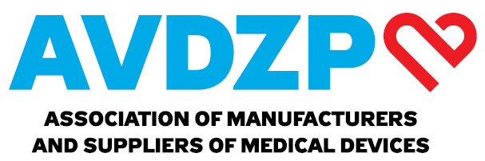

Web: [www.avdzp.cz](http://www.avdzp.cz)

3D hospital: [www.avdzp.cz/vrcatalogue](http://www.avdzp.cz/vrcatalogue)

E-mail: [petr.foit@avdzp.cz](mailto:petr.foit@avdzp.cz)

|  |
| --- |
| Carebot s.r.o. creates an AI-based recommendation system that significantly improves the quality and efficiency of physician diagnoses from X-ray images.  Web: [www.carebot.com/en/carebot](http://www.carebot.com/en/carebot)  E-mail: matej.misar@carebot.com |
| Comedeq s.r.o. specializes on turn-key primary care projects such as one-day surgery, dermatology workplaces, mobile field hospitals, and others.  Web: [www.comedeq.com](http://www.comedeq.com)  E-mail: horak@comedeq.com |
| EGO Zlín s.r.o. is a producer and distributor of complex biological protection systems, logistic and decontamination systems for urgent medicine or long-term treatments.  Web: [www.egozlin.cz/en/](http://www.egozlin.cz/en/)  E-mail: [maximova@egozlin.cz](mailto:maximova@egozlin.cz) |
| https://exporters.czechtrade.cz/getattachment/d26f85e6-4952-4309-adee-41952546fd17/logo?maxsidesize=200&width=200&height=100Kadlec - elektronika, s.r.o. develops and manufactures queue management systems and equipment, digital text and graphic LED panels, self payment kiosk, intelligent touch industrial displays, clocks and synchronized clock systems.  Web: [www.kadlecelektro.cz/en/](http://www.kadlecelektro.cz/en/)  E-mail: [info@kadlecelektro.cz](mailto:info@kadlecelektro.cz) |
| Marketing LINETu se mění, aby lépe vyjádřil hodnoty firmy. Prvním krokem je  nová, moderní vizuální identita a claim společnosti | LINETLINET s.r.o. is a major European manufacturer of hospital and nursing beds. The company’s success is based on innovations that help improve the standards of healthcare in more than 100 countries worldwide.  Web: [www.linet.com](http://www.linet.com)  E-mail: marta.fivebrova@linet.com |
| MZ Liberec a.s. designs, manufactures, supplies, and installs medical gas distribution systems. The company equips operating theatres, ICUs, anaesthesiology-resuscitation wards, and standard inpatient wards.  Web: [www.mzliberec.cz/en](http://www.mzliberec.cz/en)  E-mail: vaclav.rohlena@mzliberec.cz |
| ROYAX, s.r.o. / katalog členů AVDZPRoyax s.r.o. produces medical equipment, especially emergency medical equipment in EMS, patient transportation, and complex medical solutions (ambulances, buses, SAR boats).  Web: [www.royax.eu](http://www.royax.eu/)  E-mail: j.peska@royax.eu |