Exhibition “20th Anniversary of the Fall of the Iron Curtain” at Copenhagen University

The evening before the Czech National Holiday – the Day of the Fight for Freedom and Democracy and the 20th Anniversary of the Velvet Revolution – on 16 November 2009, the exhibition “20th Anniversary of the Fall of the Iron Curtain“ was opened at the Institute of Cross-Cultural and Regional Studies of the Copenhagen University. Copenhagen University was the last stop of the exhibitions journey around the Danish universities.

The Czech Ambassador Zdeněk Lyčka opened the exhibition with a lecture about his own personal experiences from the Velvet Revolution. On this occasion, the Ambassador presented a book by Peter Sís, a Czech artist living in USA, entitled “THE WALL: Growing Up Behind the Iron Curtain“ (2009). There were about 40 participants at the lecture, including Head of Studies, Associate Professor Morten Warmind and the Head of the Eastern European Studies, Professor Jens Nørgaard-Sørensen, who then invited the guests to a little reception in connection with the exhibition.

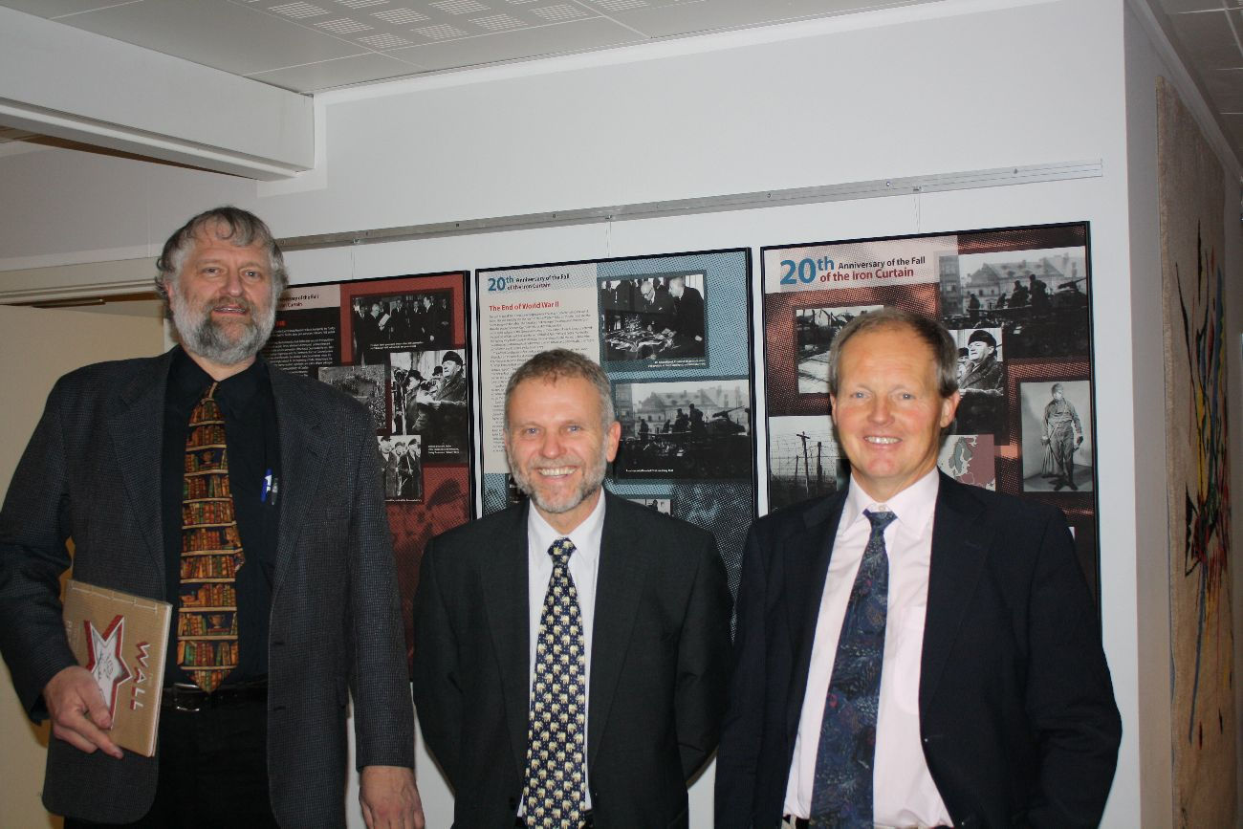

From the left: Associate Professor Morten Warmind, Czech Ambassador Zdeněk Lyčka, Associate Professor Jens Nørgaard-Sørensen

The exhibition “20th Anniversary of the Fall of the Iron Curtain”, made by the Military History Institute in Prague, focuses on the period after the end of World War II in Czechoslovakia and the historical events leading to the division of Europe and the creation of the “Iron Curtain” in 1948. However, the main theme of the exhibition is devoted to the stories of people who decided to pass through the Iron Curtain. Besides the well-known stories, such as the escape of brothers Mašín, a range of other sophisticated, but not always successful escapes – by air, water or with use of heavy technologies – are presented in the exhibition.
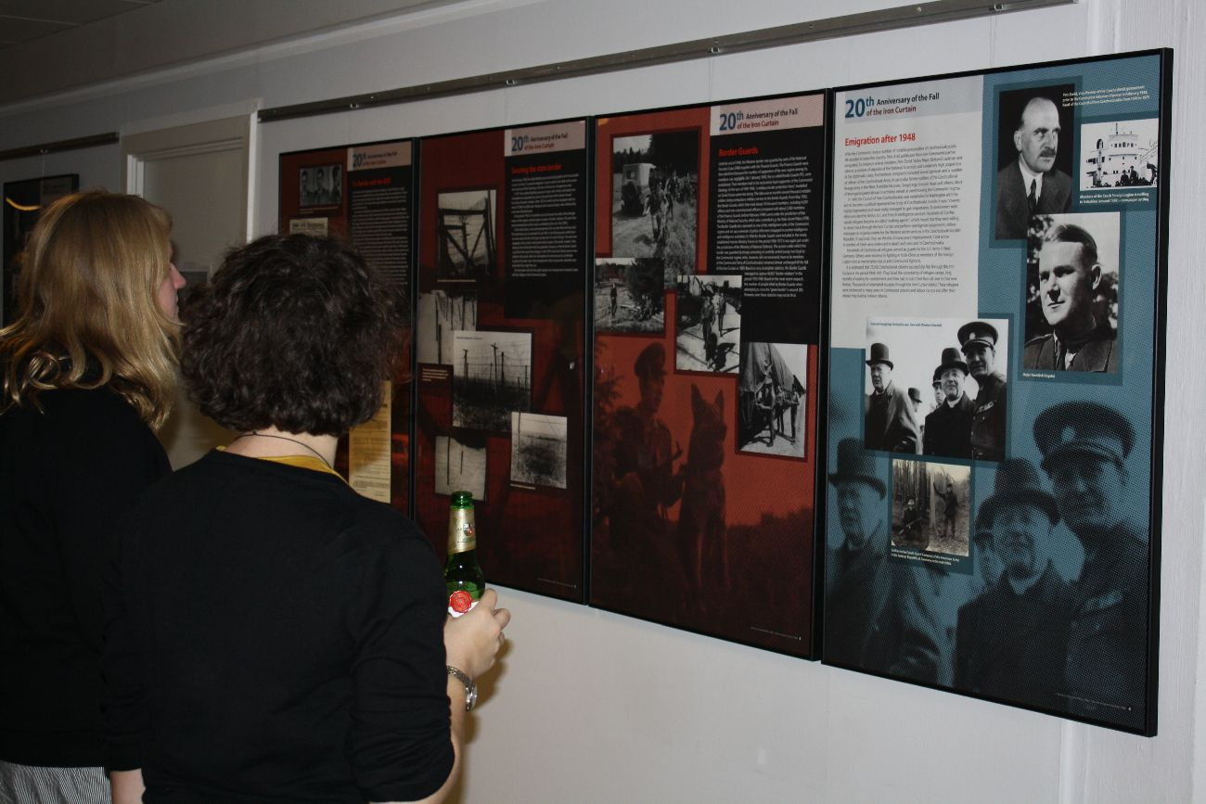

Students at the opening

The travelling exhibition “20th Anniversary of the Fall of the Iron Curtain” and the connected activities thematically follow the CZ PRES’ motto “Europe Without Barriers“ and thus recollect the Czech Presidency of the EU Council in the second half of 2009.

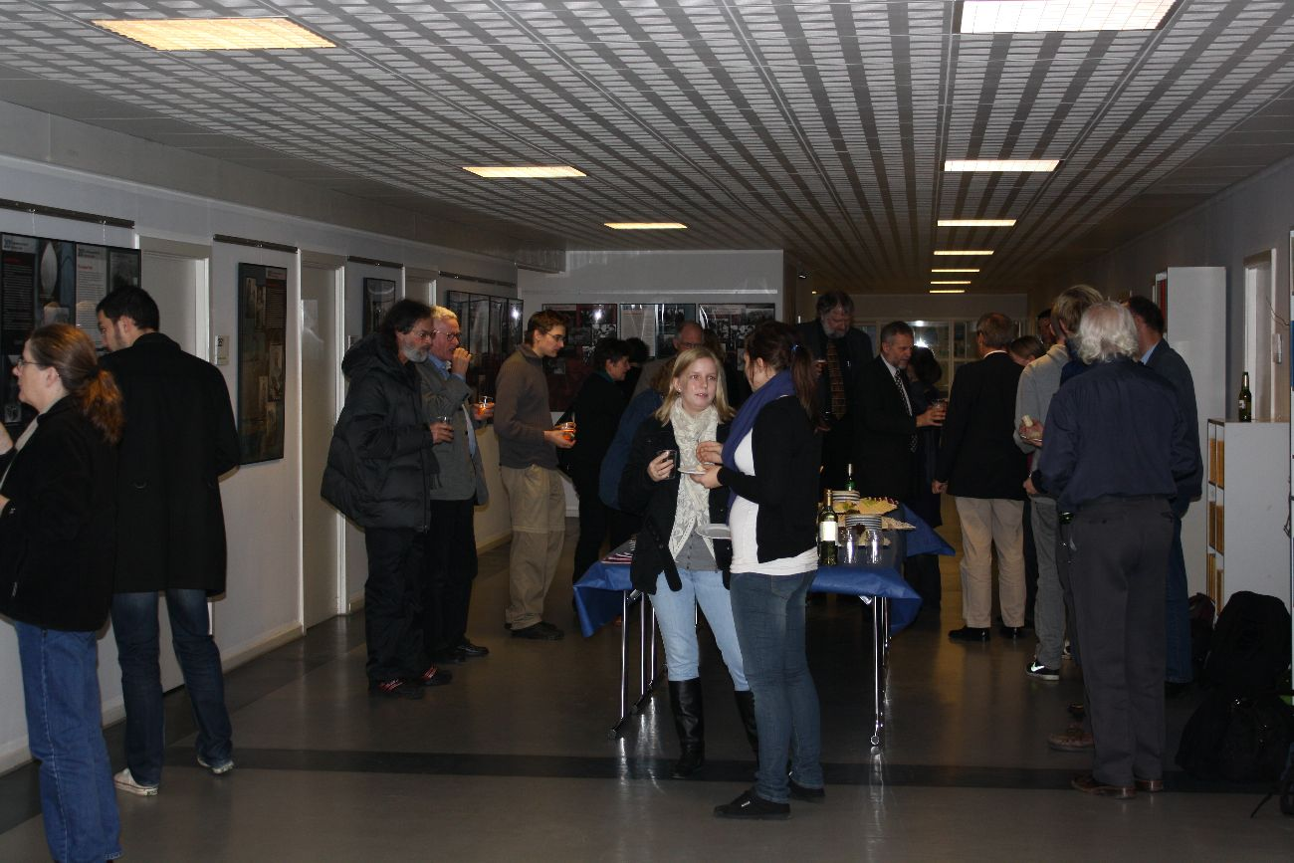

Opening of the exhibition

