Miroslav Barták – Humour Without Words
Exhibition: 40 drawings 40 x 50 cm in frames (1 transport box 106 x 58 x 46 cm - 39 kg)

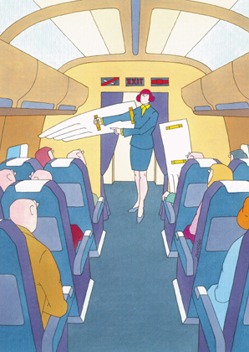
Miroslav Barták in a nutshell: born in 1938, sailor with a degree. Since 1960 he has been a free-lance humorist, cartoonist and illustrator. In 1969-2003, he has been responsible for 70 solo exhibitions in Europe, 8 books, illustrations for 50 books at home and abroad,
2 animated films, 52 short cartoons (blackouts) for TV, and participated in many volumes and journals of cartoons both in Europe and beyond the Big Pool. Since 1970, he has been a core contributor to a Swiss satirical magazine Nebelspalter and has also worked for Das Magasin in Zürich. He lives near Prague in a house with a large garden, together with his wife Teresa - a textile artist - and six cats. Two dogs - Barunka and Beránek - live in the garden. The front runners among those who help him keep in a good mood are Woody Allen, James Thurber and also Tom Sharpe.
… and about himself:
Centuries of living in an exposed Central European space have taught me that the most simple thing you can do is to confess to everything. The author of Good Soldier Svejk has put it this way: "Every denial makes a confession harder and vice versa". So, here we go.
I, Miroslav Barták, a citizen of Prague, a husband and a father of three, duly confess that
I am the author of the drawings exhibited here. I also confess that I am not a painter, only a sailor with a degree and a self-taught cartoonist. I longed to become a painter when I was a little boy. My parents, however, did not like the idea at all and so it happened that the way of their hands pushed me in the direction of a technical career. I graduated from Naval College and served 10 years aboard commercial ships and vessels. I remorsefully confess that, although I never wanted to travel and I did not long for foreign lands, for 10 years I have taken up someone's position who would pay a fortune for one night in Japan. I worked as a naval engineer, supported my family and comforted myself with the idea that I could not stand this life on the move for much longer than beyond my 30th birthday. My teenage hobby - painting large canvasses - has transformed during my 10 years at sea to drawing little sketches. It made me happy to look - through a drawing - for exactly that moment which - though alone and isolated by the margin of a paper from the course of time as well as the story - can still tell a story about both the past and the future. I can hardly deny the influence a finding by a team of Japanese scientists had on me. They discovered that the moment man starts to take things seriously, that particular individual starts losing his brain cells. It made me understand a lot.
I was 30 years old when I waved goodbye to my captain and found myself on dry land with a pack of drawings under my arm. A number of people saw the drawings and a few influential friends even started to persuade me that it was humour and that it could be printed. Please, be generous. Occupation for a sailor on a dry land is very hard to find indeed. Moreover, my body at the time was weakened by the constant changes of latitudes, longitudes and alcoholic drink labels. I became an easy catch for the hypocrites and the vision of considerable earnings also played its role. I made an attempt to become a humorist/cartoonist. This attempt has lasted to this day and I am still enjoying it.
Thanks to taking this step I could spend the next decades of my life in one place and I have to confess that - at my desk - I have lived through adventures that I have not even dreamt of when cruising the oceans. But I also have to confess that I still do not know the definition of humour and I have no idea how it can be mass-produced. Still, I am not as naive as before. When, as a child, I got to know cartoons and the circus, I felt good among laughing people because it seemed to me that a person that is able to laugh cannot be all that bad. I believed for a long time that clowns were actually the most important performers in the circus. Now
I am all grown up and I know it does not work quite like that. I even know that clowns only serve as intermission-fillers, so that Mr Director could take off his tailcoat and get changed into the lion-tamer dress. But irrespective of this knowledge I still like clowns the same way. More than that - I strongly believe that both the sage and the clown have one task in common: to try to turn what is only anticipated to become something that has a name.

