Exhibition and workshop by the Czech illustrator Renáta Fučíková in Odense

On Friday 3 September 2010 the exhibition of illustrations to Chinese fairy tales and to fairy tales by H. C. Andersen by the Czech illustrator Renáta Fučíková was opened in Odense Central Library on 3 September 2010. The exhibition was arranged as a part of the autumn cultural program in Odense with the main theme of China and the exhibition opening took place on the day of Odense Cultural Night 2010.

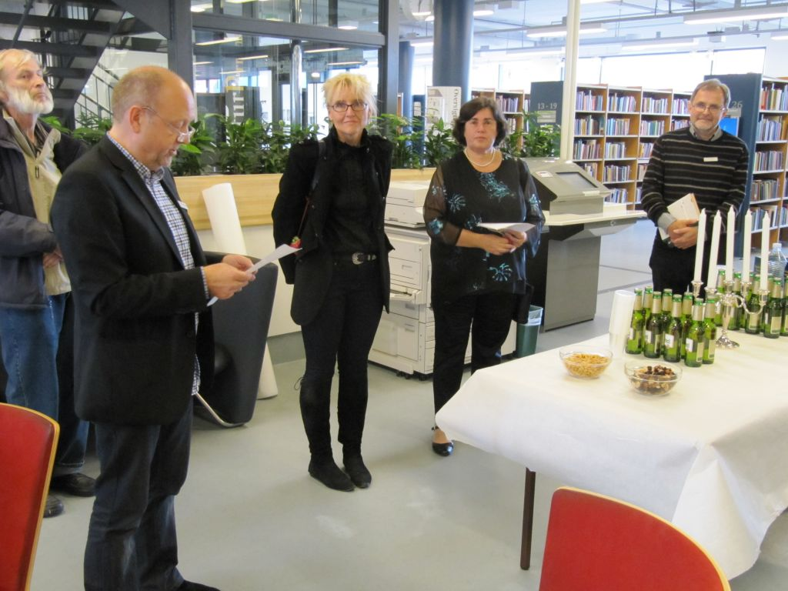
Exhibition opening (from the left: the head of the public relations department Kent Skov, the illustrator Renáta Fučíková, Czech Consul Barbora Stejskalová and the coordinator of the exhibition and librarian Tom Meisner Pedersen)

The exhibition was opened by the Head of the public relations department Kent Skov and the Czech Consul Barbora Stejskalová in the presence of the illustrator Renáta Fučíková, who participated in the program of the Cultural Night by face painting for children with Chinese themes.

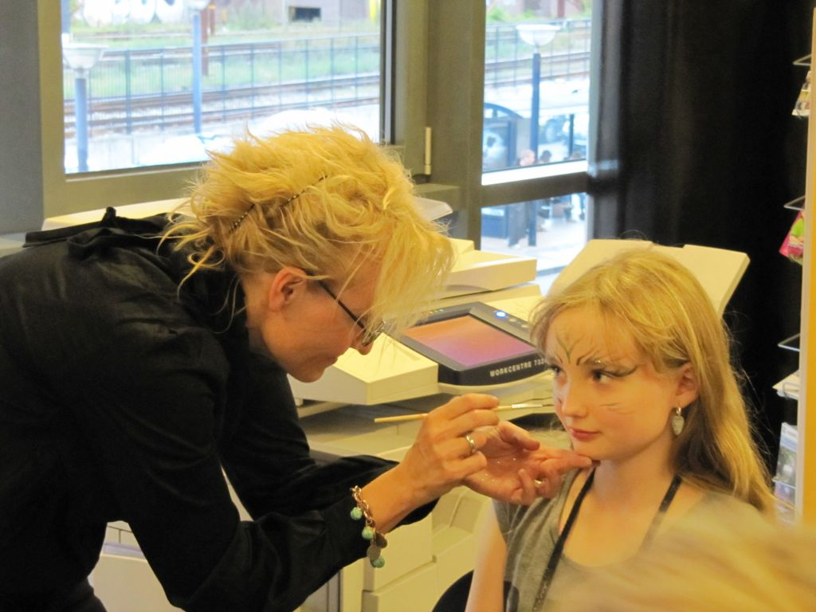
Renáta Fučíková painting
The visitors had the opportunity to buy some of the books by Renáta Fučíková thanks to the cooperation with the Czech publishing house PRÁH.

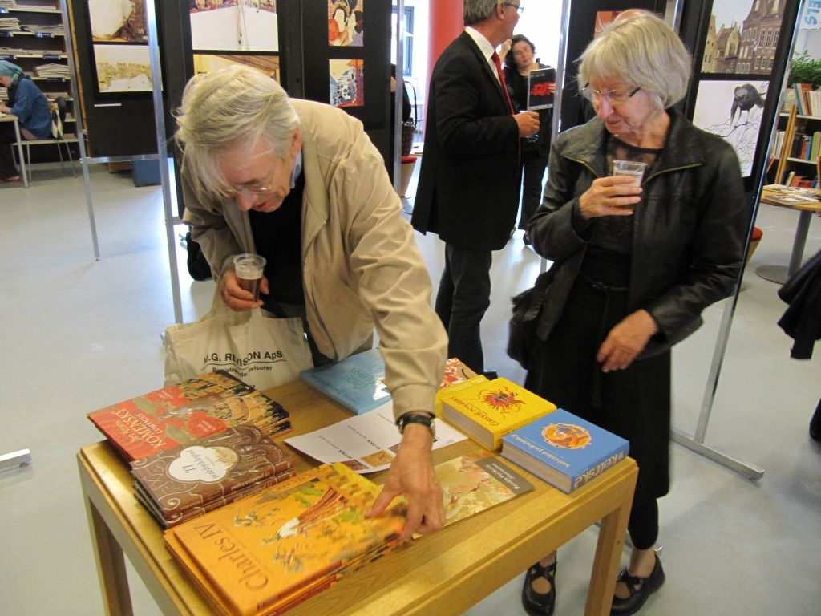
The visitors had the opportunity buy the books by Renáta Fučíková

The exhibition lasts until 30 September 2010 and after that it will continue to other Danish cities.

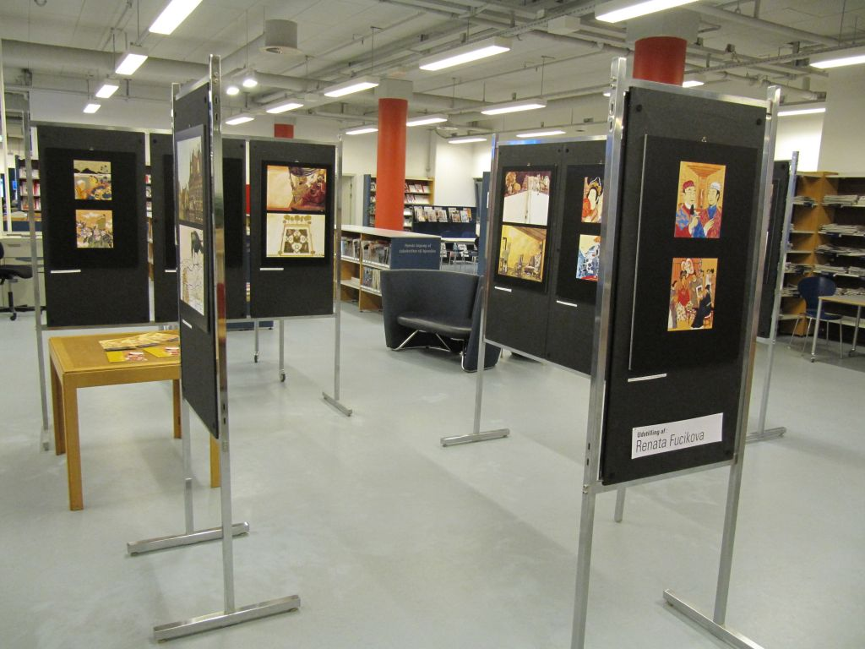
The exhibition is situated on the 2nd floor of the library

On Sunday 5 September 2010 Renáta Fučíková was invited by the Czech Children Club in Copenhagen to arrange a workshop for Czech children. Together with the children and parents, she was reading, narrating and drawing stories from the Czech history. The parents showed big interest for the books by Renáta Fučíková and appreciated the opportunity to buy them.

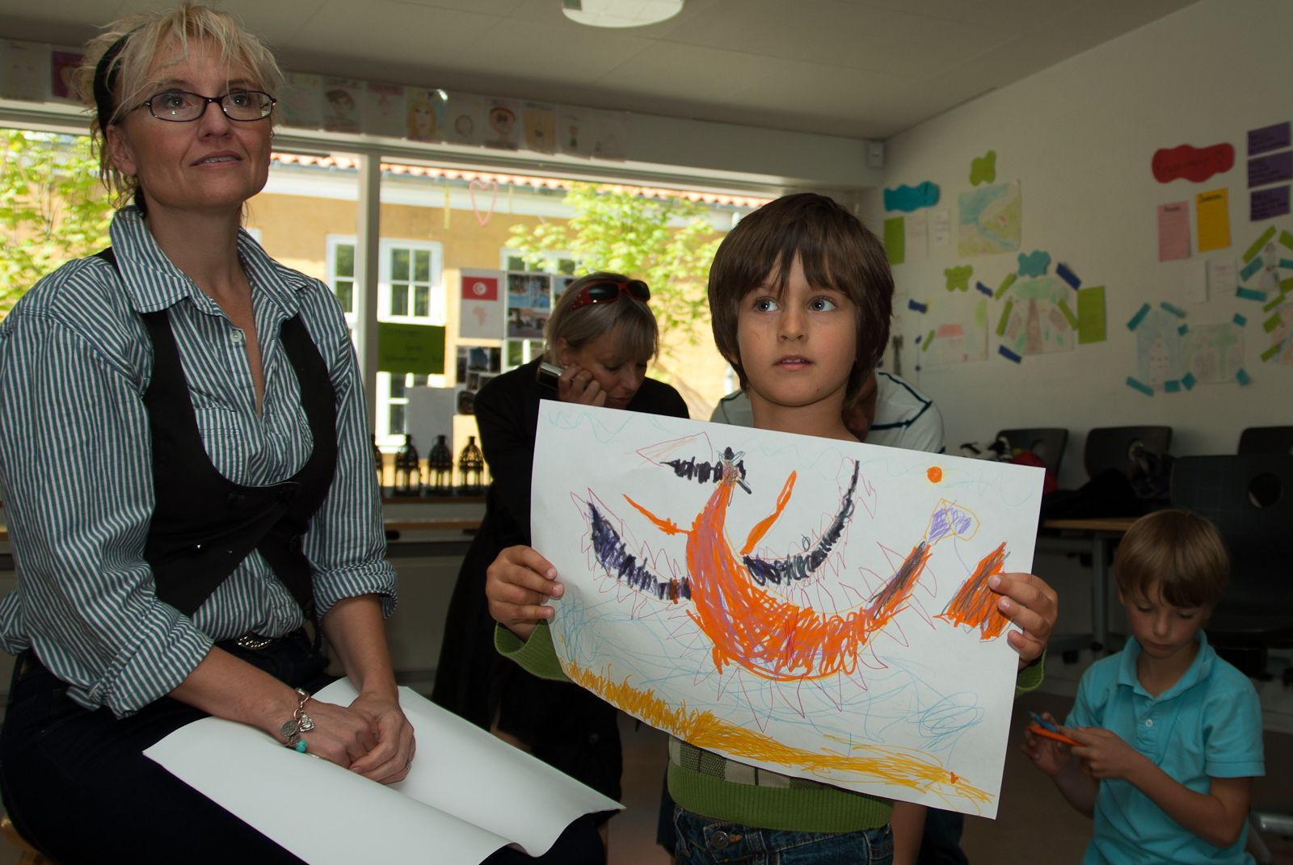
Renáta Fučíková participating at the Czech Children Club

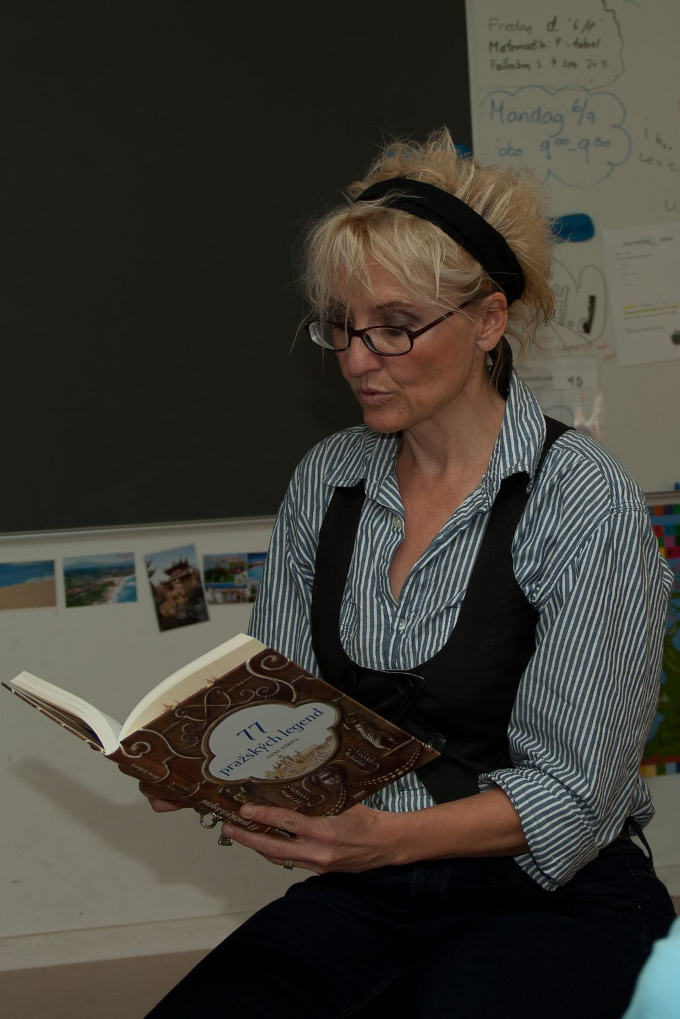
Renáta Fučíková read and narrated stories from the Czech history

