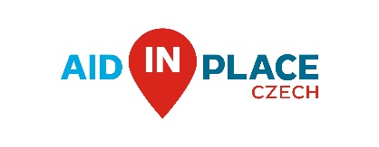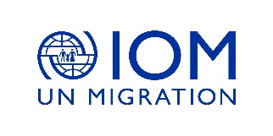
Czech Republic provides CZK 5 million to
Support BiH in responding to migrants’ immediate needs

(Sarajevo, 25th March 2021) - The Czech Republic, through Ministry of Interior of the Czech Republic, is providing the United Nations’ International Organization for Migration (IOM) with CZK 5 million for the humanitarian support to migrants in Bosnia and Herzegovina.
With these funds, the Czech aid will be supporting the work of IOM directly on the ground in five Temporary Reception Centres (TRCs) across Bosnia and Herzegovina. This grant will allow IOM to continue working with both the municipal, cantonal, and State authorities in providing humanitarian assistance and improving reception conditions of migrants.
Since 2015, the Western Balkans have become one of the main routes taken by migrants, refugees and asylum seekers from northern Africa, the Middle East and Asia to reach the European Union (EU) and other countries in Western Europe, some in search of better opportunities, some fleeing from conflicts and persecution.
While Bosnia and Herzegovina remained at the edge of this phenomenon prior to 2017, since then the country has become one of the main transit points. Migrants, asylum-seekers and refugees from northern Africa, the Middle East and Asia, have been transiting Bosnia and Herzegovina since late 2017.
BiH currently hosts approximately 5,350 migrants, asylum- seekers and refugees in official reception centres, including centres managed by the State and NGOs. IOM will use the donated funds to provide necessary Non-Food items such as blankets, clothes, hygiene items etc. to migrants and refugees accommodated in the official five TRCs.
Mrs. Ivana Hlavsová, the Czech Ambassador to Bosnia and Hercegovina, confirmed that Bosnia and Hercegovina has been a very important partner of the Czech Republic for many years and therefore her country stands ready to complement its´ broad development cooperation by assistance to mitigate migration situation in the country. She expressed her hope that the items provided through this assistance would reach the most needed and encouraged local authorities to continue their efforts in establishing an efficient and comprehensive management of migration situation.
“IOM is grateful for the initiative shown by the Czech Republic in supporting migrants in Bosnia and Herzegovina. IOM continues to support the State authorities in managing the migration situation in the country and new pledges from donors are critical to ensure no one is left behind, especially during the pandemic”, says Laura Lungarotti, Sub-Regional Coordinator for the Western Balkans and IOM Bosnia and Herzegovina Chief of Mission.
This significant contribution is helping the International Organization for Migration (IOM) provide aid to thousands of migrants and host communities in need in Bosnia and Herzegovina.

For more information, please contact:
Edita Selimbegović, IOM Public Information, eselimbegovic@iom.int

