Opening of the exhibition of illustrations by Renáta Fučíková at Aarhus Main Library

On 19 October 2011, the exhibition of illustrations to H. C. Andersen and Chinese fairy tales by the Czech illustrator Renáta Fučíková was opened at the Main Library in Aarhus, the second largest city in Denmark.

The exhibition was opened by the Czech Ambassador Zdeněk Lyčka and Marc Pereira Christensen, the Cultural Mayor of Aarhus. The Main Library was represented by Charlotte Stoltenberg, the leader of the section for public relations. Czech Honorary Consul Niels Brøchner, Czech expats and friends of the Czech Republic, also attended the opening.

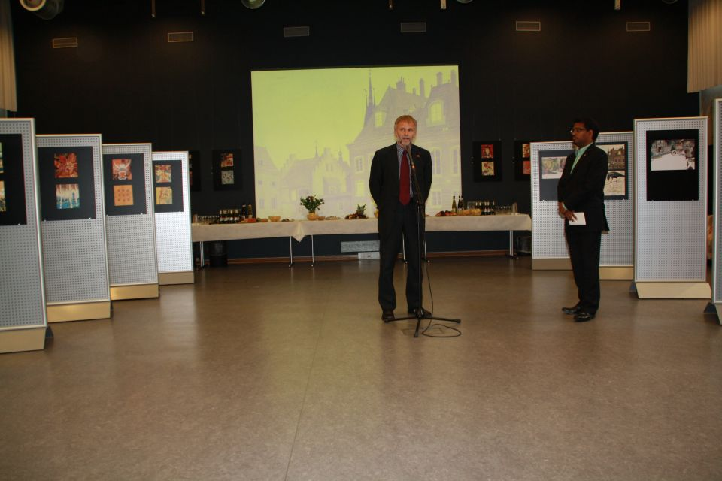
The Czech Ambassador Zdeněk Lyčka during the introductory speech
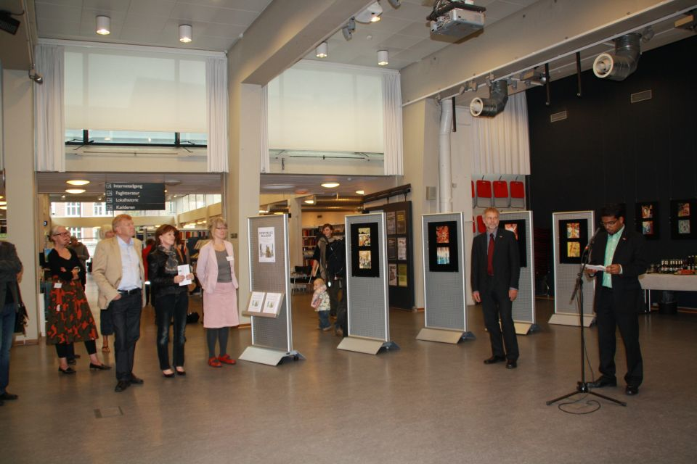
The Cultural Mayor of Aarhus, Marc Perera Christensen, during his speech

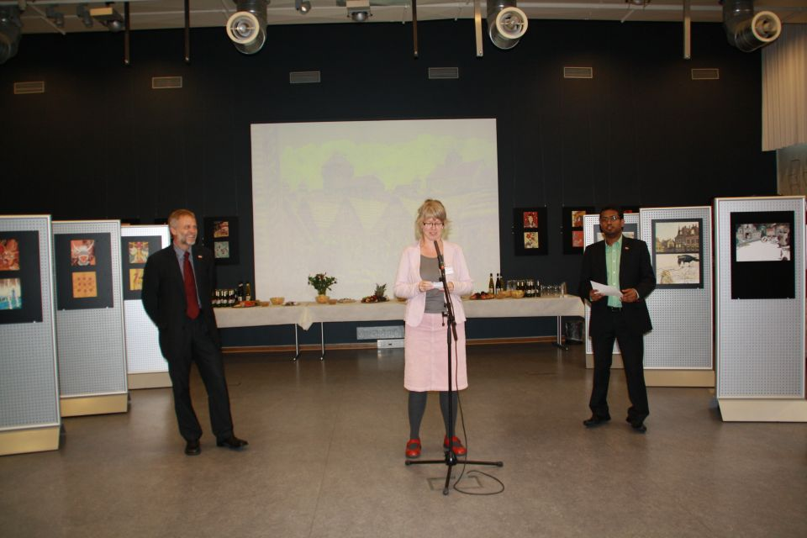
Charlotte Stoltenberg from Aarhus Main Library during her speech

Aarhus Main Library has installed the exhibition in a very suitable and professional way in the library foyer. The exhibition lasts until 9 October 2011.
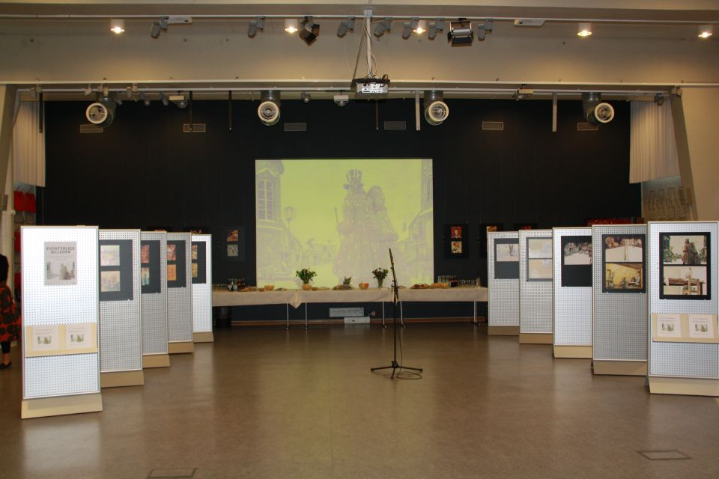
The installation of the exhibition in the foyer
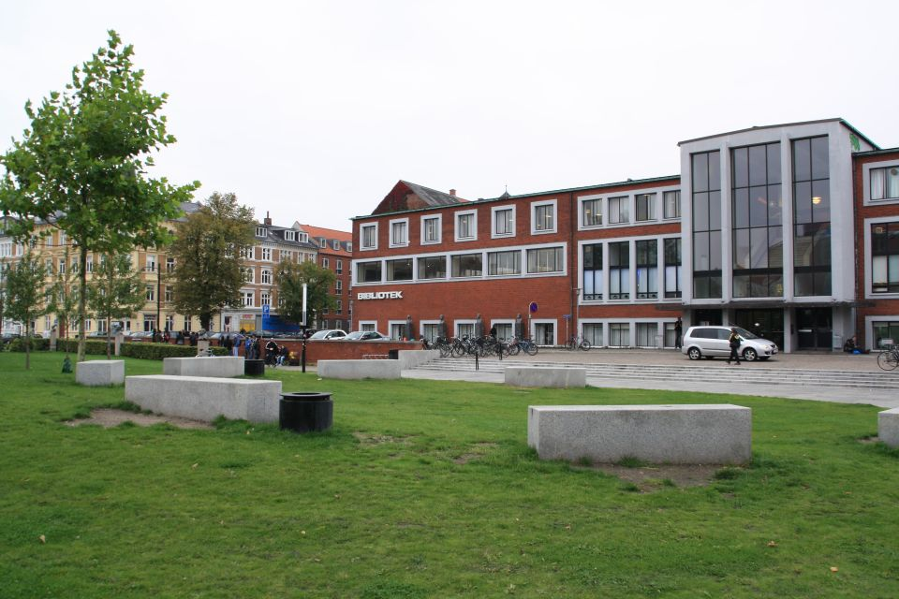
Aarhus Main Library is situated in Aarhus center

The exhibition will continue in other Danish cities, among others in Viborg and in Rudkøbing on the island of Langeland.

