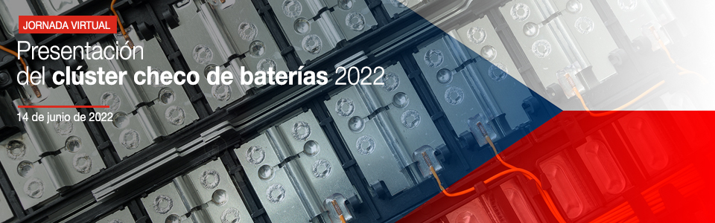
06/14/2022. Online.
10:00 (UTC +2)

ICEX España Exportación e Inversiones, partnering with CZECHINVEST and Economic and Commercial Office of Spain at Prague organize this webinar on June 14th 2022.

WHY

The Czech Republic, with a population of 10.5 million and located in centre Europe, has a better economic situation than the average EU countries. It had and still has the capacity to deal with the serious economic problems arising from the pandemic and the Ukraine war. Its macroeconomic data is excellent, with the lowest unemployment rate in the EU, but with the problem of rising inflation. The CPI stood at 14.2 % in April, due to the tensions in its labour market and the high prices of energy and fuel.

Its economic structure is somehow like the Spanish one. Therefore, the automotive industry and automotive supplier industry are the most important economic sector in the Czech Republic, as it is also in Spain. Automotive industry is one of the most important regarding bilateral trade and accounting for more than 50% of Czech exports to Spain and more than a third of Spanish exports to the Czech Republic. The Czech Republic has become a key country for international automobile production and is emerging as a logistics centre for components in Europe, within the framework of the reindustrialization of EU countries.

Since the second semester of 2021, the Czech government has been working on the project to install a battery Gigafactory for electric vehicles and other uses. They consider it essential for the automobile industry due to the recent development of the sector and aligned with Europe's path towards low emissions. Considering this, the creation of a Czech Battery Cluster was promoted. The coordinator of the project is CzechInvest, an agency of the Ministry of Industry and Commerce, coordinating companies of different sectors and sizes, universities and research and development centres. These past months of work have concluded with the Cluster been established. The webinar is going to explain the experience on the cluster’s origination and incoming actions, that could be useful to companies in the automotive sector and automotive suppliers industry, as well as to those in all those industrial sectors related.

AGENDA

10:00 – 10:01 | Welcome  Moderator  José Manuel Revuelta – Economic and Commercial Commissioner of Spain at Prague
10:05 – 10:15 | Opening remarks  Rodrigo Tilve – Industrial Technology and Professional Services Director - ICEX  Ivan Jančárek – Ambassador of Czech Republic to Spain  Angel Lossada – Ambassador of Spain to Czech Republic
10:15 – 11:20 | Czech battery cluster foundation and its future vision
10:15 – 10:20 | Petra Balladares Perez – Business Development Manager for Ecotech - CzechInvest
10:20 – 10:35 | Filip Kruta – Cluster Development Specialist - CzechInvest
10:35 – 10:50 | Tomas Kadza – Founding Member of the Czech Battery Cluster & Associate Professor - Department of Electrical and Electronic Technology - Brno University of Technology
10:50 – 11:00 | Viliam Blumtritt – Founding Member of the Czech Battery Cluster & Business Development Manager – Lithium Project - Kovohute Pribram
11:00 – 11:10 | Jana Kostalova or Jan Vejbor – Founding Member of the Czech Battery Cluster & Senior Sales Manager - EVC Group - tbc
11:10 – 11:20 | Ira Rubenstein – Cluster Manager - Czech Battery Cluster
11:20 – 11:25 | Q&A  José Manuel Revuelta – Economic and Commercial Commissioner of Spain at Prague
11:25 – 11:30 | Closing remarks  José Manuel Revuelta – Economic and Commercial Commissioner of Spain at Prague

Where | Online (Webex)
Registration | Free registration at www.icex.es (limited availability).  REGISTRATION  Registration until: 06/13/2022 at 5:00 p.m.  You will receive emails with the link to connect and further instructions at the email registered.
More info: | industrial@icex.es

