  
  
  May 2013

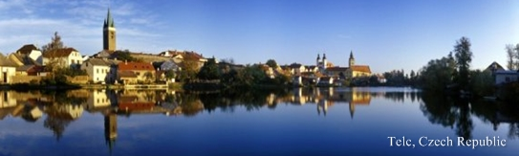

Ambassador's Message: “Last month, the Czech-American community in the United States was shocked by the tragedy in West, TX. During my visit, I personally was deeply saddened by the sight and vastness of the impact of the explosion, yet encouraged by the resilience of the community there. I am proud that the Czech Republic is able to provide financial assistance to the recovery efforts. If you would like to help those affected by the blast, you can read more in the first article of this issue of Czech the News.” ~ Petr Gandalovič


Czech Republic Helps West, TX
The Goverment of the Czech Republic has approved the donation of 4 million Czech Crowns (approximately 200,000 USD) for West, TX, which was severely damaged by the chemical plant explosion. The majority of the town's population has Czech roots. Photo Courtesy: Stephen Stephanian | Learn how you can also help.

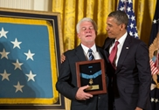
Medal of Honor Given to Chaplain
Emil Kapaun, a US Army Chaplain, posthumously received the Medal of Honor from President Obama at the White House on April 11 for his heroic acts during the Korean War. Kapaun was born in Pilsen, Kansas, to a family with Czech origin that came to the United States in the late 19th century. Photo Courtesy: Pete Souza | Read more.

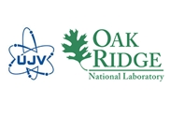
Czech-US Civil Nuclear Cooperation
The Governments of the United States and the Czech Republic have recently completed the transfer of 75 kilograms of fluoride salt from Oak Ridge National Laboratory to the Czech Nuclear Research Institute Řež. The material will be used in research and development of new generation high temperature reactors. Read more.

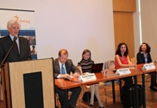
Václav Havel Journalism Fellows
On April 9, the Embassy of the Czech Republic in Washington, DC, welcomed this year´s Václav Havel Journalism Fellows during the panel discussion “Media Freedom in the European Neighborhood.” Photo courtesy: Robert Řehák | Read more.
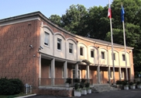
Czech Republic and Lifeline Fund
On May 16, the Embassy of the Czech Republic concluded its three-month chairmanship of the Lifeline Fund, an international fund to support embattled non-governmental organizations (NGOs) all over the world, by hosting a meeting of the Donor Steering Committee.
Photo courtesy: Mary Fetzko | Read more.

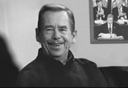
Václav Havel Human Rights Prize
The new Václav Havel Human Rights Prize will be awarded each year to reward outstanding civil society action in the defense of human rights in Europe and beyond. Nominations for the award must be submitted by June 30.
Photo courtesy: Oldřich Škácha | Read more.

Czech That Film Launches in DC
The West End Cinema will feature five new Czech films from May 29-June 26, as part of the festival Czech That Film presented by Staropramen. The DC screenings kick off with Czech director David Ondříček’s acclaimed film In the Shadow (Ve stínu) on May 29, at 7 pm. A Q&A with the director follows the screening. Photo Courtesy: Czech Center | Read more.


Theater: Light in a Darkness
From May 31-June 2, Czech physical theater actress Miřenka Čechová returns to Washington to present the original work Light in a Darkness with Radim Vizrahy and the Tantehorse Company at the Atlas Performing Arts Center. Photo Courtesy: www.treatralna.com | Read more.

Lidice Remembered through Film
On June 12, at 8 pm, the Avalon Theater will screen the film Lidice by director Petr Nikolaev. The burning of Lidice was Nazi Germany's only officially admitted genocidal act during the war. The film presents three interconnected stories in connection with the tragic razing of Lidice in 1942. Photo Courtesy: Czech Center | Read more.

