Czech Animation Masters on Tuesday 2 November 2010 at 1 pm. at the National Film School of Denmark

On the occasion of 100th anniversary of the birth of the Czech genius of movie animation – Karel Zeman – the National Film School of Denmark in cooperation with the Embassy of the Czech Republic, the Danish Design School and the National Film Archive in Prague invite you to a one-day film event with works by Czech masters of animation.
For further information please see the attached program. Please confirm your participation (the whole event, or the particular blocks A,B,C)
no later than 28 October 2010 by e-mail: elr@filmskolen.dk (Elisabeth Rosen)

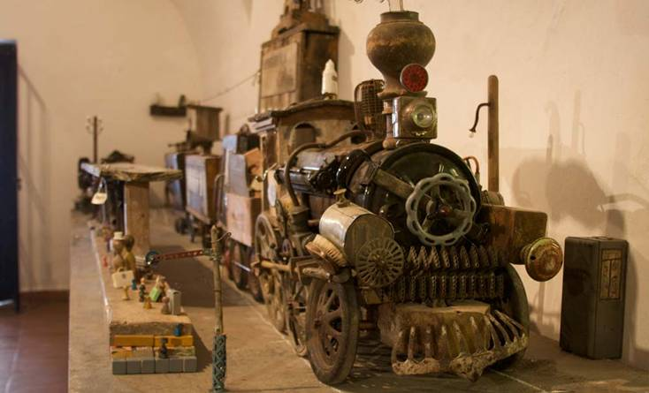

National Film School of Denmark
Animation Studies
Theodor Christensens Plads 1
1437 Københavh K
Tel. 3268 6400
www.filmskolen.dk

