Travelling Exhibition “20th Anniversary of the Fall of the Iron Curtain” at the University of Southern Denmark in Odense
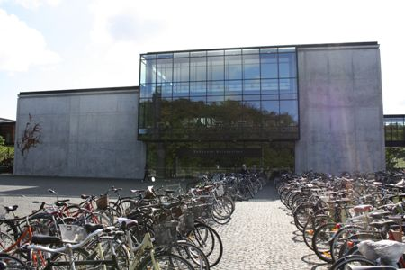
University of Southern Denmark in Odense
The Czech Ambassadør Zdeněk Lyčka opened the exhibition at the University of Southern Denmark in Odense on 14 September 2009 and delivered a lecture about his own personal experiences from the Velvet Revolution. There were about 40 participants at the lecture and at the opening, including Chancellor Jens Oddershede and Thomas Wegener Friis, Head of the Institute of History, Culture and Social Studies.
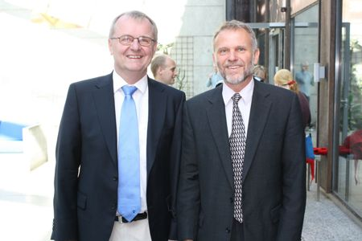
Principal Jens Oddershede (left) and Ambassador Zdeněk Lyčka
The exhibition will be shown in Odense until 1 October and then it will be installed at the universities in Århus and Aalborg. The celebration of the fall of Communism will culminate in Copenhagen, where a number of special events will follow after the opening of the exhibition at Copenhagen University on 16 November. A discussion on the Velvet Revolution and the historical events in 1989 will take place in Europe House on 18 November and on 19 November a documentary “Burma VJ: Reporting from a Closed Country” will be screened at the Czech Embassy. The director of the Burma Centre in Prague, Ms. Sabe Amthor Soe, will be present and will participate in the discussion after the film. The exhibition cycle and the following events will last until 30 November.
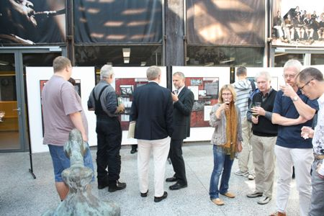
Opening of the exhibition in Odense
The exhibition “20th Anniversary of the Fall of the Iron Curtain”, made by the Military History Institute in Prague, focuses on the period after the end of World War II in Czechoslovakia and the historical events leading to the division of Europe and the creation of the “Iron Curtain” in 1948. However, the main theme of the exhibition is devoted to the stories of people who decided to pass through the Iron Curtain. Besides the well-known stories, such as the escape of brothers Mašín, a range of other sophisticated, but not always successful escapes – by air, water or with use of heavy technologies – are presented in the exhibition.
On this occasion, the Czech Embassy presents a book by Peter Sís, a Czech artist living in USA, entitled “THE WALL: Growing Up Behind the Iron Curtain“ (2009). This outstanding book gives a close look to the life behind the “Iron Curtain” – in the years 1948-1989 – through playful illustrations and cartoon drawings. Authentic diary excerpts and notes contribute to the understanding of the historical timeline.
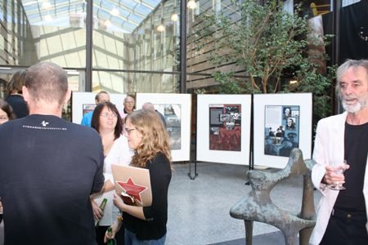
Opening of the exhibition in Odense with Peter Sís’ book THE WALL (left)
The travelling exhibition “20th Anniversary of the Fall of the Iron Curtain” and the connected activities thematically follow the CZ PRES’ motto “Europe Without Barriers“ and thus recollect the Czech Presidency of the EU Council in the second half of 2009, too. Ambassador Z. Lyčka made interviews for DR-P1 (13.09.09) and Fyns Stiftstidende (will be published on Saturday 19.09.09).

