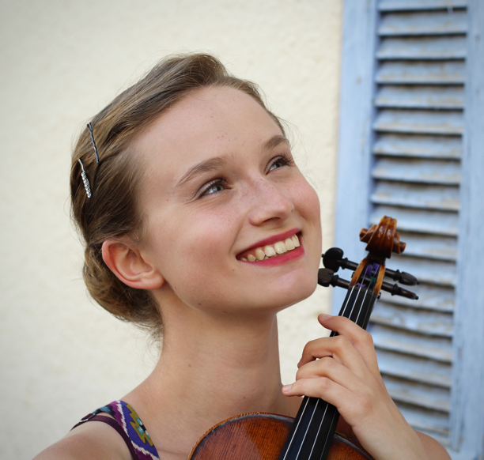

Chicago native **Bailey Wantuch** began studying the violin at age 4. Actively involved in chamber music, Wantuch has worked with members of the Vermeer Quartet, Dover Quartet, Lincoln Trio, and Peabody Trio. In recent years her ensembles have received great recognition, including first prize in the 2017 McGill Chamber Music Competition. She has also appeared as a soloist with several orchestras in the Chicagoland area. Wantuch has attended prestigious festivals in the USA such as Madeline Island Chamber Music, the Northwestern Summer Violin Institute, and the Zodiac Music Academy & Festival in southern France. In addition to performing, Wantuch is a passionate and devoted pedagogue having taught at schools worldwide, including Cuerdas Frotadas (Chile), La Escuela Superior de Música de la UJED (Mexico), and El Sistema Kenya. She obtained her Bachelor of Music from Northwestern University’s Bienen School of Music and her Master of Music in Violin Performance from McGill University’s Schulich School of Music. Her former teachers are Blair Milton of the Chicago Symphony Orchestra and Violaine Melançon of the Peabody Trio.

Wantuch has taken an interest in social justice through music education. She recently completed the Global Leaders Program, a year-long certificate program for socially-minded musicians spanning the globe.



**Hannah Emmrich** (previously Watson) is a pianist, teacher and choir director from the UK, now working as Music Director at All Saints Cathedral, Nairobi. She started her musical studies with Enloc Wu, attending the Royal College of Music Junior Department in London, and studied Modern Languages at Cambridge before deciding to pursue music full-time. Highlights of the last few years have included solo, chamber and song recitals at St Martin-in-the-Fields, the Barbican, Cardiff’s St David’s Hall, St John’s Smith Square and the Royal Festival Hall, as well as performances on BBC Radio 3’s In Tune and Afternoon on 3. Working with drama and other arts has always interested Hannah: she played in a scene for Nicholas Hytner’s film version of The Lady in the Van, starring Maggie Smith; and in a theatre adaption of Tolstoy’s The Kreutzer Sonata, starring Greg Hicks, at the Chipping Norton Theatre.

Hannah graduated with an Artist Diploma at the Guildhall School of Music and Drama, learning with Martin Roscoe and Caroline Palmer. Her studies were generously funded by a Help Musicians Postgraduate Performance Award, the Kenneth Loveland Gift, the Leverhulme Trust, the Fergal O’Mahoney Memorial Foundation, the Worshipful Company of Tallow Chandlers and the Countess of Munster Musical Trust.

**Bailey Wantuch, Violin**

**Hannah Emmrich, Piano**

Friday, July 12th, at 7:00PM

The Lord Erroll, Nairobi

**An Evening of Czech Music**

***Sponsored by the Embassy of the Czech Republic in Nairobi***

|  |  |
| --- | --- |
|  |  |
| From the Homeland (*Z Domoviny*) (1880)  I. Moderato | Bedřich Smetana  (1824-1884) |
| Violin Sonata No. 5 in F Major, op. 24 “Spring” (1800) | Ludwig van Beethoven  (1770-1827) |
| I. Allegro  II. Adagio molto espressivo  III. Scherzo. Allegro molto – Trio  IV. Rondo. Allegro ma non troppo | |
| *--- Intermission ---* | |
| Sonata for Violin and Piano (1922) | Leoš Janáček  (1854-1928) |
| I. Con moto  II. Ballada  III. Allegretto  IV. Adagio | |
| Sonatina in G Major for Violin and Piano, op. 100 (1893) | Antonín Dvořák  (1841-1904) |
| I. Allegro risoluto  II. Larghetto  III. Scherzo. Molto vivace – Trio  IV. Finale. Allegro | |