Opening of the Exhibition “The World of Inuit“

The Greenland House in Copenhagen has opened a new exhibition “The World of Inuit“ by the Czech painter Jan Vojta, together with an exposition of paintings by Lenka Rasmussen.

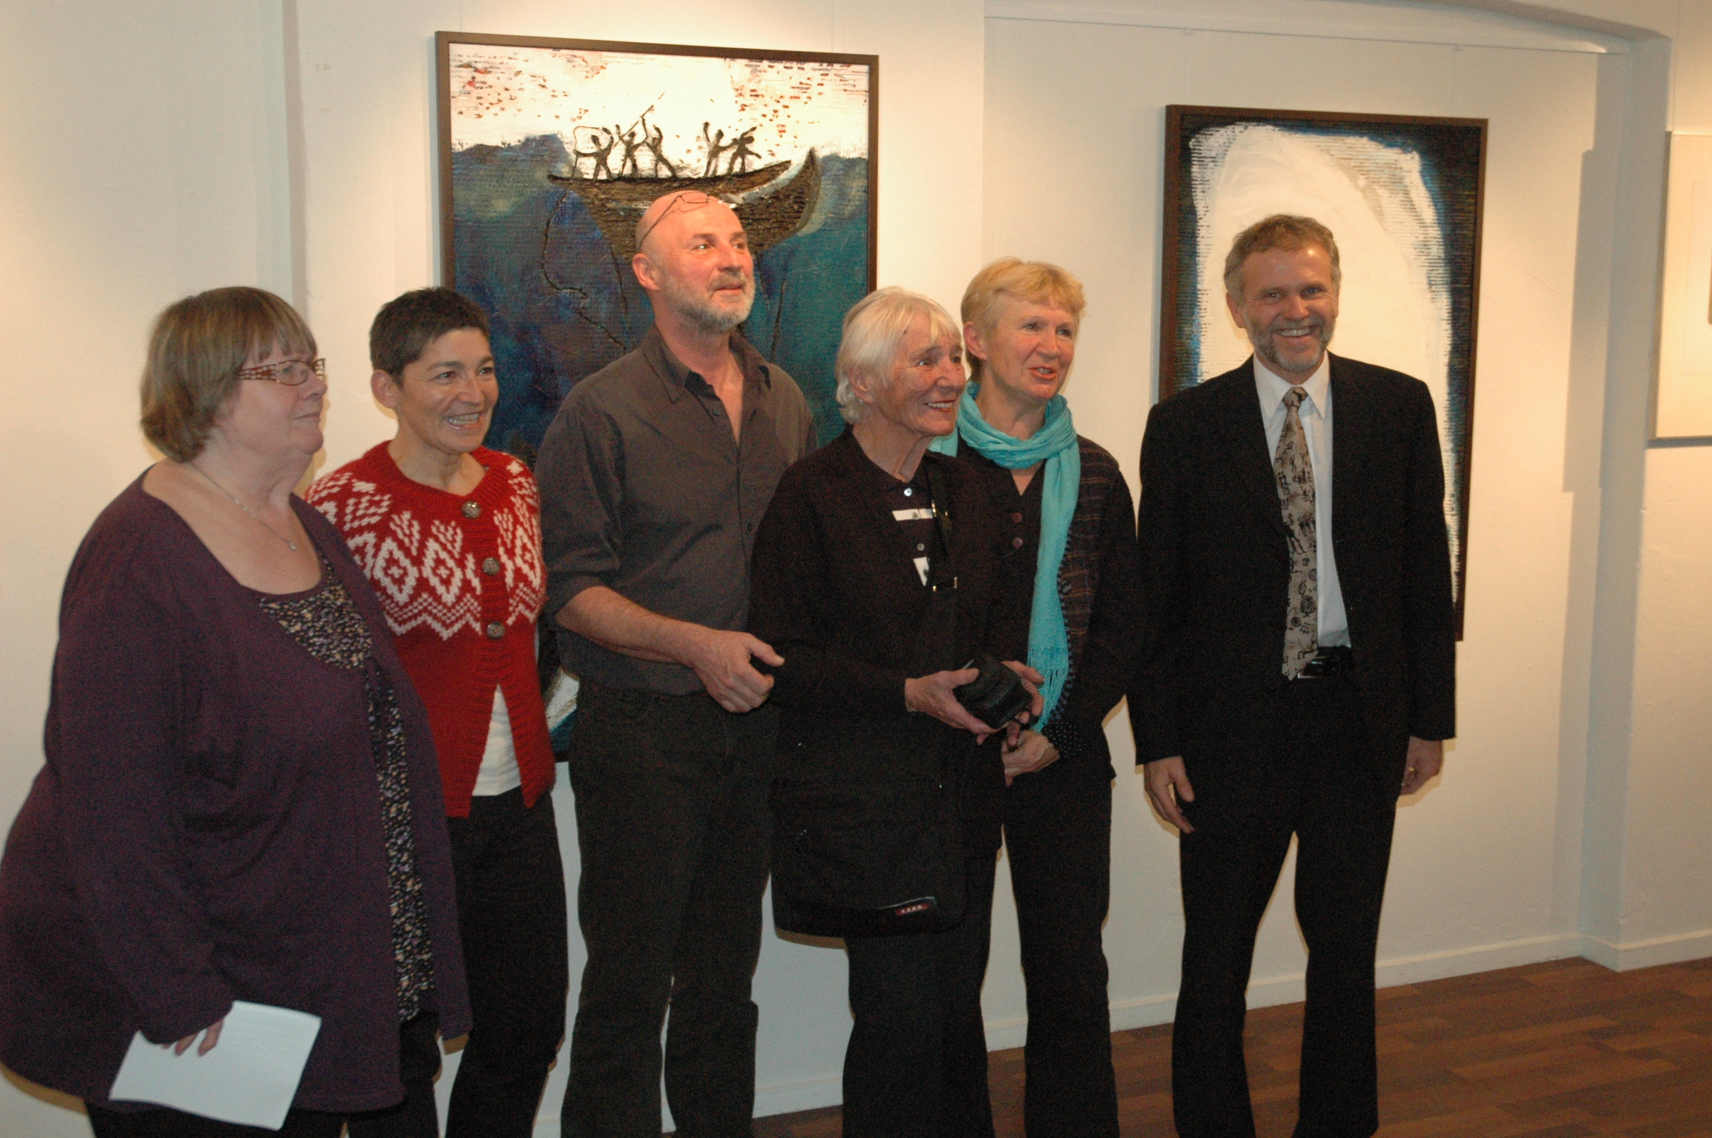
Opening (from the left): Inger Bruun, Director of the Greenland House, Pia Rosing Heilmann, teacher of Greenlandic, Jan Vojta with his mother, Lenka Rasmussen, Czech Ambassador Zdeněk Lyčka.
Photo: Søren Thalund

The exhibition was opened on 9 November by Inger Bruun, Director of the Greenland House, and the Czech Ambassador Zdeněk Lyčka, in the presence of both authors.
The exposition can been seen in The Greenland House until 21 January 2011.
Det Grønlandske Hus, Løvstræde 6, København K

Opening hours: Monday – Thursday 10:00 – 17:00
Friday 10:00 – 16:00
Saturday, Sunday and holidays closed

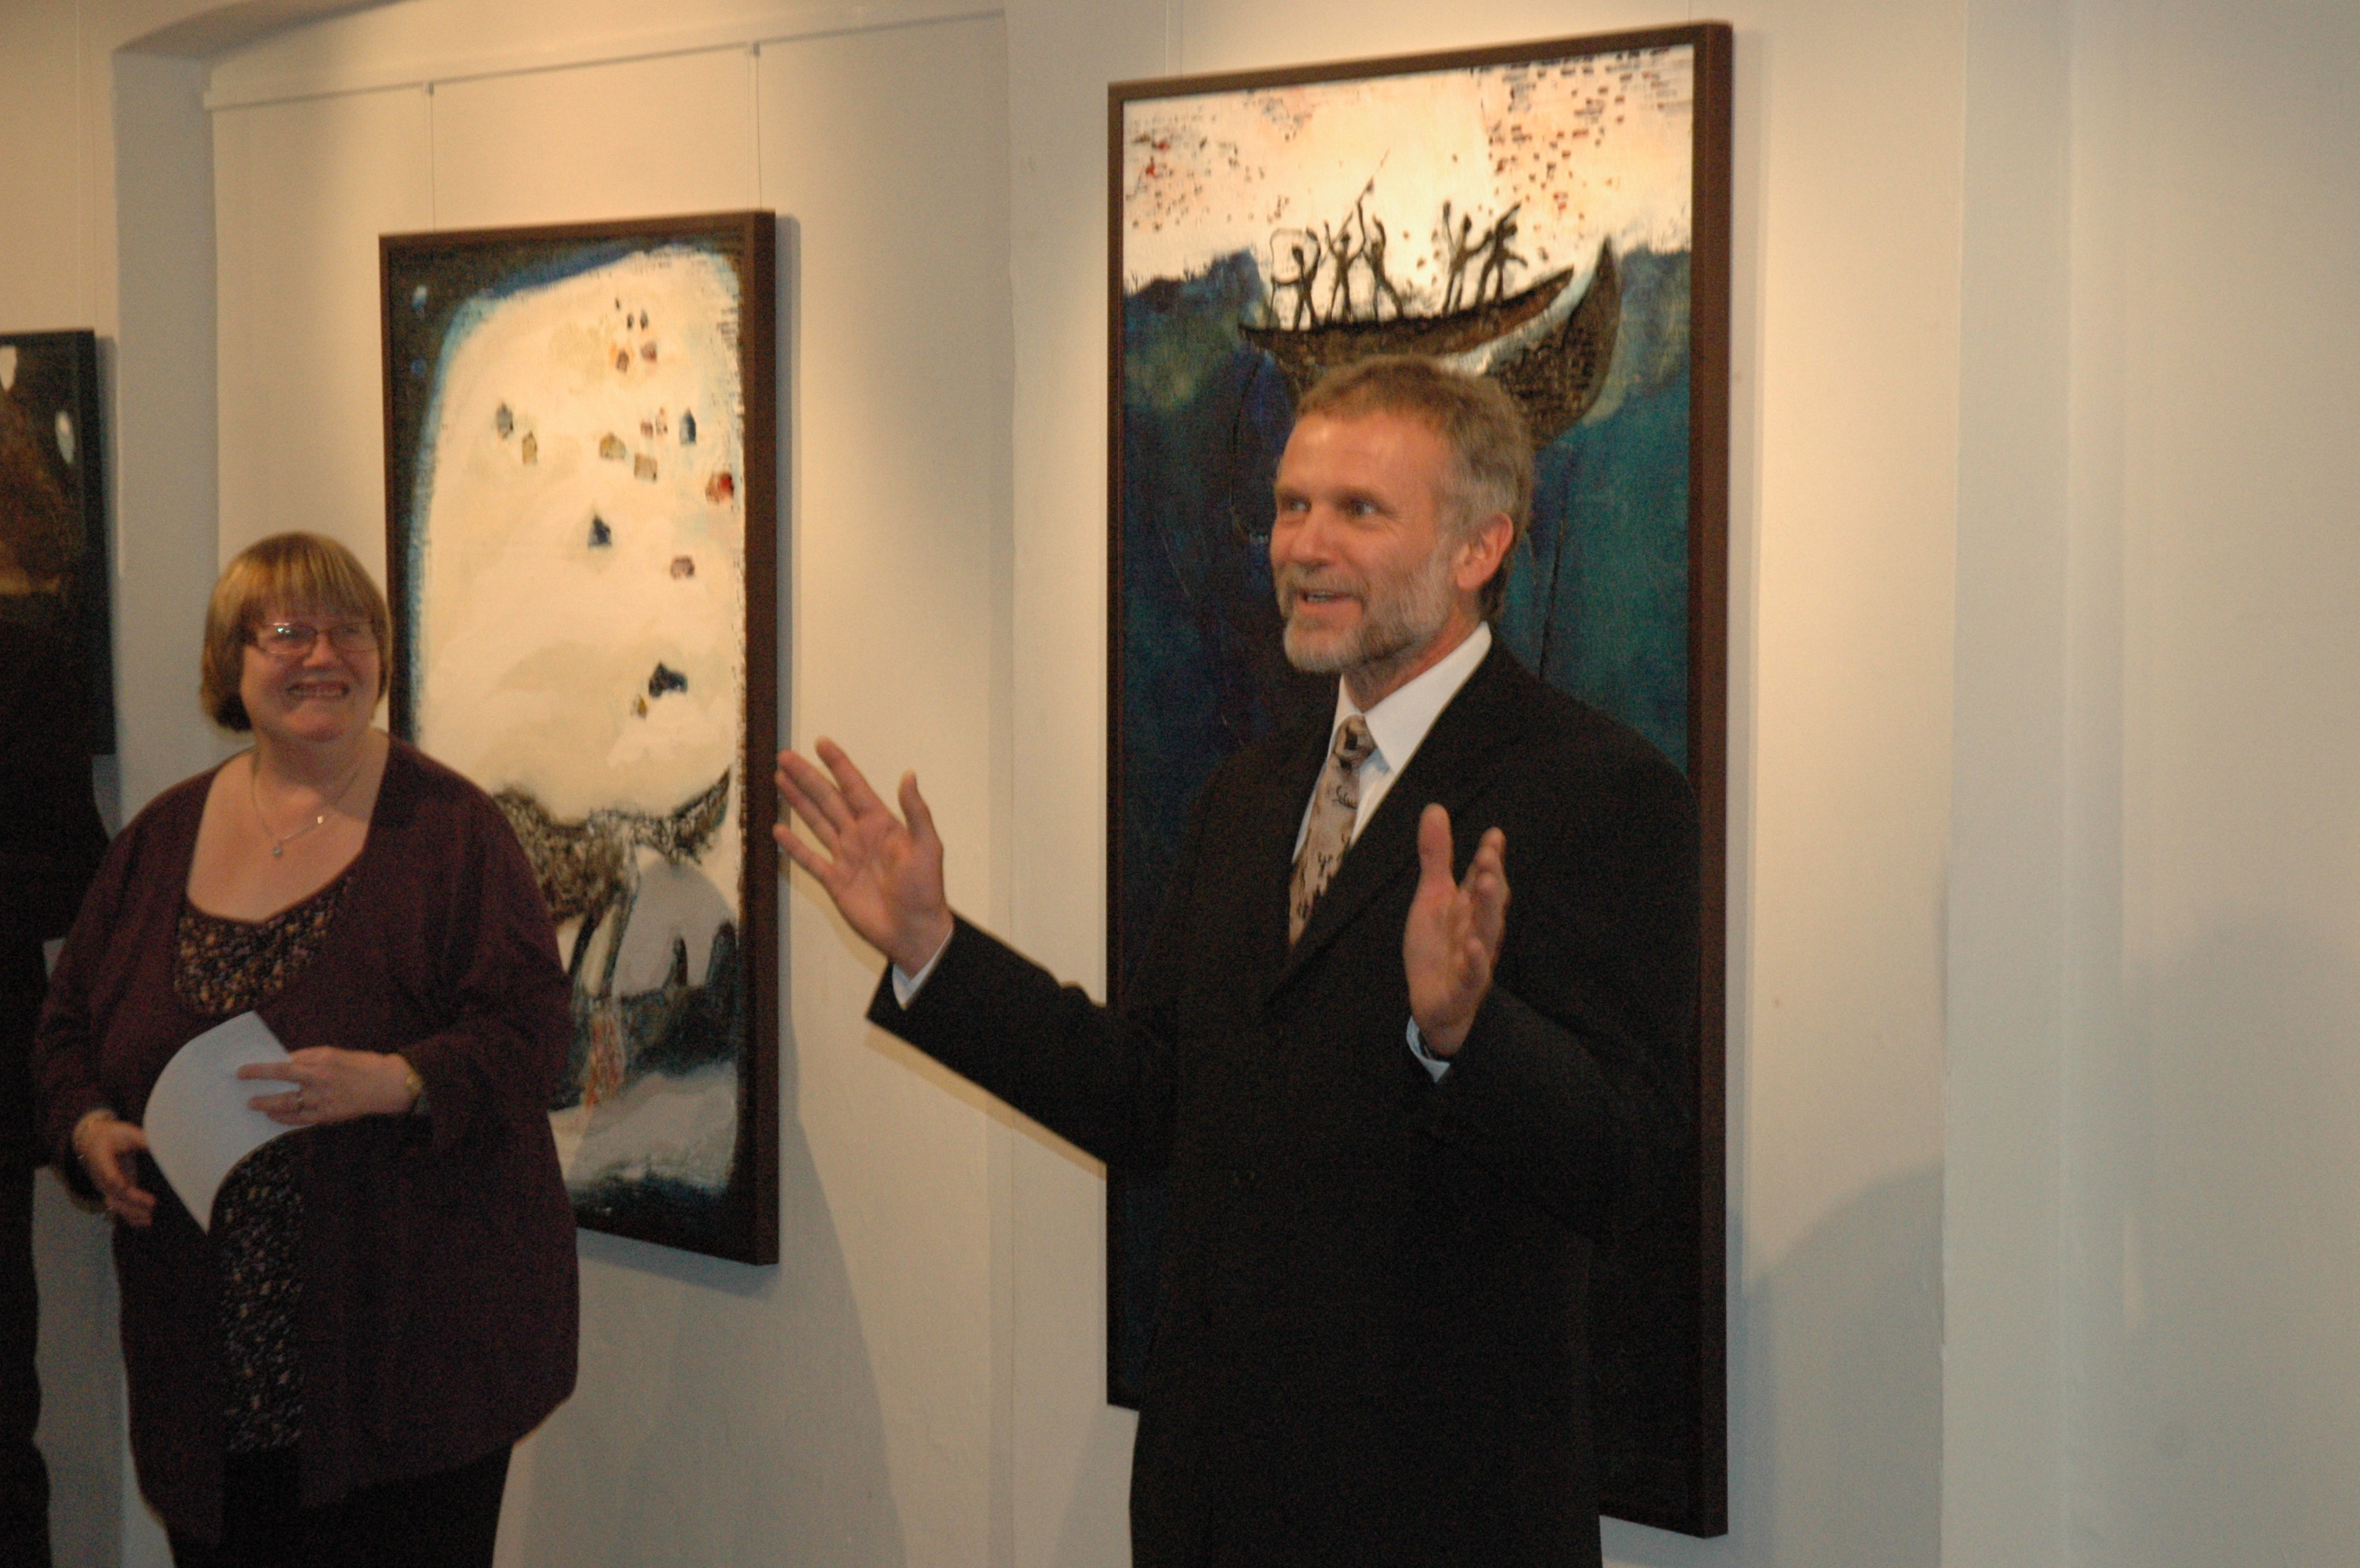
The Czech ambassador Zdeněk Lyčka’s opening speech in Greenlandic. Photo Søren Thalund

