"Sophie´s Choice in the Czech Way" in Odense

Exhibition opening 15 September 2014

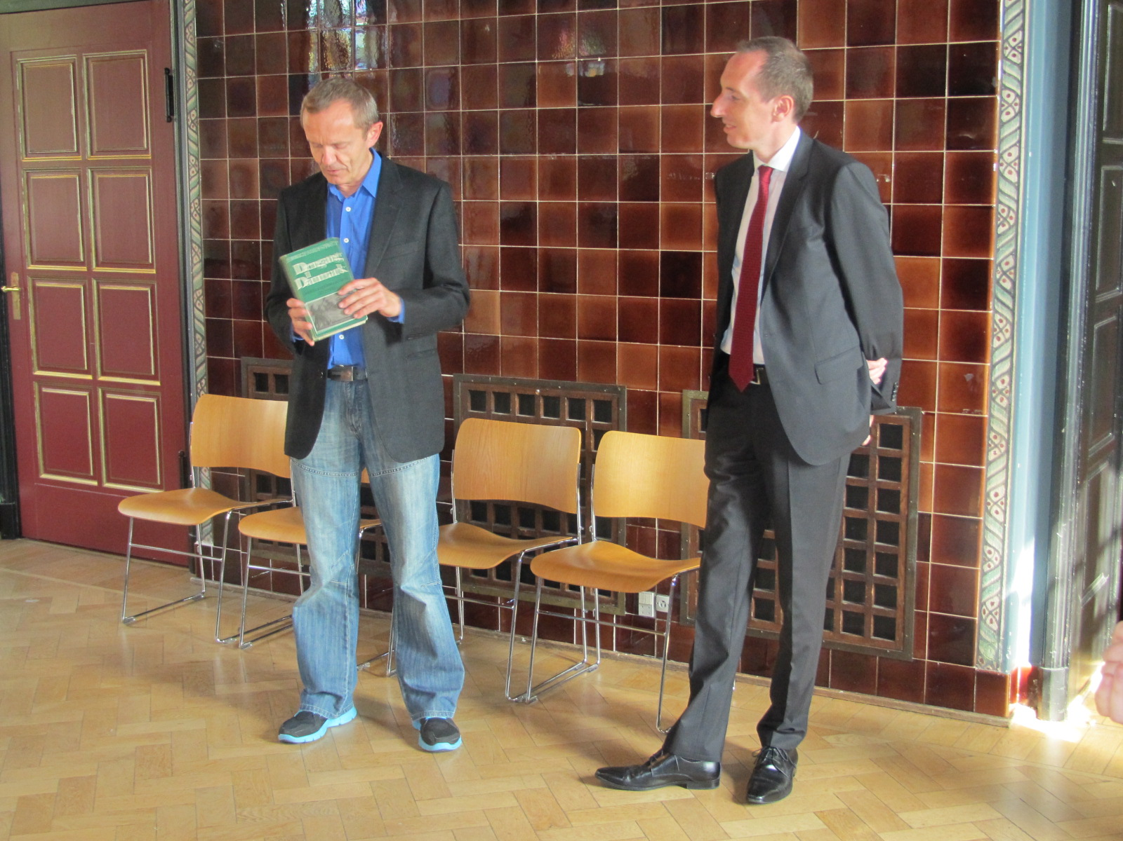
From the left: the head of Odense archive Jørgen Thomsen and Ambassador Jiří Brodský

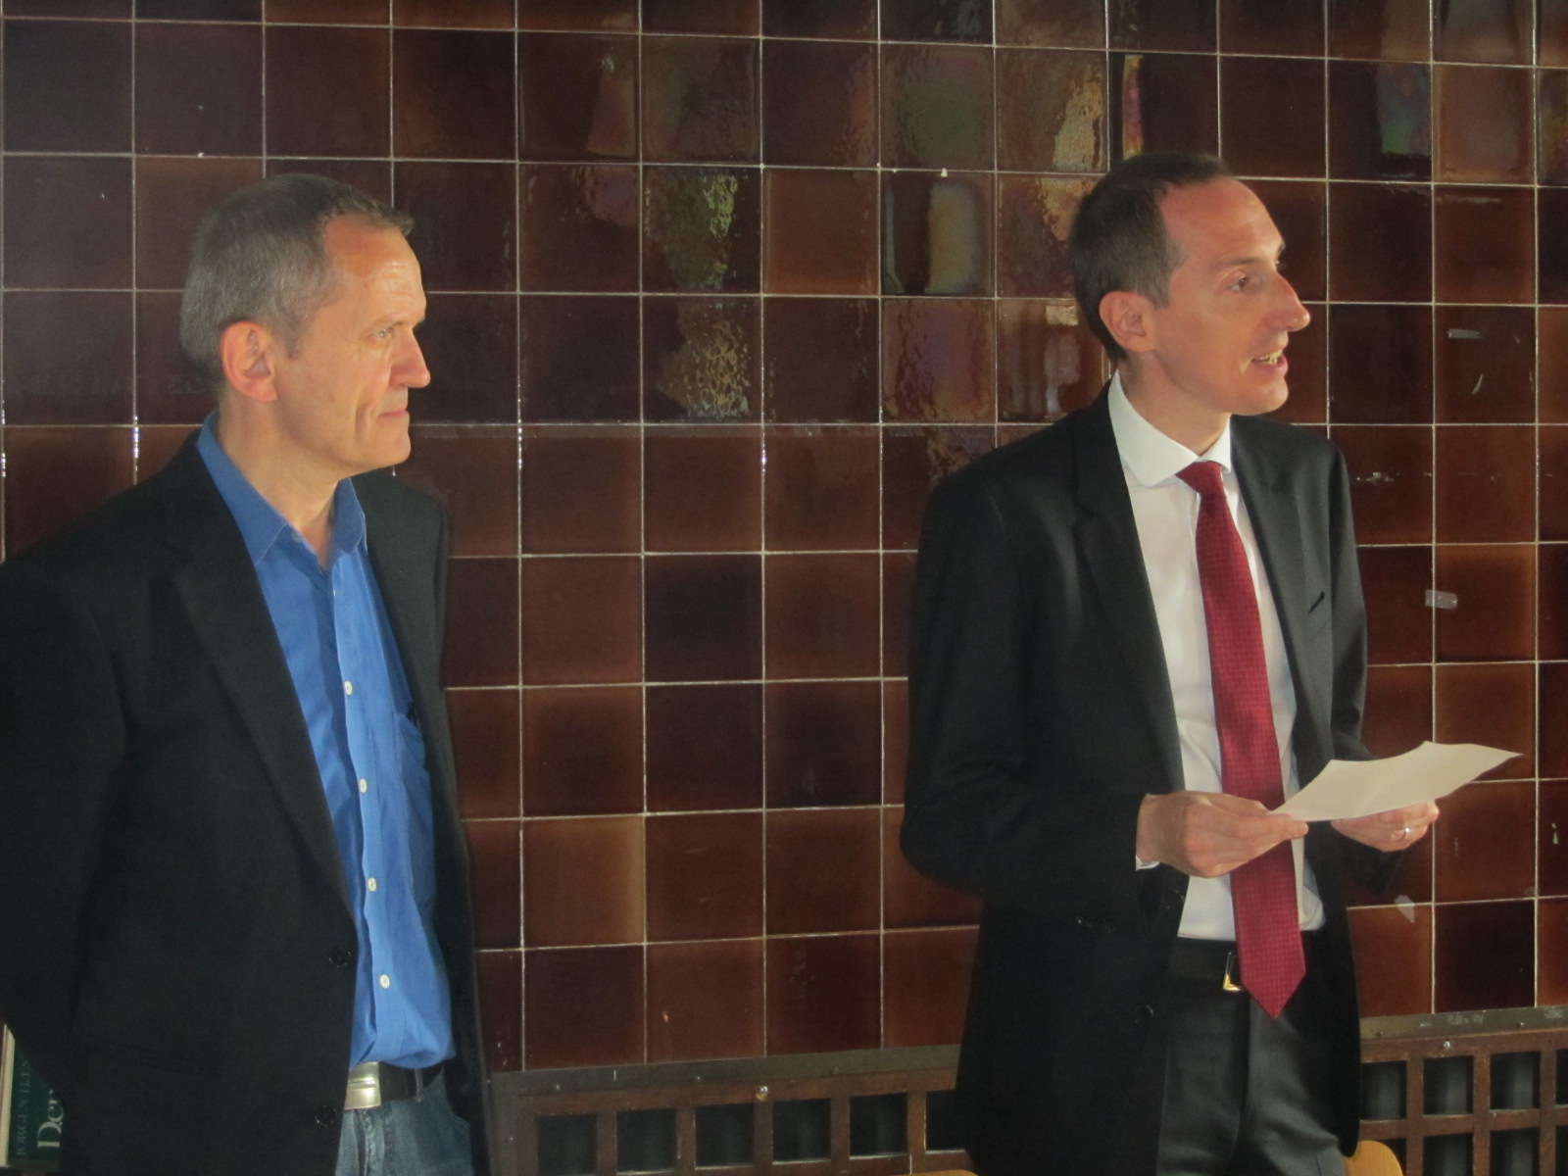
From the left: the head of Odense archive Jørgen Thomsen and Ambassador Jiří Brodský

