Lecture “Knud Rasmussen and the Greenlandic Myths and Legends“

A joint lecture entitled “Knud Rasmussen and the Greenlandic Myths and Legends“ by the Czech Ambassador and translator Zdeněk Lyčka and the curator and responsible for the Knud Rasmussen’s House in Hundested, Søren la Cour Jensen, took place at Skive Museum on 10 March 2011. Among 40 guests, who attended the lecture, was Mr Flemming Eskildsen, the Mayor of Skive Municipality.

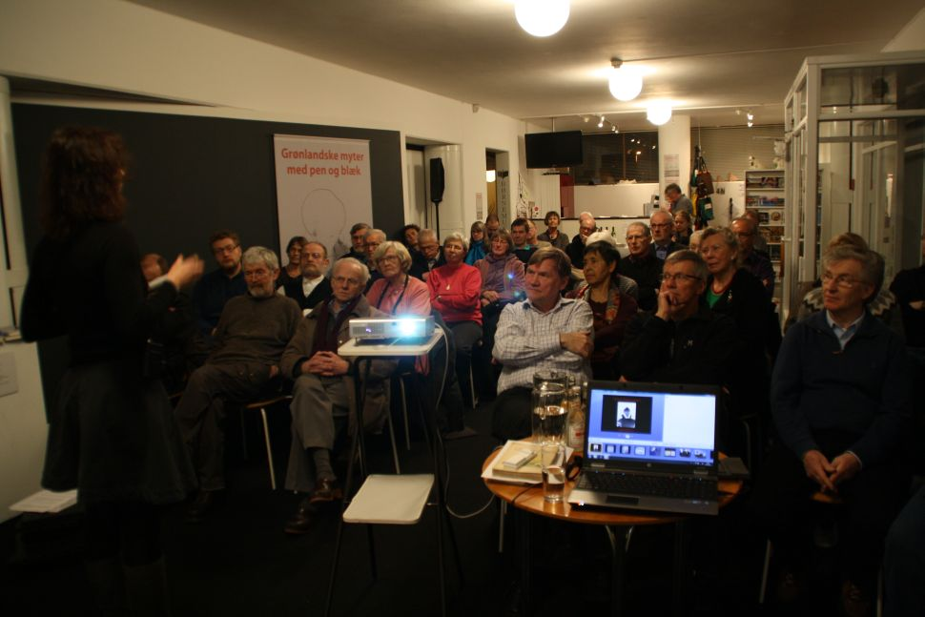
An attentive public
The lecture was a part of so-called “Greenlandic Days” in Skive, a series of lectures and educational activities arranged in connection with the exhibition of illustrations “Greenlandic Myths with Pen and Ink“ by the Czech artist Martin Velíšek. The exhibition will be open at Skive Museum until 3 April 2011.
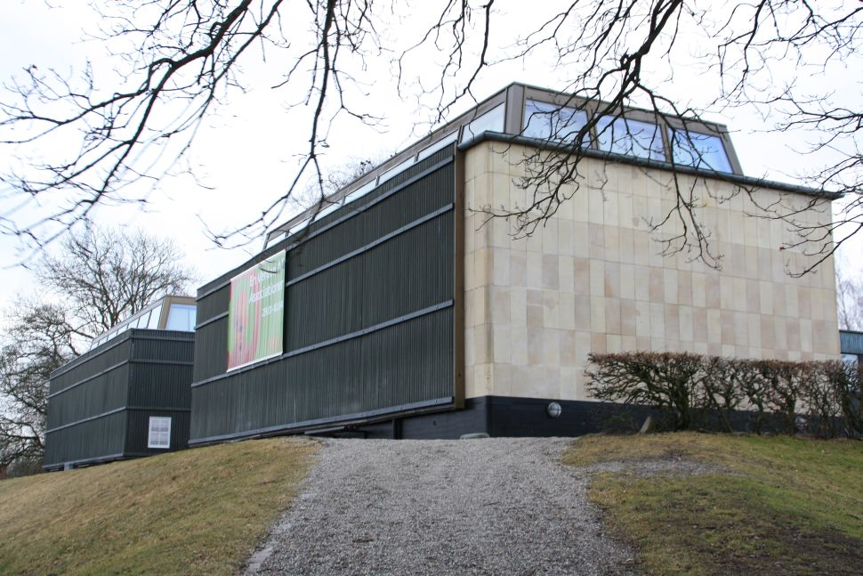
Museum Skive

