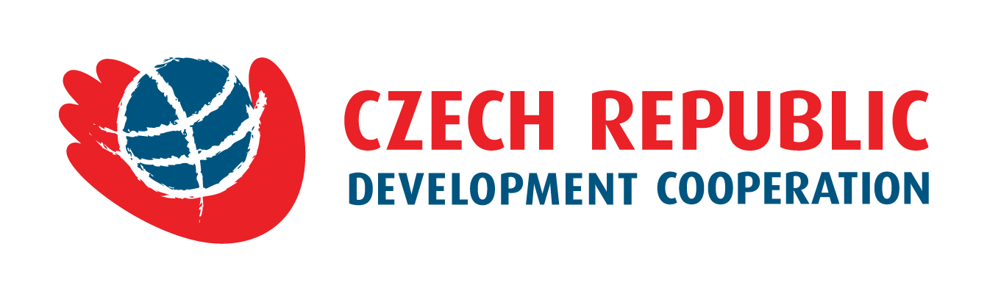
Proposal Form

Improvement of Hygiene Standards and Occupational Safety
in Wat Kirisraasong Primary School (Kirivong District, Takeo Province)
funded by the Government of the Czech Republic
within the framework of the Debt Resettlement with the Kingdom of Cambodia.

Beginning  of Project  (month/year) |  |  |  | Termination  of Project (month/year)
1. Total Project Budget
In USD
2. Requested Funding from the Czech Republic
In USD
3. Additional Funding from Other Sources (if applicable)
In USD
4. Applicant
Name of Organization
Acting By and Through (name and position)
Telephone Number
Email Address
Fax Number
Website

5. Description of Intervention and Project Results
Brief description of intervention and list of expected direct/tangible results of the project.
6. Project Activities

List of activities to be carried out in order to achieve the above mentioned project results.
6. Project Time Frame or Schedule
Major project phases and milestones, with performance target dates for achieving them.

List of Key Project Participants
Names and qualifications of the key personnel indicating who is who. CVs demonstrating qualifications must be submitted.

Budget Proposal in USD

(Please fill in the separate form in Excel)

Final Clauses

Done in (city)
Date
Submitted by
(name and position)
Telephone
Email
Signature and Stamp

