Travelling Exhibition “20th Anniversary of the Fall of the Iron Curtain” at Aalborg University Library

The next stop of the travelling exhibition “20th Anniversary of the Fall of the Iron Curtain” on the occasion of the 20th anniversary of the collapse of Communism was the University Library in Aalborg.
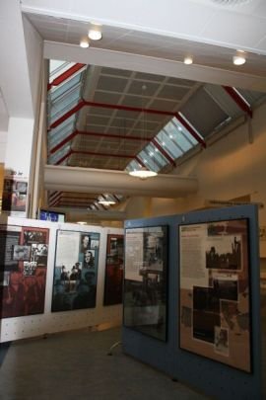
Exhibition panels at Aalborg University Library

On 3 November 2009, Czech Ambassadør Zdeněk Lyčka delivered a lecture about his own personal experiences from the Velvet Revolution. Dean Marianne Rostgaard welcomed the guests and Ass. Professor Bent Boel spoke about Danish-Czech contacts under the Cold War.
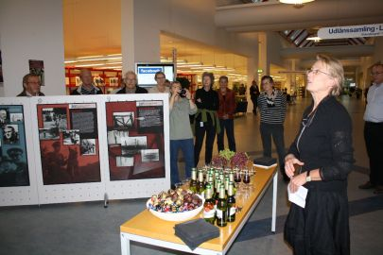
Dekan M. Rostgaard byder velkommen (th)
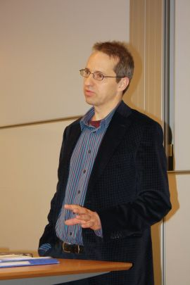
Ass. Prof. B. Boel’s lecture

After Z. Lyčka’s lecture on the Velvet Revolution, the film “The Tender Revolution” was sceeened at the library lecture hall.

On this occasion, the Czech Embassy presented a book by Peter Sís, a Czech artist living in USA, entitled “THE WALL: Growing Up Behind the Iron Curtain“ (2009).

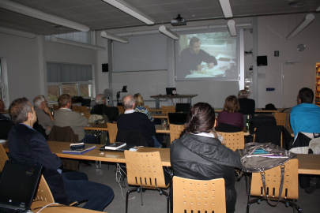
Screening of “The Tender Revolution“
The exhibition’s last stop will be Copenhagen University. The opening will take place on 16 November and the following day – the anniversary of the massacre at Národní třída – will Ambassador Z. Lyčka discuss with about 150 students and diplomats at the student club Munkekælderen. On 19 November a documentary “Burma VJ: Reporting from a Closed Country” will be screened at the Czech Embassy. The director of the Burma Centre in Prague, Ms. Sabe Amthor Soe, will be present and will participate in the discussion after the film. The exhibition cycle and the following events will last until 30 November.
The travelling exhibition “20th Anniversary of the Fall of the Iron Curtain” and the connected activities thematically follow the CZ PRES’ motto “Europe Without Barriers“ and thus recollect the Czech Presidency of the EU Council in the second half of 2009.

