  
  
  May 2014

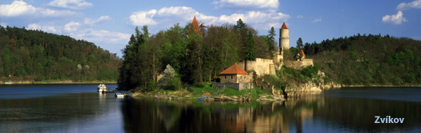
Ambassador's Message: "The last weeks have proved to be humble days of appreciation and remembrance. The Czech Embassy along with the Consulate General of the Czech Republic in New York had several opportunities to recognize, honor, and show support for those who have dedicated their lives for a better tomorrow. I, on behalf of the Czech Republic and our Embassy, salute all veterans who have placed their lives on the line for democracy, peace, and freedom." ~ Petr Gandalovič

— LATEST NEWS & EVENTS —

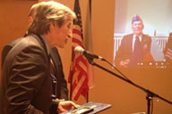
WWII Veteran Awarded Cross of Merit
During his visit in Washington, Minister of Defense Martin Stropnicky presented Staff Sergeant Ladislav "Leonard" Jindra the Cross of Merit Third Class. Jindra is a WWII veteran who served in the Battle of Normandy. He accepted the award via Skype from the Consulate General in New York City. Photo Courtesy: Martin Pizinger | Read more.

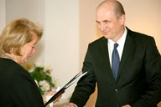
Czech-American Honored for Service
During a tribute in New York, Ambassador Gandalovič bestowed the late Jiri. F. Brotan with the Silver Medal of Jan Masaryk, a prestigious award of the Czech Ministry of Foreign Affairs. Brotan´s wife, Mila, accepted the award on his behalf. Brotan served as a member of the Czech Foreign Service from 1945-1951. Photo Courtesy: Viera Pecha | Read more.

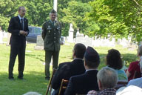
Memorial Day Observance
On May 26, 2014, Deputy Chief of Mission Jaroslav Zajíček and colonel Miroslav Šuhaj traveled to Baltimore to participate in the Annual Memorial Day Observance at Bohemian National Cemetery of Baltimore, which was founded in 1884 to serve the needs of the Bohemian community. | Read more.


Czech Composer Debuts World Premiere
As part of the European Month of Culture, the National Gallery of Art Chamber Players performed the world premiere of Rock for 22 Strings by Czech composer Miloš Orson Štědroň, as well as the compositions of other EU country contemporary composers, in the West Building, West Garden Court, on May 28. Photo courtesy: Miloš Štědroň | Read more.

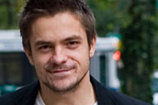
Avalon Features Czech Actor
As part of the Czech That Film Series, the Avalon Theatre will screen director Roman Kasparovšký's debut film Lousy Bastards on June 11, at 8 pm. Special guest, Czech actor Jiří Mádl will open the screening. The film follows the lives of two brothers who separate after falling in
love with the same girl. Photo courtesy: artists4film.com | Read more.

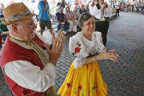
National Polka Festival in Texas
Czech tradition came alive at the annual polka festival in Ennis, TX, last weekend. About 30,000 people—more than Ennis' population—attend the celebration, which fills the streets of downtown with booths offering delicious Czech Kolache. The festival first took place in 1967 and is now in its 48th year. Photo Courtesy: Dallas News | Read more.

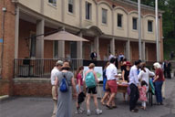
EU Open House 2014
On May 10, the Embassy of the Czech Republic welcomed more than 3,000 visitors during the annual EU Open House. During the event, the Embassy featured the work of Franz Kafka, one of the most influential writers of the 20th century. The event featured a fashion show, live jazz band, theatre readings, 1920s dance demonstrations, Czech food, and more. | View pictures.


Embassy Highlights Czech Companies
The Economic Section of the Czech Embassy, Czech Invest, and the Investments and Business Development Section of the Czech Republic, presented details on doing business in the Czech Republic as well as incentives for investors in high-tech industries and high-value added services during the EU Open House on May 10. | Read more.

The Embassy of the Czech Republic
3900 Spring of Freedom Street, NW, Washington, DC 20008
Phone: 202/274-9105 | E-mail: cul_washington@embassy.mzv.cz

