**FOR SALE**

**The Jewel of the Historical Prague City Center**

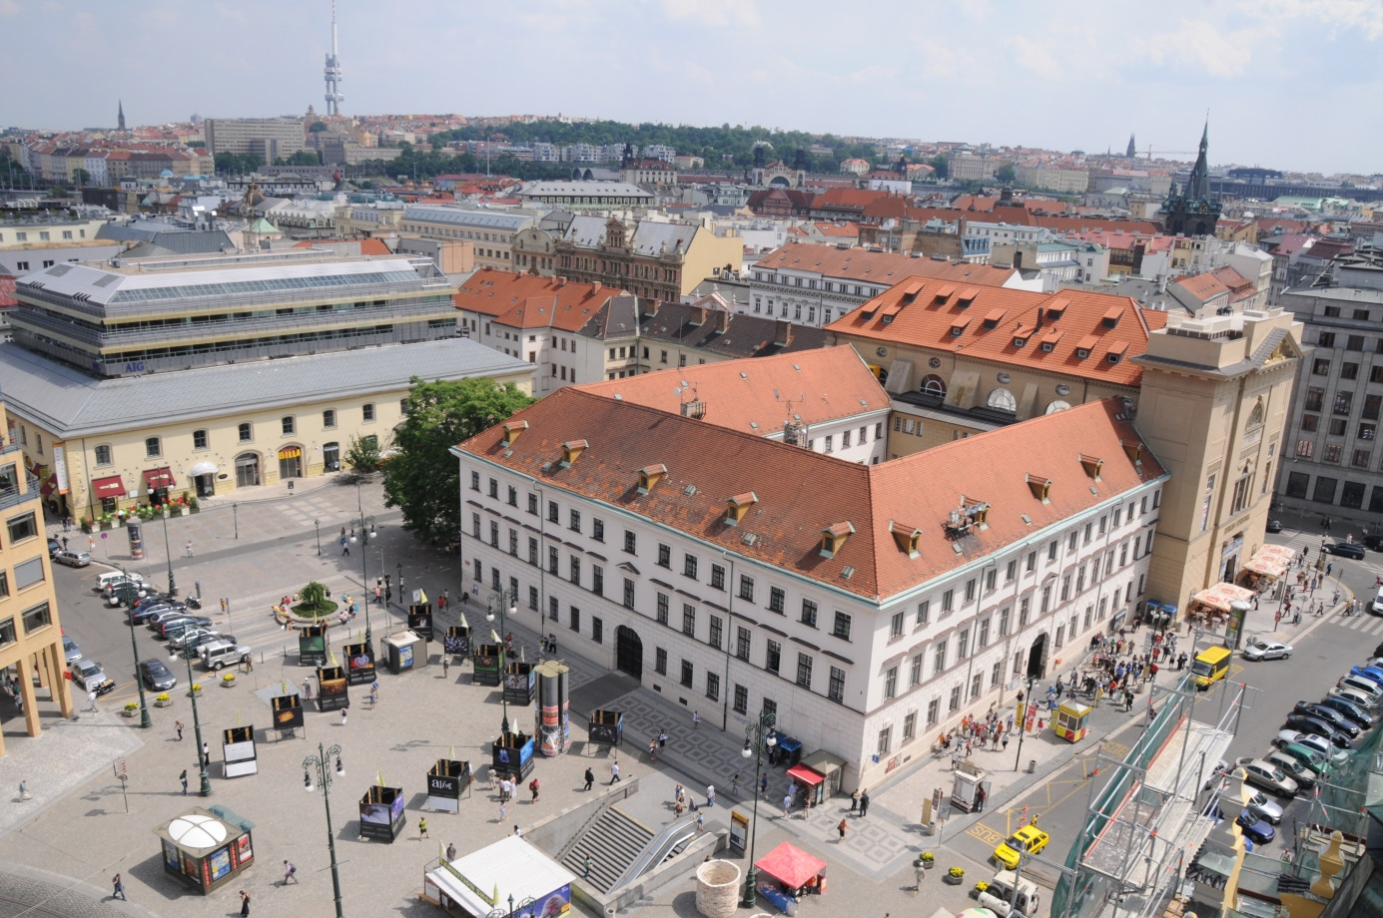

**The Office for Government Representation in Property Affairs, with the reference to the government resolution dated 8 April 2015 no. 247, is about to sell in the second half of this year an unique administrative and commercial complex located on náměstí Republiky. The property is situated right at the historical city centre of the capital of the Czech Republic and is a part of an UNESCO heritage site, standing opposite to the Obecní dům (Municipal House) - the famous Art Nouveau pearl, close to the historical Prašná brána (Powder Tower) of the Staré Město (Old Town), 50 meters far from the street Na příkopě - luxurious commercial zone ending at Václavské náměstí (Wenceslas Square). The distance to the world famous Staroměstaké náměstí (Old Town Square) is only 500 meters.**

Property No. 1037, cadastral unit: Nové Město, address: náměstí Republiky 3, Praha 1, is a real estate cultural monument, registered in the Central list of cultural sites under No: R.č.Ú.s. 39840 / 1-1057, is situated in protected area of Prague Conservation Reserve and has been declared an UNESCO World Heritage Site since 1993. The property is protected by the Act and by the Government Decree no. 66/1971 Coll., on conservation area in Prague.

Monumental three-storeyed building consisting of three wings forms the architectural complex of dimensions approximately 40x50m surrounds the inner courtyard. As a solitary block fills in the eastern side of the Náměstí Republiky formed by the streets Hybernská and V Celnici. Expressive austere classicist architecture dominates at the southwest corner with the former Church of Hibernians. Grounds of the former monastery of Hibernians (Irish Franciscan) with the Church of the Immaculate Conception of the Virgin Mary is a valuable architectural and urban complex showing the shape and form of the monastic architecture of Nové Město (New Town). The complex was built in a baroque style in 1641-1654, after 1701 modified and rebuilt in classicist style by Joseph Zobel and by Jiri Fischer in 1808-1811. The monumental main frontage is one of the most important manifestations of the Prague empire style.

Náměstí Republiky (Republic Square) with its perimeter defined by significant architectural monuments (Munucipal House, U Hybernů, Barracks of Jiří z Poděbrad, Commercial Bank, St. Joseph Church), is one of the most important public places of the historic center of Prague. The square represents a central public place in the urban structure of Prague, creating a crossing of the most important communication and commercial axis made by pedestrian zone in Prague heritage reserve.

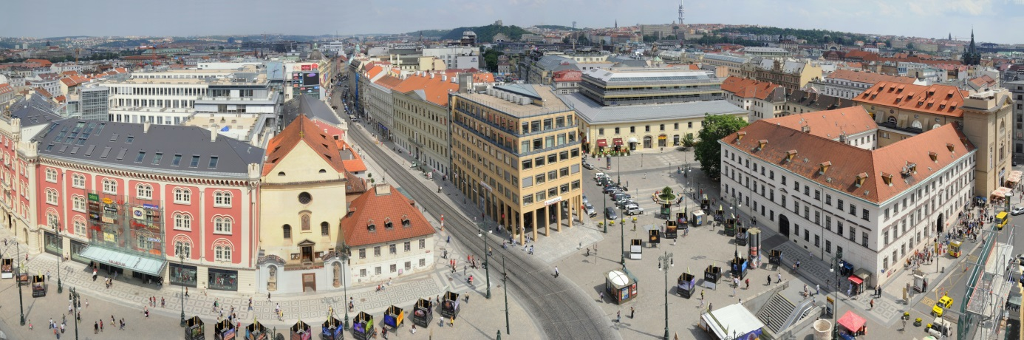

**Complex area of ​​7347 square meters in total consists of three wings convent building, creating a closed area, and one separate building.**

**Building layout is of approximately rectangular shape with dimensions of 40x50 meters and with the width of each wing about 12 m. The height of the building is 20 meters.**

**The building has partially a basement, three above-ground floors with partially used attic space under a gabled roof.**

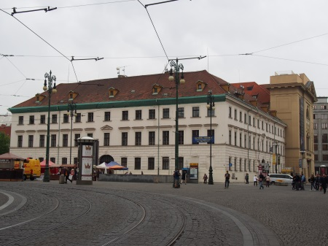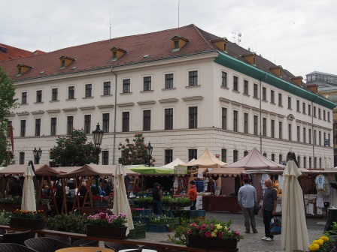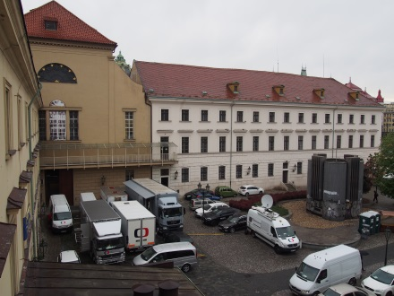

**The part of the complex area for sale is also a nearby building situated on the land No. 484/6 in the cadastral unit Nové Město. Layout of the building is 50x10 m, there is a partial basement and three above-ground floors. The annex belonging to this building has layout of 22x9 m and is 19 m high.**

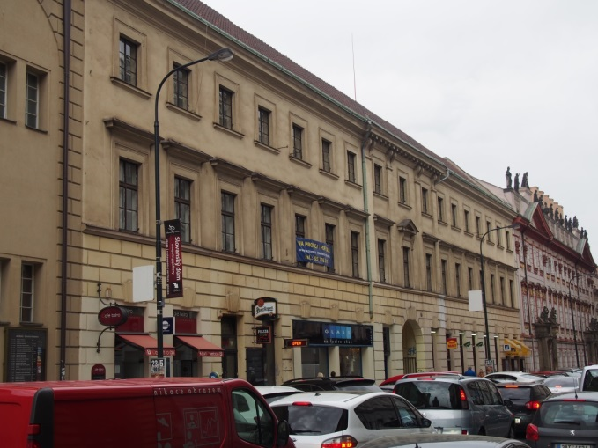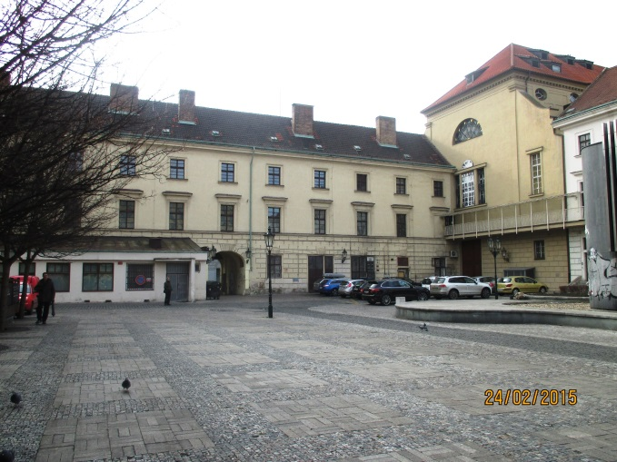

For more information see [**http://www.uzsvm.cz/namesti-republiky-2227-0-85/**](http://www.uzsvm.cz/namesti-republiky-2227-0-85/)

Address of Office for Government Representation in Property Affairs :   
  
Úřad pro zastupování státu ve věcech majetkových

Rašínovo nábřeží 390/42,

128 00 Praha 2,

Czech Republic

ID of Data Box: 96vaa2e



Layouts:

