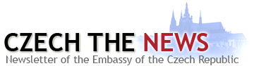


March 2013

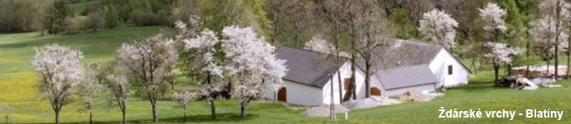

Ambassador's Message: “Spring is knocking and the Czech Embassy is gearing up to open its doors once again to the thousands of annual visitors during the EU Open House on May 11. This year, we are dedicating the celebrations to honor Václav Havel, the late first President of the Czech Republic. I hope that you join me in the day’s activities and delight in learning more about our beautiful country.” ~ Petr Gandalovič

— LATEST NEWS & EVENTS —

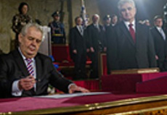
New Czech President Inaugurated
On March 8, Miloš Zeman took the presidential oath of office and was sworn in as the new President of the Czech Republic. The ceremony took place in the Vladislav Hall at Prague Castle. He succeeded Václav Klaus who served two terms which is the maximum allowed by the Constitution. Photo Courtesy: www.hrad.cz | Read more.

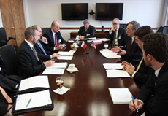
Czech Trade Mission Visits US
Czech Minister of Industry and Trade, Martin Kuba, visited the United States on February 25-March 1, accompanied by a group of representatives of more than 20 Czech companies who are interested in partnering with their US counterparts. The delegation visited Chicago, Charlotte, and Washington, DC. Photo Courtesy: Martin Pizinger | Read more.

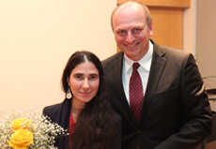
Blogger Presents Picture of Cuba
A standing ovation and roar of applause greeted internationally renowned blogger Yoani Sánchez as she spoke to an audience of over 100 people at the Czech Embassy, marking her first visit to Washington and the opening of the exhibition Country of Pixels (País de Píxeles) with exhibition director Orlando Luis Pardo Lazo and graphic artist Rolando Pulido on March 19. Photo Courtesy: Martin Pizinger | Read more.

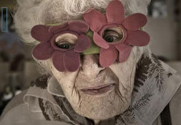
Exhibition Marks Day of Holocaust
The Embassy of the Czech Republic, in collaboration with the Embassy of Israel and the Jewish Museum in Prague, will open the photo exhibition Silver Tide by renowned photojournalist Karel Cudlín to mark Yom HaShoah—Day of Holocaust on April 8, 2013, at 6:30 pm. This exhibition provides a glimpse into the contemporary life of the Jewish community in Prague. Photo courtesy: Karel Cudlín | Read more.

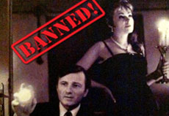
V4 Film Series Launches
The Embassies of Poland, Hungary, Slovakia and the Czech Republic present the 2nd V4 film series: Banned! by Communist Governments: Films They Didn't Want You to See. The series launches on April 4, at 7 pm, with the screening of Interrogation (Przesłuchanie) at the Embassy of the Republic of Poland. Photo Courtesy: Czech Center | Read more.

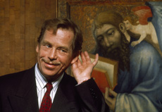
EU Open House
The Czech Embassy will celebrate the life and legacy of dissident, playwright, and former Czech President Václav Havel through theater, photography, film, music and beer—a sneak peek of the Mutual Inspirations Festival 2013 planned for this fall. Czech out the happening inside the Embassy on May 11, from 10 am to 4 pm, to get a sense of the many colors of his personality. Photo Courtesy: Pavel Štecha | Read more.

