Opening of the exhibition “Queen Dagmar, Princess of Bohemia“ in Aarhus
On 5 February 2013 the exhibition “Queen Dagmar, Princess of Bohemia“ was opened at the entrance hall of Aarhus City Hall.
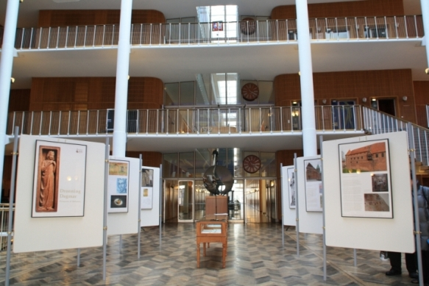
The exhibition in Aarhus City Hall
The Mayor of Aarhus Jacob Bundsgaard and Czech Ambassador Zdeněk Lyčka launched the exhibition with their opening speeches. The exhibition in Aarhus was arranged with the help of Niels Brøchner, Honorary Consul of the Czech Republic, and with financial support by ŠKODA company. The representatives of Czech Studies at Aarhus University, Peter Bugge and Kateřina Haušildová, and Czechs living in Aarhus were also present at the opening.
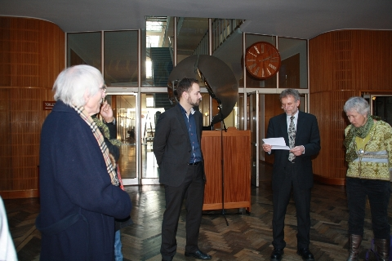
The exhibition opening: Mayor of Aarhus Jacob Bundsgaard (on the left) and ambassador Zdeněk Lyčka
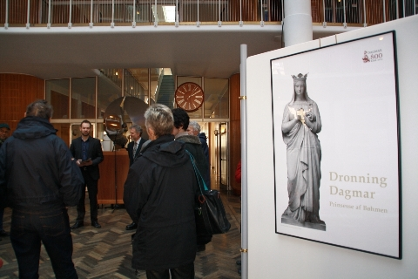
The exhibition opening
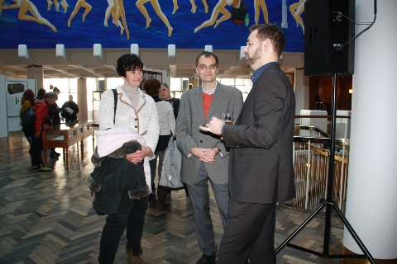
From the right: Mayor of Aarhus J. Bundsgaard, lecturer P. Bugge and the Honorary Consul’s colleague G. Rosschou
Ambassador Zdeněk Lyčka, Honorary Consul Niels Brøchner and Consul Barbora Stejskalová met with the Mayor of Aarhus Jacob Bundsgaard before the opening to discuss possible cultural cooperation between the town of Plzeň and Aarhus. Plzeň will be the European Capital of Culture 2015 and Aarhus will get its turn in 2017. The Mayor welcomed the possibility of common events.
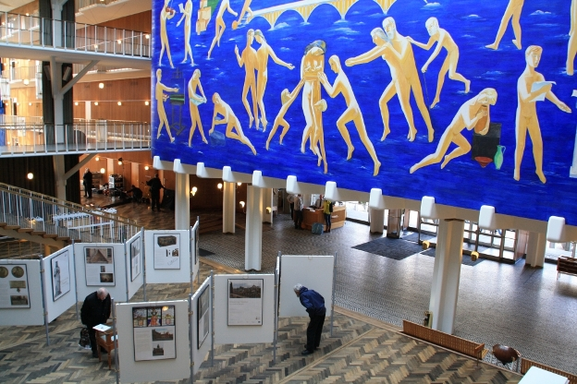
The exhibition in Aarhus City Hall
The exhibition Queen Dagmar, Princess of Bohemia travels around Denmark to commemorate the 800th anniversary of a historical person who embodied a direct personal connection between Denmark and the Czech Republic. The exhibition was first presented in May 2012 in Ribe (where the Queen lived and died) during the festival Dagmar800. The second host of this exhibition was Ringsted where Dagmar is buried. After the third stop, this time in Copenhagen, the exhibition travelled to Roskilde Library. In December people could see it in the regional museum Stitftsmuseet Maribo. In January the exhibition came to Stege on the island of Møn. After being shown in Aarhus it will continue its journey around Jutland and visit the towns of Viborg, Holstebro, Horsens and Kolding. The island of Bornholm will welcome the exhibition this summer.
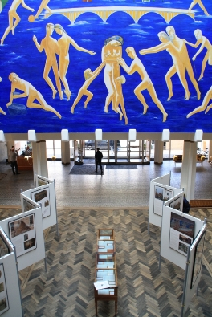
The exhibition in Aarhus City Hall
The Czech version of the exhibition which was created on the Czech Ambassador’s initiative and support by the Nordic Chamber of Commerce in the Czech Republic, was held 27 September – 30 October 2012 at the National Library in Prague. The exhibition was ceremonially opened on 8 November 2012 in Kutná Hora, the Czech twin town of Ringsted. Now it’s possible to visit it at the Moravian Museum in Brno. Later it will continue to the Regional Museum in Olomouc, to Hradec Králové, Zlín, Štramberk, Velké Pavlovice and other cities in the Czech Republic.

