


June 2012

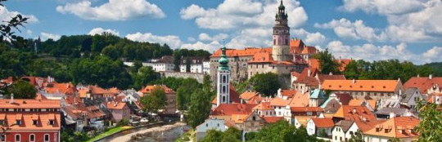
Ambassador's Welcome: “I would like to share with you my enthusiasm for the upcoming Mutual Inspirations Festival 2012- Miloš Forman, celebrating the 80th birthday and work of the Oscar-winning Czech American director, as well as highlighting the transatlantic achievements of the film industry. We have many enriching film programs already planned for this year’s festival in prestigious venues. I invite you to join in the celebration and support the festival, be it in your kind attendance or financially. Please contact the Embassy for details on how to become an integral partner or visit the festival website www.mutualinspirations.org.” ~ Petr Gandalovič

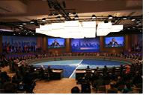
Czech Leaders Participate in NATO Summit
President Václav Klaus, Prime Minister Petr Nečas, Minister of Foreign Affairs Karel Schwarzenberg, and Minister of Defense Alexandr Vondra visited Chicago on May 19-20, to attend the NATO Summit hosted by Presidet Barack Obama.
Photo Courtesy: www.klaus.cz
Learn more about his visit.
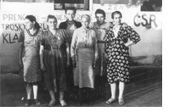
Embassy Commemorates Lidice
The Embassy of the Czech Republic will commemorate the 70th anniversary of the Lidice massacre with a special screening of In the Shadow of Memory with co-producer Jerry Zbiral and the opening of the exhibition Return of the Lidice Women.
Photo Courtesy: Jerry Zbiral
Check out event details.

Intellectual Property Rights Protected
For the second year in a row, the Czech Republic is not listed in the U.S. Trade Representative's Special 301 Report listing countries where protection of intellectual property rights is considered an issue.
Photo Courtesy: istockphoto.com
Find out more about the report.

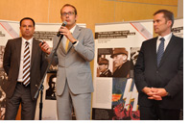
Exhibition Opens on Heydrich Assassination
On May 31, 2012, the Embassy of the Czech Republic opened an exhibition on Reinhard Heydrich's assassination, commemorating the 70th anniversary of the event and the Lidice massacre. Special guests included members of the Parliament of the Czech Republic.
Photo Courtesy: Czech Embassy
Read more about the opening.

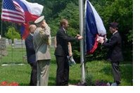
Czech Community Observes Memorial Day
On May 28, 2012, Deputy Chief of Mission Jaroslav Zajíček and Colonel Miroslav Šuhaj participated in the Annual Memorial Day Observance and Celebration of the 140th Anniversary of Sokol Baltimore.
Photo Courtesy: Czech Embassy
Discover more about the event.

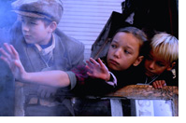
Avalon Theater Features New Documentary
The Embassy of the Czech Republic, in collaboration with the Embassy of the Slovak Republic, will present at the Avalon Theater the screening of the highly acclaimed documentary Nicky's Family, about one of the greatest rescue operations in history.
Photo Courtesy: Menemsha Films
Read more about this special screening.
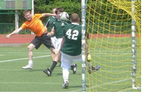
Diplomatic Soccer Tournament
On May 26, 2012, the Ukrainian Embassy hosted the Diplomatic Mini-Soccer Cup. It was held as a tournament between the European Embassies in order to promote the upcoming European Championship in soccer that Ukraine, together with Poland, is going to host.
Photo Courtesy: Czech Embassy
Check out the tournament.

