Opening of the exhibition of illustrations by Renáta Fučíková in Nakskov

This year’s last stop of the travelling exhibition of the illustrations to H. C. Andersen’s and Chinese fairy tales by the Czech illustrator and author Renáta Fučíková became the town of Nakskov on the island of Lolland. The exhibition was launched on 2 December 2011 in Nakskov Library by the Czech Ambassador Zdeněk Lyčka, the Library Deputy Director Bente Kaspersen and the chairman of Commercial and Cultural Committee of the Lolland Municipality and consortium Femern Bælt, Hanne Møller.

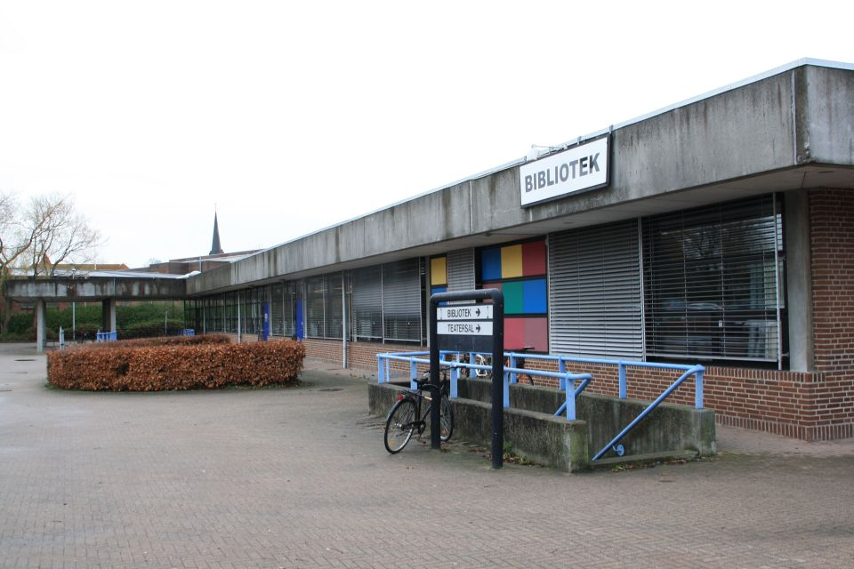
Nakskov Library

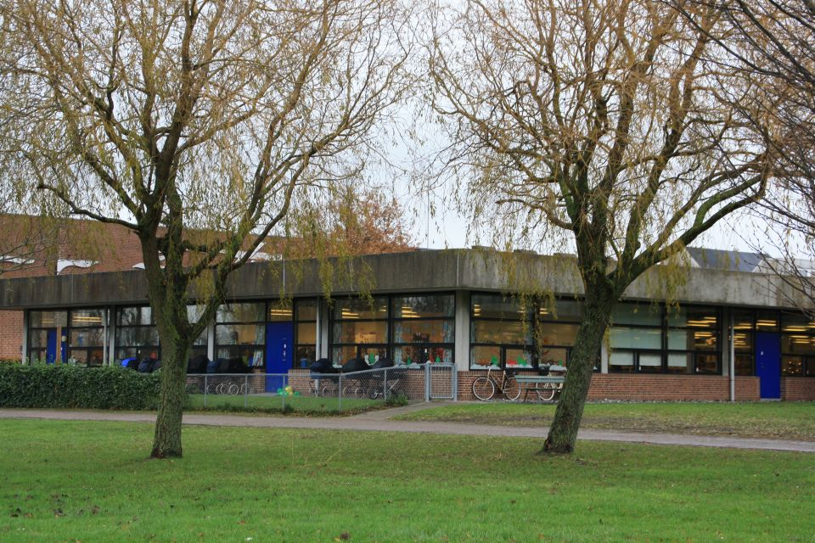
Nakskov Library

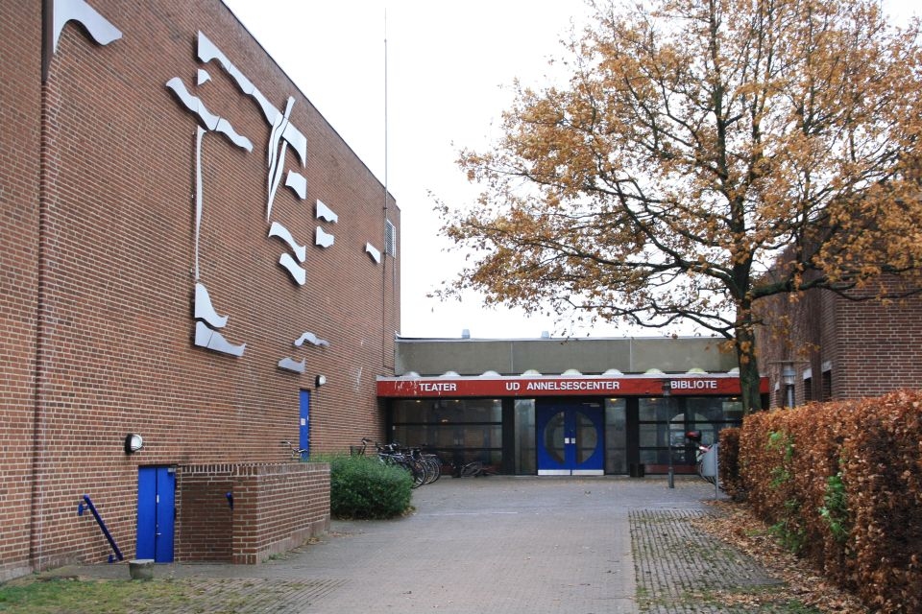
Nakskov Library

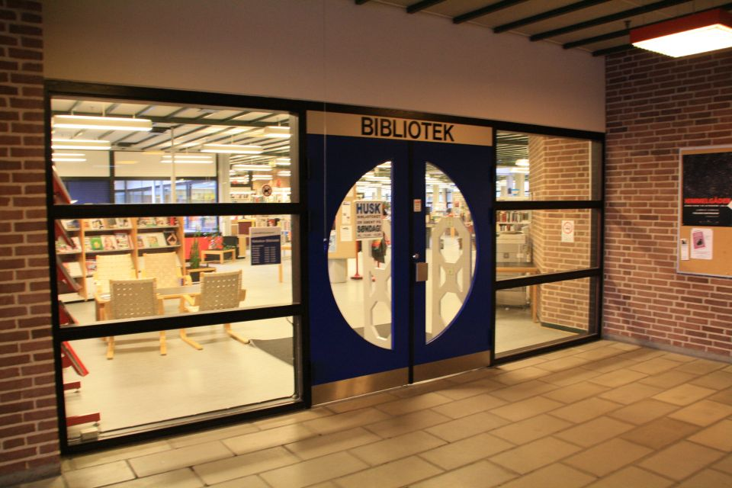
Nakskov Library

The exhibition opening took place only one day after the inauguration of the “Embassy“ of the Municipalities Lolland-Falster in the centre of Copenhagen. With hyperbole and humor one could say that the exhibition of the illustrations by Renáta Fučíková was the very first international event of this newly opened “Embassy“ in this region. Ambassador Zdeněk Lyčka offered cooperating on some other projects with the library such as commemorating the 800th anniversary of the Czech princess and Danish queen Dagmar’s death in 2012.

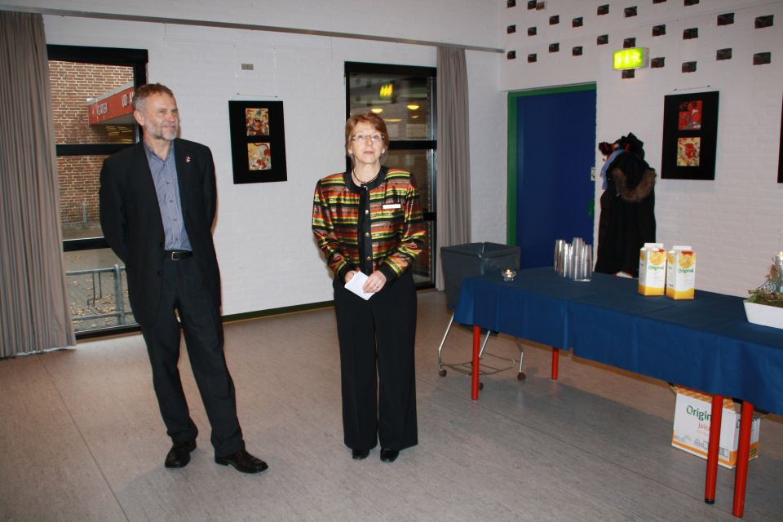
The exhibition opening: Deputy Director of the library B. Kaspersen
with Ambassador Z. Lyčka

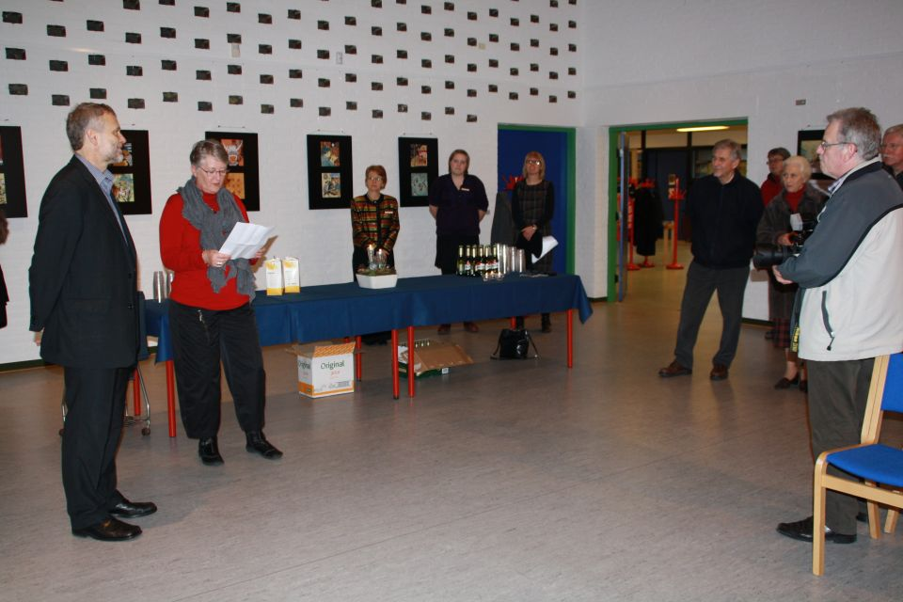
The exhibition opening: H. Møller, the chairman of Commercial and Cultural Committee of the Lolland Municipality and consortium Femern Bælt, with Ambassador Z. Lyčka

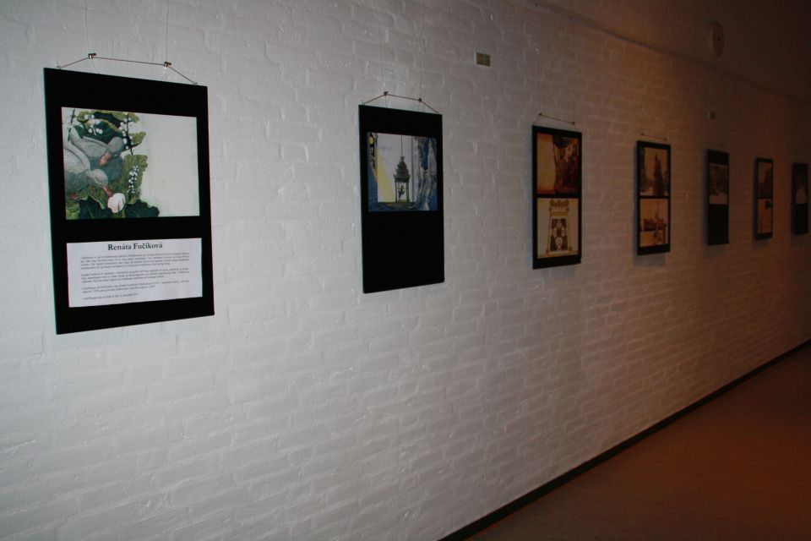
The exhibition of illustrations in Nakskov Library

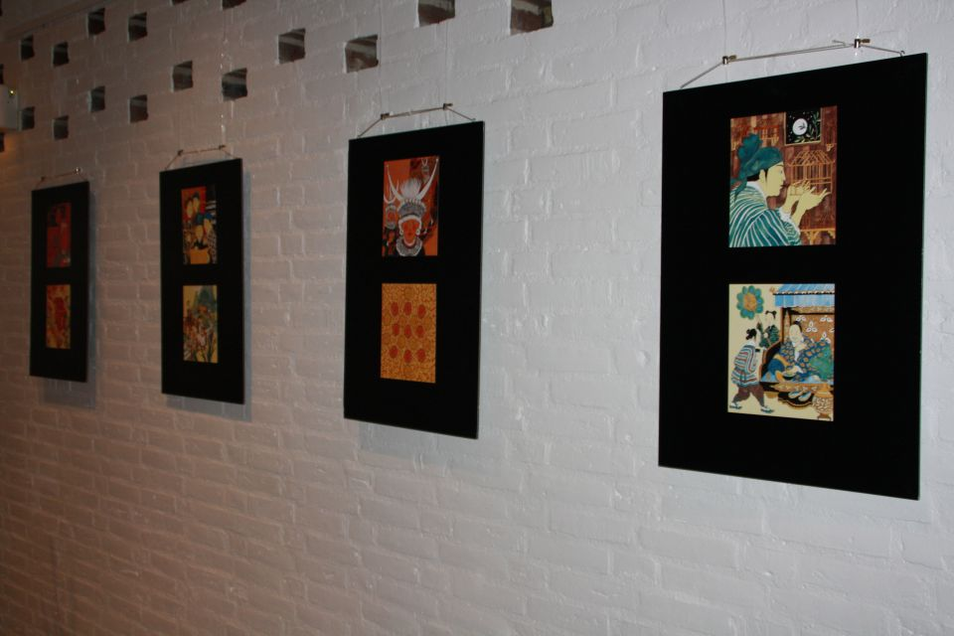
The exhibition of illustrations in Nakskov Library

The exhibition in Nakskov will last until 16 December 2011.

