Opening of the exhibition of illustrations by Renáta Fučíková in Rudkøbing

This time the travelling exhibition of illustrations to H. C. Andersen’s and Chinese fairy tales by the Czech illustrator Renáta Fučíková was welcomed in Rudkøbing on the island of Langeland. The exhibition was launched on 11 November 2011 in the Langeland Library by the Czech Ambassador Zdeněk Lyčka, the Mayor of Langeland Bjarne Nielsen, Library Director Anni Bagge Jensen, Langeland Municipality Director, Jørgen Christiansen and a member of the Communal Council, Helle Hansen.

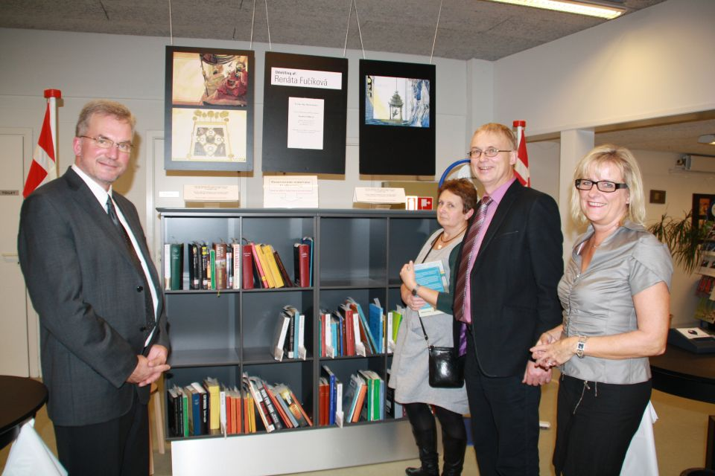
The exhibition opening (from the right): the Library Director A. B. Jensen,
the Mayor of Langeland B. Nielsen, member of the Communal Council H. Hansen
and the Langeland Municipality Director J. Christiansen

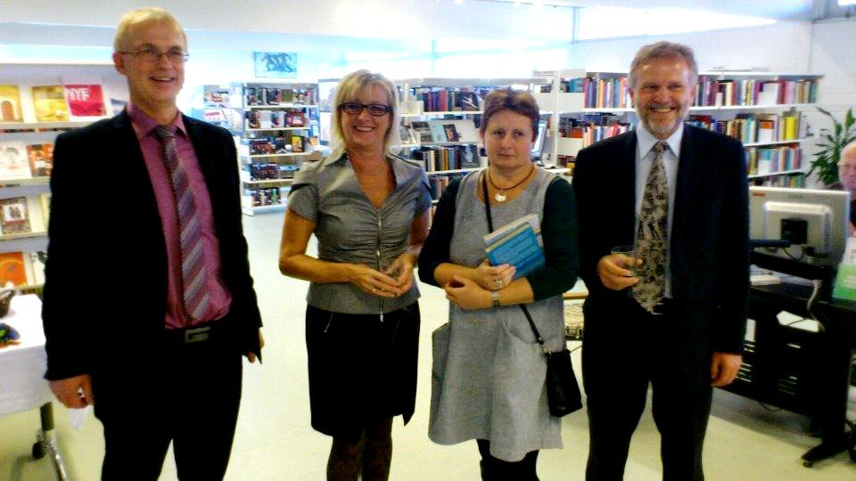
From the left: The Mayor of Langeland B. Nielsen, the Library Director A. B. Jensen,
member of the Communal Council H. Hansen and the Czech Ambassador Z. Lyčka

The exhibition in Rudkøbing will last until 27 November 2011, afterwards it will continue to the nearby town of Nakskov on the island of Lolland.

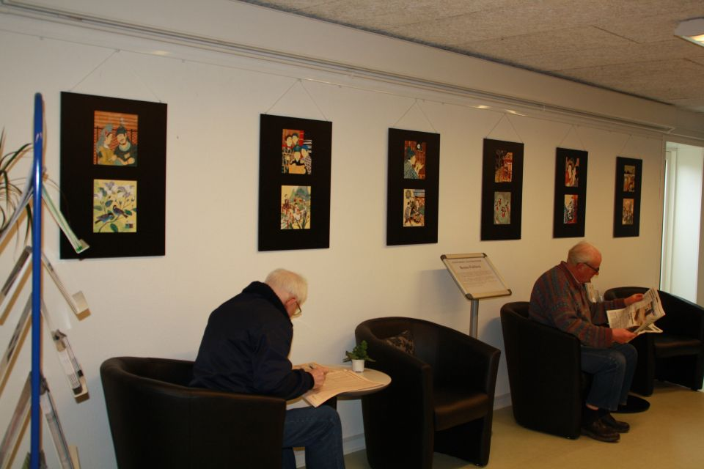
The exhibition of illustrations in Langeland Library

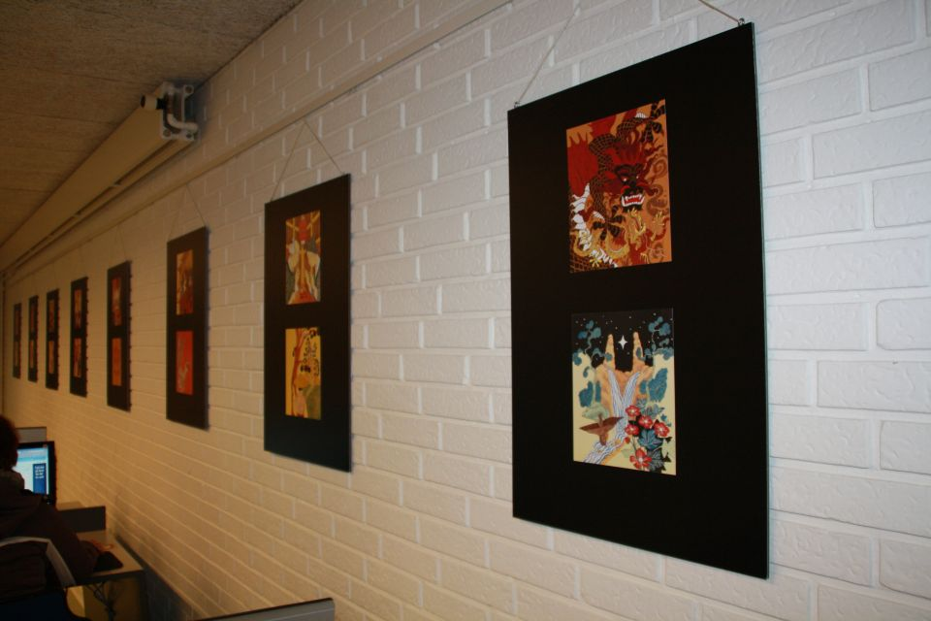
The exhibition of illustrations in Langeland Library

