Opening of the exhibition of illustrations by Renáta Fučíková at Viborg Main Library

On 10 October 2011, the travelling exhibition of illustrations to H. C. Andersen’s and Chinese fairy tales by the Czech illustrator Renáta Fučíková was opened at the Main Library in Viborg in West Jutland. The exhibition was launched by the Czech Ambassador Zdeněk Lyčka, together with the Library Director, Britta Thuun-Petersen, and the Mayor of Viborg, Søren Pape Poulsen.

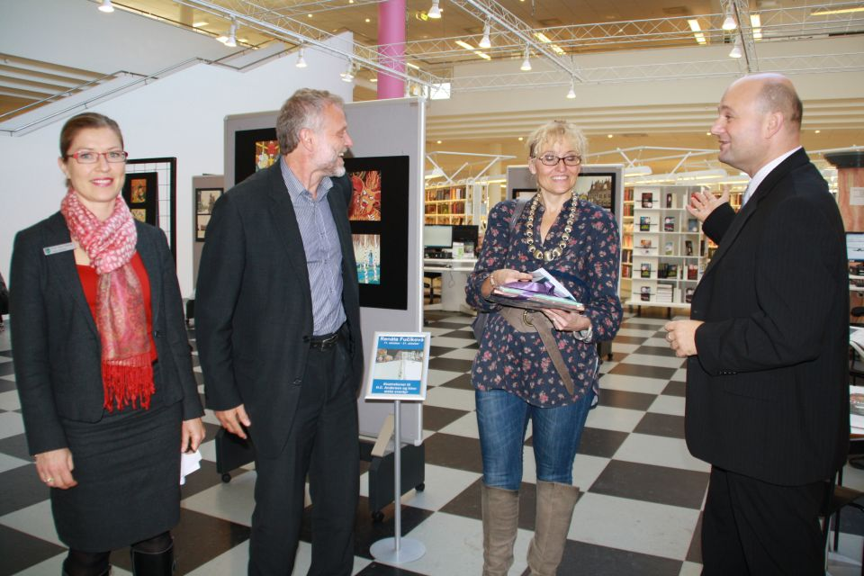
From the left: the Library Director Britta Thuun-Petersen, the Czech Ambassador Zdeněk Lyčka, the Czech illustrator Renáta Fučíková and the Mayor of Viborg Søren Pape Poulsen

The illustrator Renáta Fučíková also attended the opening. During the afternoon she had the opportunity to present her pictures and show the guests a few pieces of her latest work including the brand new book History of Europe which she not only illustrated but also authored.

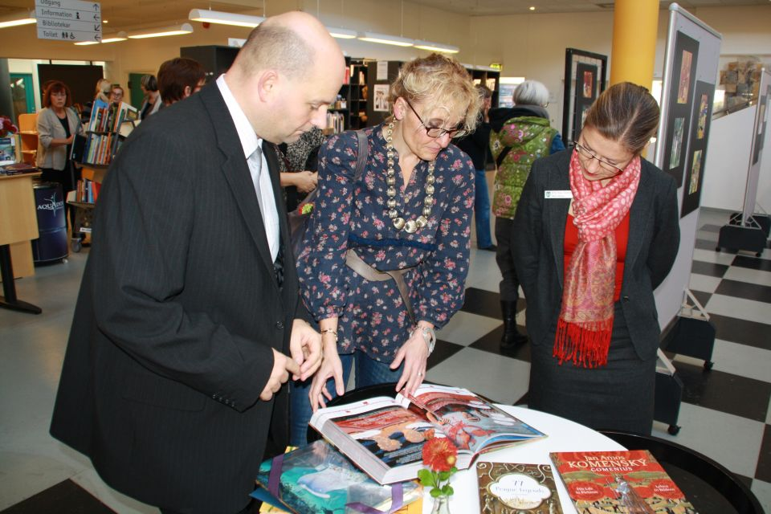
Søren Pape Poulsen together with Renáta Fučíková and Britta Thuun-Petersen

Children from the local kindergarten came to see the pictures to well-known fairy tales by H. C. Andersen. Renáta Fučíková prepared a special programme for them where she offered to paint their faces.

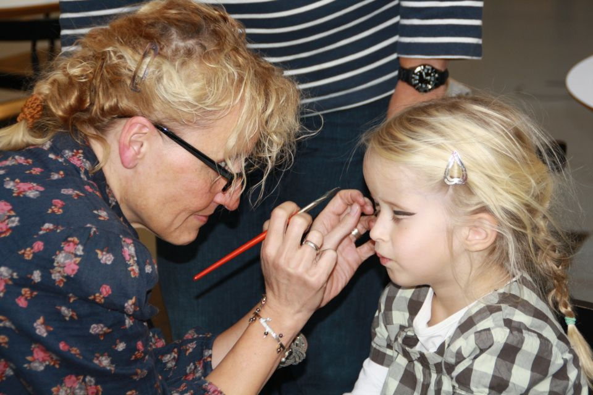
Renáta Fučíková painting a child´s face

