Opening of the exhibition of illustrations by the Czech artist Renáta Fučíková

On 1 August 2011 the exhibition of illustrations to H. C. Andersen and Chinese fairy tales by the Czech illustrator Renáta Fučíková was opened at the Culture Center and Library in Rentemestervej at Bispebjerg, North-West Copenhagen. The exhibition was opened by the Czech Ambassador Zdeněk Lyčka, together with the Library Director Tine Garsdal. The Cultural Mayor of Copenhagen, Pia Allerslev, and the Chairman of the Local Administration Bispebjerg, Alex Heick, also attended the opening. Approximately 40 guests appreciated the illustrations and the possibility to taste Czech beer Pilsner Urquell offered by the Czech Embassy.

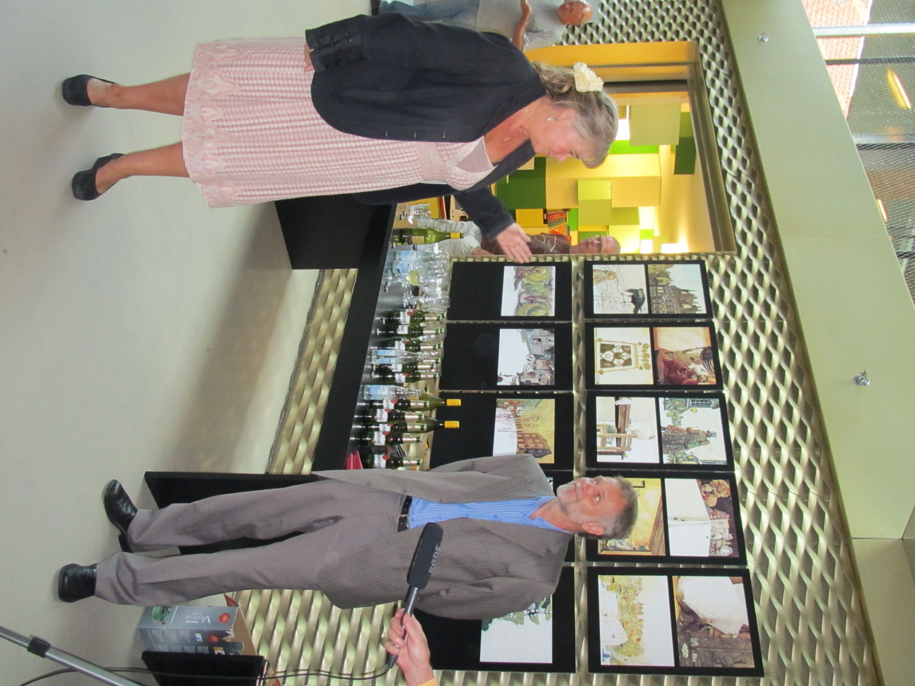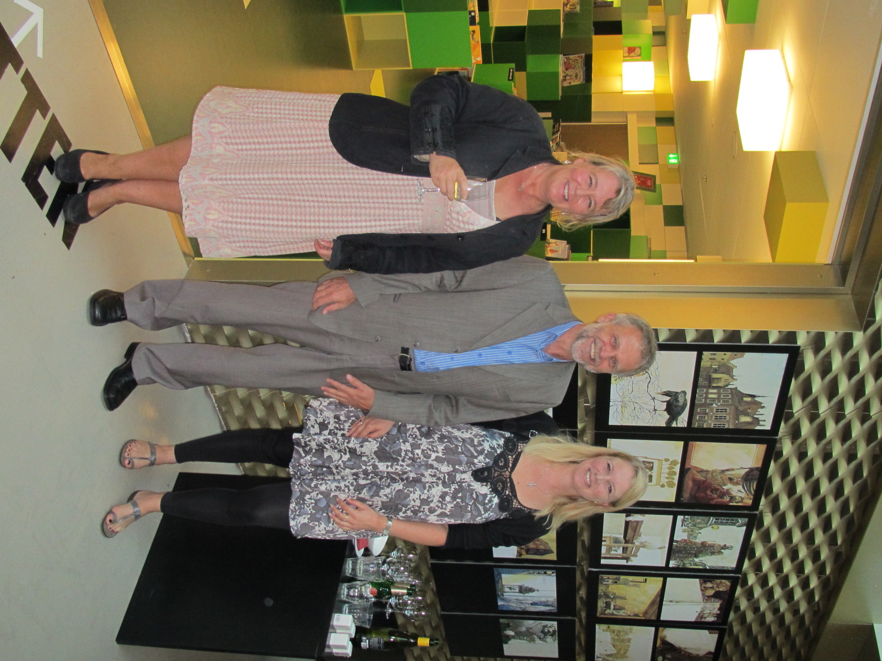

Photo on the left: The Library Director Tine Garsdal and the Czech Ambassador Zdeněk Lyčka
Photo on the right (from the right): The Cultural Mayor of Copenhagen, Pia Allerslev, the Czech Ambassador Zdeněk Lyčka and the Library Director Tine Garsdal

The Culture Center has opened in the generously reconstructed building with a modern extension in May 2011. It contains a library, a concert hall, creative workshops, citizen service center and a cafeteria. The Embassy initiated a cultural cooperation with the Culture Center and discussed the possibility to arrange a classical concert of Czech music in the concert hall. The Embassy took also initiative to introduce twin-city cooperation between Copenhagen North-West – Bispebjerg and Prag 6.

The exhibition will continue from Copenhagen to the second largest Danish city, Aarhus, and then to Viborg, Rudkøbing on Langeland and possibly to other Danish cities.

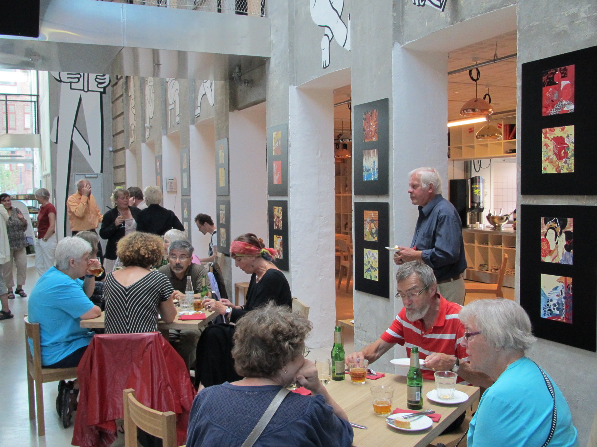
The exhibition is placed in the foyer of the library near the cafeteria, where most of the visitors can see it

