Opening of the Exhibition
The opening of the exhibition of Martin Velíšek’s illustrations to the Czech edition of Knud Rasmussen’s Myths and Legends from Greenland took place at Skive Museum on 29 January 2011.
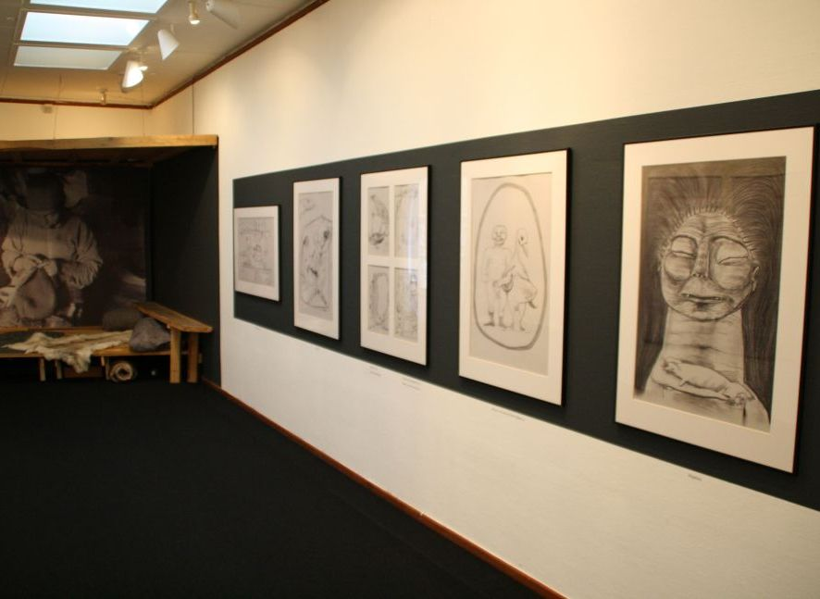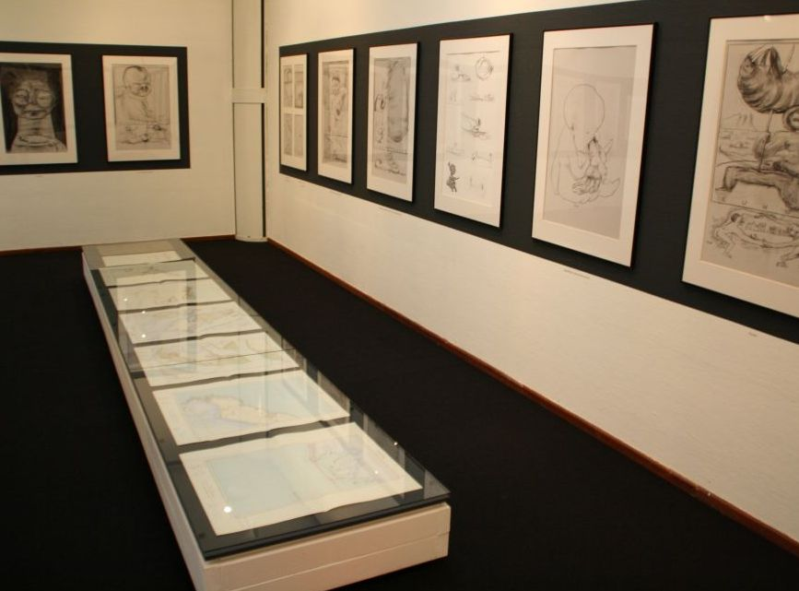
After the opening song by the Greenlandic choir Kilitaq, Museum’s Director Carina Serritzlew and Mayor Flemming Eskildsen held speeches. The exhibition was opened by the Czech Ambassadør Zdeněk Lyčka who tried to say a few words in Greenlandic, thanked the organisers for cooperation, informed about the history of the exhibition and add some interesting information on the translation of Knud Rasmussen’s myths and legends into Czech and on the illustrator Martin Velíšek.
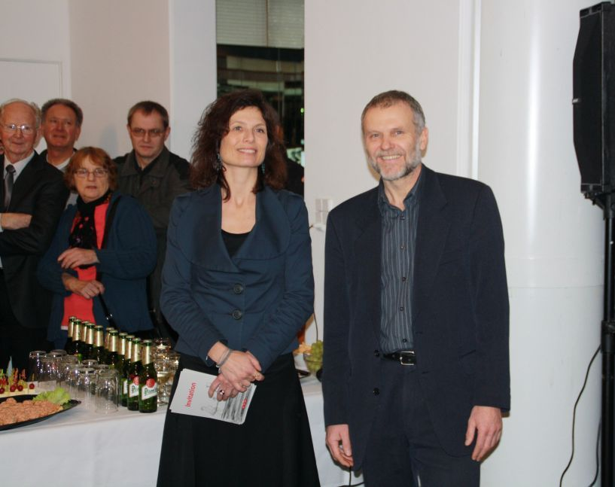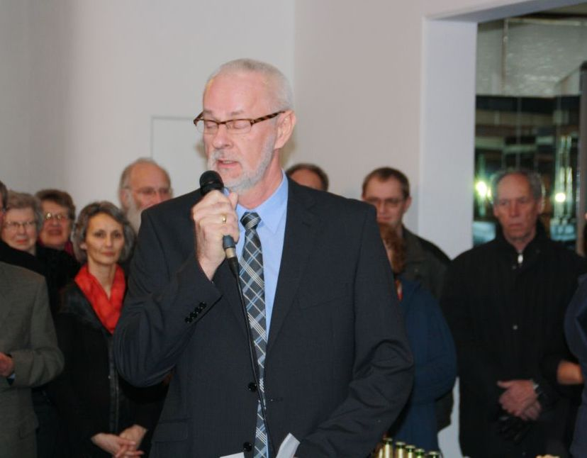

Museum’s Director C. Serritzlew and Ambassador Z. Lyčka (photo Mogens Lildballe)
Mayor Flemming Eskildsen (photo Mogens Lildballe)

More than 80 opening guests listened to more Greenlandic songs by the Kilitaq choir and saw the performance by two Greenlandic dansers in traditional masks. Czech beer was served during the opening.

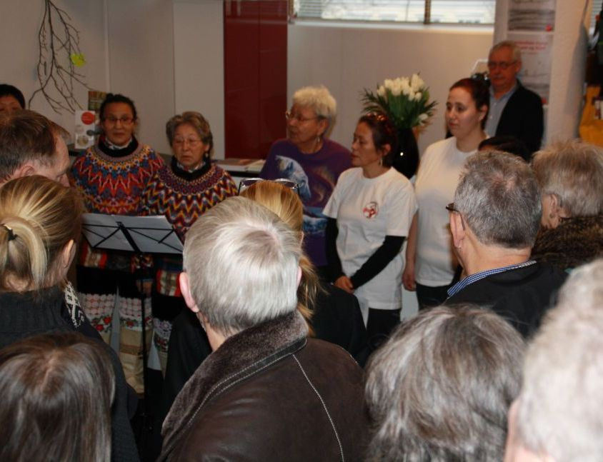

Kilitaq choir surrounded by many spectators
A masked danser

Z. Lyčka made an interview for the Greenlandic daily Sermitsiaq and Kalaallit Nunaata Radioa Danmark. Please hear or read the interview on KNR´s homepage.

