**Terms of Reference for the Contract   
between the Embassy of the Czech Republic in the Kingdom of Cambodia and a Consultant**

The Embassy of the Czech Republic in the Kingdom of Cambodia is searching for a consultant to provide technical assistance on updating sectoral study titled *Expert Research Study On The Current State Situation And Needs In The Education Sector In Cambodia With The Focus On Secondary Education And Vocational Education*. The objective of this study was to provide analysis of the current state of the education system in Cambodia and recommendations for the formulation of development aid measures as of the end of 2017. A focus of this research is on secondary education and vocational education training including apprenticeships in conjunction with an analysis of local labour market needs. This study tries to identify issues and gaps in the

Education system in Cambodia. The result of this research are conclusions and key recommendations for future development cooperation in terms of sector focus and potential partner’s identification.

The Background

**Bilateral Development Cooperation Programme of the Czech Republic Cambodia 2018–2023; Inclusive social development; Outcome 3:** Increase the number of youth and adults who have relevant skills, including technical and vocational skills, for employment, decent jobs and entrepreneurship (SDG 4.4.)

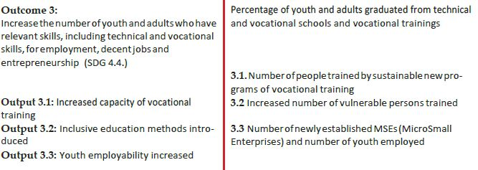

**Picture no. 1:** *Priorities from the Bilateral Development Cooperation Programme of the Czech Republic to Cambodia (2018–2023)*

**SDG 4. (respect. 4.4.):** By 2030, substantially increase the number of youth and adults who have relevant skills, including technical and vocational skills, for employment, decent jobs and entrepreneurship

The Expert Research Study on the Current State Situation and Needs in the Education Sector in Cambodia by EuroPlus Consulting & Management, s.r.o contributed significantly to the relevance of the design of the whole program and its project components since it provided the contextual framework for all the following interventions. The only limitation is that the study has become out-of-day for future planning and needs to be updated. It also lacks practical recommendations for schools and project implementers for efficient linkages with the private sector and income generation for the schools.

Expected outcomes from the Consultant

A consultant is asked to work on points a) to e) specified below.

1. Revise sectoral priorities within the current Bilateral Programme and draft relevant baselines and indicators for the new phase 2024 – 2028.
2. Update information from a study carried out in 2017 by Czech Development Agency called *Expert Research Study On The Current State Situation And Needs In The Education Sector In Cambodia With The Focus On Secondary Education And Vocational Education*[1]. This study is to serve as the implementation tool of the Bilateral Programme mentioned above.
3. The update should include specific recommendations/road map for (1) Improving the relevance of technical and vocational education for the changing employment and market needs, including hard- and soft skills and STEM knowledge. (2) Decent work and income from income-generating opportunities in the informal sector.
4. Mapping of other donors' training and Stakeholder mapping and drafting of institutional sustainability

Requirements

* Minimum **5** years experience working in the technical and vocational skills in Cambodia and demonstrated ability to carry out assessment study of similar scope
* Good understanding of governmental strategies and policies in the sector
* Good understanding of Cambodia’s TVET system
* Good understanding of Cambodia’s employment and market needs

**Relevant documentation and contact details will be provided to the selected candidate. Both candidates international and Khmer are encouraged to apply.**

concluding provisions

Final documentation elaborated by the expert should be handed over both hard copy to the Embassy of the Czech Republic in Phnom Penh (the iCON Building (5th floor), 216 Norodom Boulevard) and soft copy via email to the Development Section of the Embassy of the Czech Republic in Phnom Penh ([development_phnompenh@mzv.cz](mailto:development_phnompenh@mzv.cz)).

**The deadline for submission of CV and short motivational letter (max. one page) is due June 15, 2024.**

**Expected remuneration is USD 200 per day (max. 32 working days starting 1st of July).**

*Should you have any further queries, please contact:*

Mrs. Barbora Zackova

Head of Development Section

Embassy of the Czech Republic in the Kingdom of Cambodia

[barbora_zackova@mzv.cz](mailto:barbora_zackova@mzv.cz)

+855(0)16 231 000

1. https://mzv.gov.cz/file/5199740/CzDA_Study_on_Situation_in_Education_Sector_in_Cambodia.pdf