Karel Zeman (1910 – 1989)

Karel Zeman, a Czech director, animator and visual artist, is considered a founder of Czech animated film. Due to his creativity and mixture of live-action with animation and wonderful special effects he is often called a successor of the film magician Georges Méliès.

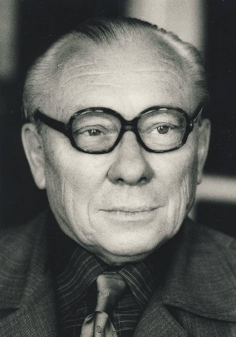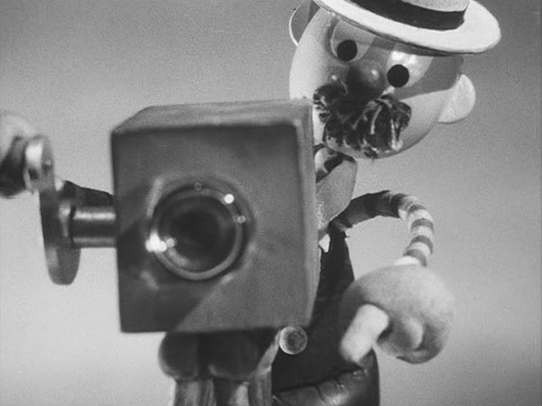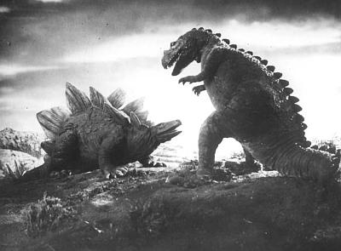

He started his professional career as head of advertisement for the Bata Service Home in Brno. Under the occupation Zeman began working at Czechoslovak famous Zlín Film Studios together with Hermína Týrlová. Their co-production Christmas Dream (1945) won a prestigious award at the IFF in Cannes. In the mid-'40s, he created a satiric series with Mr. Prokouk, a popular cartoon character. In 1949 he created the Inspiration-Work (1947), an attempt to animate the delicate beauty of figures made by Czech glassmakers.
His first film combining live actors, animation and special effects A Journey into Primeval Times (1954) became a turning point in his career and was awarded the Grand Prize in Venice and in Edinburgh. Four years later, he released his masterpiece An Invention for Destruction (1958), opening a new world of possibilities that he explored in his other adaptations of Jules Verne novels – The Stolen Airship (1966), On the Comet (1969), and classic stories such as Baron Munchausen (1961), A Jestre´s Tale (1963), and many more. The great success of these science fiction and fantasy features is a tribute to Zeman’s sense of humor and storytelling abilities, as well as his technique and originality. Though most of Zeman’s films are meant for children, they possess a sophisticated wit and visual style that enchants adults as well. In the middle of the 1970s, Karel Zeman returned to classic feature fairy tales (e.g. The Sorcerer's Apprentice, 1978) and died in 1989 shortly before the fall of communism in Czechoslovakia.

