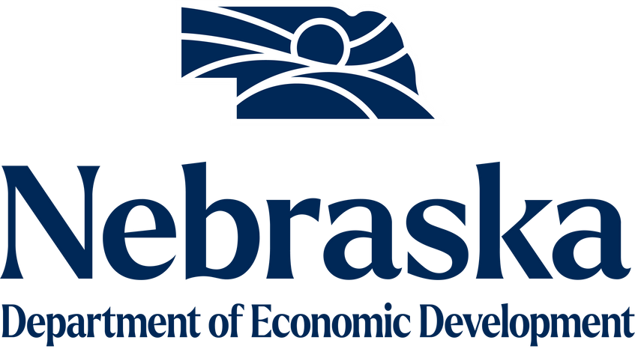

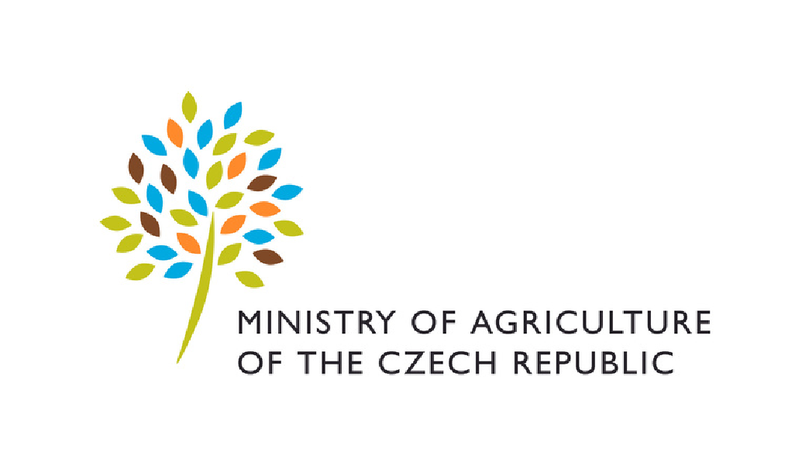

**You are invited to participate in the online**

**Nebraska & Czechia Irrigation Roundtable *Sharing Experience and Best Practices***

**Save the date:**

**February 29, 2024**

# 8.30 am - 10.30 am CST 9.30 am - 11.30 am EST 3.30 pm - 5.30 pm CET

**Access the online event via this** [**link**](https://teams.microsoft.com/l/meetup-join/19%3ameeting_YTc1Y2QyNTYtZmZmYS00NjlmLTgyOGUtY2IxODMyYzgzMzJm%40thread.v2/0?context=%7b%22Tid%22%3a%223e68563a-068d-40d7-93d1-c38683543fd8%22%2c%22Oid%22%3a%22a1298b8d-c95d-4b83-8d5b-e4098b6822e2%22%7d)

**(The platform of the event is MS Teams)**

**Nebraska & Czechia Irrigation Roundtable**

**Sharing Experience and Best Practices**

# Agenda

1. Opening Remarks (8.30 am – 8.45 am CST/ 3.30 pm – 3.45 pm CET)

[**Jakub Utěšený**](https://mzv.gov.cz/chicago/en/about_the_consulate_general/consul_general/index.html), Consul General, Consulate General of the Czech Republic in Chicago

[**Jim Pillen**](https://drive.google.com/file/d/1zoR6l-m-vI1g_350sO5rfoTn2hmjaWjq/view?usp=sharing), Governor, State of Nebraska

**Dr. Pavel Sekáč**, Deputy Minister, Ministry of Agriculture of the Czech Republic

Moderator: Dr. Monika Bokšová, Vice-Consul, Consulate General of the Czech Republic in Chicago

1. Keynote Speeches (8.45 am – 9.15 am CST/ 3.45 pm – 4.15 pm CET)

[**Dr. Pavel Punčochář**,](https://drive.google.com/file/d/1wGzYMMt4uKWOIVYyjNVdxgjhdnc6Fo7G/view?usp=sharing) Ministry of Agriculture of the Czech Republic *Irrigation Systems in the Czech Republic: History and Recent Situation*

[**Dr. Renata Placatová**,](https://drive.google.com/file/d/1al_mzSmAjOddFWA-oFFQLleUBjIH3UTa/view?usp=drive_link) [Research Institute for Soil and Water Conservation](https://www.vumop.cz/en)

*Smart Tools for Management of Irrigation Systems, Crop Water Requirement Calculator, Controlled Drainage for Subirrigation, Regional Irrigation Studies*

**Dustin Wilcox**, [Nebraska Association of Resource Districts](https://www.nrdnet.org/) (NARD)

*Review of the Current Situation, Conditions, Basic Regulations, and Challenges*

Moderator: Tereza Černá, Agricultural Attaché, Embassy of the Czech Republic in Washington, DC

**Nebraska & Czechia Irrigation Roundtable**

**Sharing Experience and Best Practices**

# Agenda

III. Research & Development (9.15 am – 9.45 am CST/ 4.15 pm – 4.45 pm CET)

[Mendel University in Brno](https://mendelu.cz/en/)

[**prof. Milada Šťastná**](https://drive.google.com/file/d/1Yiy_3H3mKy307pcm852gRttDFaX42xli/view?usp=drive_link),Department of Applied and Landscape Ecology

*Research and Education in the Water Sector (Transfer of Knowledge to Practice)*

[University of Nebraska - Lincoln](https://www.unl.edu/)

[**Dr. Nick Brozovic**](https://waterforfood.nebraska.edu/meet-our-people/nick-brozovic)**,** [**Dr. Renata Rimsaite**](https://waterforfood.nebraska.edu/meet-our-people/renata-rimsaite), Daugherty Water for Food Global Institute

*Irrigation Policy*

[**Dr. Dipak Santra**](https://agronomy.unl.edu/santra)**,** Department of Agronomy and Horticulture *Drought-resistant crops*

[**Dr. Xin Qiao**,](https://bse.unl.edu/faculty/xin-qiao) Institute of Agriculture and Natural Resources

*Irrigation Technologies under Limited Irrigation Conditions*

Moderator: Tereza Černá, Agricultural Attaché, Embassy of the Czech Republic in Washington, DC

IV. Private Sector (9.45 am – 10.00 am CST/ 4.45 pm – 5.00 pm CET)

Nebraska Private Sector

*presented by Colby Angst, Export Consultant, Nebraska Department of Economic*

*Development (companies´ representatives available for the Q&A)*

Industrial-Irrigation - Justin Osborne (Irrigation Equipment)

Lindsay Corp. - Damien Cochelin (Irrigation Equipment)

Reinke Mfg. Co., Inc. - Mitch Kreps (Irrigation Equipment)

Sentinel Fertigation - Jackson Stansell (Fertigation and software)

IDEM Irrigation - Jared Ross (Irrigation Equipment)

NAVE analytics - Jessica Korinek (Irrigation Analytics)

Czech Private Sector

*presented by Tereza Černá, Agricultural Attaché, Embassy of the Czech Republic in Washington, DC (companies´ representatives available for the Q&A)*

V. Q&A (10.00 am – 10.30 am CST/ 5.00 pm – 5.30 pm CET)

Moderator: Tereza Černá, Agricultural Attaché, Embassy of the Czech Republic in Washington, DC