The Embassy of the Czech Republic in Denmark
&
Café Svejk

cordially invite you to

ROLL OUT THE BARREL
THE HISTORY OF CZECH BEER

17 March – 18 April 2010

at Café Svejk
Smallegade 31, 2000 Frederiksberg

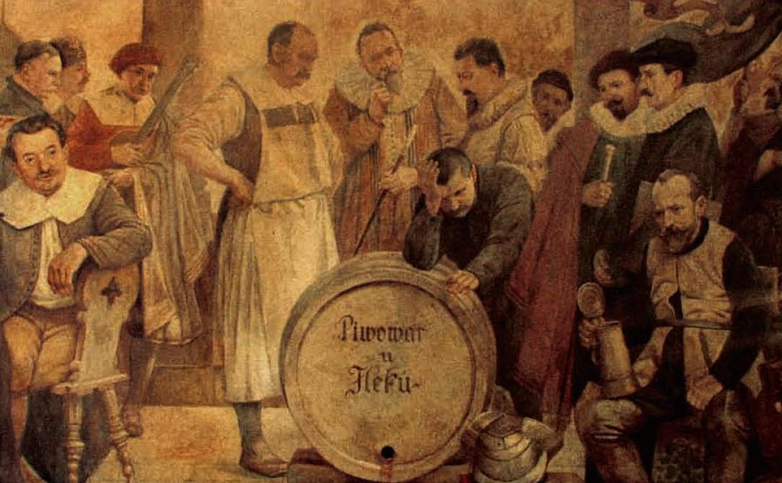

The well-known English song “Roll Out the Barrel” is actually an adaptation of a Czech song that became popular among Allied soldiers during the Second World War.
Of course, the song is about beer,
the most popular low-alcohol-content drink in the world.
The exhibition presents the long history of Czech brewing starting in the 10th century.

Today, the Czech Republic continues its proud, centuries-old tradition of brewing excellent beers that have gained renown worldwide.

