Curriculum Vitae
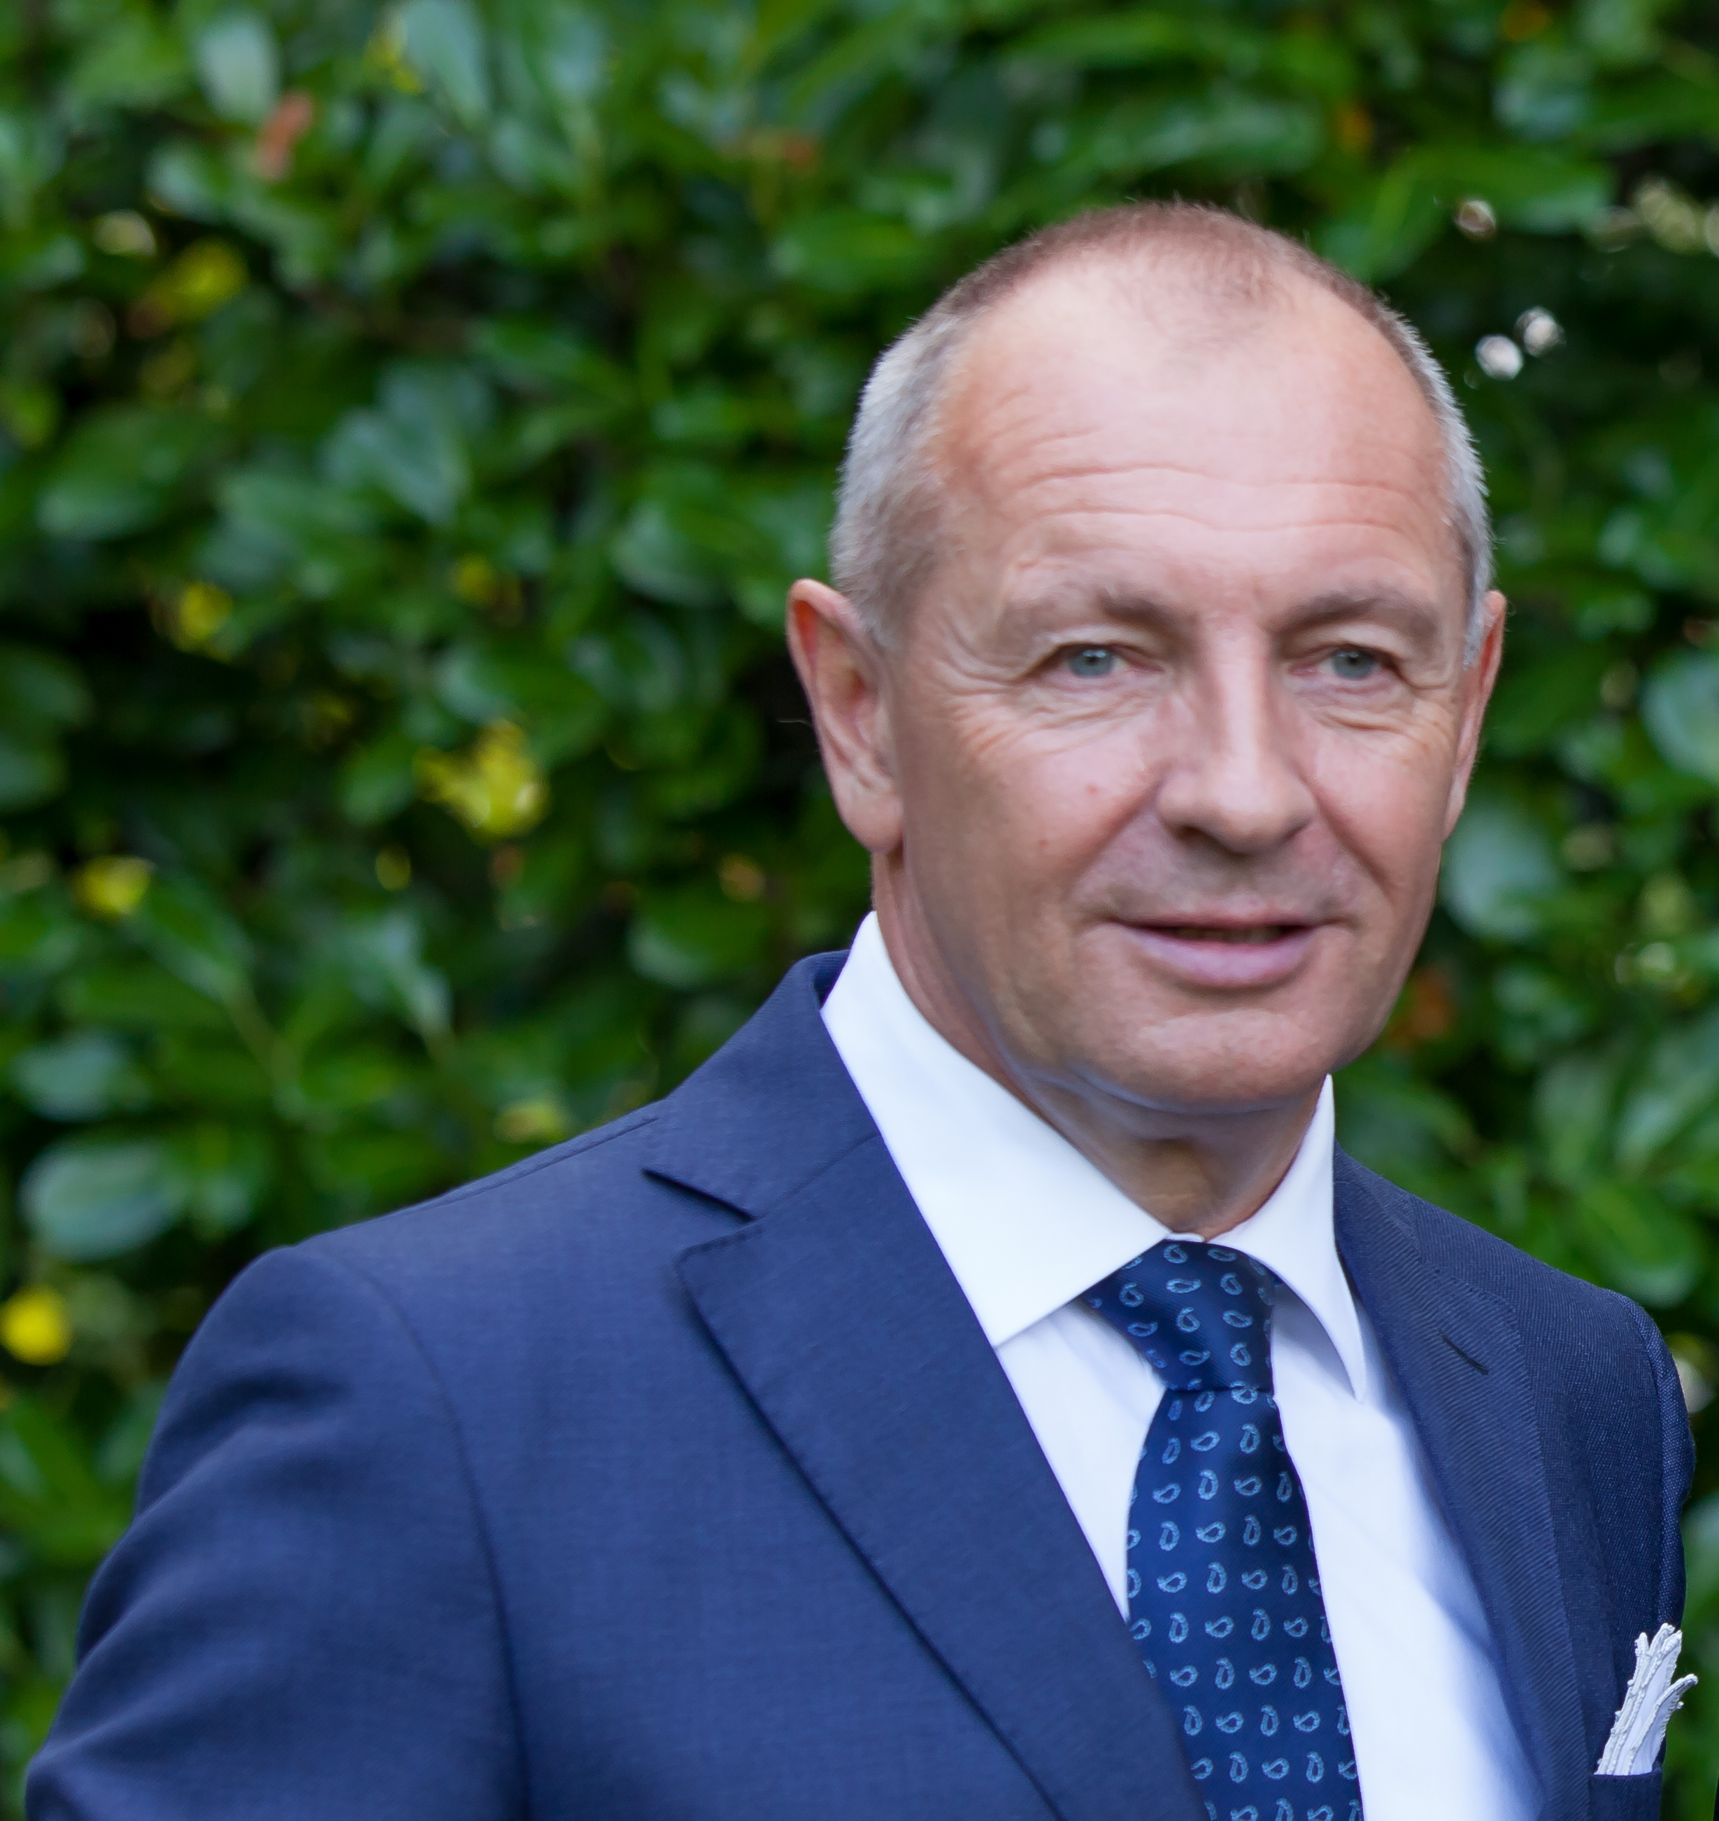
Mr. Libor Sečka was born on October 8th 1961 in the city of Znojmo, Czech Republic.
He is married to Mrs. Sabrina Sečková and has three children – two daughters, Kateřina and Stella, and a son Libor.
Professional career
08/2021 MFA - Appointed as the Special Envoy for the Indo-Pacific
2016 - 2021 Ambassador to the Court of St. James to the United Kingdom of Great Britain and Northern Ireland, London
2009 - 2015 Ambassador of the Czech Republic to the People´s Republic of China
2006 - 2009 MFA - European Union Section, Director-General
2003 - 2006 Ambassador of the Czech Republic to Italy and Malta
2000 - 2002 Ambassador of the Czech Republic to the European Union
1999 - 2000 Ambassador of the Czech Republic to Mexico
1997 - 1999 Member of the Czech Republic Delegation for the Negotiations with the EU - appointed by the Government
1997 - 1999 MFA - Department of the Political Relations with the EU, Director
1996 MFA - European Community Department, Head of Political Division
1995 MFA - Latin America Department
1993 - 1995 Embassy of the Czech Republic to Spain, Counsellor of Embassy - Deputy Head of the Mission
1990 - 1992 Embassy of the Czech and Slovak Federative Republic to Spain, First Secretary of Embassy
1986 - 1990 MFA - European Department

Education
1980 - 1985 The Moscow Institute of International Relations, International Economic Relations, Master Degree
Special courses
09/1997 Bonn, Germany - Federal Academy for Public Administration, EU affairs
10/1996 London, UK - Institute of Advanced Legal Studies, Negotiating Skills Course
02/1996 Brussels, Belgium - European Commission, European Union matters

Mr. Sečka speaks fluently English, Spanish, Italian and Russian.

