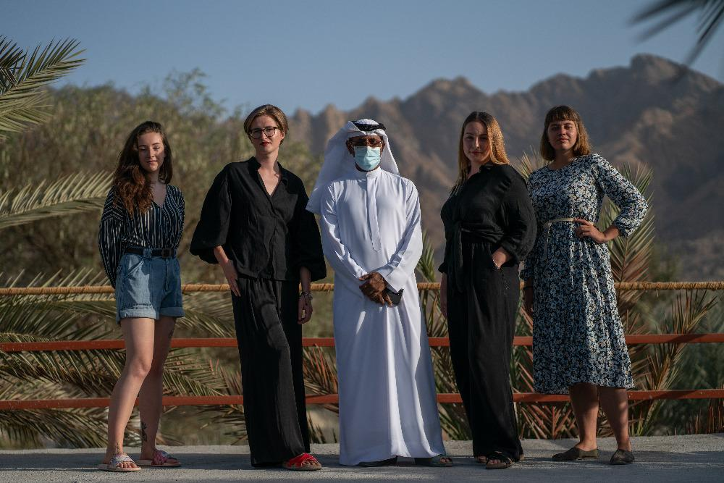

Director of ArtHub Hatta, Mr. Ahmed Saleh Al Yafei and group of Czech students ( from the left : Glozová, Čaplová, Kučerová, Vitvarová)

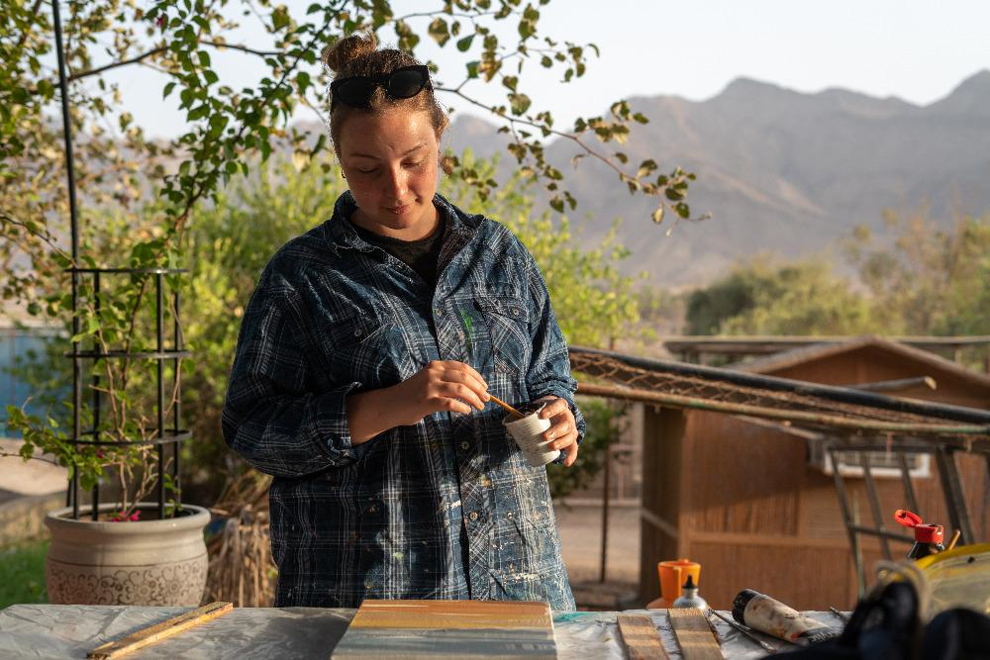

Ms. Kamila Kučerová, 26 years, graphic designer, Master´s student at University of West Bohemia in Pilsen

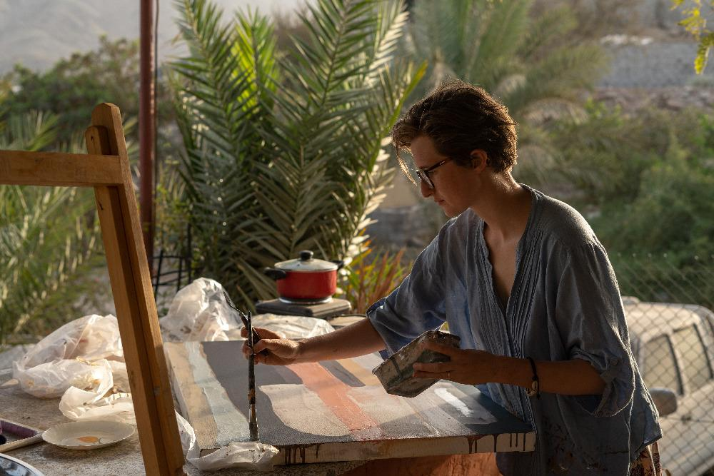

Ms. Karolína Čaplová, 24 years, graphic designer and illustrator, Master´s student at University of West Bohemia in Pilsen

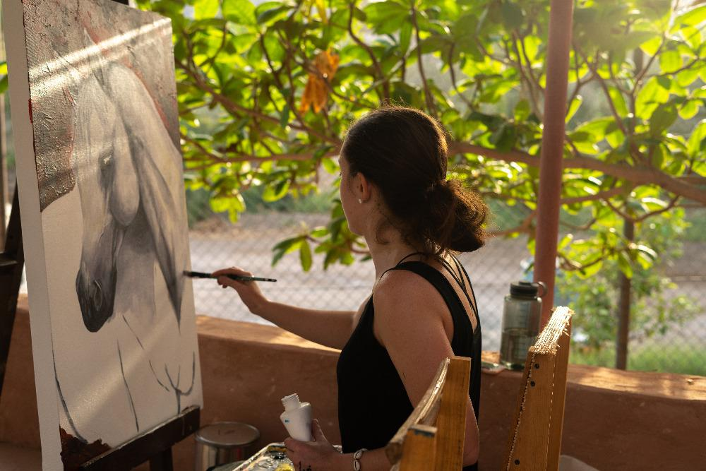

Ms. Sofie Glozová, 23 years, painter, student of Pedagogy at the University of Hradec Králové

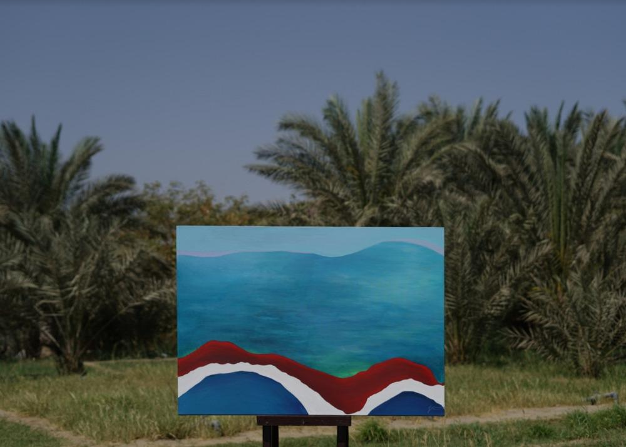

„Dawn“ from Ms. Anna Vitvarová

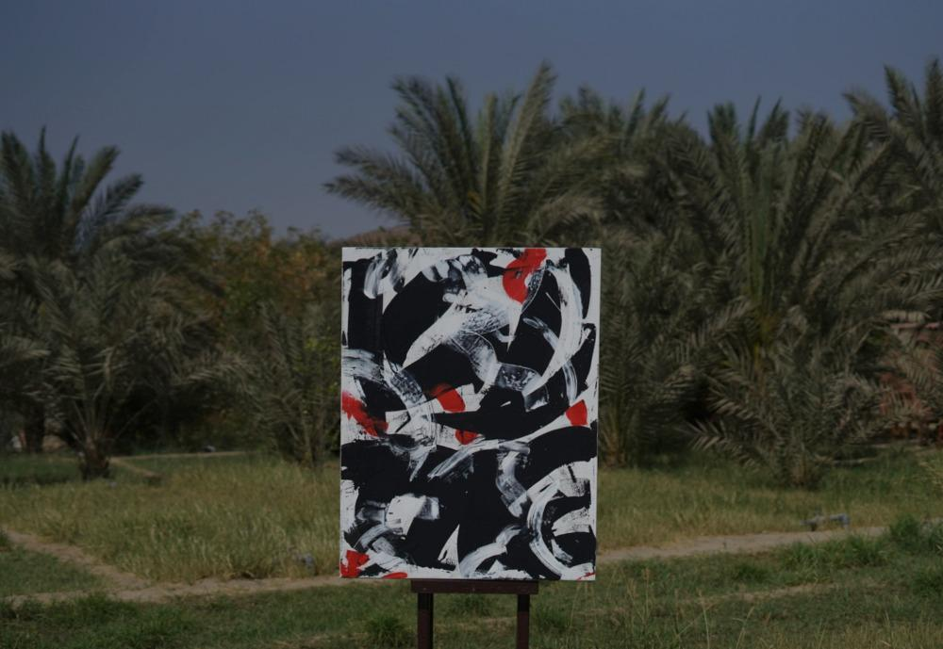

„People from Hatta“ from Ms. Kamila Kučerová

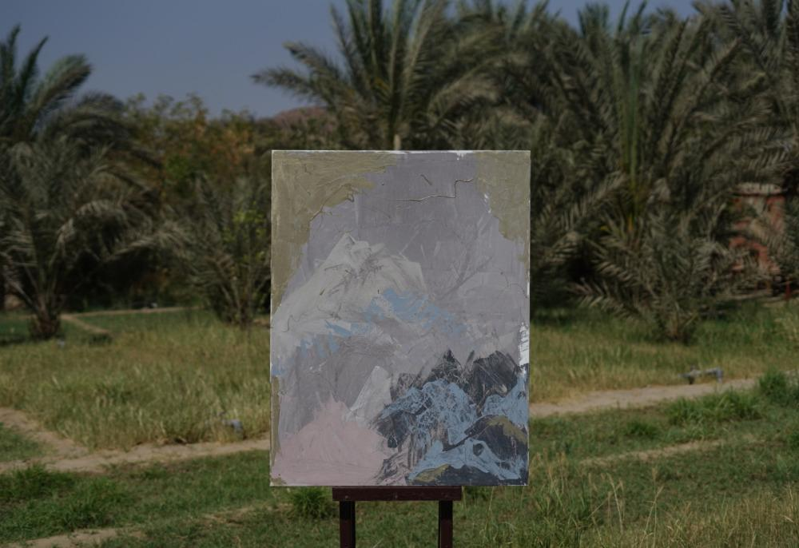

„ Hajar Mountain 3 “ from Ms. Karolina Čaplová

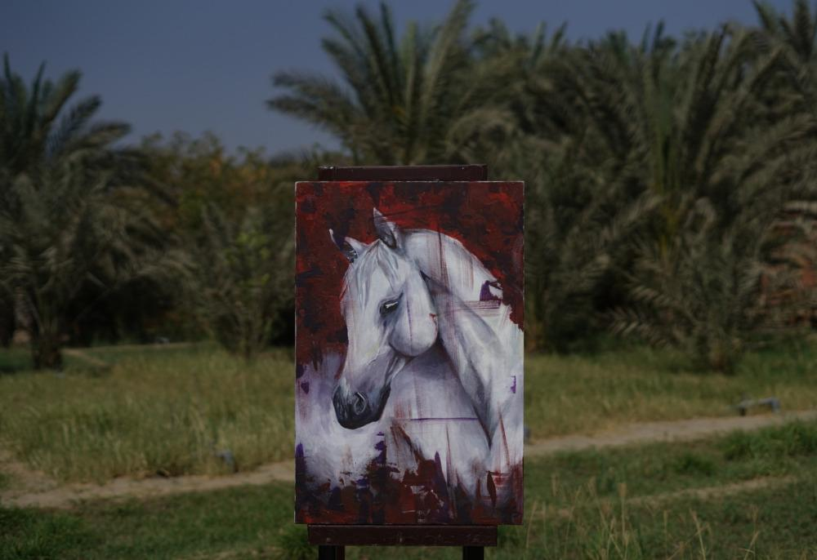

„Horse“ from Ms. Sofie Glozová