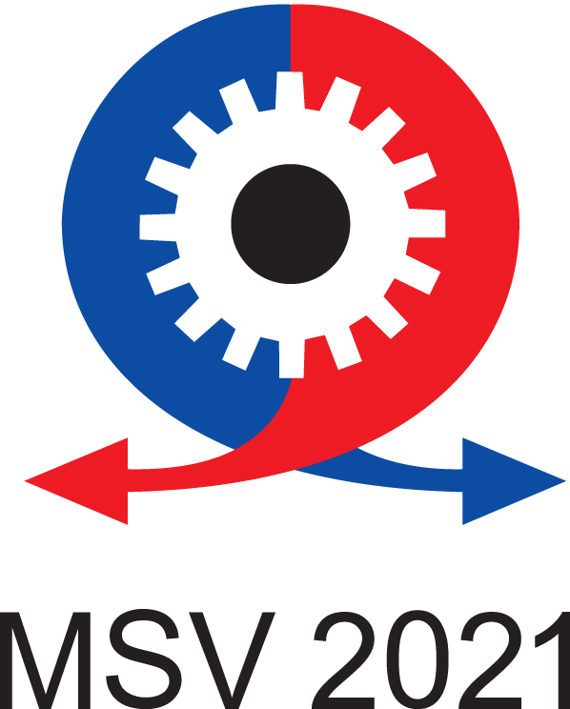
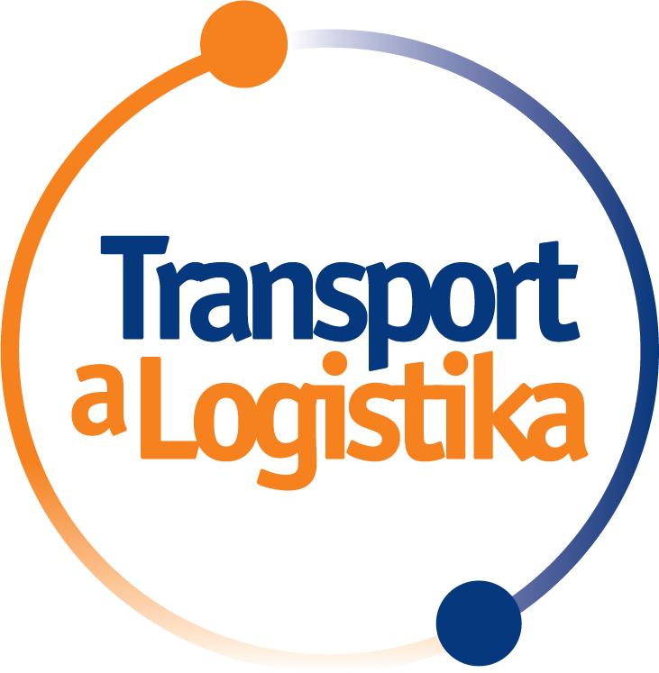


62nd MSV International Engineering Fair moved
to November

The MSV International Engineering Fair in Brno will take place this year from 8 to 12 November 2021. The management of BVV Trade Fairs Brno (Veletrhy Brno, a. s.) has decided to move it from September, taking into account the current development of the COVID-19 pandemic. Together with MSV, the Transport and Logistics and Envitech trade fairs will also take place on the same date. Dates of other events planned for the autumn will be adjusted accordingly.

"We believe that in the second half of the year, the results of the vaccination strategy will be delivered and there will be a gradual return to normal life. We expect that in November it will be possible to organize the MSV without significant restrictive measures. This is a key event for the economy that should help companies to introduce innovations, new technologies, and thus to return to economic growth in the post-COVID time," said Jiří Kuliš, CEO of Trade Fairs Brno. "This is a strategic decision, which aims to enable the fair to take place under relatively standard conditions, although as a result it means a change in the dates of most events planned for the autumn," Kuliš added.

Moving the deadline is the right decision
The move to a later date is also positively evaluated by the exhibitors. "Negotiations with exhibiting companies and partner associations have shown that the decision to move to November is the right step. The new dates will enable companies to prepare better, it does not conflict with any other major industry event abroad. In the second half of the year, travel will hopefully be possible for international exhibitors and visitors to participate in the event," said Michalis Busios, director of the International Engineering Fair.

"MSV is the most important engineering event in Central Europe and postponing the deadline to November increases the chance of holding it this year. Member companies of the Association of Engineering Technology are ready to participate in the fair and consider the decision to be very reasonable," said Oldřich Paclík, director of the Association of Engineering Technology.

"After last year's break, we consider it very important for the MSV to take place this year. Not only for the trade fair industry, which was hit hard by the pandemic, but also for the return to a standard B2B cooperation. Despite the rapid development of digitization, business meetings cannot replace personal meetings. Thanks to the fair, Czech companies can show how they have used the time since the last MSV to innovate and compare themselves with international competition. We expect to continue the tradition of organizing the General Assembly of the Confederation of Industry of the Czech Republic on the first day of the fair," said Dagmar Kuchtová, General Director of the Confederation of Industry of the Czech Republic.
Businesses are missing personal contact
The loss of personal contacts during the pandemic confirmed that trade fairs are an indispensable business presentation for companies. The business and marketing importance of MSV was also demonstrated by a survey among exhibitors who perceive the engineering fair as an important and irreplaceable presentation enabling effective personal meetings with existing and new customers and partners. "We perceive a significant demand from companies for holding the fair and having personal contact at it. It turns out that virtual events cannot replace a physically-held fair with human emotions, where building personal bonds is key," added Busios.

The importance of the fair is also emphasized by traditional exhibitors. “We miss MSV! A better concentration of contacts in such a time and space simply does not exist anywhere else. It is always a very important social event for us. This cannot be replaced by video conferencing, a webinar or online training. It's like Christmas; once a year, with great preparations, a turbulent course and a pleasant absorption of everything for some time after the end. We hope and believe that we will enjoy the fairs again as in the "old days," says Gabriela Prudilová, marketing manager of SCHUNK, which regularly participates in MSV.

The ABB Czech Republic Country Managing Director Vítězslav Lukáš evaluates MSV in the same way: “In the future, we consider participation in the fair to be an important and prestigious part of our presentation. We want to be part of an event that affects our entire industry and sets the latest technological trends. The traditional autumn fair in Brno can withstand the strictest standards in a global comparison, and we have the opportunity to always witness a professionally managed event. The fair has now become an important social event."

The importance of MSV for business was also confirmed by the exhibitors in an ongoing survey. The declaration of participation, which exceeds 70%, contributed to the decision to find a new date acceptable to the exhibitors.

Deadline for exhibitors at the end of June
With the postponement of the deadline to November, the conditions of participation are also adjusted so that sufficient time is created for exhibitors to prepare for participating. Preparation of trade fair participation, including preparation of exhibits, requires 4-6 months. "By June, the development of the situation should be so clear that companies will be able to decide on participation in time and perhaps without a high risk of losses from investments in the preparation of the fair. That is why we have decided on a new deadline for submitting applications under favorable conditions until 30 June," said Busios.

Further changes of trade fair dates
Due to the change in the MSV, the dates of other events planned for the autumn will be adjusted accordingly. The changes will be gradually published on the website www.bvv.cz.

Contact for media
Jaroslav Bílek, press spokesman
jbilek@bvv.cz

Michal Svoboda, MSV press spokesman
msvoboda@bvv.cz

