Travelling Exhibition “20th Anniversary of the Fall of the Iron Curtain” at the University of Århus.
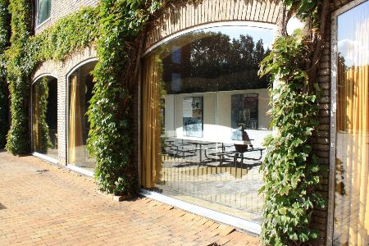
Exhibition ground of the University of Århus
The next stop of the travelling exhibition “20th Anniversary of the Fall of the Iron Curtain” on the occasion of the 20th anniversary of the fall of Communism was the University of Århus. On 7 October 2009, the Czech Ambassadør Zdeněk Lyčka delivered a lecture about his own personal experiences from the Velvet Revolution. Almost 30 participants were present at the lecture, incl. Jan Ifversen, Head of the Institute of History and Areal Studies, Associate Professor Peter Bugge and Lector Kateřina Haušildová from the Department of East-European Studies who made the exhibition and lecture possible. On 8 October, the film “The Tender Revolution” was sceeened at the University.
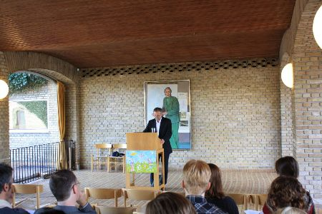
Lecture by Ambassador Zdeněk Lyčka

On this occasion, the Czech Embassy presented a book by Peter Sís, a Czech artist living in USA, entitled “THE WALL: Growing Up Behind the Iron Curtain“ (2009).

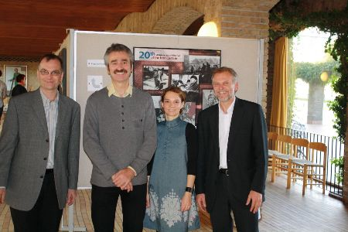
Associate Professor Peter Bugge (left), Head of the Institute of History and Areal Studies Jan Ifversen, Lector Kateřina Haušildová, Ambassador Zdeněk Lyčka

The exhibition was shown in Århus until 8 October and then it was sent to the University of Aalborg.
The travelling exhibition “20th Anniversary of the Fall of the Iron Curtain” and the connected activities thematically follow the CZ PRES’ motto “Europe Without Barriers“ and thus recollect the Czech Presidency of the EU Council in the second half of 2009, too.

