Příloha č. 1: Shrnutí v anglickém jazyce / Summary

Purpose of the evaluation
This document aims to independently evaluate two related multi-annual projects supported by the Czech Development Cooperation (CDC) in Georgia in the sector of public governance and civic society / general protection of environment, whose focus was to preserve the environmental as well as cultural values of the specific region of Tusheti. Final conclusions and recommendations will be highly relevant for future identification and implementation of projects within the multi-sectoral objective “Sustainable development of mountainous regions” formulated in the Bilateral programme of cooperation between Czech Republic and Georgia for period 2018 – 2023.
Description of evaluated intervention and context of the evaluation
Objects of the evaluation are two projects, whose implementation was co-funded by the CDC:
- First project, “Preparation of Management Plan for Tusheti Protected Landscape”, was aimed at elaboration of the Management Plan of the Tusheti Protected Landscape and, furthermore, formulation of guidelines for elaboration of Management Plans for this category of protected areas in general. Specific activities, such as data collection, community outreach, analysis of gathered data, training and further capacity building, were implemented in the scope of this project. Its key Georgian partner was the municipality of Akhmeta, founder of the administrative unit – Tusheti Protected Landscape Administration (TPLA).
- Second evaluated project was a follow-up initiative, its aim was to implement selected measures of the finalized Management Plan in practice. The project “Implementation of Selected Measures from the Management Plan for the Tusheti Protected Landscape“ was thus focused on measures in the fields of tourist infrastructure, monitoring of species and inventory of significant natural phenomena. In the scope of this project the following activities were implemented: proposition of the system of trail marking and delimitation of the basic network of tourist trails, including its marking in the territory, mapping of traditional toponyms, presentation and promotion of the protected landscape, etc.
A significant number of other initiatives supported by CDC as well as other donors were implemented in the region, which are not the subject of this evaluation. However, it is necessary to consider these as context.

Evaluation team.
Evaluation was carried out by HaskoningDHV Czech Republic Ltd in close cooperation with significant local actor, Tusheti Development Fund (TDF). Representatives of TDF are members of Tusheti community, however, they also cooperate with a number of international and national donors on developmental projects implemented for the benefit of Tusheti region aiming at facilitation of socio-economic and environmental development of Tusheti and increasing the quality of life of Tush communities.
Evaluation team consists of: Lukas Malac, chief evaluator and team leader, Juraj Svajda, expert in the field of management of protected areas and Giorgi Abulidze, local expert.

Most significant findings and conclusions
Relevance of the support is assessed as high. Implemented initiatives are fully in line with relevant strategies of Georgia, CDC as well as with the needs of its target groups and fulfil the relevant Sustainable Development Goals. Target groups clearly formulate the need to develop infrastructure and offer for tourism. This, however, also bears a risk of losing the authenticity of landscape and villages of Tusheti due to precipitous development of incoming tourists. Authenticity is, however, the key added value and is the main reason why visitors arrive to Tusheti. Establishment and strengthening of TPLA is, to a large extent, a relevant response to this very dilemma – solving it by, on the one hand, supporting initiatives in development of tourist infrastructure and visitors attraction to the region, while, on the other hand, at the same time strengthening the protection and preservation of natural and culturally – historical heritage of the region. Establishment and strengthening of TPLA is therefore highly relevant with regard to the needs of target groups.

Efficiency of the support is assessed also as rather high. On the level of costs of implemented activities no resources that would be used inefficiently were identified. Moreover, achieving and taking advantage of synergies and cooperation with other donors and stakeholders had a positive impact on the efficiency of evaluated projects.
On the other hand, higher efficiency of evaluated initiatives could not be reached due to a very low cooperation on operative tasks as well as on-going coordination between representatives of TPLA and Tusheti Protected Areas (TPA, local office of the Agency for Protected Areas of Georgia). These deficits seemingly led to doubling of activities, inefficient operations and unsatisfactory utilization of project outputs.
The elaboration of the Management Plan is, without doubt, an example of good practice. The document plays a role of the key reference document of TPLA that effectively guides the operation of the institution as well as its long-term development. However, it must be also noted that the elaborated Management Plan represents a very ambitious document in the context of Tusheti Protected Landscape and it is evident that a significant number of its measures could not be implemented and fulfilled in the six years horizon of its validity. In effect, a significant portion of attention was devoted to initialization of measures / activities, whose full implementation in the TPLA will be possible first in a longer period of time.

Effectiveness of support is also assessed as rather high. Main goals and general purposes of the evaluated initiatives have been mostly reached: a more or less stabile administrative structure of TPL is in place and a quality document, Management Plan, has been approved and is being implemented. Also the quantitative goals of evaluated projects were mostly fulfilled: a sharp increase in the number of tourists is observed, which generates significant incomes for locals, whose life standard has, in effect, also risen. However, causality between these trends and implementation of evaluated projects is rather low.
Part of planed outcomes were reached only partly. A system of biodiversity monitoring was put in place and high quality guidelines as well as baseline studies were elaborated, however, monitoring is almost not at all implemented by the TPLA due to capacity reasons. Similarly in the field of communication and PR a logo of Tusheti region was elaborated and a communication strategy formulated, however, actual activities of TPLA in the field of communication and PR are very limited; evaluation team has, moreover, not registered any case of a visitor who would get information on Tusheti from TPLA web or other communication channels of the agency, or was even motivated to visit the region in effect of TPLA communication and PR. Also the goal of generation of additional incomes from tourism was rather not reached, pilot application of voluntary entrance fees generated only 1650 GEL during two months of operation.
However, it must be noted that these were rather only supplementary or pilot initiatives or initiatives that are not yet fully implemented due to insufficient capacities of TPLA, however, their strengthening can be expected in the future (provided that capacity of TPLA will be sustained and strengthened). Also it should be reminded, that insufficient fulfilment of these outcomes was in many cases caused rather by inflexible and personally instable cooperation with the Agency for Protected Areas that could not be influenced by the project teams.

Regarding impacts, a very positive trend of socio-economic development as well as quality of life of local inhabitants is observed. It should be noted, that it is very difficult to actually isolate the contribution of CDC to these trends – socio-economic development is rather caused by external factors, most importantly, rapid development of tourism in the region. However, support provided by the CDC has significantly contributed to management of this increase and to improvement of the experience of visitors, moreover, initiatives of CDC were originally represented a significant impulse that contributed to initializing of these trends (those initiatives are, however, not the subject of this evaluation – especially electrification of guesthouses and other objects should be noted in this context). In direct effect of the existence of administrative structure (TPLA) a number of new regulations have been issued and enforced in the region. These have positive impact on the protection and preservation of natural and culturally-historical heritage of the region. The impact of evaluated initiatives on increasing the participation of local communities on decision-making has not been manifested so far.
On this basis the impact of CDC support on the development of Tusheti is assessed as rather high and evaluated initiatives are considered to be examples of good practice – CDC was successful in establishing a basis for future development of the region.
Sustainability of outcomes must, on the other hand, be assessed as rather low. TPLA has so far not sufficient capacity to operate effectively on its own and fulfil independently the measures of Management Plan. These measures are usually fulfilled only if external financial resources are available. On the other hand, a high level of ownership and motivation of TPLA representatives with regard to the Management Plan has been observed.
Recommendations
On the basis of formulated conclusions, the following recommendations are suggested:

Recommendations of process and system nature:
Recommendation | Key addressee | Gravity
In the case of projects aimed at capacity building of institutions require at least in its earlier stages of implementation a long-term presence of implementer in the target region. | CzDA | 1
Require such formulation of results and their indicators that would fulfil the SMART characteristics. | CzDA | 2
In case there are more donors and other stakeholders engaged in the target area, seek for establishment of shared local structures instead of implementation of own solution. | Implementers / CzDA | 2
Carry on in systematic coordination on the level of the Embassy (or local representative of the CzDA) with other donors and stakeholders that are active in target region. | Embassy | 1

Recommendations related to continuation / phase-out of CDC in Tusheti
Recommendation | Key addressee | Gravity
Carry on in initiatives supporting the capacities of TPLA, focusing on missing expertise and knowledge (biodiversity, preservation of cultural heritage, communication and PR). | CzDA / Implementers | 1
Support the process of formalization of Tusheti community representation and participation on the most suiting platform (Tusheti Council, LAG - Local Action Groups, etc.) | CzDA / Embassy | 2
Consider support to a pilot project aimed at establishment of an association or any other form of formal cooperation of entrepreneurs in tourism in Omalo, which could take over the responsibility for activities in marketing and provision of information to tourists. | CzDA | 2
Further develop tourist infrastructure – especially with regard to marked trails leading to Chevsureti; construct, in cooperation with other partners, accompanying infrastructure (camps, shelters, etc.) | CzDA | 2
Carry on in negotiations with relevant institutions of Georgia with regard to finding an acceptable model of compulsory entrance fees in Tusheti. | Embassy | 3

Recommendation related to implementation of the CDC programme and replicability of approaches applied in Tusheti.
Recommendation | Key addressee | Gravity
In case of favorable legislative and institutional preconditions in Georgia replicate the model of support based on Management Plan and Action Plan. | CzDA | 1
From the start support systematic development and application of principles of community management and participation when it comes to elaboration and implementation of Management Plan; in case the approach is combined with establishment of a LAG pay close attention to institutional and process interlinking of all structures so that double-track is avoided. | CzDA / Embassy | 1
Carefully prioritize measures of Management Plan / Strategy and develop relevant activities in a long-term perspective. | Implementers / CzDA | 2
Initiate as soon as possible work on relevant regulations in the administrative structures (consistently involving local communities to their formulation), since these are tools that have the potential to weaken the negative impacts of raising the attractiveness of a region to visitors. | Local institutions, implementers | 2
Accompany system activities with resources for investments of lower scope so that early implementation of several specific measures of Management Plan / Strategy can be reached and also the ownership of target groups as well as CDC visibility is raised. | CzDA | 1
Consider limiting the implementation of support to mountainous areas in the Programme of cooperation to only one region. With regard to geographic proximity and functional interlinks, choosing region Mtscheta/Mtianeti for continuation of CDC support seems as more logical choice. | Ministry of Foreign Affairs, CzDA, Embassy | 3

Příloha č. 2: Seznam použitých zkratek

- AOPK: Agentura ochrany přírody a krajiny České republiky
- APA: Agency for Protected Areas
- CAWI: Computer Assisted Web Interviewing
- CENN: Caucasus Environmental NGO Network
- CHKO: Chráněná krajinná oblast
- CLLD: Community led local development
- CNF: Caucasus Nature Fund
- ČR: Česká republika
- ČRA: Česká rozvojová agentura
- EBRD: Evropská banka pro obnovu a rozvoj
- EU: Evropská unie
- EQ: Evaluační otázka
- FLEG: Forest Law Enforcement and Governance
- FS: Fokusní skupina
- GEL: Gruzínský Lari (měna)
- GIS: Geographic Information System
- GIZ: Deutsche Gesellschaft für Internationale Zusammenarbeit
- CHKO: Chráněná krajinná oblast
- ITAP: International Technical Assistance Program
- IUCN: International Union for Conservation of Nature
- Kč: Česká koruna
- KRNAP: Krkonošský národní park
- LAG: Local Action Group
- MEPA: Ministerstvo ochrany životního prostředí a zemědělství Gruzie
- MP: Management Plan
- MSC: Most Significant Change
- MZV: Ministerstvo zahraničních věcí
- NACRES: Centre for Biodiversity Research & Conservation
- NEAP: Národní akční program pro životní prostředí
- NNO: Nestátní neziskové organizace
- NP: Národní park
- OECD-DAC: Organization for Economic Cooperation and Development - Development Assistance Committee
- PL: Protected Landscape
- RAPPAM: Rapid Assessment and Prioritization of Protected Area Management
- SDG: Sustainable Development Goals
- SMART (indikátor): Specifický (Specific), Měřitelný (Measurable), Dosažitelný (Achievable), Relevantní (Relevant) a Termínovaný (Time-Bound) indikátor
- TBIE: Theory Based Impact Assessment
- TDF: Tusheti Development Fund
- TPA: Tusheti Protected Areas
- TPL: Tusheti Protected Landscape
- TPLA: Tusheti Protected Landscape Administration
- USAID: United States Agency for International Development
- ÚSOP: Ústřední seznam ochrany přírody
- WWF: World Wide Fund for Nature
- ZRS ČR: Zahraniční rozvojová spolupráce České republiky
- ZÚ: Zastupitelský úřad

Příloha č. 3: Seznam prostudovaných dokumentů

Primární zdroje
- Projektové dokumentace k jednotlivým projektům
- Zprávy z monitoringů projektů
- Plán péče CHKO Tušsko

Strategie a kontextuální informace
- Ministry of Environment Protection of Georgia: National Environmental Action Programme of Georgia
- Ministry of Agriculture of Georgia: Strategy for Agriculture Development in Georgia 2015 – 2020 (2015)
- Government of Georgia: Social-economic Development Strategy of Georgia „GEORGIA 2020“
- Government of Georgia: Rural Development Strategy of Georgia 2017-2020

Metodologické zdroje
- OECD: Quality Standards for Development Evaluation (2010)
- UNDP: Handbook on planning, monitoring and evaluation for development results (2009)
- UNDP: Project-level evaluation – Guidance for conducting terminal evaluations of UNDP-supported GEF-financed projects (2012)
- The World Bank: Handbook on impact evaluation – quantitative methods and practices (2010)
- The World Bank: User-friendly handbook for mixed method evaluations (1997)
- Bamberger, M – Rugh, J. – Mabry, L.: Real World Evaluation (2006)
- INESAN: Methodology for the Evaluation of Cross-Cutting Themes in Development Cooperation (2017)
- Davies, R. – Dart, J.: The ‘Most Significant Change’ (MSC) Technique: A Guide to Its Use (2005)
- PRISM: Toolkit for Evaluating the Outcomes and Impacts of Small/Medium-Sized Conservation Projects, https://conservationevaluation.org
- Švajda, J. – Sabo, P.: Manažment chránených území (2013)
- http://www.conservationmeasures.org/
- http://www.fosonline.org/

Příloha č. 4: Seznam realizovaných interview

5. 6. 2018, Praha: Ministerstvo zahraničních věcí (zadavatel)
20. 6. 2018, Praha: Česká rozvojová agentura
AOPK / KRNAP
2. 7. 2018, Praha: Referenční skupina – evaluační metodologie (workshop)

Průběžně červen – červenec 2018: Skype konzultace s Tusheti Development Fund

Evaluační mise 1:
16. 7. 2018, Tbilisi: APA – Valerian Mchedlidze (předseda), Tamar Khakhishvili, Ana Akhalia (International Relations and Project Management Division) + 2 kolegyně
CENN – Nino Shavgulidze, Natalia Davlianidze
Interní schůzka evaluačního týmu (vč. TDF)
17. 7. 2018, Tbilisi: ZÚ – Jan Černík
Caucasus Nature Fund – Tea Barbakadze
Georgian National Tourism Administration – Tornike Zirakishvili (Conventiona and Exhibition Bureau of Georgia – Head of the Bureau)
Michal Nekvasil (identifikace nové iniciativy v Arakvi)
18. 7. 2018, Tbilisi: National Agency for Cultura Heritage Preservation of Georgia – Manana Vardzelashvili (Hean of UNESCO and Internationl Relations Unit), Marina TUmanishvili (Chief Specialist of the Unit)
Ministry of Environmental Protection and Agriculture of Georgia – George Khanishvili, Deputy Minister
19. 7. 2018, Akhmeta: Municipalita Akhmeta - Ioseb Karumashvili, starosta
TPLA - Eristo (Zaza) Lagazidze (ředitel) a další kolegové (ad hoc)
Zástupce municipality Akhemta pro Alvani a zástupce Tušska v regionálním parlamentu - Anzor Khizanaidze, Merabi Otiuridze
20. 7. 2018, Alvani: Skupinový rozhovor s místními obyvateli původem z Tušska aktivními v oblasti zachování kulturního dědictví – ženy

23. 7. 2018: Dolní Omalo – skupinový rozhovor s rangery TPA (cca 10 rangerů)
Dolní Omalo – Giorgi Bakuridze, Návštěvnické centrum Národního parku
Dolní Omalo – skupinový rozhovor s rangery TPLA (3 osoby)
Dolní Omalo - Eter Markhvaidze, penzion a internetová kavárna
Horní Omalo - Ia Buchaidze, pekárna a kavárna
24. 7. 2018: Bochorna – skupinový rozhovor s obyvateli (5 osob, vč. Dr. Irakli Khvedaguridze, který v Bochorně zůstává přes zimu)
Bochorna – Lavrenti a Kaxa Mishidze (vlastní prázdninový dům, v Tušsku se pouze rekreují)
Bochorna - Anano Otiuridze, kavárna a obchod
Jvarboseli – vlastníci a zaměstnanci Posholi guesthouse (3 osoby)
Dolní Omalo – setkání s delegací Elkana realizující projekt Geografického označení původu v Tušsku – 2 zahraniční experti, pracovníci Elkana, zaměstnanci National Food Agency, národní a regionální inspektoráty, atd.
25. 7. 2018: Diklo – guesthouse Gulnazi a Nino Khelaidze
Diklo – rodina Giorgi Otaridze (4 dospělé osoby) – vlastníci stáda krav, obchod se suvenýry pro turisty
Shenako – penzion Kako BUkavidze a jeho ženy, nejstarší penzion v Shenaku, zůstávají přes zimu (vlastní několik kusů dobytka)
Horní Omalo – Lado Kakhoidze, zástupce starosty Akhmety pro Tušsko
Horní Omalo – Slavomír Horák, koordinátor skupiny dobrovolníků z ČR v Tušsku
26. 7. 2018: Horní Omalo – skupinový rozhovor se zástupkyněmi 2 penzionů (Natia Bakuridze-Shina, -Nato Kaadze- Lasharai)
Dartlo - Beso Idoidze, vlastník penzionu, zároveň hospodaří s dobytkem a zůstává přes zimu
Dartlo – skupinový rozhovor se 4 mladými lidmi (cca 15-18 let), kteří navštěvují Tušsko na prázdniny (rodiny vlastní nemovitosti v Dartlu)
Dartlo – guesthouse rodiny Mariky Otiuridze
Dolní Omalo - Levan Sulakauri, investor budovaného velkokapacitního ubytovacího zařízení (bude otevírat příští sezónu, kapacita více než 70 hostů)
Horní Omalo – Jonathan Etzold (plus kolega s NACRES), kontraktor projektu GIZ v Tušsku
27. 7. 2018: Alvani – ředitel TPA

Evaluační mise 2:
10. 9. 2018: Skupinový (verifikační) workshop Alvani
11. 9. 2018: Skupinový (verifikační) workshop Dolní Omalo
Tbilisi: Zurab Baiashvili, zástupce projektu ENPARD pro municipalitu Akhmeta
12. 9. 2018, Tbilisi: CENN - Nino Shavgulidze, Natalia Davlianidze
Projekt ZRDA (USAID) - Katy Tchumburidze, zástupkyně vedoucího mise USAID
13. 9. 2018, Tbilisi: ZÚ – Jan Černík
Studio 21 – architekti zpracovávající Územní plán Tušska a další (regulační) dokumenty, Nana Meparishvili plu 1 kolega
Vojtěch Kubec
14. 9. 2018, Tbilisi APA - Tamar Khakhishvili, Ana Akhalia (International Relations and Project Management Division) + 2 kolegyně

24. 10. 2018: Skype rozhovor s Natiou Kobakhidze, zástupkyní vedoucího mise GIZ v Tušsku

Příloha č. 5: Schéma intervenční logiky hodnocené intervence

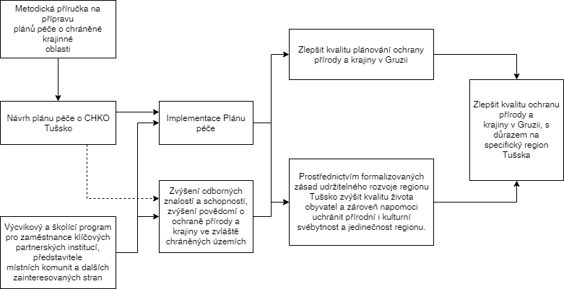

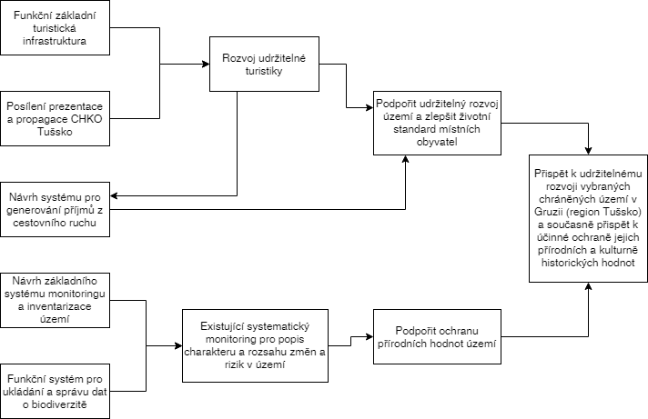

Příloha č. 6: Využité dotazníky

Dear Sir or Madam,
We would like to ask you for cooperation in the evaluation of Czech Development Cooperation support to Tusheti region. In the evaluation we would like to find out what kind of impact and effects these projects are experienced by local inhabitants, most importantly by the providers of services to tourists. Therefore we address you with this questionnaire.
Your participation will contribute a lot to our analysis. I would therefore kindly ask you for a few minutes of your time (not more than 10 minutes). The questionnaire is completely anonymous, your name will not be recorded, neither will be disclosed any details that could be used to your identification.
Thus, once again assuring you that your response will be kept confidential, I would like to ask for your truthful and open responses for the questionnaire. Your cooperation might directly contribute to raising the quality of support of the Czech Republic to remote areas in Georgia!

- Name of the village where you live and/or provide your services:_______________
- Gender of the respondent.
- Male
- Female

- What is your age group?
- 18-30
- 30-40
- 40-50
- 50-60
- More than 60

- Which services do you provide to tourists?
- Accommodation
- Catering (i.e. restaurant, cafe, etc.)
- Guide
- Transportation
- Rental of horses
- Shop
- Other, please specify:___

- How long have you provided these services? __________________ years

- Please estimate, how did key indicators of your business change since 2013 (or since the first year when you started your business, if it was later than 2013). Please select the response that you find the most appropriate.
We stress here again, that we ARE NOT INTERESTED in absolute values, we would only like you to share the trend with us.

Indicator | What trend you observe? | Comment (optional)
Number of tourists to whom you provided services (e.g. accommodated guests, clients of your service, etc.) | Significantly decreasing (less than half of 2013 values)  Rather decreasing  More or less the same as 2013  Rather increasing (not more than a half more than 2013)  Significantly increasing (nor more than triple the value of 2013)  Dramatically increasing (more than triple the value of 2013)
Your net incomes generated from services provided to tourists
Prices of your services for tourists (e.g. price per night, etc.)
Overall number of tourists arriving to Tusheti (in your experience)

- Please try to compare, what was the share of your net incomes (in %) from providing services to tourists on the overall yearly net incomes of your family in 2013 (or in the year when you started providing the services, if later than 2013) and toady (2017):
- Share of net income from tourism on overall income of my family in 2013 / in the year when I started providing services:___________%
- Share of net income from tourism on overall income of my family in 2017: _________%

- Did the quality of life of your family increase in direct effect of tourism in Tusheti since 2013?
- Definitely yes
- Rather yes
- Rather no
- Definitely no
- I don’t know
Please provide details to your reply (why yes/no, what kind of changes you experienced, etc.):_____________________________________________

- What are, in your point of view, the reasons for the increase of tourism in Tusheti in the last 5 years?

_______________________________________________________________________

- What is your approach towards the development of tourism in Tusheti?
- I’m fully in favor and I will be only happy if the number of tourists further increases.
- The increase of tourists is generally a positive trend, but in the future we will have to be more careful with the following:___________________________________
- I believe there are enough tourists today and the number should not increase too much in the future
- I believe there are already too many tourists and we should put some restrictions in force
- Different answer:_____________________________________

- Do you experience any negative impact of tourism in Tusheti?
- Yes, please elaborate:___________________________
- No

- What are, in your point of view, the most significant barriers to development of tourism in Tusheti?
____________________________________

Thank you for your replies!

Příloha č. 7: Okruhy pokládaných otázek
APA
- Where did, in your knowledge, the initiative to implement this project come from?
- How did the initiative to establish a PL in Tusheti actually appear? Whose initiative was it and what was the role of APA in the process?
- How did CDC get involved?

- How were you involved in the creating of the Management Plan (MP) for Tusheti (and its implementation)?
- How do you assess your involvement? Sufficient / not enough / etc.
- How do you assess the initiatives in general? What was done well and what should have been done better?
- How do you assess the involvement of local community and other partners?
- How do you assess the outcomes – especially the Management Plan, with regard to the needs and capacity of local resources? Most importantly, how do you assess the applicability of the Plan?
- Was the result achieved, in your point of view? Did the plan help to protect natural specifics and biodiversity of the region? How?
- Did the plan contribute to protection of cultural and historical heritage? How?
- TO what extent is, in your point of view, is the increase in attractiveness of the region attributable to the activities of CzDA?
- What was not achieved (and you expected it happening)?
- Did you experience any negative impacts of the initiatives? E.g. in relation to development of tourism?

- In what respect is TPL different from other PLs? To what extent is that the effect of Czech support? Is there any “added value” in comparison with other PLs?
- How are other PLs established? Who elaborates the Management Plans, etc.? What resources are typically necessary for such activities? Compared to TPL?
- Is comparison with National Parks relevant? How different is the establishment of NPs and PLs? What is the difference in resources necessary?

- Did you receive the methodology for elaboration of MPs? How do you assess its relevance and applicability?
- Is it replicable?
- Did you actually apply the methodology in any other PL? Or partly?
- Did the methodology and in general establishment of TPL influence APA documents in any respect? Strategies, pans, methodologies, etc.…
- What about other methodologies, e.g. the one for touristic markings (there were some frictions…) – any influences on APA methodologies, approaches, etc.?
- How did, in general, the project influence the operation of your organization?

- What data do they have with respect to biodiversity? How are this collected, what methodologies?
- Similar with tourism
- TPL vs. Tusheti National Park – what are the complementarities and synergies? Are these taken advantage of? Are there any frictions, conflicts? Etc.… (Also with regard to logo and communication strategy towards tourists)
- Issue of entrance fees has to be discussed (APA was against, so what is their approach, etc.)
- Sustainability and capacity
o How do they see the future of the TPL Administration?
o Does TPLA have sufficient resources, knowledge, finances, etc. to carry on in implementation of the Management Plan measures?
o Does TPLA have sufficient authority in the region? Can it enforce the Management Plan?
o Upcoming update of MP – will the TPLA be able to do on its own? Are they able to hold the high standard of MP? Will they not succumb to different approaches and interests and actually create a watered-down version?
o External resources to be applied – are there any? What about GIZ, will it take responsibility for implementation of parts of the MP…
Ministry:
- Why has, to your knowledge, been established the PL in Tusheti?
- What is the advantage of PL compared to other methods of protection and conservation of selected areas?
- Are there any disadvantages?
- Was the establishment of TPL an exception or was it a pilot to be further replicated?
- Do you have any strategy or plan as to establishment of PLs?
- How do you decide where new PLs should be established?
- What is the approach of locals to establishment of PLs?
- What were the lessons from Tusheti with regard to establishment of PLs? What should be replicated in the future? And what should be avoided?
- How do you assess the role of Czech consultants in establishment of TPL?
- What are, in your point of view, the most significant impact of the establishment of TPL? Were there any surprising impacts? Any negative ones?
- How do you assess the capacity of TPLA?
- How do you assess the sustainability of TPLA? Is it ready to administer the area on its own? Formulate new Management Plan?
- Based on the experience made so far, what would be your recommendation to similar projects in the future?
NNO:
- What is your role in the support of preservation of natural and cultural heritage in Tusheti?
- Why are you involved in Tusheti?
- Were you involved in the creating of the Management Plan for Tusheti (and its implementation)? How exactly? And how do you assess your involvement? Sufficient / not enough / etc.
- How do you assess these initiatives in general? What was done well and what should have been done better?
- How do you assess the involvement of local community and other partners in Tusheti?
- How do you assess the outcomes – especially the Management Plan, with regard to the needs and capacity of local resources? Most importantly, how do you assess the applicability of the Plan?
- What were, in your point of view, the results achieved? Did the plan help to protect natural specifics and biodiversity of the region? How?
- Did the plan contribute to protection of cultural and historical heritage? How?
- To what extent is, in your point of view, is the increase in attractiveness of the region attributable to the activities of CzDA? What would have happened without this support?
- What was not achieved (and you expected it happening)?
- Did you experience any negative impacts of the initiatives? E.g. in relation to development of tourism?
- What is, in your point of view, the added value of CzDA involvement in Tusheti? Do you observe any difference in establishing the TPL compared to other PLs?

- TPL vs. Tusheti National Park – what are the complementarities and synergies?
- Are these taken advantage of?
- Are there any frictions, conflicts?

- How do you assess the issue of entrance fees? Is it a good and replicable way forward for PAs in Georgia?

- Sustainability and capacity
  - How do they see the future of the TPL Administration?
  - Does TPLA have sufficient resources, knowledge, finances, etc. to carry on in implementation of the Management Plan measures?
  - Does TPLA have sufficient authority in the region? Can it enforce the Management Plan?
  - Upcoming update of MP – will the TPLA be able to do on its own? Are they able to hold the high standard of MP? Will they not succumb to different approaches and interests and actually create a watered-down version?
  - External resources to be applied – are there any? What about GIZ, will it take responsibility for implementation of parts of the MP…
- What are, for you, the lessons learned in Tusheti? What might be replicated?
- What do you see as the greatest success of the initiatives in Tusheti? Any disappointments?

Heritage protection:
- What is your approach towards Tusheti region from the point of view of protection / conservation of cultural heritage?
- Are there any sites that are especially valuable in Tusheti?
- How do you assess recent developments in Tusheti with regard to protection and conservation of the sites of especial significance?
- Do you see any positive trends in the protection in the region? If so, what is the reason?
- What should be done more and better in the protection / conservation in Tusheti?
- What is the impact of increased tourism on these issues? Benefits or threats?
- DO you have any plans and/or strategy towards protection of cultural heritage in the region?
- What can local actors do more and better in the future in this regard?
Municipality
- Whose initiative, as far as you know, it was to establish the TPL?
- What were the reasons and what did the municipality expect from establishment of TPL?
- How do you assess the process of establishment of TPL? Is there anything that you would do differently today?
- How do you assess the assistance that Czech experts provided in establishment of the TPL?
  - Relevance of their involvement and advice – did they know the region, did they propose relevant and implementable measures? Etc.
  - Quality of elaborated MP? Again, relevant and implementable?
  - Does it make sense from the development point of view or it’s only focused with nature and its conservation?
  - Processes and communication with the municipality / TPLA?
  - Processes of participation of local community?
  - How do you assess the efficiency of the support? Was all the support useful and necessary or would you say that with some activities it was not the case? Which activities brought the most benefit and which did not bring much benefit?
  - If it was up to you, what would you have changed on the assistance provided by Czech experts in retrospect?
- How was the municipality involved in the elaboration and implementation of the Management Plan? How do you assess the involvement?
- What are the benefits of the Management Plan formulation and implementation for your municipality? Are there any disadvantages, limitations, from the point of view of the municipality?
- How do you see the impacts of the formulation of MP and its implementation?
- To what extent were your original expectations fulfilled?
- Did the establishment of TPLA in general have any unexpected outcomes and impacts? Did something surprise you?
- What are the negative impacts?
- What were the impacts of establishment and implementation of the MP on the local society? Positive as well as negative?
- What kind of impacts on the environment do you observe?
- How did, in general, change the life of local population in the last 6-7 years? What were the positive changes and what were the negative changes?
- Which of the changes would, in your point of view, happen even without Czech support to the region? To what extent and how would it be different?
- Which of the changes would, in your point of view, happen without the existence of the TPL? How would it be different?

- How do you assess the situation and capacity of TPLA today? Will the administration be able to further develop the TPL and implement MP measures on its own?
- Did TPLA implement so far any measures of the MP on its own? What kind of measures and what is the general experience?
- Does the TPLA have, in your point of view, sufficient financial capacities for independent operation?
- Does TPLA have sufficient personal and expert capacities to operate independently?
- Is there any way how TPLA can increase their own revenues? How?
- Will TPLA be able to elaborate the new MP on its own? Or what kind of further assistance would it require?
- What is the capacity of the municipality to further increase the capacity of TPLA? What are the limitations?
- Are any other donors involved in the implementation of MP and development of the TPL in general? Which and how? Where did this initiative come from?
- What is, in general, the future of TPLA in your point of view?

- How does the TPLA, in general, cooperate with the management of NP?
- Do you observe any complementarities between the operation of PL and NP? In what way? Are these complementarities taken advantage of? Is there any “division of work” between NP and TPL?
- On the contrary, are there any frictions and conflicts? What are the causes? What are the solutions in the future?
- Do you cooperate with other institutions in the protection of natural and cultural heritage?
- Do you share your experience with other regions where the PL should be established?

- In general, what would you see as the greatest benefits of the establishment of TPLA and assistance provided by Czech experts?
- What lessons did you learn in this process? What would you recommend to other municipalities that are on the beginning of this process?
PL rangers
Overall
- What are your tasks and responsibilities in PLA?
  - Forest management
  - Governance of the region
  - Establishment and maintenance of tourism infrastructure
  - Inspection, „policing“, protection, law enforcement
  - Biodiversity monitoring and practical measures (e.g. habitats maintenance)
  - PR of the region (communication with stakeholders and visitors)
  - Other? (environmental education, rescue service, guiding…)
- What is your professional background/education? Are you from Tusheti originally?
- Do you work as ranger full time? Number of rangers? Facility (ranger station, uniforms, cars etc.)?
Capacities, capacity building
- Do you have sufficient capacities for the tasks you have in the PL? For which tasks you have sufficient capacity and for which no?
- Do you have sufficient knowledge and expertise? For which tasks yes and for which no?
- What kinds of tasks are the most demanding with regard to your capacities today? What do you expect in the future?
- Are you missing equipment, qualification and knowledge in any fields?
- What kind of support will you require in the future?
- Do you have specific training programs? Do you have a training plan?
- Is there platform for exchange information between PL Administration people?
Interaction between PL and PA
- How do cooperate the rangers of NP and PL in practice? Do they interact? How?
- Are the tasks in management of the region somehow divided between NP and PL?
  - In what way do the tasks differ?
  - Are there, on the other hand, any intersections, cross-cutting points?
- Are activities of NP and PL representatives coordinated? How does the coordination look like? Which activities are coordinated and which are not?
- Are there any frictions between the activities of NP and PL? Which topics? How are these facilitated?
- Is there a room for a higher degree of coordination / cooperation? In which fields (tourism infra, biodiversity monitoring, forest management, etc.)? What would have to be done?
Biodiversity
- How did, in your experience, contribute the establishment of PL to increasing the protection of environment in the region?
- How did, in your experience, the PL contribute to improvement of biodiversity in the region?
- How do you monitor the trends in biodiversity?
  - What do you monitor (species, habitats, threats)?
  - What methodology do you follow? Are you filling data to species database?
  - How often do you monitor biodiversity?
- What is, according to your measurements, happening in biodiversity in your region?
- Do you have sufficient knowledge / resources to implement the monitoring in accordance with the methodology?
Protection of cultural and historical heritage
- How exactly did, in your experience, the establishment of PL / impl. of MP contribute to the protection and conservation of cultural and historical heritage in the region? (give us examples)
- What would have been, in your point of view, the trends had the PL not been established?
Tourism infra
- How do you assess the marked tracks – as for its methodology, design as well as implementation in the field?
- In your experience, how do the tourists assess marked paths? Do they use them?
- Did you take part on the design of tourist track and layout in the field (incl. painting the marks)? How exactly? Do you feel you were involved sufficiently?
- How will the marked tracks be maintained and further developed? Do you have a strategy / plan of maintenance and development? Do you have sufficient resources and knowledge?
Local engagement
- How have the local community been involved in the formulation and implementation of the Management Plan?
- Has the involvement been, in your point of view, sufficient?
- To what extent is the local community a partner for the PL Administration? In what way? How do you assess?
- How relevant is actually the MP for local community? How exactly does it affect their lives?
- Does the MP / PL in general limit the ways of life / operation of local community? In what way, what are the limitations or boundaries to the life of locals that would not have been there otherwise?
- On the contrary, in what way does the existence of PL help locals, how exactly do they benefit?
Conclusion
- What do you see as the biggest impact of the establishment of PL?
- What do you think should be avoided the next time in similar initiatives?
- What do you see as the biggest pressure/threat for PL? (waste management, tourism, illegal activities, overgrazing, forest fire and infestation, invasive species, climate change, insufficient communication, depopulation, poor infrastructure, urban development…)
NP rangers
Overall
- What are your tasks and responsibilities in the NP?
- What is your professional background? Are you from Tusheti originally?
- Do you work as ranger full time?
Capacities, capacity building
- Do you have sufficient capacities for your job? IN which of your tasks you do not find your capacities sufficient?
- Are you missing any qualifications, expertise, etc.?
Interaction between PL and PA
- How do cooperate the rangers of NP and PL in practice? Do they interact? How?
- Are the tasks in management of the region somehow divided between NP and PL?
  - In what way do the tasks differ?
  - Are there, on the other hand, any intersections, cross-cutting points?
- Are activities of NP and PL representatives coordinated? How does the coordination look like? Which activities are coordinated and which are not?
- Are there any frictions between the activities of NP and PL? Which topics? How are these facilitated?
- Is there a room for a higher degree of coordination / cooperation? In which fields (tourism infra, biodiversity monitoring, forest management, etc.)? What would have to be done?
Biodiversity
- Do you have any system of monitoring of biodiversity in place? If so, please explain:
  - What do you monitor?
  - What methodology do you follow?
  - How often do you monitor biodiversity?
  - What system do you use?
- What is, according to your measurements, happening in biodiversity in your region since the beginning of the monitoring?
- Do you cooperate with the TPL in monitoring of biodiversity? In what way?
Tourism
- How do you assess the raise of popularity of the region among tourists?
- What is, in your experience, the reason of the increase? Why do tourists keep coming into the region?
- What kind of impacts of the increase in tourism do you observe? Do you see any negative impacts?
- How did, from your point of view, contribute the establishment of PL to the increase in tourism?
- How do you see the future of tourism in Tusheti? And what should public authorities do in that regard?
Conclusion
- What do you see as the biggest impact of the establishment of PL?
- What do you think should be avoided the next time in similar initiatives?
Info Centre
Introduction and tourists
- How many tourists do visit the Centre per week, in average?
- Who are the tourists that come to Tusheti, in your experience? What do they look for here, what are their plans and why do they arrive?
- What is the profile of a typical tourist?
- What information do tourists typically seek when they visit you?
- How do tourists assess Tusheti? Is there anything they miss, disappointments? Any offer / services / highlights they require and cannot receive in Tusheti?
- How do you assess the raise of popularity of the region among tourists?
- What kind of impacts of the increase in tourism do you observe? Do you see any negative impacts (erosion, disturbance of species, conflicts between visitors…)?
- How did, from your point of view, contribute the establishment of PL to the increase in tourism?
- How do you see the future of tourism in Tusheti? And what should public authorities do in that regard?
Tourism infra
- How do you assess the marked tracks – as for its methodology, design as well as implementation in the field?
- In your experience, how do the tourist assess marked paths? Do they use them?
- How do you perceive the sustainability of the marked tracks? And what about development, who should take part in that?
- What tourism infrastructure in general is missing in Tusheti?
Conclusion
- What do you see as the biggest impact of the establishment of PL?
- What do you think should be avoided the next time in similar initiatives?
- What do you see as the biggest pressure/threat for NP? (waste management, tourism, illegal activities, overgrazing, forest fire and infestation, invasive species, climate change, insufficient communication, depopulation, poor infrastructure, urban development…)
Infra and services
Introduction and tourists
- Who are the tourists that come to Tusheti, in your experience? What do they look for here, what are their plans and why do they arrive?
- What is the profile of a typical tourist?
- How do tourists assess Tusheti? Is there anything they miss, disappointments? Any offer / services / highlights they require and cannot receive in Tusheti?
- How do you assess the raise of popularity of the region among tourists?
- What kind of impacts of the increase in tourism do you observe? Do you see any negative impacts (erosion, disturbance of species, conflicts between visitors…)?
- What kind of impacts of tourism on local society do you observe?
Tourism infra
- How do you assess the marked tracks – as for its methodology, design as well as implementation in the field?
- In your experience, how do the tourist assess marked paths? Do they use them?
- How do you perceive the sustainability of the marked tracks? And what about development, who should take part in that?
- What tourism infrastructure in general is missing in Tusheti?
Governance
- Do you know about the establishment of PL in Tusheti region?
- How did, from your point of view, contribute the establishment of PL to the increase in tourism?
- How did the establishment of PL (and implementation of MP) change the governance of Tusheti? How did the governance improve or worsen?
- Is the governance more effective today?
- Do you know what is the division of competencies? Who decides what? Who do you go to if you need anything? What is, form your point of view, the division of competencies between the PLA and Akhemta municipality (and central institutions) like?
- What should improve in the governance of the region in general?
Local engagement
- How have the local community been involved in the formulation and implementation of the Management Plan?
- Has the involvement been, in your point of view, sufficient?
- To what extent is the local community a partner for the PL Administration? In what way? How do you assess?
- How relevant is actually the MP for local community? How exactly does it affect their lives?
- Does the MP / PL in general limit the ways of life / operation of local community? In what way, what are the limitations or boundaries to the life of locals that would not have been there otherwise?
- On the contrary, in what way does the existence of PL help locals, how exactly do they benefit?
Protection of cultural and historical heritage
- How exactly did, in your experience, the establishment of PL / impl. of MP contribute to the protection and conservation of cultural and historical heritage in the region? (give us examples)
- What would have been, in your point of view, the trends had the PL not been established?
Conclusion
- How do you see the future of tourism in Tusheti? And what should public authorities do in that regard?
- What do you see as the biggest impact of the establishment of PL?
- What do you think should be avoided the next time in similar initiatives?
- How do you see the future of development of the region in general? What should be the role of the PLA in this regard?
- How do you assess the sustainability of the Administration? Do they have sufficient capacity, knowledge, expertise, authority to facilitate the development of Tusheti?
- What do you see as the biggest pressure/threat for NP? (waste management, tourism, illegal activities, overgrazing, forest fire and infestation, invasive species, climate change, insufficient communication, depopulation, poor infrastructure, urban development…)

Příloha č. 8: Analýza výsledků dotazníkového šetření

Analysis of survey among providers of services for tourists
n=26
Collection methods: CAWI, CATI
15 September – 15 October 2018

- Name of the village where you live and/or provide your services
n=25
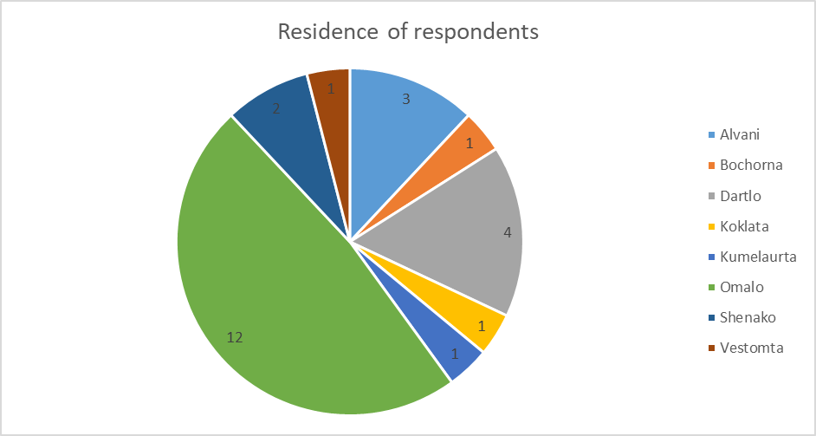
- Gender of the respondent.
n=24
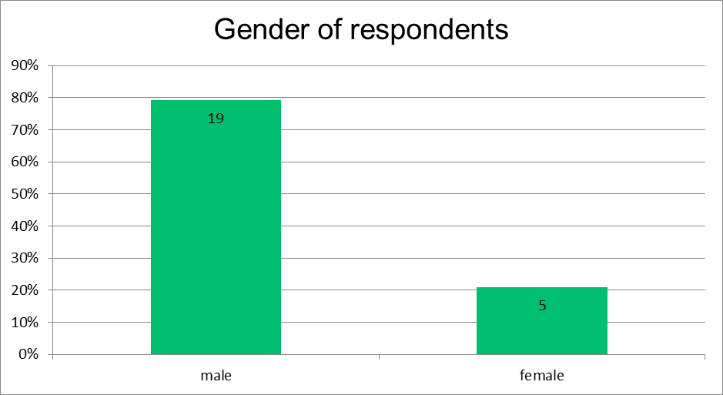

- What is your age group?
n=26
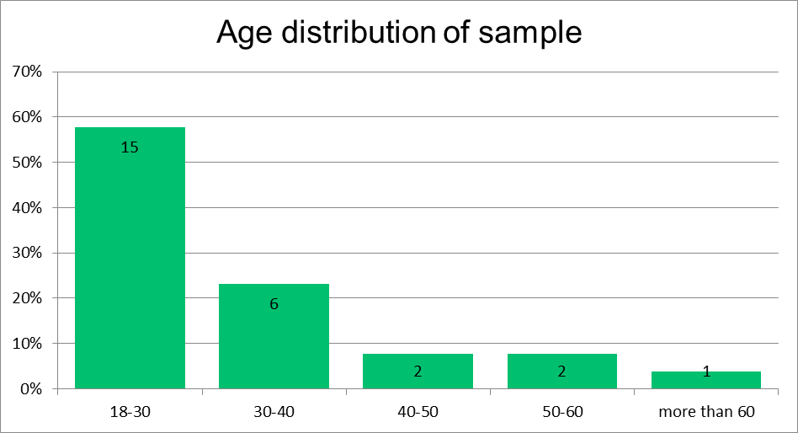

- Which services do you provide to tourists?
n=26, multiple answers enabled
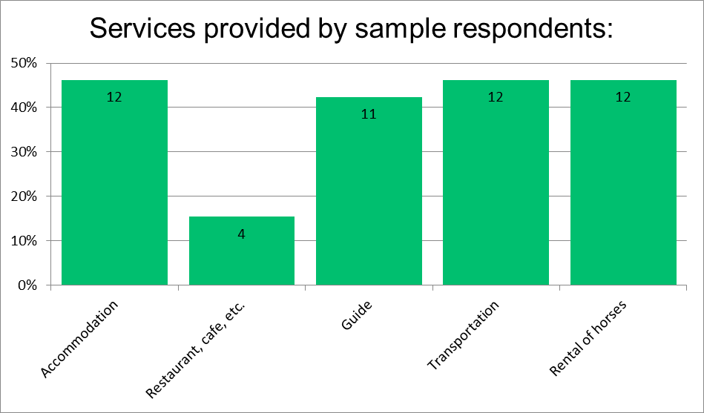

- How long have you provided these services?
Length of operation in years is shown in the following histogram (n=26)
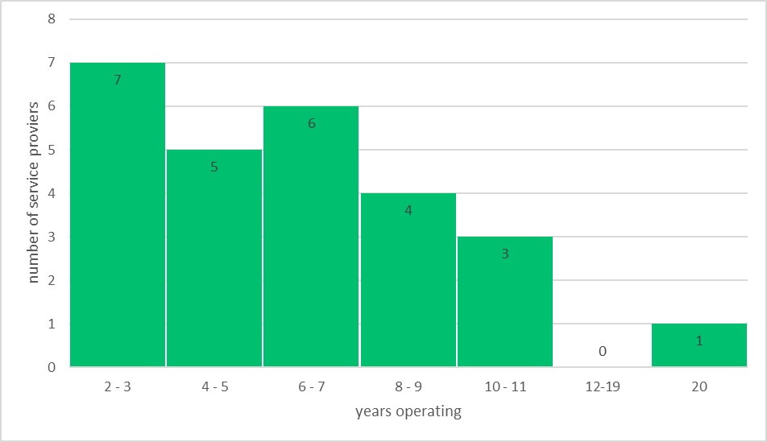

- Please estimate, how did key indicators of your business change since 2013 (or since the first year when you started your business, if it was later than 2013). Please select the response that you find the most appropriate.
We stress here again, that we ARE NOT INTERESTED in absolute values, we would only like you to share the trend with us.
n=26
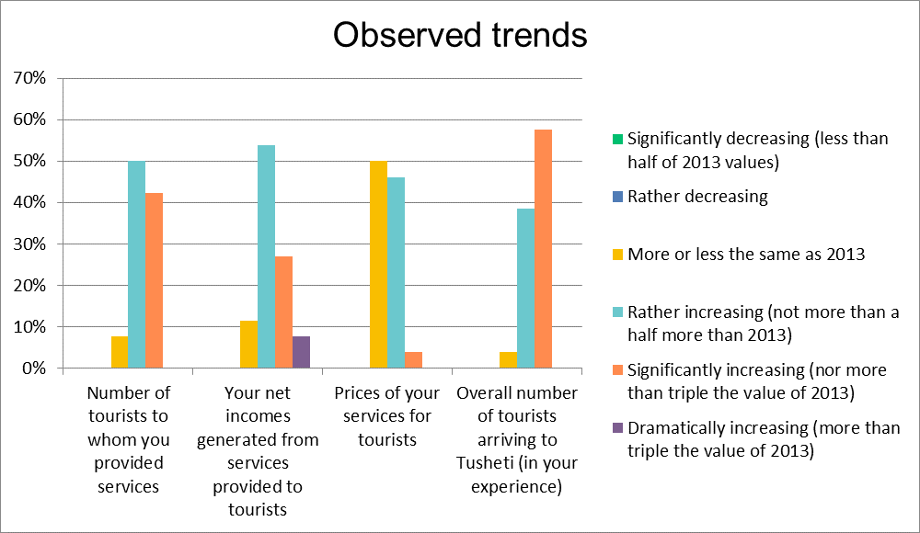

- Please try to compare, what was the share of your net incomes (in %) from providing services to tourists on the overall yearly net incomes of your family in 2013 (or in the year when you started providing the services, if later than 2013) and toady (2017):
n=23
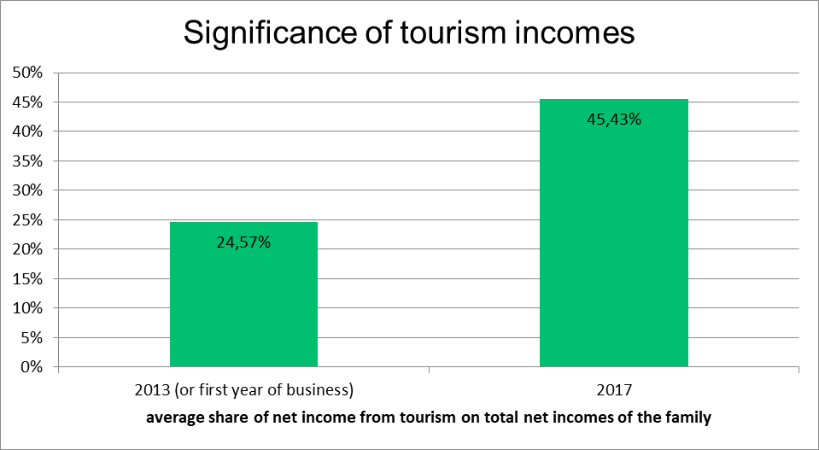
On average, the share of net incomes from tourism on total incomes of the respondents’ families has almost doubled (1.85 x) between 2013 (or the year when the business if later than 2013) and 2017.
The figure is, however, distorted by the presence of respondents who already registered a high share of net income from tourism in 2013. Naturally, if all revenues of a family came from tourism-related services in 2013 already, the share could not be higher in 2017 (although absolute values of this net income most likely did increase significantly, see question no. 6).
Therefore an analysis of a sub-sample of respondents whose net incomes from tourism-related services in 2013 was less than 50 % of all net incomes of the family was realized:
n = 20
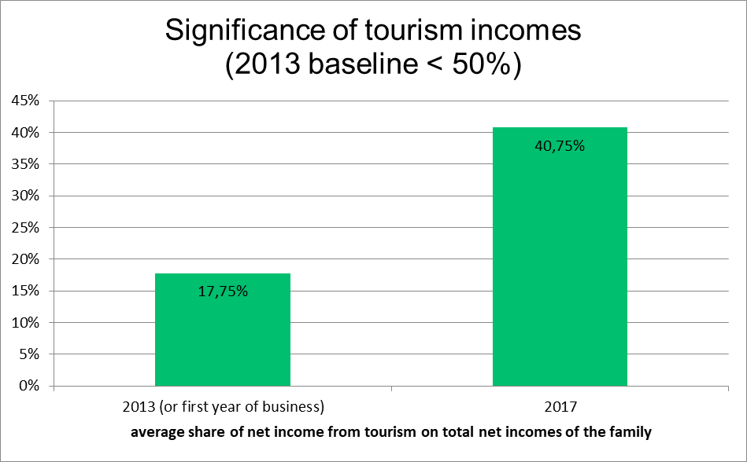
If this sub-sample is analysed separately, its share of tourism-related incomes has multiplied, on average, by 2.3.

- Did the quality of life of your family increase in direct effect of tourism in Tusheti since 2013?

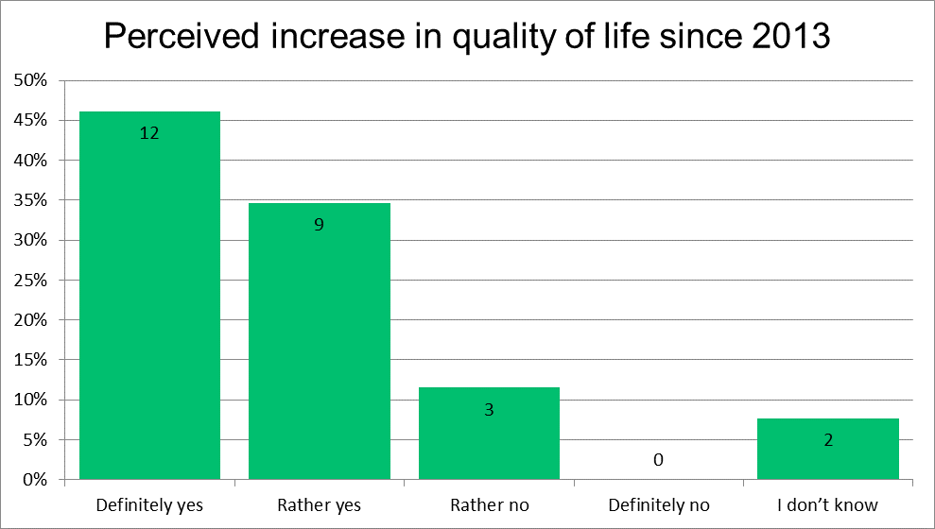

Characteristics of respondents who do not observe an increase in quality of life:
 | Residence | Age | Gender | Provided services | Follow-up answer, explanation
Respondent 1 | Dartlo | 30-40 | male | Transportation | Observes some negative impacts of tourism – waste, “chaos”; insufficient infrastructure is the largest barrier to development of tourism
Respondent 2 | Omalo | 18-30 | N/A | Guide
Respondent 3 | N/A | > 60 | N/A | Accommodation  Catering | insufficient infrastructure is the largest barrier to development of tourism (dangerous road)
No clear trends are observed, negative responses are therefore random.

- What are, in your point of view, the reasons for the increase of tourism in Tusheti in the last 5 years?

Most frequently mentioned factors (n=22):
Factor | No. of respondents mentioning
Nature | 3
Traditions | 4
Development of services | 8
More information on Tusheti available, advertisement, higher awareness of the region, etc. | 16
New tourist attractions | 1
General trend of increase of tourists in Georgia | 2
Low prices | 1

- What is your approach towards the development of tourism in Tusheti?
N=26
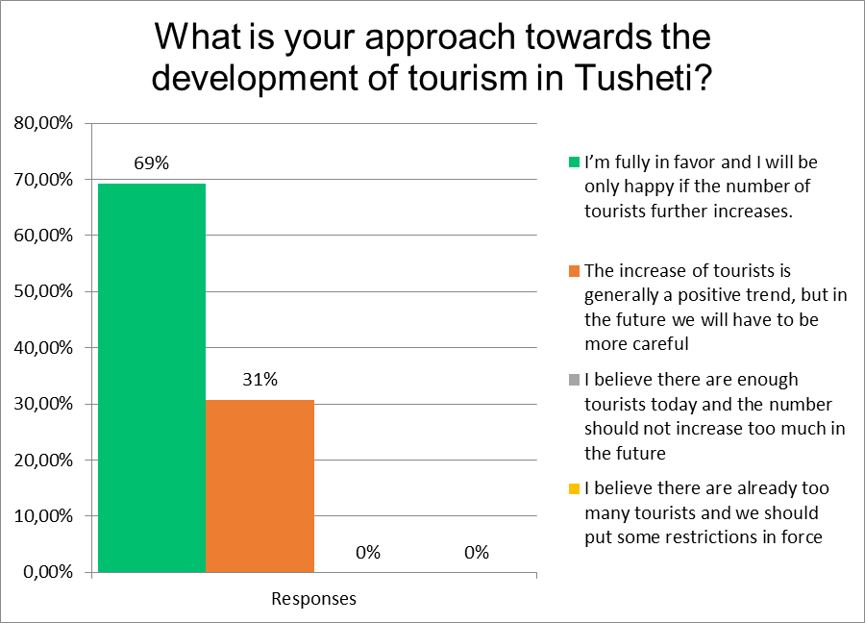

- Do you experience any negative impact of tourism in Tusheti?
n=26
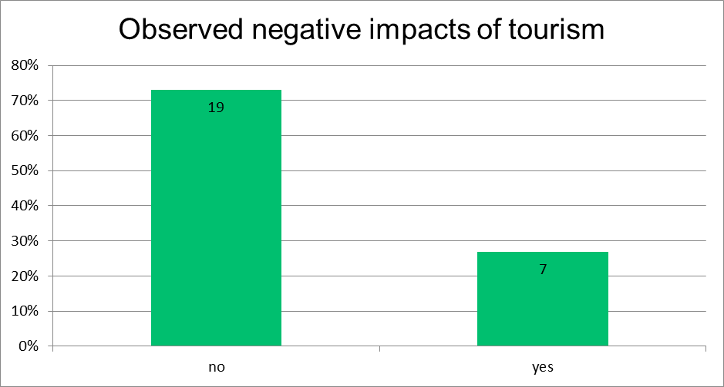
Most frequently mentioned negative impacts (n=7):
Negative impacts | No. of respondents mentioning
Waste | 2
Chaotic development in general, most significantly physical infrastructure | 2
Human interactions cooler | 2
Damages to traditional architecture | 1
Traditions endangered (shrines, pork meat, etc.) | 1
Not specified | 2

- What are, in your point of view, the most significant barriers to development of tourism in Tusheti?
n=24
Most frequently mentioned barriers (n=24):
Barrier | No. of respondents mentioning
Short season | 5
Accessibility of the region, poor quality of road | 17
Underdeveloped services for tourists (most importantly quality) | 3
Lacking technical infrastructure (sewage, water, energy, communications) | 5
Development limited to only few villages | 1
Missing attractions for tourists | 1
Governance-related issues | 3
Unclear, not specific | 1

Příloha č. 9: Výsledky sběru dat prostřednictvím MSC

For additional information, please contact: Giorgi Abulidze and Natia Gogotidze, representatives of Tusheti Development Fund

- XX-bakery, café owner, village Lower Omalo, 54 years old.

Changes she sees in her life:

- Her life is totally changed by 180 degree.
- When she came back from immigration, she already could see that work could be done in Georgia as well.
- She got the funding from “Enterprise in Georgia” and opened a traditional cuisine café and is planning to open a guesthouse as well.

Changes she sees in Tusheti:

- Tusheti became more known
- Water problem has been taken care of.
- Trash management system has started
- The number of Tourists has increased, but due to camping wherever they want the nature is becoming more trashy.
- Yearly festivals attract more tourists that is good for her business too.
- Youth are more interested in Tusheti and they are coming back, started to become guides, bought horses and cattle, the source of income has increased.
- There are more workshops for children, there is a person who teaches English to kids voluntary and there are more activities for them not to be bored.
- People started to come back to Tusheti and stay longer.

- XX, 38 years old, driver

Changes he sees in his life
- There are more working places and he doesn’t have to go abroad to work and he works in Tusheti
- The source of income has increased
- Due to increased number of tourists he is thinking of opening the guesthouse

Changes he sees in Tusheti:

- There is less illegal hunting or fishing and the nature is more biodiverse.

- XX, entrepreneur, 23 years old, Village Shenako:

Changes that had happened in his life:
- Internet project - that gave him access to the world, communication has developed and got easier, now he can work from Tusheti and it gave him a possibility to come back.
- There are more working places for young people, for instance he got involved with Tusheti Special planning by studio 21 and now he works as an architect-coordinator for the projects.
- In general entrepreneurs are more supported and encouraged. He started a startup selling Tushetian traditional herbal tea.

General Changes he sees in Tusheti:

- Community is more involved in the decision making-process.
- Residents obey rules and do not do illegal cutting of the trees or hunting, due to this fact it is more biodiversity now.
- General level of life has increased-Mobile network, electricity.
- The road is more damaged.
- There is more misunderstanding between Tsova Tushi and Chaghma Tushi.
- There are more working places for people and youth.
- Tusheti became more known and famous.

- XX, Visitors Specialist at TPA and Guesthouse owner, village Khakhabo, 30 years old

Changes that had happened in his life:
- Became employed and started working at the protected areas of Tusheti.
- The source of income has increased and became involved with Tourism.
- Helps out local business owners for the tourism development and gives tips to visitors.
- Opened a guesthouse in Khakhabo and is thinking to widen his business.
- He even gave up his work because of Tusheti (he worked in a wine cellar before).

General Changes he sees in Tusheti:

- There are more working opportunities for young people.
- Tourism and agriculture is more developed.
- People are more economically stable than before.
- Eco-Tourism is developing.
- In general, Tourism has changed Tusheti, the landscape is not as it was before.
- The service is increased and production has grown.
- Infrastructure has changed including touristic trails.
- There is no trash management.
- The number of tourists are increasing but there is not enough infrastructure for them, for instance camping places, people camp wherever they want and due to this fact the ecosystem is damaged.
But in general he thinks that there are more pros than cons, even with unsuccessful cases he started thinking how to solve the problems.

- XX, resident of village Dochu, 25 years old

- Her life became more comfortable and got easier.
- Her village Dochu is not that changed, she goes there for a shorter period of time, the village is not taken care of, tourism is less developed.
- Central villages are more developed, for instance village Omalo is a totally different places from Omalo, the infrastructure is changed, there are more tourists, communication is easier and life is very easy.
- Tusheti became more known than it was before.
- She thinks that changes that had happened in Omalo is an example of negative changes in Tusheti, but more peripheral village Dochu is not changed.

- XX, village Dartlo, Ranger, 29

Changes in her life:
- Her life became easier and became more comfortable.
- Her income increased, started working as a ranger and because of tourism her income increased more, she opened a guesthouse.
- She is making handicrafts and sells.

Changes in Tusheti:

- Tusheti is more developed, the level of life has increased and it is more economically stable.
- Tourism and agriculture is more developed.
- People started to come back to Tusheti and everyone is doing something.
- The number of guesthouses are increasing yearly.
- There are more working places for youth: tourism, driving opportunities, building the villages.
- There is less illegal hunting or wood cutting.
- The mentality and awareness of the people changed.

- XX, resident of Dochu, 42 years old.

- Nothing has changed in her life in Tusheti.
- Generally she thinks that tourism is developed, but more in other villages.
- Tusheti became more modern, there is internet.
- People from Omalo are more changed, people are not together anymore and do everything on their own.
- Regarding to Dochu, almost no tourist stays here and they only pass by.
- The only thing that has changed is her husband’s business, he is a shepherd and he has to pay higher fees for pastures.

- XX, guide, 27 years old.

Changes in his life:

- He was unemployed 8 years ago, the only thing he could do is go to work in the cattle or sheep farms.
- Now he works with tourists and his life is more interesting due to the fact that he meets people from all parts of the world and he learns a lot from them, gets to know new cultures and people in general.
- When he started working as a guide, he had to move from village Koklata to Omalo, to the center, in order to have access to more job opportunities.
- He does all kinds of tours, walking tours, horse tours and he helps them out to plan, find accommodation and etc.
- He uses different websites to attract the tourist and uses Instagram to popularize Tusheti.
- Now, it is much easier regarding to transportation, certain years ago there was no road going to the villages and now there is a car road going to his village and people starting to go back to their villages.
- His means of transportation changed-from horse to car rides.

General changes in Tusheti:

- The mentality of people changed.
- The number of guesthouses increased and now people have more source of income.
- Even locals are changed, they care about only money and the relationship between people got colder.
- Tusheti became a place to get money, not to rest or go vacation.

In general, he thinks that the changes are positive and he likes the way Tusheti is developing and he hopes it will be developed more and good enough so the general looks will not be changed.

- XX, village Bochorna, 47 years old

- The life in Bochorna is just changing, there are no guesthouses right now, but became a touristic place as it is the highest settlement in Europe and more people are coming to visit and there is much potential of tourists here.
- In general her life has not changed, but if she considers changes in Tusheti, the economic situation of the residents have improved.
- The number of tourists increased.
- There is no more illegal cutting, she remembers how people were coming from Kakheti, cut the trees illegally, whatever they wanted, they would take it back to Kakheti and sell there. Now they need special permissions.
- The style of buildings have changed, building houses with regular blocks and not traditional „sipi“ stones damages the general looks of Tusheti.
- Her children now have a source of income, as they started working as a guides and young people started to go back to Tusheti
- Now more people are going for a vacation.

- XX, resident, 22 years old, village Kvavlo

- During the last 8 years, he sees that more diverse people are coming up in the mountains. In old times, there were more local people coming for the vacation and now basic residents are the owners of the guesthouses and tourists.
- There were many local people in the village, living for the vacation. At nights they were making bonfires and there were several fires and several circles around the fires, now there are not enough people to have even one circle.
- His life became more comfortable, there was not electricity, water, internet and now he has everything.

- XX, guide, 25 years old

- He saw that there is a perspective in tourism.
- Tusheti has a future of tourism.
- He started to think about it and set his goals and he wants to create his own business in Tusheti.
- He became a guide and started to work with tourists. He got involved more in tourism.
- His family is running a sheep farm business and he sees that the demand on the products is increased, he got involved more in family business.
- People started to look at Tusheti in different ways, now they see it as a business place.

- XX, cheese making, Cooperative Alaznistavi, 54 years old

- Not many things have changed, I decided to become a sheep and a cattle owner as I saw a potential in it.
- I started to make cheese with traditional ways, almost no one is making cheese this way.
- The biggest change he can see that the number of tourists are increasing.
- The economic situation of the people became more stable and now they have more source of income.
- People became more integrated to the world.
- It is a threat of mass tourism.
- Over-grazing of the territories is also a big problem, it is not well controlled.

- XX, engineer, village Chala, 54 years old

- His life in Tusheti has changed in a way that it got easier to live and to have access to different sources of information.
- He can work from Tusheti, check the emails and communicate with others through different means of contact: telephone, internet and etc.
- As an engineer, he thinks that the general looks of the villages has changed, it is not as used to be.
- He was supervising the Dartlo Rehabilitation project in order so the village would have its own authentic look.
- He promotes that others should also use the old technique of building the houses with traditional stones and roofs and not that very modern styles and is happy that there is this requirement that at first the project should be confirmed and after that the house to be built.
- He mentioned that this increase of Tusheti development is caused by the increase of tourists in the area.

- XX, village Vestomta, shepherd, 60 years old

- There are not many things changed in his and his family’s life, they are still doing the same work and it is still tough working conditions. However, in the past few years, they are trying to increase the number of sheep.
- In the meantime, they are trying to connect tourism and agriculture in their village Vestomta and developing agro tourism.
- He thinks that there are many changes in Tusheti in general, but the car road is still tough and nothing has changed at all.
- Main changes have happened in the central villages or the ones that are close to the road, the situation in peripheral villages is the same or getting worse.
- He assess the steps taken in the field of producing Tushetian Guda cheese positively and thinks that it will bring more income, besides he thinks that those changes affected Tusheti and Tushetian people in general, however the life of cattle and sheep owners (especially the ones who live in a peripheral villages still have to work very hard due to harsh working conditions.
- He thinks that it is easier to get information and education is more accessible in Tusheti.

- XX, shepherd, 54 years old, Vakisdziri

- He cannot see any big changes, he is still doing the same work that he was doing before.
- Regarding to his village Vakisdziri, many changes have happened, now there is a car road available going to village, they have an access to internet and have installed the solar panels.
- Tourism became more demandable and he sees the perspective of agro tourism.
- The development of road made the life of Vakisdziri people a way easier. However the main Tusheti road is still not very good, there are more cars going and the number of accidents are increasing because of having no control on the road.
- There is no waste management in peripheral villages and villages are more polluted.

- XX, accountant, 29 years old, village Koklata

- Many infrastructural and life changes supported and developed the level of people’s live.
- The management of civil engineering materials got easier and there is a better management of using resources.
- Local people are more interested in entrepreneurship in Tusheti, in the fields of Tourism and agriculture.
- There are many negative changes on Tusheti road, the number of accidents are growing.
- The changes that had happened in Tusheti in the past few years affected my and my family’s life in a positive way, for instance: internet project, subsidized helicopter flights, ambulance and the service of emergency is more effective.

- XX, Farmer, 80 years old, village Diklo

- Tourism is now more developed in Tusheti and there is more demand on local products, now we can sell the products in Tusheti as well, for instance dairy products and handmade crafts.
- Production is increasing and the customers are also increasing yearly.
- The changes that has happened in Tusheti, affected people at first, as they are shifting from agriculture to tourism.
- In whole Tusheti, I can see negative architectural changes that damage the old look of the villages.
- Local people are leaving Tusheti and because of this many houses are destroyed.
- Using the wood became more difficult because of the new regulations.

- XX, the guesthouse owner, 51 years old. Village Koklata

- There has been many changes in Tusheti, but in general I can assess it as positive as a whole. The economic changes have also directly affected Alvani.
- There are many changes regarding to youth, they are more interested in getting education and studying foreign languages.
- Young people prefer to work in the fields of Tourism.
- The increased number of tourists can also be a problem, as there is a big problem of trash and also there is no enough necessary infrastructure, (trash cans, toilets) the internal road is still bad.
- In the last few years, local people have received a lot of funds from international donors that is a very good change.
- There has not been many changes in the peripheral villages.

- XX, horse owner, 27 years old
- He used to work at sheep farms, now he shifted to Tourism that has significantly increased his income.
- People “lost” their cultural and mental authenticity, now they are only thinking about earning the money.
- People now know how to take care of trash and there is a better waste management and less pollution.
- There are significant changes in the central villages and almost no changes in peripheral villages.
- In the last years, in Tusheti there are more positive changes that has changed the life of Tushetian people in a good way.

- XX, farmer, Shenako, 39 years old

- There have been many changes in Tusheti people that affected local people in a positive way, now they have free electricity, water and etc.
- Getting a loan from the banks got easier, that lead him and some other farmers to bankruptcy.
- People are leaving Tusheti and the remaining people who stayed here are changing.
- He likes the development of Tourism and thinking of opening a tourist spot himself in the future.
- There are more technological changes and locals got used to it easily.
- Everything gets more and more expensive in Tusheti due to high costs of transportation.

Assessment and systematization of stories elaborated in separate document – Excel sheet attached as Attachment 9a.

Příloha č. 11: Dodatečné texty

Předpoklady a rizika hodnocených projektů

Následující kapitola představuje klíčové předpoklady a rizika tak, jak jsou definovány v dokumentacích jednotlivých projektů.
Mezi předpoklady a rizika realizace projektů realizátor uvádí především následující:
- Koordinace a řízení projektu zajišťující efektivní spolupráci mezi českou a gruzínskou stranou
- Stabilní politicko-ekonomická situace
- Fyzická dostupnost území
Dále jsou zmiňována následující rizika:
- Jazyková bariéra (nutnost tlumočení – nedostatečná komunikační znalost angličtiny u partnera)
- Obtížné dosahování koncensu u místních obyvatel
- Personální nestabilita klíčových orgánů státní správy
- Nízká finanční kapacita Správy CHKO Tušsko i orgánů státní správy (APA – Agency for Protected Areas)
- Nedostatek zkušených odborníků a odborných konzultací
- Částečná závislost realizace projektu na národních systémech a metodikách, které vykazují nestabilitu, resp. není jasný jejich status quo (např. národní systém značení turistických cest) a nutnost schválit Plán péče na národní úrovni
Obecnější rizika spojená s implementací projektů:
- Zvýšení návštěvnosti regionu a s tím spojené negativní dopady
- Chybějící koordinace na národní úrovni
- Místní obyvatelé nebudou pružně reagovat na zvýšení návštěvnosti regionů rozvojem odpovídajících služeb
- Nedostatečné personální, odborné a finanční kapacity pro samostatné fungování CHKO
- Potenciální konflikty mezi různými zájmovými skupinami o strategickém směřování regionu

Výše uvedené předpoklady nebo rizika, které byly obdobně formulovány také při individuálních rozhovorech, vycházejí z místního kontextu, který lze utřídit do několika okruhů:
- Existence několika územních jednotek, které jsou předmětem ochrany v regionu.
Jak bylo výše uvedeno, v Tušsku existuje několik územních jednotek, které jsou předmětem různého stupně ochrany. Při realizaci hodnocení je nutné mít tento specifický kontext na zřeteli. V Tušsku existují následující chráněná území:
- Národní park Tušsko (rozloha cca 70 tis. ha)
- Chráněná krajinná oblast Tušsko (Tusheti Protected Landscape, rozloha cca 32 tis. ha)
- Přírodní rezervace Tušsko (Tusheti State Nature Reserve, rozloha cca 13 tis. ha).
Mimo různé stupně ochrany je další komplikací skutečnost, že administrativa jednotlivých zón je výrazně odlišná. Správu Tušského národního parku a Přírodní rezervace zajišťuje centrální organizace, Agency for Protected Areas (APA), která je přímo podřízena Ministerstvu ochrany životního prostředí a zemědělství Gruzie (MEPA). Naopak, správa CHKO Tušsko je svěřena instituci Tusheti Protected Landscape Administration (TPLA), která je zřízena lokální administrativou, tedy municipalitou Akhmeta, do jejíhož území region Tušska spadá. Specifické rozdělení zodpovědností mezi tyto instituce – a zprostředkovaně tak mezi centrální správu a místní samosprávu – je významným faktorem realizace projektů a bude nutné jej zohlednit také při evaluaci.
- Rozmanitost aktérů zainteresovaných do ochrany přírodního a kulturního dědictví v regionu Tušska.
S ohledem na výše uvedené je nutné zohlednit skutečnost, že do iniciativ na ochranu přírodního a kulturního dědictví je na různých úrovních zapojena řada dalších subjektů. Mimo zmíněné orgány státní správy a místní samosprávy se jedná především o:
- Mezinárodní organizace v sektoru ochrany přírody a managementu chráněných oblastí. Jde především o Mezinárodní unii pro ochranu přírody (IUCN – International Union for Conservation of Nature), která je mezinárodní autoritou v oblasti ochrany přírodního bohatství a sdružuje 1300 členských organizací zainteresovaných v této oblasti (veřejné instituce, soukromí i nestátní aktéři). IUCN má kancelář v Gruzii, tzv. Caucasus Cooperation Center a je výrazně angažovaná v oblasti managementu chráněných území v Gruzii
- Mezinárodní donoři, kteří se angažují v této oblasti. Jde především o:
  - GIZ, která je výrazně zainteresovaná v podpoře Národního parku Tušsko
  - U.S. Department of the Interior – International Technical Assistance Program (ITAP), který rovněž poskytoval podporu pro rozvoj managementu přírodního a kulturního dědictví (v Gruzii ovšem byl program ITAP již ukončen)
  - Evropská unie, která se v dané problematice angažuje především v rámci svého programu „Forest Law Enforcement and Governance“ – FLEG, resp. FLEG II, který byl implementován v období 2013 – 2016. Programu FLEG (II) se v Gruzii účastnila také Rakouská rozvojová agentura.
- NNO v oblasti ochrany přírody – relevantní v této oblasti je například organizace „Centre for Biodiversity Research & Conservation“ (NACRES)
Tato rozmanitost aktérů, kteří jsou nějakým způsobem zainteresováni do podpory a rozvoje ochrany přírodního a kulturního dědictví v Tušsku bude nutné v rámci evaluace zohlednit.
- Potenciální nesoulad mezi know-how realizátora projektů a normami/legislativou v cílové zemi.
S ohledem na výše uvedené angažování nejrůznějších veřejných i dalších aktérů v oblasti podpory systému ochrany přírody v Gruzii může být relativně problematické bezprostřední přenesení českého know-how a zkušeností v oblasti plánů péče o chráněná území. Zapojení Gruzie do mezinárodních projektů v této oblasti mohlo vytvořit legislativní a normativní systém ochrany životního prostředí, který není kompatibilní se systémem v ČR, resp. EU. V rámci evaluace bude proto velmi důležité zohlednit tento kontext při vyhodnocování efektivnosti realizovaných aktivit.
Nad rámec těchto předpokladů / rizik vnímá hodnotitel jako zcela zásadní otázku dostatečné kapacity Správy CHKO, která je nezbytnou podmínkou pro udržitelnost výsledků projektu a jejich další rozvoj. Správa by měla být, po ukončení realizace projektu, schopna samostatně implementovat opatření Plánu péče, resp. získávat další externí zdroje pro jeho naplňování. V dohledné době navíc bude muset být zahájen proces aktualizace Plánu péče, poněvadž ten byl schválen pouze na šestiletou periodu. Proces aktualizace bude vypovídajícím „testem“ kapacity lokálního managementu, a tedy udržitelnosti jako takové. Zároveň významně hrozí riziko, že aktualizace povede ke snížení detailnosti a relevance Plánu péče.
Další významnou složkou udržitelnosti projektů (resp. ohrožením této udržitelnosti) je míra zapojení místní komunity do řízení CHKO a její schopnost dosahovat koncensu. Různí aktéři v území mohou mít protichůdné zájmy, přičemž lze předpokládat především narůstající význam a sílu zájmů podnikatelů poskytujících služby návštěvníkům regionu. V případě, že nebude dosaženo koncensu ve smyslu rovnováhy mezi ekonomickými zájmy a potřebami ochrany přírodních a kulturně-historických hodnot území, hrozí, že budoucí generace Plánů péče bude pouze formálním a příliš obecným dokumentem, který nebude mít schopnost skutečného dlouhodobého řízení udržitelného rozvoje Tušska.

Podrobná informace o řešiteli evaluace

Řešitelem evaluace je společnost HaskoningDHV Czech Republic, spol. s r.o. Tato společnost má bohaté zkušenosti s přípravou, hodnocením a implementací rozvojových programů a projektů v ČR i v zahraničí. Realizované projekty tematicky pokrývají celou řadu konkrétních oblastí, jakými jsou metodické přístupy k implementaci strukturálních fondů EU, integrace nadřízených dokumentů (Nařízení rady, Working Papers apod.), realizace technické pomoci, finanční a procesní řízení, příprava projektů, práce s monitorovacími indikátory, hodnocení výkonnosti programů apod. Společnost se účastní také projektů zahraniční rozvojové spolupráce financovaných ze zdrojů ČR i zahraničních donorů (USAID, EBRD, atd.), a to na pozici realizátorů projektů i hodnotitelů, a to především na Ukrajině, Moldavsku a také v Gruzii, Bosně a Hercegovině a dalších státech. Právě v Moldavsku, Gruzii, Bosně a Hercegovině, Etiopii nebo Libanonu řešitel v minulých letech realizoval velmi obdobné evaluace, a sice sektorové evaluace projektů ZRS ČR, resp. humanitární pomoci ČR v různých sektorech.
Evaluace je realizována v úzké spolupráci s významným lokálním aktérem, organizací Tusheti Development Fund (TDF). Pracovníci TDF pocházejí z tušské komunity, zároveň ale spolupracují s řadou mezinárodních i národních donorů na rozvojových projektech ve prospěch tušského regionu (např. rozvoj turistického ruchu, pokrývání území Tušska připojením k internetu, obnova a zachování kulturních tradic, atd.). Mají tedy dokonalou znalost místního prostředí a prostřednictvím svých rodinných vazeb a „zakořeněnosti“ v regionu vytvořené neformální sítě napříč celým Tušskem (včetně Tušů, pobývajících aktuálně v údolí), zároveň ale také vnímají mezinárodní rozvojový kontext a mají zkušenost s praxí monitoringu a evaluace. Cílem organizace je facilitovat socio-ekonomický a environmentální rozvoj Tušska a zlepšovat kvalitu života tušských komunit.
Dnes je TDF uznávaným partnerem pro aktéry působící v oblasti rozvojových politik a ochrany životního prostředí na národní i mezinárodní úrovni a funguje jako přední komunitně založený a vedený reprezentant tušské komunity.
Evaluační tým tvoří:
- Lukáš Maláč, hlavní evaluátor a vedoucí evaluačního týmu: Hlavním evaluátorem a metodikem projektu je Lukáš Maláč na základě svých zkušeností v oblasti evaluace veřejných politik a/nebo procesů strategického řízení regionů. V pozici vedoucího projektů je zapojen do realizace řady projektů zaměřených na regionální rozvoj, a to jak v ČR, tak i v zahraničí. Pozici hlavního evaluátora a vedoucího týmu zastával také v projektech komplexního hodnocení ZRS ČR v Moldavsku, Gruzii, Etiopii a Bosně a Hercegovině a humanitárních projektů ČR v Libanonu, má tedy dobré znalosti kontextu rozvojové pomoci. Mimo zkušeností s navrhováním a implementací obecného metodologického designu evaluace má Lukáš Maláč zkušenosti rovněž s realizací vlastního terénního šetření a praktickým užíváním evaluačních metod, jako např. dotazníkových šetření, fokusních skupin a (polo)strukturovaných rozhovorů, vedených v bezprostředním kontaktu i telefonicky.
- Juraj Švajda, specialista pro oblast managementu chráněných území: je předním odborníkem na oblast managementu chráněných druhů a území, vlivu turismu, ekosystémových služeb a humánní dimenzi v managementu přírodních zdrojů. Má mnohaletou akademickou i profesionální praxi v této oblasti v kontextu vysokohorské přírody. Disponuje navíc významnou zkušeností v oblasti hodnocení plánů péče a jejich implementace, dopadů turistického ruchu na chráněná území a obecněji monitoringu a řízení návštěvnosti v kontextu vysoce chráněných vysokohorských oblastí. V pozicích člena realizačního týmu se podílel na monitoringu, hodnocení a managementu návštěvnosti v chráněných územích v USA, Slovensku a Polsku (Vysoké Tatry) nebo v Norsku. Je autorem řady učebnic a odborných textů v oblasti managementu chráněných území a tuto problematiku také vyučuje na VŠ. Podílel se také na hodnocení národních parků a jejich efektivity v ČR a SR dle metodiky World Wide Fund for Nature (WWF) Rapid Assessment and prioritization of protected area management (RAPPAM) nebo v hodnotících týmech International Union for Conservation of Nature (IUCN). Podílel se na formulaci plánu péče pro Tatranský národní park.
- Giorgi Abulidze, lokální expert – junior: spolupracovník lokálního partnera evaluace, Tusheti Development Fund, který přímo působí v tušské komunitě a realizuje rozvojové projekty. Mimoto působí také jako tour operátor v tušském regionu, má tedy hluboký vhled do problematiky rozvoje turistického ruchu, jeho potenciálu i rizik a poptávky po regionu jako turistické destinaci.

Podrobná analýza souladu projektů s prioritami strategických dokumentů ZRS ČR, dotčené partnerské země a příslušných globálních cílů (SDG
Strategie rozvoje venkovských oblastí Gruzie pro období 2017-2020 se specificky věnuje problematice vysokohorských oblastí, mezi jejichž klíčovými problémy vyjmenovává především nízkou ekonomickou diverzifikaci (závislost na zemědělství, které je velmi neefektivní) a vylidňování, zejména potom odchod mladých lidí z důvodu nedostatku příležitostí. Mezi klíčovými opatřeními pro rozvoj těchto vysokohorských oblastí proto udává podporu rozvoje (udržitelného) cestovního ruchu, který je zásadně důležitý pro rozvoj venkova. Tomu odpovídá také strategická část dokumentu, která formuluje tři prioritní oblasti a tři cíle pro každou z nich. V prioritní oblasti „ekonomika a konkurenceschopnost“ je jedním z cílů (cíl 3) „Rozvoj cestovního ruchu ve venkovských oblastech, založených na venkovských specificích a jedinečné kulturní identitě.“
Hodnocené intervence tedy postupují v souladu s touto Strategií, když se (mimo jiné) zaměřují na rozvoj udržitelného cestovního ruchu a považují jej za oblast, která umožní rozvíjet nové příležitosti, diverzifikovat místní ekonomiku a v konečném důsledku zvýšit životní úroveň obyvatel regionu a oslabit jeho vylidňování.
Klíčovým strategickým dokumentem v oblasti ochrany životního prostředí je především Národní akční program pro životní prostředí (NEAP) Gruzie. V období realizace iniciativ byla relevantní především jeho druhá generace, implementovaná v období 2012-2016.
Dokument uvádí, že zřizování chráněných území je nejdůležitějším nástrojem pro efektivní ochranu biodiverzity. Nad rámec toho mají zřízená chráněná území vysokou hodnotu v oblasti vědeckého výzkumu a v socio-ekonomické oblasti, především potom pro rozvoj vnitrostátního a mezinárodního cestovního ruchu. NEAP tedy, podobně jako hodnocené iniciativy, propojuje význam chráněných území nejen pro ochranu a zachování životního prostředí, ale také jako nástroje pro rozvoj cestovního ruchu, který umožňuje socio-ekonomickou stabilitu území.
NEAP dále uvádí, že nejzásadnějšími problémy v rozvoji chráněných území jsou především chybějící nebo nedostatečné Plány péče a nedostatek kvalifikovaných lidských zdrojů.
Ve své strategické části proto formuluje 5 cílů, mezi kterými uvádí:
- Cíl 3: Rozvoj jednotné a efektivní sítě chráněných území
- Cíl 4: Zvýšení efektivity managementu chráněných území prostřednictvím budování kapacit jejich administrativ (…)
- Cíle 5: Sestavení řádných databází pro ochranu biodiverzity a udržitelné řízení přírodních zdrojů prostřednictvím rozvoje relevantního monitoringu
Jednotlivé cíle jsou dále rozpracovávány, přičemž především následující opatření jsou obzvláště relevantní pro hodnocené iniciativy:
- Opatření 3.2: Podpora socio-ekonomického rozvoje nárazníkových zón skrze implementaci rozvojových projektů;
- 4.2: Zpracovávat a schvalovat Plány péče pro existující a nová chráněná území;
- 4.3: Zlepšit využívání přírodních zdrojů v chráněných územích;
- 4.6: Posílit potenciál chráněných území v eko-turistice (mj. prostřednictvím rozvoje infrastruktury, marketingu, kvality nabízených služeb nebo rozvoje nových služeb);
- 4.7: Posílit kapacitu zaměstnanců chráněných území;
- 5.1 – 5.5: Opatření zaměřená na sběr dat ohledně monitoringu biodiverzity a jejich analýzu.
Je zřejmé, že všechny aktivity realizované v rámci podpořených iniciativ jsou plně v souladu s opatřeními NEAP. Zpracování Plánu péče pro TPL bezprostředně odpovídá na potřebu těchto řídících dokumentů formulovanou NEAP. Stejně také aktivity v oblasti monitoringu biodiverzity, rozvoje infrastruktury pro cestovní ruch a propagaci regionu odpovídají opatřením NEAP. Zcela v souladu s tímto dokumentem jsou také další iniciativy TPLA v oblasti řízení a regulace využívání přírodních zdrojů Tušska, implementované na základě zpracovaného Plánu péče.
Třetím klíčovým dokumentem pro daný sektor je Národní strategie a akční plán v oblasti diverzity 2014-2020 (NBSAP), který ve vysokém detailu rozpracovává konkrétní aktivity, které mají být implementovány na podporu rozvoje biodiverzity. Strategie se opět podrobně věnuje roli chráněných území pro rozvoj ochrany přírodních hodnot, přičemž mimo výše uvedeného doplňuje následující rozvojové potřeby:
- Rozvoj územních plánů chráněných oblastí;
- Využívání a rozvoj alternativních způsobů správy chráněných území, jako je co-management, správa prostřednictvím místních obyvatel a komunit, atd.;
- Posílit roli managementu nárazníkových/podpůrných zón;
- Zajistit plnou participaci stakeholderů, především místních komunit, na managementu chráněných území prostřednictvím přijímání efektivních mechanismů a regulací;
- Zajistit kvalifikovaný personál a profesní rozvoj zaměstnanců chráněných území.
Tyto i výše uvedené požadavky jsou zevrubně rozpracovávány v Akčním plánu dokumentu. Obzvláště relevantní jsou:
- Aktivity v opatření B.1-o2, zaměřené na jednoznačné rozdělení zodpovědností centrálních a místních entit ve vztahu k využívání přírodních zdrojů a jeho regulaci;
- Aktivity v opatření B.4-o2 (2.1), požadující realizaci pilotních projektů udržitelného managementu přírodních luk (pastvin) – tyto iniciativy jsou aktuálně naplňovány v Tušsku za podpory GIZ a jsou součástí Plánu péče TPL;
- Aktivity v opatření C.4-o5, které rozpracovávají problematiku posilování kapacity lidských zdrojů, požadují zpracovávání Plánů péče a především požadují posílit zapojení stakeholderů, především místních komunit, do managementu a plánování v chráněných územích;
- Aktivity v opatřeních E.1 a E.2, zaměřující se na rozvoj monitoringu biodiverzity, především potom prostřednictvím budování kapacit a znalostí na úrovni administrativy chráněných území i mimo ně.
Z výše uvedeného je jednoznačně patrné, že veškeré aktivity realizované v rámci hodnocených iniciativ byly plně v souladu s klíčovými strategickými dokumenty cílové země. Realizované iniciativy jsou rovněž v souladu především s následujícími Cíli udržitelného rozvoje OSN (SDG):
- 8: Důstojná práce a ekonomický růst (Cíl: „Podporovat trvalý, inkluzivní a udržitelný hospodářský růst, plnou a produktivní zaměstnanost a důstojnou práci pro všechny“)
  - 8.9: Do roku 2030 navrhnout a realizovat politiky podpory udržitelného cestovního ruchu, který vytváří pracovní místa a podporuje místní kulturu a produkty;
- 11: Udržitelná města a obce (Cíl: „Vytvořit inkluzivní, bezpečná, odolná a udržitelná města a obce“)
  - 11.4: Zlepšit úsilí na ochranu a záchranu světového kulturního a přírodního dědictví;
  - (zprostředkovaně) 11.a: Podporovat pozitivní ekonomické, sociální a environmentální vazby mezi městskými, příměstskými a venkovskými oblastmi zlepšením národního a regionálního rozvojového plánování;
- 15: Život na souši (Cíl: „Chránit, obnovovat a podporovat udržitelné využívání suchozemských ekosystémů, udržitelně hospodařit s lesy, potírat rozšiřování pouští, zastavit a následně zvrátit degradaci půdy a zastavit úbytek biodiverzity“)
  - 15.4: Do roku 2030 zajistit zachování horských ekosystémů, včetně jejich biodiverzity, aby se zvýšila jejich schopnost poskytovat výhody, které jsou nezbytné pro udržitelný rozvoj
  - 15.5: Přijmout neodkladná a výrazná opatření na snižování degradace přirozeného prostředí, zastavit ztrátu biodiverzity a do roku 2020 chránit a zabraňovat vyhynutí ohrožených druhů
  - (zprostředkovaně) 15.6: Přijmout neodkladná opatření ke skoncování s pytlačením a pašováním chráněných druhů rostlin a živočichů a řešit nabídku i poptávku po nelegálních přírodních produktech
  - 15.7: Do roku 2020 začlenit hodnoty ekosystému a biodiverzity do národního i regionálního plánování, rozvojových procesů a strategií na snižování chudoby
- 16: Mír, spravedlnost a silné instituce (Cíl: „Podporovat mírové a inkluzivní společnosti pro udržitelný rozvoj, zajistit všem přístup ke spravedlnosti a vytvořit efektivní, odpovědné a inkluzivní instituce na všech úrovních“)
  - 16.7: Zajistit odpovědné, inkluzivní, participační a zastupitelské rozhodování na všech úrovních
Na úrovni ZRS ČR byla Gruzie před rokem 2018 pouze projektovou zemí, nebyl tedy přijat dvoustranný program spolupráce, který by formuloval, jaké aktivity by měly být prioritně implementovány. Relevanci iniciativ v tomto smyslu lze proto posuzovat pouze na úrovni Koncepce ZRS na období 2010-2017. Hodnocené iniciativy byly v souladu se sektorovými prioritami této Koncepce, a to zejména prioritního sektoru Životní prostředí (udržitelné využívání přírodních zdrojů, ochrana biologické rozmanitosti) a Ekonomický rozvoj.
Od roku 2018 je v platnosti Program dvoustranné rozvojové spolupráce České republiky a Gruzie 2018-2023, který stanovuje následující cíle:
- Inkluzivní sociální rozvoj (SDG 1 a 3);
- Zemědělství a rozvoj venkova (SDG 2 a 15);
- Řádná demokratická správa věcí veřejných (SDG 6 a 13).
Iniciativy obou projektů jsou plně v souladu s cílem Zemědělství a rozvoj venkova. Tento cíl je zaměřen na udržitelný rozvoj horských regionů a mají být podporovány iniciativy vedoucí k ochraně horských ekosystémů a udržitelnému hospodaření (mimo jiné také ve vztahu k udržitelnému rozvoji turistiky a rozvoji místních komunit). V této souvislosti je explicitně formulován výstup 3.1: Zlepšení Plánů péče horských chráněných území. Tematicky tedy jsou evaluované iniciativy plně v souladu s novým Programem spolupráce. Geograficky se ovšem v následujícím období má program cílený na udržitelný rozvoj horských regionů a místních komunit koncentrovat v regionech Mtscheta/Mtianeti a Rača/Lečchumi, tedy mimo oblast Tušska (byť v případě regionu Mtscheta-Mtianeti jde o sousední region).

Příloha č. 12: Biodiverzita v Tušsku

Biodiversity of Tusheti Protected Areas
Tusheti flora is distinguished by its diversity, here are 1062 species of plants. Forest habitat of the protected ares is mostly represented by the Caucasian pine (Pinuskochyana). Pine forest is spread at 1700-2000 meters above sea level and its total area covers about 15000 hectares.
With evelation Pine forest is replaced by birch trees. There are birch forests at 1700-2400 meters above sea level, the most spread species are warty and Litvinov birch.(here are also crooked birch trees). Crooked forests mainly include Litvinov birch. But in some places there is alosRadde’s birch. The total area of broadleaf forests is not more than 1400 hecatares. Subalpine forests totally cover 6200 hectares. The upper lower zone of the forest spreads from 1650 meters to 1900 meters. Subalpine forests are represented from 1700 meters to 2600 meters.
Species from the “Red List” of Georgia
From Tusheti National Park 2 woody species are included in the “Red List” – Radde’s and black birch. 8 Herbaceous species (Allium otschiauriaeTscholokaschvili, Erysimumsubnivale Prima, FicariavariaOtschiauri, Galeopsis nana Otschiaur, Jurineaexuberans(Trautv.)Otschiauri, Rosa irysthonicaManden, TragopogonotschiauriiKuthatheladze) are assessed as nationally vulnerable categories.
Endemic species
The Park is distinguished by endemic plant species.
230 species of Tusheti National Park flora are the Caucasian endemic (more than 20% of the total number of the Cauacasian endemic), and 11 species are Georgian endemic. Form Georgian and local endemic species there are: Tushetian aconite, lily, Tushetianweetbrier, Tebulo buttercup and Tushetian skullcaps. And from the Caucasian endemic: Radde’s birch, rhododendron, Sosnovski pine, Litvinov birch, fritillaries, primrose and squill.
Fauna
In Tusheti Protected area fauna is represented in about 180 species. With unverified data in Tusheti there are: 60 species of mammals, about 120 – birds, 3-reptiles, 6-amphibian and one species of fish.
Weathered sloped of the Caucasus and inaccessible cliffs are the homeland of East Caucasian tur chamois and wild goat. The neighbor of Caucasian tur is Caucasian endemic – the Caucasian Snowcock, and in rhododendron shrubs and birch groves lives the Caucasian black grouse.
From large ungulates in Tusheti forests it is possible to meet roe and rearly deer. A boar regularly comes from the neighboring Dagestan.
Tusheti is rich in predators – fox and wil is met everywhere. Almost in the entire territoey there are: brown bear, lynx, hare, chamois and tur.
Tusheti is a diverse region in terms of ornithology. There are many birds of different size and different lifestyle. Tusheti inaccessible cliffs are the nesting place for huge birds- vultures, Bearded vultures and Golden eagles. In the National Park there are also a great number of: crossbill, several kinds of woodpeckers, red head finch, mountain Pipit and wallcreeper, partridge, mountain kestrel, buzzard and the fastest bird on the planet – falcon.
Tushetirivers are rich in trout.
There are three species of reptilies in Tusheti: Coronellaaustriaca, Vipera ursine, Laerta sp. And others, also there is one species of the green toad.
Species fom the “Red List” of Gerorgia
18 species (10 birds, 7 mammals and 1 fish) of Tusheti National Park fauna are included in the “Red List”. From mammals there are: European barbastelle, otter, brown bear, wild goat, tur, deer, aucasian grouse and Caucasian Snowcok. From rare species of birds are common: Imperial eagle, greater spotted eagle, lesser kestrel, corncrake, steppe eagle, black kite, vulture, field Montagu’s Harrier. There is only one species of fish on this territory – trout.
Endemic species
From endemic mammals in Tusheti can be found: Sorex raddei, Sorex volnuchini, Myotis daubentonii Chionomys gud, Chionomys roberti, Terricola majori, Terricola daghestanicus and others.
From endemic birds Caucasian grouse and Caucasian Snowcock are notable.

Gravity of recommendations: 1 – most important, 2 – important, 3 – less important

