Ministry of Foreign Affairs

of the Czech Republic

Department of human rights & Transition Promotion Policy

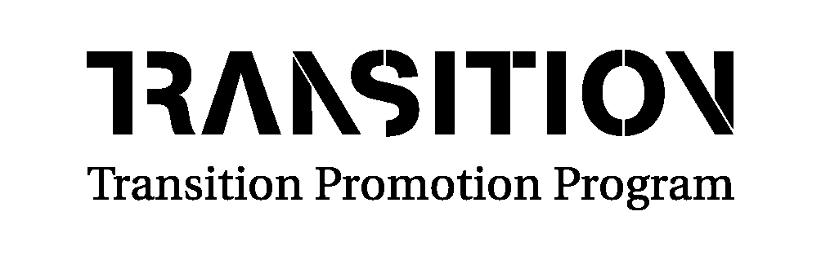

Program of Transformation Cooperation

2017

Project Title

Date of Realization

APPLICANT

1. General project information

Application Date
Project name
Area | Please indicate:  1) Promoting Critical Thinking and Media Literacy in Ukrainian Public  2) Advocacy, Advising and Implementation of Anti-corruption and Judicial Reform  3) Monitoring, Analysis and Advocacy of Human Rights in Crimea and/or Luhansk and Donetsk Oblasts
City and region in which the project will be located

2. Details of applying organization/applicants

Name | Both in Ukrainian and English
Address

Telephone
Fax
E-mail
Contact person | Name and position (title)of the person who have the right to sign the contract  Name and position (title) of the person who will be the contact person
Bank account number (TL) & Branch name and number
IBAN number
Account holder
Contact details of the bank | Address of the bank
Aims of organization | Background (history) information, activities, projects etc. (max 3 lines)
Former projects with this embassy | Name, main aim, project period, (use 1 line per project in bullets)
Personnel capacity | Employees, members, volunteers
Financial capacity of the organization (list income and expenditures of last 3 years) | Last three (3) years
3. Name other partner(s) in the project (if applicable)
Name of the partner organization(s)
Brief information about the partner organization(s) | Max 5 lines
Their role in this project | Max 5 lines
4. Summary of the project
Give a short description of the project including aim, project activities, and expected results in max. 10 lines.

5. Project description

Duration of the project
Starting date- Ending date
Problem description

Main aim of the project

Solution, Project activities (preferably in bullet points)

Expected results, Verification
Sustainability
Your Experience in the Field
Risk assessment

6. Budget

General overview of the budget (UAH) | Please breakdown in activity-results-aim (max. 10 lines)  The budget should clearly show what budget is needed to reach your objectives in a cost-effective way.
Other donor(s) contribution | If yes, please indicate who and when
Own contribution (money, material, work, etc.) (UAH)
Requested contribution from the Czech Republic (UAH)
Total budget | UAH
Total budget | CZK*
Please use also the provided Budget application form (excel sheet)

Attention! Applications have to be written in English. Filled form should not exceed 8 pages.
Please send your application forms to the following addresses: lucie_hanzlickova@mzv.cz and alina_cubko@mzv.cz.
Should you have any questions please send them in a written form to lucie_hanzlickova@mzv.cz and alina_cubko@mzv.cz (also in Ukrainian) no later than 4 days prior the deadline. The Embassy has a right not to provide clarifications to questions received after this date.

*The official exchange rate of the Ministry of Foreign Affairs of the Czech Republic for this month is 1UAH=0,937CZK. To get the correct amount in CZK please multiple the amount in UAH with 0,937.

