Profiles of the Speakers
Conference “Africa as a Partner”
Thursday, May 25, 2017, Ministry of Foreign Affairs of the Czech Republic

PANEL 1
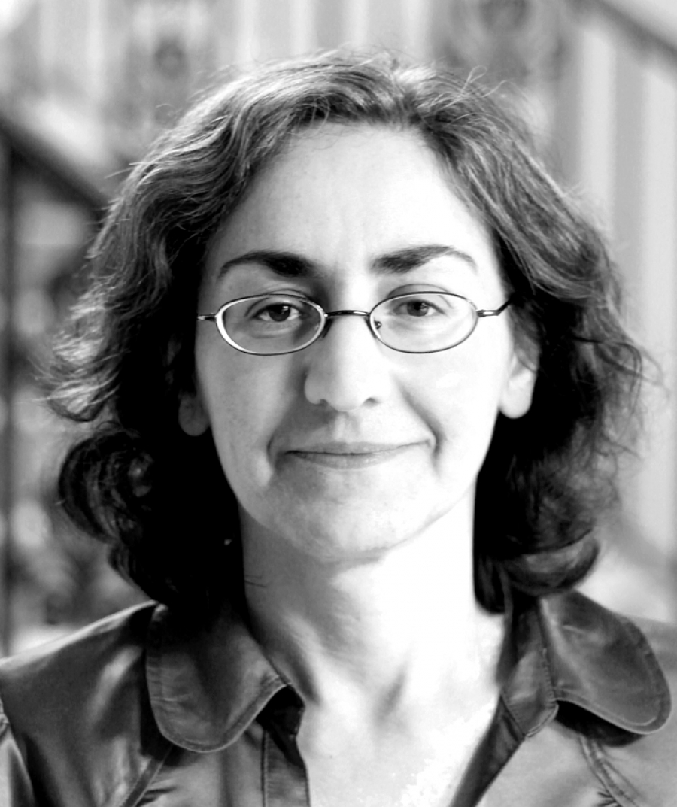Elizabeth Sidiropoulos (South Africa)
Since 2005, Elizabeth Sidiropoulos has been the chief executive of the South African Institute of International Affairs (SAIIA). From 1999 to April 2005, she served as Director of Studies at SAIIA. Previously, she worked as a research director at the South African Institute of Race Relations and as an editor of the South Africa Survey. She is editor-in-chief of the South African Journal of International Affairs.

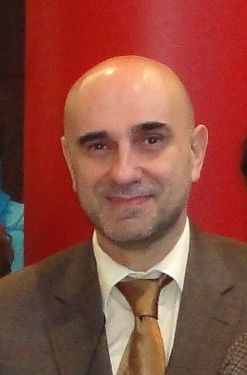 José Costa Pereira (EEAS)
José Costa Pereira is currently Adviser to the Managing Director Africa in the European External Action Service (EEAS). He is a national diplomat that after stints as Portuguese Consul-General in Sydney and Deputy Head of Mission in Tokyo and Washington worked as Head of the Task Force Africa in the EU Council secretariat and was Head of the Pan-African Division in the EEAS. In his national service he served also, at different periods, as Director for Human Rights, Director for Security and Defence Organisations and Director for Europe.

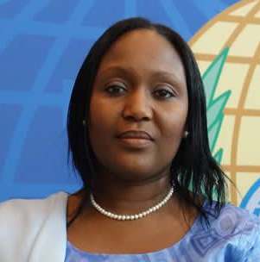Teneng Mba Jaiteh (The Gambia)
H.E. Ms Teneng Mba Jaiteh is accredited as the ambassador of The Gambia to the European Union and its seven member countries, including the Czech Republic. In addition, she serves also as The Gambia’s representative to several international organizations such as the African Caribbean Pacific Group, the International Criminal Court in The Hague, the Organization of Prohibition of Chemical Weapons, the World Custom Organization and the World Trade Organization. H.E. holds a BA in History and an MSc in Development Studies.

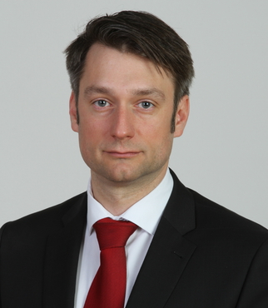Jakub Landovský (Czech Republic)
Since 2015 Jakub Landovský has been Deputy Minister and Head of the Defence Policy and Strategy Section at the Ministry of Defence. Previously, he served as Adviser to Chairman of the Foreign Affairs Committee of the Chamber of Deputies of the Czech Parliament or worked as a project coordinator of the “Water at the Middle East” project of the Forum 2000 Foundation. He has expertise in water resource conflicts and international law.

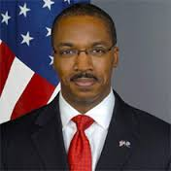Reuben E. Brigety II. (USA)
Since October 2015, Ambassador Reuben E. Brigety has been Dean of the Elliott School of International Affairs at George Washington University. Former representative of the US to the African Union and Permanent Representative of the US to the UN Economic Commission of Africa, Dr. Brigety also served as Deputy Assistant Secretary of State in the Bureau of African Affairs, Deputy Assistant Secretary of State in the Bureau of Population, Refugees, and Migration, Director of the Sustainable Security Program at the Center for American Progress, a Special Assistant in the Bureau for Democracy, Conflict, and Humanitarian Assistance at the U.S. Agency for International Development, and as Senior Advisor for Development and Security to the U.S. Central Command Assessment Team in Washington and in Doha, Qatar. A 1995 distinguished midshipman graduate of the U.S. Naval Academy, he earned his M.Phil. and Ph.D. in international relations from the University of Cambridge, England.

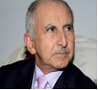Prof. Dr. Tajjedine El-Husseini (Morocco)
Professor Tajjedine El-Husseini is a Moroccan analyst of international relations and a professor of international relations at the Faculty of Economics and Social Sciences, University of Mohammed V. Agdal, in Souissi in Rabat. He is an international economic law professor and legal advisor to many national and international institutions.

PANEL 2
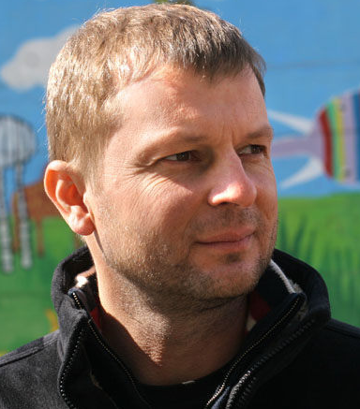Michal Broža (Czech Republic)
In 2004, Michal Broža was appointed as Director of the UN Information Centre in Prague. From 2005 to 2006, he served as a civilian worker at the UN peacekeeping mission in Libya (UNMIL) information service. In the past, Mr. Broža also served as a consultant of the World Bank.

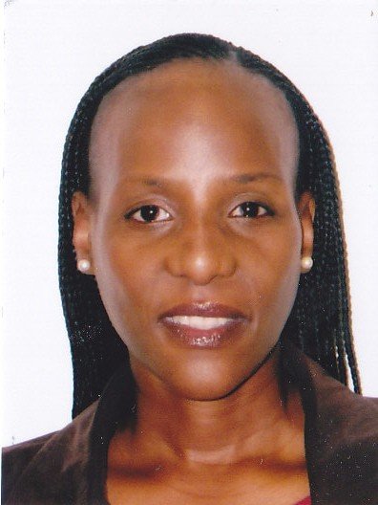Tandeka Nkiwane (South Africa)
Tandeka C. Nkiwane is Special Advisor to the CEO of the NEPAD Planning and Coordinating Agency, the technical implementation agency of the African Union. A professor of international relations, she also served as Director of the Development Research Institute in Johannesburg. Her areas of expertise include regional economic integration, political economy, regional integration, South African public policy, gender and development, as well as economic development in Africa. Professor Nkiwane has taught at a number of universities in South Africa, as well as in the Department of Government at Smith College in Massachusetts, USA. She completed her Ph.D. studies at the School of Advanced International Studies (SAIS) of The Johns Hopkins University, Washington D. C., and in 2007 she was named une personnalitée d’avenir by the French Ministry of Foreign Affairs.

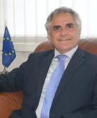Roberto Ridolfi (European Commission, Belgium)
Roberto Ridolfi is Director for Sustainable Growth and Development at Directorate-General Development and Cooperation – EuropeAid. Twice Ambassador / Head of delegation to the European Union, Mr Ridolfi served first, from 2005 to 2007, in Suva, where he was in charge of EU relations with 15 countries and territories as well as with the Pacific Forum. Later, in 2011, he was appointed by High Representative of the EU Catherine Ashton to serve in Uganda, until September 2013. In between, during his duty as a head of unit of Europe Aid F3, he managed programmes dealing with environment, food security, migration and asylum as well as the One-Billion-Euro Food Facility in 50 countries.

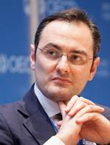Federico Bonaglia (OECD, Italy)
As one of two deputy directors, Federico Bonaglia supports the director in the effective management of the OECD Development Centre and implementation of its programme of work. Amongst his responsibilities, Mr Bonaglia supervises the Centre’s activities with Africa and with Latin America and the Caribbean as well as the Centre’s Perspectives on Global Development and its work on migration, natural resources and territorial development. He also manages the operations of the Centre’s Governing Board, where representatives from 52 member countries and the European Union provide strategic guidance and oversight of the programme of work. In addition, Mr Bonaglia represents the OECD in the G20 Development Working Group and supports the OECD Sherpa Office in coordinating the OECD’s contributions to the G20 in the area of development.

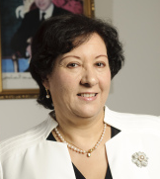 Souriya Otmani (Morocco)
H.E. Mrs. Souriya Otmani is the Ambassador Extraordinary and Plenipotentiary of Morocco to Czech Republic. Ambassador of His Majesty the King of Morrocco Mrs. Souriya Otmani graduated at the Faculty of Law at the University of Mohammed V. Agdal in Rabat. After her civil service at the Ministry of Education, she joined the Ministry of Foreign Affairs and Cooperation in 1982. During her diplomatic career, she worked also as Head of the Department of the Financial Development Cooperation and she served at the embassies in Austria, Sweden and as Consul General in Montreal.

PANEL 3
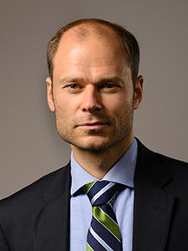Radek Špicar (Czech Republic)
Radek Špicar is vice president of the Confederation of Industry of the Czech Republic (SPAD). In the past he served as executive director of the international think-tank Aspen Institute Prague. During his years in the public sector he focused on competitiveness of the Czech economy, the labour market and promotion of science and research. He worked also as director of external relations in Škoda Auto.

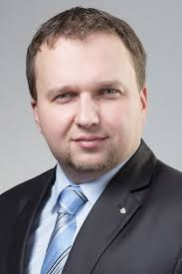Marian Jurečka (Czech Republic)
Marian Jurečka is a Czech politician and current Minister of Agriculture of the Czech Republic. Since 2013, he has been a member of the Chamber of Deputies of the Czech Parliament. From 2012 to 2013, he was a member of the Regional Council for the Operational Programme Central Moravia. He also worked as Head of the Agricultural Chemistry Division in Agro 2000 s.r.o. and Head of the Agricultural Chemistry Distribution Centre in Lukrom spol. s.r.o.

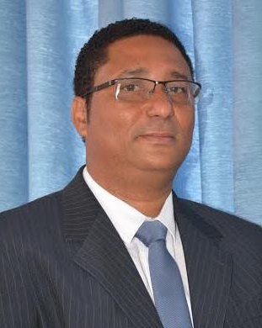Gilberto Silva (Cape Verde)
Gilberto Correia Carvalho Silva is currently Minister of Agriculture and Environment of Cape Verde. He earned his Master's degree in the field of biology and micro-biology and Ph.D. in applied and landscape ecology at the Faculty of Science, Charles University in Prague. During his career in the public sector of Cape Verde, he focused on environment, agriculture, food security and fishery. He served e.g. as National Advisor to FAO or Councillor of Praia for Environment and Civil Protection. Minister Silva speaks fluent Czech.

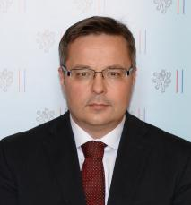Martin Tlapa (Czech Republic)
Martin Tlapa is Deputy Minister of Foreign Affairs for Non-European Countries, Economic and Development Cooperation. He is a lecturer at the University of Economics, Prague, and member of the Scientific Councils of the University of Economics, Czech Technical University and MBA Programme at the Sheffield Hallam University. In the past, he also served as Deputy Minister of Industry and Trade, Deputy State Secretary for European Affairs, and Director General of Czech-Trade.
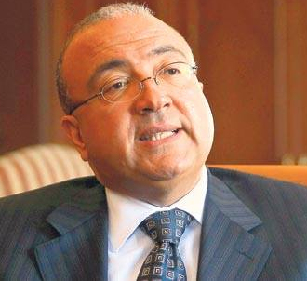Abderahman Salaheldin Abderahman (Egypt)
Before being appointed Ambassador of Egypt to the Czech Republic, H.E. Abderahman Salaheldin Abderahman served from 2010 to 2013 as Ambassador of Egypt to Turkey. He served also as Assistant Minister of Foreign Affairs for Middle East and Arab Affairs or as Political Counsellor at the Permanent Mission of Egypt to the UN in New York, where he was dealing with Middle East and peace-keeping issues. In late 1990s, he was a member of the national delegation to the Madrid conference on the settlement of the Middle East conflict.

PANEL 4

Aleš Michl (Czech Republic)
Aleš Michl is an external financial adviser to the Minister of Finance. In the past, he worked in the teams of the Deputy Prime Ministers for Economics Martin Jahn and Jiří Havel. He founded the think-tank verejnydluh.cz (public debt) and wrote for the newspaper Hospodářské noviny during his studies. Until 2015, he worked for Raiffeisenbank.

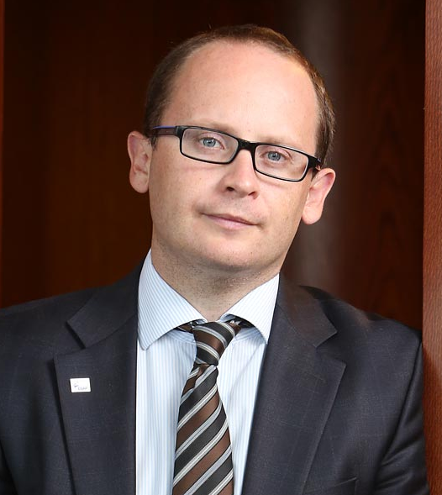Jan Procházka (Czech Republic)
Jan Procházka is Director General of the Export Guarantee and Insurance Corporation (EGAP). After completion of his studies he worked in CYRRUS a.s., where he served as chief analyst and director of the Prague branch. He was also a member of the National Economic Council of the Government, and served in the Government Legislative Council – in the RIA Commission and in the Independent Energy Commission II.

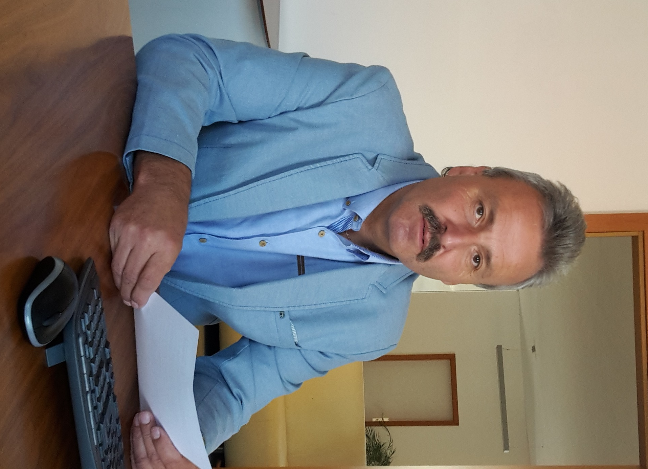Miloslav Zelený (Czech Republic)
Since 1978, Miloslav Zelený has worked for VEBA, a textile company. After having finished his studies he worked at the company on various technical and technological positions. After 1989, he joined the sales team where he initially dealt with sales of domestic textiles. Following VEBA´s strategic decision to focus on the African market, Miloslav Zelený became product manager for African brocade, a position he has been holding until today. Nowadays, African brocade is the company´s main business and production line and competes with traditional European producers.

Miloš Pavlů (Czech Republic)
Miloš Pavlů is founder and managing director of PAVLŮ - Complex, s.r.o., a family business founded in 2002, which is currently the most significant company in the field of machine supply for production of PVC and Al windows on the Czech market. The company exports its products (complex technological units for the production of windows and isolation glass) to Africa and is responsible also for the installation and service. South Africa, Ghana, Benin and Burkina Faso are a case in point. The company is currently preparing for exports also to other African countries. The company develops its own machines and research - the partners of the company hold or are co-authors of more than 30 patents.

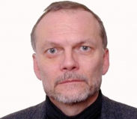 Ilja Mazánek (Czech Republic)
Ilja Mazánek is Chairman of the Foreign Section of the Czech Chamber of Commerce. In the past, he worked for 17 years in Czech diplomacy, where he dealt with Middle East and North African countries. In recent years, he has been working in the private sector in the sphere of aerospace and airport industries.

