Executive Committee of China International Cartoon and Animation Festival
China National Youth and Children’s Palace Association
China Association for Children’s Plastic Arts
Notice on
The 12th China International Children’s
Cartoon Competition

The 12th China International Children’s Cartoon Competition held by Executive Committee of China International Cartoon and Animation Festival, China National Youth and Children’s Palace Association and China Association for Children’s Plastic Arts, undertaken by Hangzhou Youth & Children’s Center, and co-undertaken by Zhejiang Provincial People’s Association for Friendship with Foreign Countries and Hangzhou Municipal People’s Association for Friendship with Foreign Countries. The relevant issues of the competition are as follows:

I. Purpose:
To encourage children and the youth to dig out their creative inspiration and to use cartoon to describe the various kinds of things in the real world so that their creative thoughts can be cultivated and their aesthetic quality can be improved. In the meanwhile, through the competition, it is hoped that the cartoon culture can be promoted among children and youth and the cultural communication of all nations and countries can be boosted.
II. Overview:
The China International Children’s Cartoon Competition has been successfully held for 12 times since 2006. Now it has become a brand activity of CICAF which has most participants and highest internationalization level as well as one of the international teenager’s cultural activities which have much influence in China. What’s more, it is a big platform for the cultural exchange and communication among children and the youth of China and other countries who love paining arts. Up to now, there are participants coming from five continents and 40 countries and regions participating in the competition with a total participants of more than 250,000; and 11 series of more than 40,000 copies of award-winning works have been published. The Competition advocates original works, and every year, it picks theme from a variety of themes including Chinese zodiac culture, thinking of future freely, humane care, environmental protection, etc. by combing the current trend. The competition also invites several experts both home and abroad including Han Meilin, Zhu Deyong, Huang Yulang and Cai Zhizhong, Phil Ye (US), Pang Bangye (South Korea) etc. to be the judges of the competition.
To further strengthen international exchange and cooperation, international itinerant exhibition has been held in recent three years by relying on the power of the hosts and undertakers while. Over 1100 award-winning works have been selected to present at the 42 international itinerant exhibitions in countries including Malaysia, Germany, Japan, Russia, Canada, Singapore, Hungary and regions including Taiwan. At the same time, six overseas sub-divisions have been set up in Malaysia, Japan, Canada, Singapore, Britain and Germany which have laid good foundation for further expansion of Chinese culture in the world.
III. Steps:
1. In early October 2016, launch the competition
2. From November 2016 to April 2017, organize the relevant competition activities to promote the competition concept.
3. Deadline for contribution is March 1, 2017.
4. From March to April 2017, initial evaluation, re-evaluation and final evaluation of works will be conducted; exhibition and award ceremony will be prepared; works will be printed out as collection afterwards. (Issues related to award ceremony will be further noticed in early April).
5. In early May 2017, perform awarding and exhibition during the time when the China International Cartoon and Animation Festival is held.
6. By the end of June 2017, certificate and collection of works for the competition will be issued and mailed.
7. From June 2017 to the end of 2017, the domestic and international itinerant exhibitions of the awarded works will be held.
IV. Attentions
1. The competition will not charge for entry fees in any form.
2. Organizing prize will be awarded based on quantity and award-winning conditions of contribution.

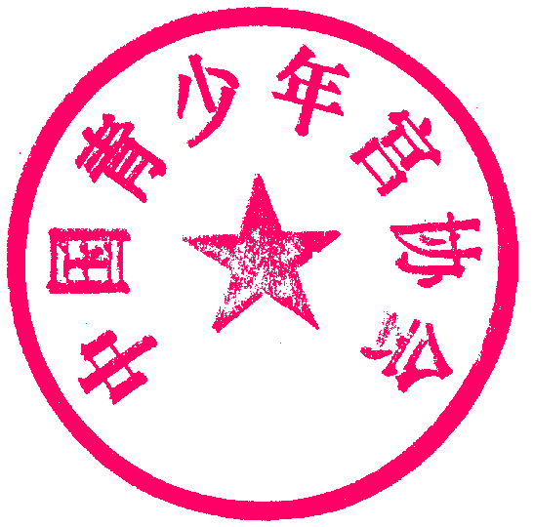
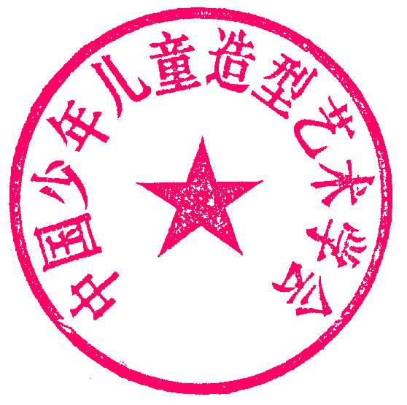
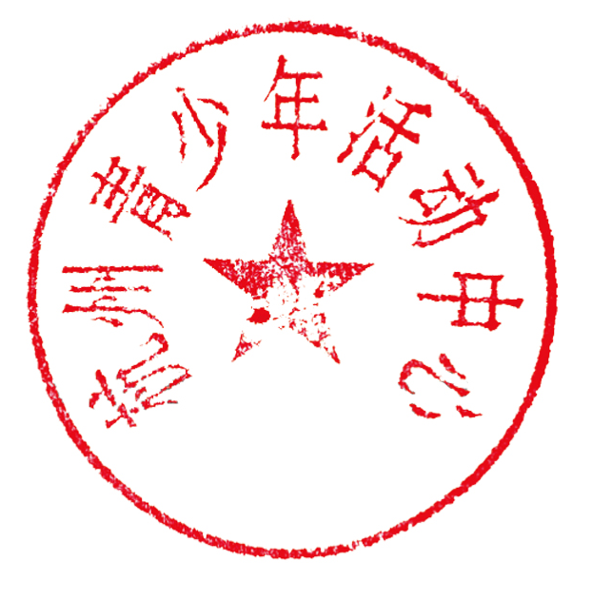
3. Refer to Appendix 1 for Contribution Invitation of the Competition and Appendix 2 for Registration Table of the Participating Works and Appendix 3 for Statistical Table of Group Participation.

Executive Committee of China International Cartoon and Animation Festival (Seal)
China National Youth and Children’s Palace Association (Seal)
China Association for Children’s Plastic Arts (Seal)
Hangzhou Youth & Children’s Center (Seal)

October 25, 2016

Appendix 1:

Notice on the 12th China International Children’s Cartoon Competition

I. Competition Name:
The 12th China International Children’s Cartoon Competition
II. Host
Executive Committee of China International Cartoon and Animation Festival
China National Youth and Children’s Palace Association
China Association for Children’s Plastic Arts
III. Undertaker:
Hangzhou Youth and Children’s Centre
IV. Co-undertaker:
Zhejiang Provincial People’s Association for Friendship with Foreign Countries
Hangzhou Municipal People’s Association for Friendship with Foreign Countries
V. Supporting Unit
Humorist comics
Burst Joy in School magazine
Global Children Arts Brand KiddyColor
Art Kingdom
VI. Undertaker of International Sub-division
Southeast Asia Cultural Arts & Education Exchange Association (Malaysia Sub-division)
Goldstone Education Group (Canada)(North America Sub-division)
Japan Fukui International Communication Association- Gifu International Exchange Association and Gifu Japan-China Cultural Exchange Association (Japanese Sub-division)
Singapore Sunshine Education (Singapore Sub-division)
Good Shepherd Primary and Nursery School (British Sub-division)
SINIKA Culture & Business Development GmbH (German Sub-division)
VII. Participants
Any youth or child under 18 worldwide (born after March 1, 1999).
VIII. Themes (choose one)
1.Rooster Paintin in the Year of Rooster 2. My Field of Vision
IX. Rules
1. Participants are divided into the Youth Group (middle school students and high school students) and Children Group (Primary School Students and Smaller Children).
2. Participating works shall be original freehand sketching, instead of modification, reproduction or copy from others. In case of violation, the award winning qualification of such works will be cancelled.
3. Each participant is allowed to contribute 1 piece of works.

X. Requirements
1. Original works with healthy, positive and innovative content. The patterns of manifestation are not limited. Paper of single, four panel comic, cartoon strips, cartoon books or other innovative cartoon can all be contributed, both white & black or multi-color. The single cartoon should be between 20×30cm and 40×55cm. No framing is needed. Cartoon books should be no more than 8 pages with a size between 15×20cm and 30×40cm, and should better be bound together in book form.
2. Each work will be stuck on the bottom right corner a Registration Table of the Participating Works (refer to Appendix 2) which includes nationality, nation, name, gender, date of birth and group to attend, name of school (or organizations not from the school), address, post code, telephone number, tutor, title and brief introduction to works, etc to be filled out by the author. Visit the official website of China International Cartoon and Animation Festival http://www.cicaf.co and the website of Hangzhou Youth and Children’s Center http://www.hzqsn.com to download the forms of Registration Table of the Participating Works and Statistics Table of Group Participation.
XI. Awards:
1. Top Grade Prize will be awarded to 10 contestants (RMB 1,000 each).
2. Gold Prize, Silver Prize, Bronze Prize and Merit Prize will be awarded for 1%, 1.5%, 2.5% and 5% participants of total contribution works respectively.
3. Excellent Organizer Award for the team who has delivered more than 200 pieces of works or the team with the maximum awarded works.
4. Excellent Tutor Prize for tutors of Grade Prize Winners and Gold Prize Winners and main principal teachers of the organization winning the Organization Prize.
5. Excellent works winning prizes will be included in the Collection. Contestant winning the Bronze award or above will be awarded with a certificate and one Collection.
6. Prize winning participants will have the priority to sign with Humorist comics and Burst Joy in School magazine to be their specially-invited contributor.
XII. Works Exhibition
Name List of all prize winners will be announced at the beginning of May on the websites of China International Cartoon and Animation Festival and Hangzhou Youth and Children’s Center. Prize-winning works will be displayed in various forms..Award-winning works in 2017 will be released in magazines including Humorist comics, Burst Joy in School, Gamersky and Shanhaijing·Junior Edition etc .In the second half of 2017, International itinerant exhibition of China International Children’s Cartoon Competition will be held successively in Canada, Japan, Malaysia, Singapore, Germany, Britain etc. Exhibitions of award-winning works will be organized in different domestic cities.
XIII. Special Invitation
1.Sincerely invite undertakers of international sub-division. The Competition will continue to set up international sub-divisions worldwide. Any unit who has the ability and is willing to do so can apply to the Organization Committee.
2.Sincerely invite you to attend the Forth China Hangzhou· Youth Cartoon & Animation Creativity Teaching Forum. The Competition plans to hold Youth Cartoon & Animation Creativity Teaching Forum in Hangzhou from the end of 2017 to the beginning of May, thus to propel the development of youth cartoon & animation education and teaching. The Forum will invite domestic and international experts, scholars and first line teachers to conduct academic guidance and teaching exchange. It will also organize to visit the 13th China International Carton and Animation Festival as well as the Award Ceremony of this time. Please call the organization committee for details about participation.
3.Sincerely invite domestic itinerant exhibition undertakers. The competition in 2017 have quality participating units from different cities of China to hold plenty of domestic exhibitions. Any unit who has the ability can apply to the Organization Committee.
4.Sincerely invite international itinerant exhibition and exchange summer camp cooperators.In summer vacation of 2017, international sub-division will organize award winners to participate in the Opening Ceremony of the local culture and art exchange activity and international itinerant exhibition, and to issue the international exhibition certificate. Being invited by the Britain Culture Education Exchange Consulting Limited, it will visit Britain to hold the “Britain Cartoon & Animation” Summer Camp; being invited by Southeast Culture and Art Education Exchange Association, it will visit Malaysia and Thailand to hold “Cartoon & Animation Malaysia and Thailand” Summer Camp; being invited by Goldenstone Education Group (Canada), it will visit Vancouver to hold “Cartoon & Animation Dairy of Canada” Summer Camp; being invited by Germany SINIKA Culture & Business Development GmbH, it will visit Germany to hold “Bridge” Summer Camp. The origination committee of the Competition sincerely invite all participating units to participate in the international exchange and exhibition activities together.
XIV. Agreement
No work will be returned back. The authors agree to transfer the publishing right, exhibition right and property right of the works to the Host. All the participants are deemed to agree with the rules above.
XV. Deadline
March 1, 2017 (according to the date of email)
XVI. Works shall be Mailed to
Cartoon Competition Office, Hangzhou Youth and Children’s Center , No. 22, Zhaoqingsili Street, Xihu District, Hangzhou, Zhejiang Province，China, Post Code: 310007
Cartoon Competition Addressee: Wang Zhan, 71293924@qq.com, Mobile: 0086-13336036997
Telephone: 0086-0571-85821035 (except for Monday and Tuesday)

