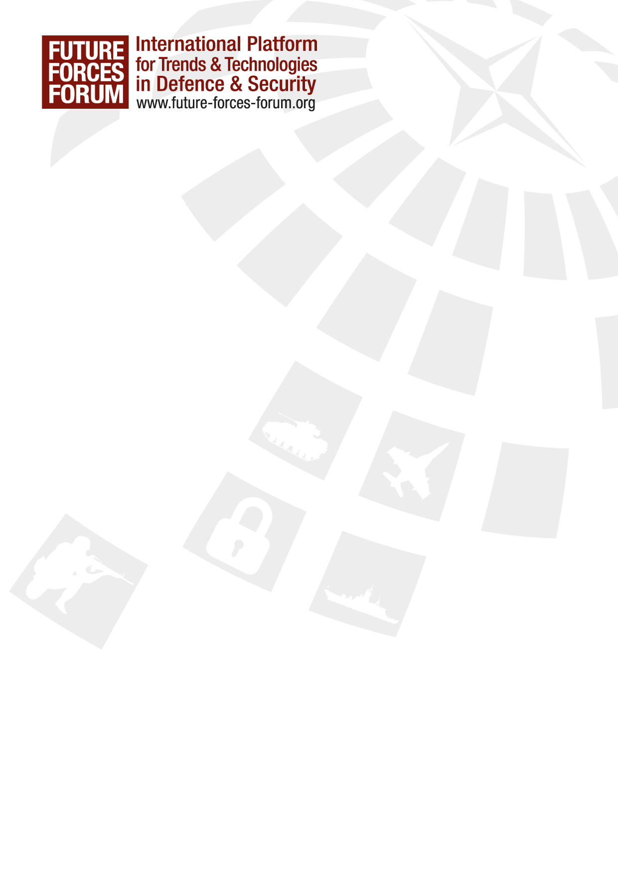

FUTURE FORCES FORUM
17th –21st October 2016, Prague, Czech Republic

Motto: „BetterSecurity = BetterFuture“
The Future Forces Forum (FFF) is supported by the Ministry of Foreign Affairs of the Czech Republic and many other national and international institutions. The objective is to support and promote government, industry, science, research and education in the field of defence and security. It is a way of international global networking and presentation of the trends in the field of defence and security in the form of conferences, seminars, workshops, exhibitions and business meetings - B2G (business-to-government), B2B (business-to-business) and G2G (government-to-government). The FFF project is primarily focused on the presentation of current and future needs of the armed and security forces and offers for the representatives of security forces, industry, science and research worldwide. The Project seeks to create conditions for the most effective cooperation between all of these sectors.
MAIN CONCEPT OF THE FFF:
- focus on affordable and achievable technology for today’s operations
- examine the developments operationally and technically affecting international operation’s needs
- look at future concepts, projects, innovations, new materials, future operation’s needs
- offer the possibility to each nation to support development in defence and security, the latest products and technologies
- discussions of interoperability, counter terrorism, capability development, fostering partnership, etc.
FFF 2016 PROGRAMME:
- Future Forces Exhibition (FF16) – 19th – 21st October 2016
- Future Soldier Systems Conference (FSSC) – 20th – 21st October 2016
- World CBRN and Medical Congress (CEBIRAM) – 19th – 21st October 2016
- Military Advanced Robotic Systems Conference (MARS) – 20th – 21st October 2016
- Geospatial, Hydrometeorological and GNSS Workshop (GEOMETOC) – 19th – 21st October 2016
- Logistics Capability Workshop (LCW) – 20th – 21st October 2016
- Future of Cyber Conference (FCC) – 20th – 21st October 2016
- 20+ NATO Working Groups - 17th – 21st October 2016

FFF VIPs, Speaker and Distinguished Guests include i.e.:

H. E. Martin Stropnický, Minister of Defence, CZE
H. E. Jan Mládek, Minister of Industry and Trade, CZE
H. E. Dan Ťok, Minister of Transport, CZE
H. E. Jan Hamáček, President of the Chamber of Deputies of the Parliament of the Czech Republic, CZE
GEN Josef Bečvář, Chief of General Staff, CZE
GEN Petr Pavel, M.A., Chairman of the Military Committee, NATO
GEN Rashad Mahmood, Chairman Joint Chiefs of Staff Committee, PAK
GEN Mikhail Kostarakos, Chairman of the European Union Military Committee (CEUMC)

GEN David G. Perkins, Commanding General, U.S. Army Training and Doctrine Command (TRADOC), USA
LTG Jiří Baloun Ph.D. MSc., First Deputy Chief of the General Staff, CZE
RADM Donald L. Singleton, Chairman of the Board of Directors of MLCC, Director of Logistics of US European Command, USA
MG Jaromír Zůna MSc. Ph.D., Director of the Division of Support, CZE
MG John W. Charlton, Vice Director for Joint Force Development, USA
MG Jeffrey Clark, Director, Defense Health Agency, Healthcare Operations Directorate, USA
MG Jean-Robert Bernier, Chairman, Committee of the Chiefs of Military Medical Services (COMEDS), NATO
MG Trond R. Karlsen, Director of the Logistics and Resources Division, NATO
MG Tomáš Tuhý, Police Commissioner, CZE
MG Drahoslav Ryba, GM Fire Rescue Service, CZE
MG Ludwig Leinhos, Director Activation Staff of the Cyber Information Domain Service, DEU
MG Erich Staudacher, Deputy Director Bundeswehr Planning Office, DEU
BG Dionigi Maria Loria, Director LOGRES Directorate, EU Military Staff (EUMS), EU
BG Ĺubomír Gacko, Chief of the Operations Support Staff, SVK
BG Thomas H. Todd III, Commanding General, NATICK, Soldier Systems, Deputy Commanding General of the U.S. Army Research, Development and Engineering (ARDEC), USA
Major Brigadier Mário Luís da Silva Jordão, Commander of the Brazilian Air Space Defense Command, BRA
BG H.C. MacKay,Surgeon General / Commander Canadian Forces Health Services Grou, CAN
BG Zoltán Bubeník M.D., Surgeon General, Director of Military Medical Agency of Armed Forces, CZE
BG Imre Pogácsás Dipl. Eng., Ph.D., Chief of Logistics Directorate, General Staff, HUN
Commodore Marcel Hallé, ACOS J4, SHAPE, Supreme Headquarters Allied Powers Europe (SHAPE), NATO
Mr. Wolfgang Rudischhauser, Director, Weapons of Mass Destruction Non-Proliferation Centre, NATO
MG (Ret.) Oldřich Martinů, Deputy Director, EUROPOL
BG Dr. Pavel Kříž LL.M.,Chief of Military Police, CZE
Prof. Petr Konvalinka, Rector of the Czech Technical University in Prague, Head of the Experimental Centre Faculty of Civil Engineering, CZE
Mr. David Grimes, World Meteorological Organization, WMO
Mr. Ray Swider, Chairman NATO Capability Panel 2 (Identification and Navigation), USA
MG (Ret.) Denis Koehl, Senior Military Adviser, European Aviation Safety Agency, EASA
Mr. Pascal Legai, Director of European Union Satellite Centre, EU
Mr. Jaroslav Šmíd, Deputy Director, National Security Authority, CZE
Mr. Václav Dvořák, Director Czech Hydrometeorological Institute, CZE
Mr. Berndt Körner, Deputy Executive Director, FRONTEX
Dr. Oleg Chestnov, WHO Assistant Director-General, Noncommunicable Diseases and Mental Health, WHO
Mr. Jamie A. Williamson, Head of Unit for relations with the Arms Carriers, International Committee of the Red Cross, ICRC
Mr. Martin Hill, Chairman NATO Industry Advisory Group (NIAG), GBR
Mr. Ray Swider, Chairman NATO Capability Panel 2 (Identification and Navigation), USA
Mr. Jorge Domecq, Chief Executive, European Defence Agency, EDA

For more information, please contact:
Pavel Zelenka
Director of Foreign Relations - International Coordination Centre
Tel.: +420 603 520 520
E-mail: zelenka@future-forces-forum.org
www: www.future-forces-forum.org



