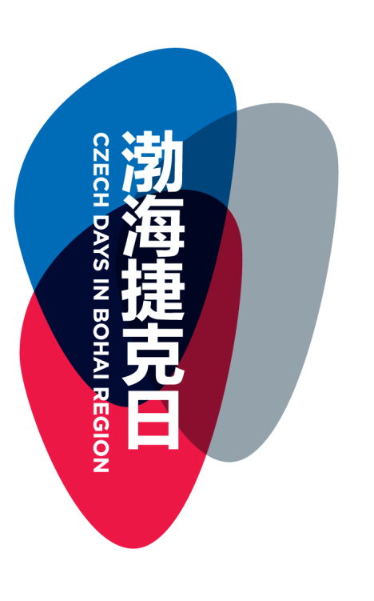

CZECH DAYS IN BOHAI REGION
(JING-JIN-JI JIEKE RI)

3rd - 4th May 2016, Beijing
Czech Days Opening Ceremony and Czech Food Festival at the Czech Embassy
Participation of the Minister of Agriculture of the Czech Republic
- Czech Days Opening Ceremony, 3rd May, Embassy of the Czech Republic
- Czech Food Festival and Reception, 3rd May, Embassy of the Czech Republic
including Cymbalian Band Baranica concert
- B2B Seminar, 4th May, W hotel

18th - 22st May 2016, Beijing and Tianjin
„Czech Republic - Land of Stories“: Tourism Promotion Activities in Bohai Region, Czech Companies at the BITE 2016 – Beijing International Tourism Exhibition, Beer and Film Festival in Tianjin

Participation of the Minister of Regional Development of Czech Republic
- Czech participation at the Beijing Tourism International Fair
- Land of Stories promotional event at the Czech Embassy, 19th May
- Beer Festival in Tianjin, 20th-22nd May
including the concert of Václav Koubek (accordion) and Pipe and Violin Artists Duet performances
- Land of Stories promotional event in Tianjin, 21st May
- Film Festival

28th May - 1st June 2016, Beijing
Czech Companies at the CIFTIS 2016 - China International Fair for Trade in Services, Czech Services at Your Service Workshop

Participation from the Czech Republic to be confirmed
- Czech participation at the CIFTIS
- Workshop: „Czech Services at Your Service“

15th-19th June 2016, Beijing, Hebei, Tianjin
Czech Days Closing events: Reception at the Czech Embassy, Czech Participation at the 16+1 Local Leaders Meeting in Tangshan and and Exhibition, Financial and Services Cooperation Forum and Art Exhibition in Tianjin

Participation of the Czech Prime Minister and regional delegations
- Czech Days Reception at the Czech Embassy
- Czech Participation at the LLM Exhibition in Tangshan as a Partner Country
- Tourism and regional promotional events in Tangshan „Land of Stories“
- Painting Exhibition of Czech Artist Josef Zlámal

Organizers:

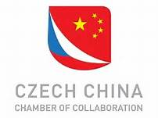

Main Partners:



(Skoda logo and CEFC to be added)

Partners:

(Huawei, Hainan
Ministry of Regional Development, Ministry of Foreign Affairs, Ministry of Agriculture, CzechTrade, Czech Tourism)

