 | 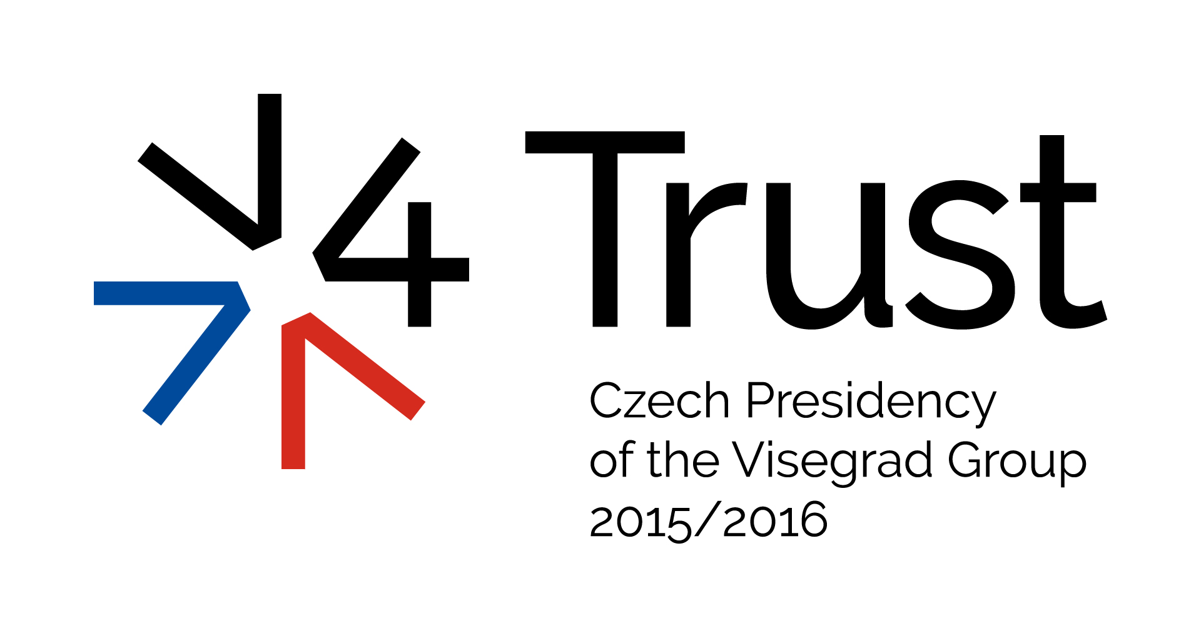 | 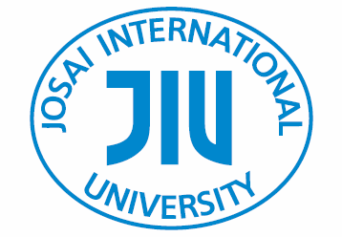  
Visegrad plus Japan Seminar 2016

Security Situation in Europe/Middle East
and
New Role of Japan in the International Security Cooperation

co-host: Ministry of Foreign Affairs of Japan, Embassy of the Czech Republic in Tokyo in collaboration with other V4 Embassies in Tokyo and Josai University

1. Date and time: 10th February 2016, 10:00-16:00

2. Venue: Josai University Educational Campus, Kioi-cho Campus
http://www.josai.jp/access/

3. Program:
Opening
10:00-10.05 Opening Speech: Dr. Noriko Mizuta,
Chancellor, Josai University Educational Corporation

10:05-10:15 Keynote Speech: Mr. Yoji Muto
State Minister for Foreign Affairs

10:15-10:25 Keynote Speech: H.E. Mr. Tomáš Dub
Ambassador, Embassy of the Czech Republic in Tokyo (V4 Presidency)

Session 1 Perspective role of Japan in the international security cooperation
Moderator: Mr. Masaki Ikegami
Director, Central and South Eastern Europe Division, MOFA

10:30-10:50 “Adoption of new security laws in Japan, further steps expected to be undertaken and their possible implications”
Speaker: Ms. Chikako Kawakatsu- Ueki, Professor of International Relations,
Graduate School of Asia-Pacific Studies, Waseda University

10:50-11:10 “Will future bring an enhanced role of Japan in the international security cooperation? ”
Speaker: Mr. Ippeita Nishida, Research Fellow, Tokyo Foundation

11:10-11:25 Discussion

11:25-11:40 Coffee Break 15 minutes

Session 2 New security and humanitarian paradigm in Europe
Moderator: Mr. Masaki Ikegami
Director, Central and South Eastern Europe Division, MOFA

11:40-12:00 Migration, Integration, EU: the Hungarian Perspective”
Speaker: Mr. Márton Schőberl, Director-General, Institute for Foreign Affairs and Trade (Hungary)

12:00-12:20 “Frozen conflict in Eastern Ukraine and estimates of its development”
Speaker: Mr. Róbert Ondrejcsák, Director, Centre for European and North
Atlantic Affairs (Slovakia)
12:20-12:35 Discussion

12:35-13:35 Lunch break

Session 3 Middle East in Turmoil and Rising Threat of International Terrorism
Moderator: Mr. Masaki Ikegami
Director, Central and South Eastern Europe Division, MOFA

13:35-13:55 “Summer NATO summit in Warsaw (and the role of the V4) and the Czech participation in the struggle against the Islamic State”
Speaker: Mr. Zbynek Pavlačík, President of the Jagello 2000 Association (Czech Republic)

13:55-14:15 “Situation in Syria, estimates of further development and connected risks, future role of Russia, US and EU in the region”
Speaker: Mr. Wojciech Lorenz, Senior Analyst at the Polish Institute of International Affairs (Poland)
14:15-14:30 Discussion

14:30-14:45 Coffee Break 15 minutes

Session 4 Security situation in East Asia
Moderator: Mr. Masaki Ikegami
Director, Central and South Eastern Europe Division, MOFA

14:45-15:05 “Recent developments in East Asia, assertive steps of China in East and South China Sea, their effects on Japan-China relations and regional security situation”
Speaker: Mr. Bonji Ohara, Research Fellow, Tokyo Foundation

15:05-15:25 “Future role of US in East Asia and possible new regional alliances of Japan”
Speaker: Mr. Tetsuo KOTANI, Senior Fellow, Japan Institute of International
Affairs
15:25-15:40 Discussion

Closing Session
15:40-15:45 Wrap-up by Moderator
15:45-15:50 Closing remark: TBD by Josai University Educational Corporation

Followed by a reception hosted by Josai University Educational Corporation

