
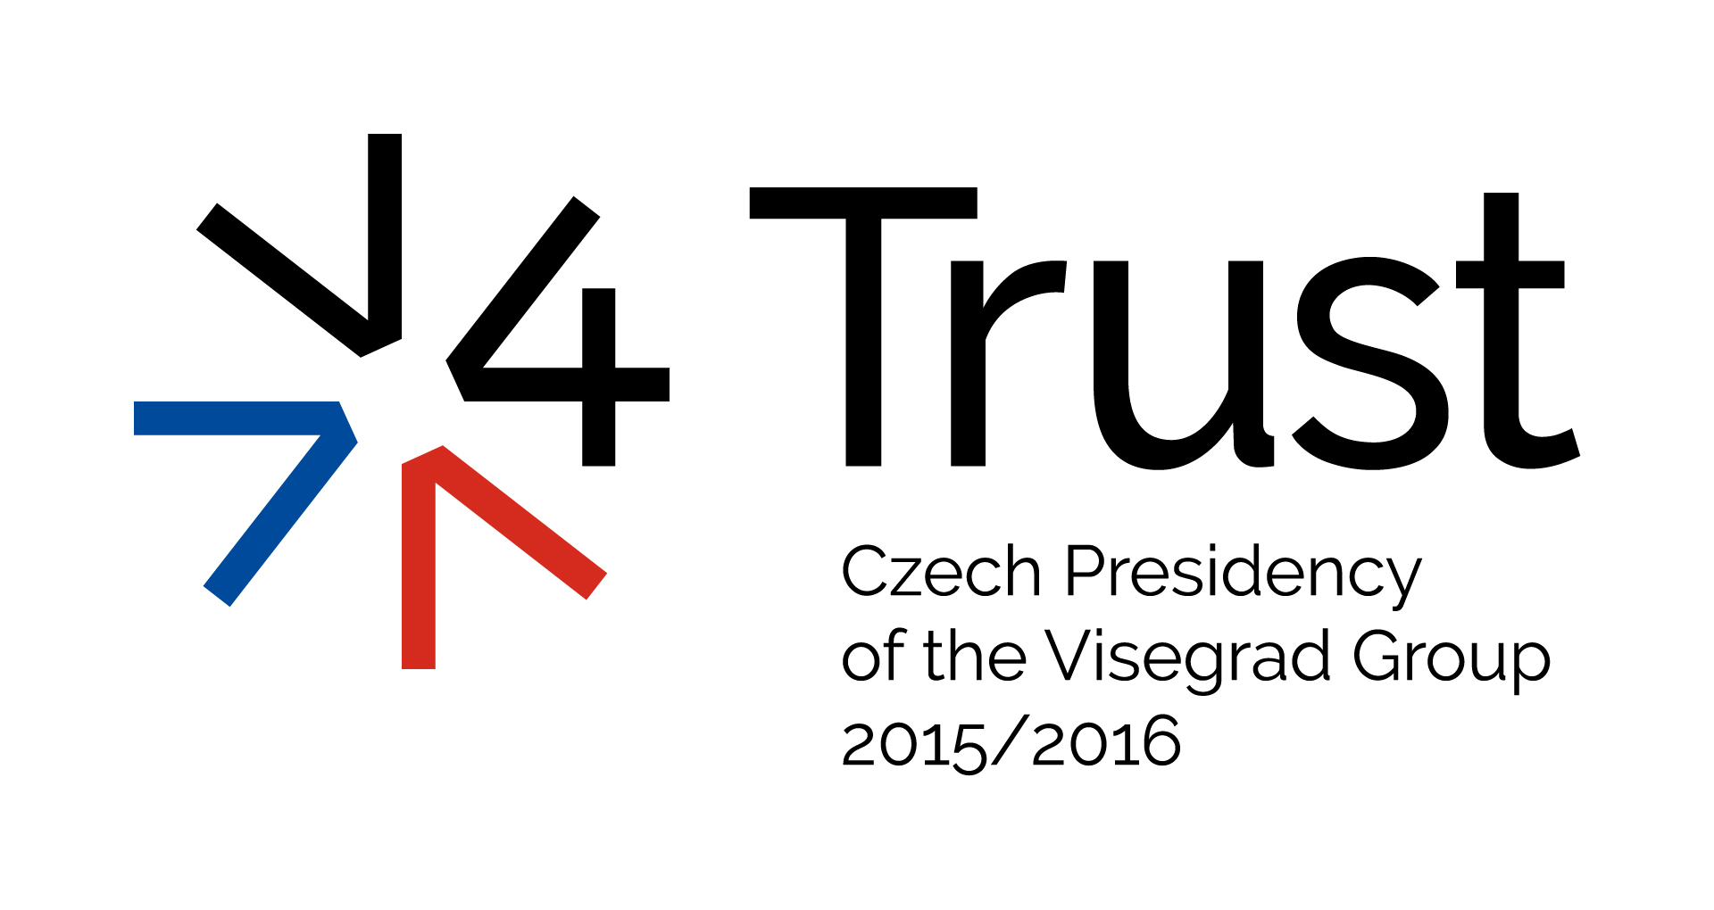

V4 Road Show in Chernivtsi, Ukraine
Concept Paper and Final Program

Title V4 – Ukraine: Chernivtsi Conference on Funding of Higher Education and Science

Date Tuesday, October 13, 2015

Venue Chernivtsi Yuri Fedkovych National University, 2 Kotsiubinskiy St., Chernivtsi, Ukraine

Organizer Ministry of Foreign Affairs of the Czech Republic in cooperation with Ministry of Foreign and European Affairs of the Slovak Republic, Ministry of Foreign Affairs and Trade of Hungary, and the Ministry of Foreign Affairs of Poland, and Ministry of Foreign Affairs of Ukraine

V4 Partners Czech Development Agency, Visegrad Fund, Association of International Affairs (CZ)

UA Partners Ministry of Science and Education, Chernivtsi Regional State Administration, Chernivtsi City Council, Chernivtsi Yuri Fedkovych National University

Languages English and Ukrainian (with simultaneous translation)

Goal The conference is part of the initiative “V4 Road Show in Ukraine” agreed by the V4 Deputy Foreign Ministers in Lviv on October 7, 2014 with the aim, first, to share reform experiences of the V4 countries with Ukraine in the selected policy areas, and second, to enhance coordination of the V4 assistance to Ukraine. The V4 countries agreed on their specific roles when it comes to sectorial focus of their assistance to Ukraine in its reform process related to the implementation of the Association Agreement with the EU. The Czech Republic led event will focus on education reform. The conference in Chernivtsi will be held under the auspices of Ministry of Foreign Affairs of the Czech Republic and aims to facilitate sharing the V4 experience with Ukrainian partners in the field of implementing the education reform, specifically the model of financing of the education and research institutions (VET, HEI and science institutes) which is a complex and unresolved issue that still lingers, as well as determines, a broad possibility of the reforms implementation.

Introduction of the Law on Higher Education triggered changes in a wide range of critical issues in the higher education system of Ukraine. Fundamental things like quality assurance system, student centered learning, internationalization, are tackled by the reform. The changes in progress reflect a general direction of the Ukrainian higher education towards the European Higher Education Area. It is hardly conceivable to Europeanize the education and science system without a complex overhaul of the financial underpinning. An obsolete Soviet system of the “state order” is not only disconnected from the current labor market conditions, but is also detrimental for the state budget and the country’s long-term development.

Changing the financing approach of the education and science is a challenging task, but it has to start, first and foremost, from a clear vision of a desired system. There is an evident lack of understanding and consensus among the Ukrainian stakeholders on a needed model. This is exactly an issue, where the international experience is of utmost importance, especially from the countries that have experienced a similar transition process. The V4 + Ukraine conference on education and science funding should cover, for instance, such facets as a shift from the state order system: experience of the V4 countries, sources of funding (state\local budget, private investments), formula for the costs and expenditures calculation, distribution of state funds among the universities (criteria, indicators etc.), possible introduction of vouchers/loans systems, calculating costs and benefits of the tax funding, introduction of grant system in the science funding, financing VET institutions etc. Learning from the practices, success stories and pitfalls, of the V4 countries is crucial for Ukraine prior to launching comprehensive systemic changes in the education and science funding model.

Final draft program (as of 09/10/2015)

Monday 12/10/2015 Suggested arrival of V4 delegations and UA experts to Chernivtsi; Accommodation

Accommodation (arranged by CZ)
- CZ, HU, SK delegations, UA deputy ministers: Georg Palace hotel (Ivana Bohuna St, 24) georgpalace.com.ua +380 372 576 116
- PL delegation, UA experts: Bukovyna hotel (Holovna St, 141,) bukovyna-hotel.com +380 372 585 625

20:00–22:30 Informal buffet dinner for conference participants hosted by CZ V4 presidency
Chernivtsi Yuri Fedkovych National University, 2 Kotsiubinskiy St.,
Main Entrance, Cerulean (Blue) Hall

Tuesday, 13/10/2015 8:15–9:00 Registration of participants

9:00–9:30 Welcome and Introductory Remarks, Red Hall
(Speeches: 2-3 minutes)
1) Mr Stepan Melnychuk, Rector of Chernivtsi Yuri Fedkovych National University
2) Mr Jaroslav Ludva, Junior Deputy Minister, Ministry of Foreign Affairs of Czech Republic, V4 Chair
3) Mr Oleksandr Fyshuk, Head of the Chernivtsi Regional State Administration (TBD)
alt. Mr Volodymyr Kulish, Deputy Head of the Chernivtsi Regional State Administration
5) Mr Peter Mišík, Director General, Political Section of the Ministry of Foreign and European Affairs of the Slovak Republic
6) Mr Konrad Pawlik, Undersecretary of State for Development Cooperation, Polish Diaspora and Eastern Policy of the Ministry of Foreign Affairs of the Republic of Poland
7) Mr László Csaba Pap, Deputy Head of Mission, Embassy of Hungary
8) Ms Inna Sovsun, First Deputy Minister for Education and Science

9:30–11:00
Panel I. Strategies for Efficient Funding of Education and R&D
The first panel aims to address the question how to improve the design of the funding system in order to enhance funding efficiency and thus support the underlying facet of the education and science modernization via discussing the most suitable design of a funding system for a country (philosophy behind), building strategic alliances of the interested stakeholders to reach a workable and mutually supported system. Moreover, the pace of funding reform (how to plan a smooth transition) and the importance of coherence and compatibility in funding approached to the different education levels, science and research.

Chair (10 minutes): Ms Inna Sovsun, First Deputy Minister for Education and Science

V4 speakers (10 minutes):
Mr Jiří Nantl, Operational Director CEITEC (Centre of Scientific Excellence in the Fields of Life Sciences and Advanced Materials and Technologies), Masaryk University Brno, Czech Republic
Ms Edit Tóth, Deputy Head of Department for Institute Financing and Financial Monitoring, Ministry of Human Capacities of Hungary
Mr Andrzej Kurkiewicz, Deputy Director, Department of Innovation and Development, Ministry of Science and Higher Education of Poland
Mr Martin Benikovský, SK expert, National University in Uzhgorod

Ukrainian speaker (10 minutes):
Mr Andriy Bondarenko, Head of Unit for Financing of Education, Ministry of Finance of Ukraine

Q&A (30 minutes)

11:00–11:30 Coffee Break, Gallery in front of Marble Hall

11:05–11:45 Press briefing, Marble Hall
Moderator: Mr Pavel Buček, Deputy Head of Mission, Embassy of the Czech Republic
Attendance: Mr Stepan Melnychuk, Ms Inna Sovsun, Mr Jaroslav Ludva, Mr Konrad Pawlik, Mr Peter Mišík, Mr László Csaba Pap, Mr Oleksandr Fyshuk

11:30–13:30 Panel II. Funding of Higher Education, Technical and Vocational Education (TVET), Red Hall
The second panel should bring a clear notion on how to fund universities efficiently, how does the change of funding approach affect the HEIs network (push towards merger processes) will be the main questions of the third panel, more specifically how public funding is delivered to the HEIs, how to ensure the transparency of allocation. Developing a funding formula, the importance of indicators, establishing key performance indicators, pros and cons of performance based funding will be discussed as well. Views of HEIs practitioners on strategic planning and internal funding allocation will be welcomed. Some speakers should discuss different education system contexts that affect VET costs and benefits, types of VET financing, approaches to state-regulated VET systems as well as fostering public-private partnerships as a co-funding mechanism.

Chair: Mr Iegor Stadnyi - expert, CEDOS

V4 speakers (15 minutes):
Mr György Szent-Léleky, Senior Counsellor from the Ministry for National Economy of Hungary
Ms Karolina Gondková, Directress of the Department for higher Education, Ministry of Education, Youth and Sports of the Czech Republic
Mr Andrzej Kurkiewicz, Deputy Director, Department of Innovation and Development, Ministry of Science and Higher Education of Poland

Replies:
Ms Jadwiga Parada, Minister Counselor, Department of Vocational and Continuing Education, Ministry of National Education

Q&A (45 minutes)

Program for V4 political delegations:
12:00–13:15 Meeting of the V4 Deputy Ministers of Foreign Affairs at the Chernivtsi Region Administration also with the city and regional self-governance authorities (format 1+1)
Hrushevs´koho 1

13:30–15:00 Buffet lunch for all conference participants hosted by CZ, Cerulean (Blue) Hall

14:30–16:00 Public side event for students organized with UA partners, Marble Hall
The side event should cover the opportunities of studying in V4 countries for the Ukrainian students and the importance of full membership in the Erasmus program.

Chair (10 minutes): Ms Alžběta Chmelařová, Third Secretary, Embassy of the Czech Republic

V4 speakers (5-10 minutes):
Mr Andrzej Kurkiewicz, Deputy Director, Department of Innovation and Development, Ministry of Science and Higher Education of Poland
Mr Iegor Stadnyi, UA expert, CEDOS
Mr Roman Žatko, Counsellor of the Embassy of the Slovak Republic (TBC)
Ms Ljudmyla Tysyachna, Student of the Masaryk University of Brno, Czech Republic
Ms Eszter Németh, Third Secretary of the Embassy of Hungary

Q&A (30 minutes)

15:00–16:30 Panel III. State-Funded Science and Research, Red Hall
The last panel will address the need of reforming the obsolete post-Soviet research system and infrastructure, decentralization of institutions deciding on the allocation of funds for research, pros and cons of grant system, transparent earmarking of funds for the best research, introducing viable and efficient assessing systems, role of international scientific cooperation in funding distribution, co-financing of multilateral projects.

Chair: Dr Natalia Shuľga, Ukrainian Science Club CEO

V4 speakers (15 minutes):
Mr. Jan Marek, Head of Unit, Section for science, research and innovation of the Government of the Czech Republic
Mr Andrzej Kurkiewicz, Deputy Director, Department of Innovation and Development, Ministry of Science and Higher Education of Poland
Ms Edit Tóth, Deputy Head of Department for Institute Financing and Financial Monitoring, Ministry of Human Capacities of Hungary
Mr Jiří Nantl, Operational Director CEITEC (Centre of Scientific Excellence in the Fields of Life Sciences and Advanced Materials and Technologies), Masaryk University Brno, Czech Republic

Q&A (30 minutes)

16:30–16:45 Coffee Break, Gallery in front of Marble Hall

16:45–17:00 Concluding Remarks, Red Hall
- Ms Inna Sovsun, First Deputy Minister for Education and Science (10 min)
- Mr Jaroslav Ludva, Junior Deputy Minister, Ministry of Foreign Affairs of the Czech Republic, V4 PRES (2-3 min)
- Mr Stepan Melnychuk, Rector of Chernivtsi Yuri Fedkovych National University (2-3 min)

17:00–17:45 Excursion for all participants around the University Campus
Note: Meeting with guides in front of Red Hall. Two groups – one in English, another in Ukrainian.

17:50 Bus transfer organized by CZ (courtesy Chernivtsi ODA)

18:00–20:00 Buffet dinner for all conference participants hosted by the Chernivtsi Regional State Administration
Georg Palace hotel, Ivana Bohuna St, 24

Wednesday, 14/10/2015
Individual departure of both Ukrainian and Visegrad Group participants
***

