CROSSING BORDERS –
PAINTING AND SCULPTURAL GLASS BY CZECH ARTISTS

At present, there are about 170 practising creative artists in The Czech Republic. Most have achieved an established reputation, not only in Europe but in the U.S. and Japan as well. Their work may be seen in numerous museum collections, has been bought by foundations and private collectors, or form a part of architecture.
Czech artists frequently participate in international exhibitions, symposiums and competitions and they teach the art of glass making all over the world.

Of course it’s impossible to present all these artists in a single exhibition, so I have chosen 25 prominent personalities, whom I consider among the best representatives of the various artistic currents, and who – even in the present millennium – contribute substantially to the renewal of the concept of ”The Czech School of Glass” with regard to the conceptual matter and the specific aesthetics as well as the new technological potential.

The exhibited works of glass sculpture demonstrate the use of internal light and reflection, the transparency of the material and its structure and surface. The aesthetics of the glass vacillates from spontaneity to relative rationality, i.e. encompasses flowing as well as tight forms; colours but clarity too; express themselves both figuratively and non-figuratively.
Works are included in which the artists pose the question whether technique and the attractive qualities of the material are viable in their own right, and in which they strive to overcome cheap decorativeness and empty ornamentation.

There are obvious parallels between the idiom of the exhibited glass artefacts and the experimental styles of other types of material, all exploring borderlands and crossing the ruling aesthetic frontiers.

In addition to glass, there will be paintings, drawings, etchings, and sculptures in other materials in order to prove the sustainability of the artistic idea, regardless of the chosen media. Simultaneously, the specific properties of glass are clearly expressed.

A number of works are very large or created for a specific environment. For obvious practical and economic reasons, it will be impossible to transport them to far-away destinations. These types of projects may be documented by photo and video.

MAINSTREAMS OF HISTORY
As an artistic medium, glass was ”discovered” as early as the 1950’s in Czechoslovakia. To the government it was a matter of prestige to draw attention to one of the country’s traditional trades. For this reason, artists were subsidized generously in order to develop their glass projects for the world exhibitions Expo (Brussels ’58 and later Montreal and Osaka) and other international events (eg. the Milan Triennial in 1957). Their works in Bas-relief, sculptures, pillars, and unique specimens aroused attention as something
quite new.

Moreover, it wasn’t just in connection with the government commissioned work that artists were enabled to materialize their new visions at the numerous glass factories in close cooperation with the craftsmen.

In the planned economy during communism, labour and manpower was extremely cheap. In this situation it was no problem to provide the artists with the best glass blowers, cutters, engravers, painters and many others.

Early on, cooperation with architects was established, and glass works of monumental dimensions became an integral part of public reconstructions, reception buildings, and restoration of historical architecture. Moreover, it is easier by far for a glass artist to avoid political messages or actual social critique than for a painter or a writer.

All this new thinking in terms of glass would not have been possible without professional training. Firstly, one studies for four years at one of the three schools for glass manufacture. Here one can learn the actual craft and choose a specialty among various disciplines such as glass blowing, cutting, painting etc.

The most talented students can go on to do six years of training at the Academy of Art, Architecture and Design (AAAD), which harbours two glass departments. Here the training first and foremost consists of the basic disciplines in art: drawing, painting and modelling or sculpting. The main idea throughout the course of the artistic idea is the concept. That is why most students of glass can work with other materials with equal ease and liberty.

This pattern of education has been in force – with minor alterations – since the 1940’s, and has attracted a lot of talent. Together with the long tradition of glass manufacture it forms the most vital prerequisite of the idea of ”the Czech School of Glass”.

THE FOUNDERS AND THEIR SUCCESSORS
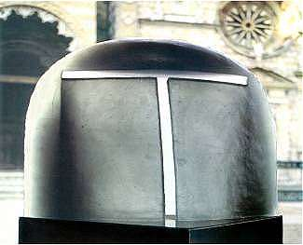
Among the most important persons who have influenced glass art are Stanislav Libensky and Jaroslava Brychtová. Their numerous works, in which Libensky’s pictorial talent is strengthened by Brychtová’s three-dimensional feeling, are part of architecture all over the world. Over the years this couple have developed and mastered the technique of casting glass, enabling them to produce large objects in one piece.

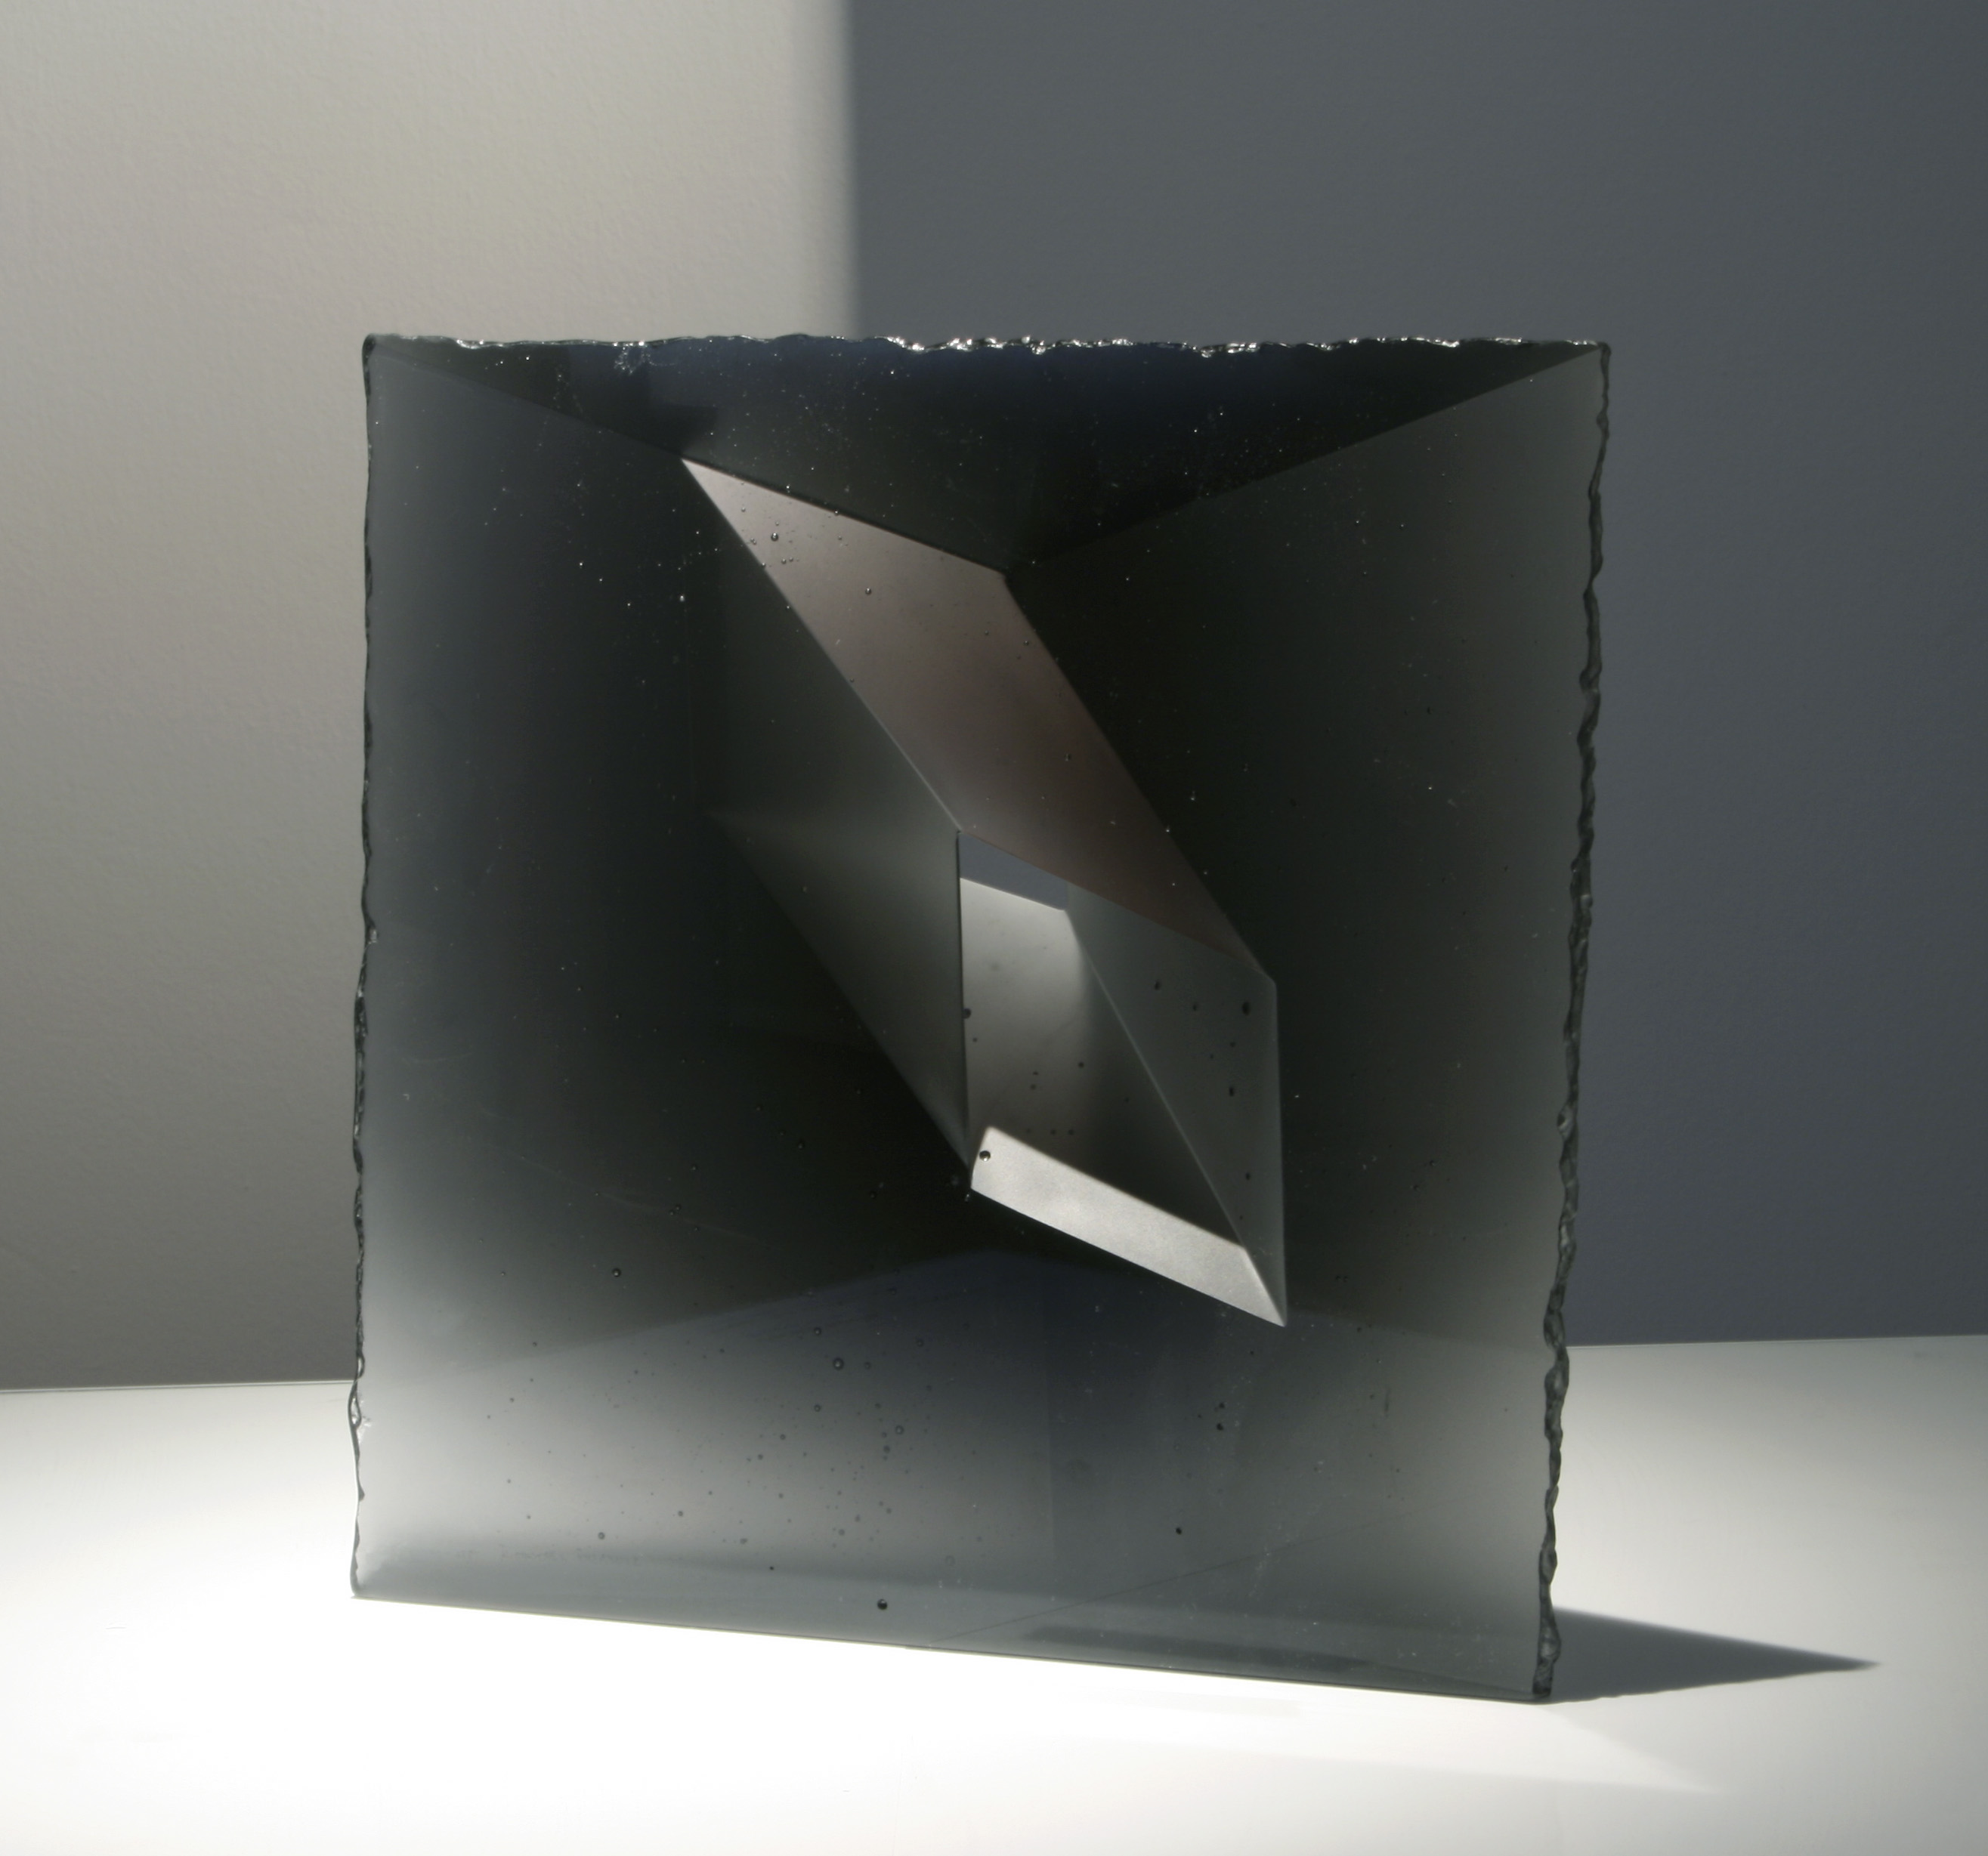
The exhibition will show their monochromatic sculptures with a compact, simple shape in which the inner space is shaped by shades of colour in connection with the thickness of the glass and its play with light through the glass. Along with two of Libensky’s drawings they represent his last works before he died.

As a professor at the Academy, Libensky influenced several generations of glass artists. Their work is presented in a selection of glass objects, and since several express themselves in painting as well, there will be works in this medium too.

For instance, the Rubicon Group, a group of artists, has created some interesting paintings during their common summer painting camp. This group is represented by Jaroslav Matous muted observations of scenery on canvas as well as in cast glass combined with metal wire and glass beads. Jan Exnar and Jaromir Rybák are both members of the Rubicon Group and will be mentioned later.

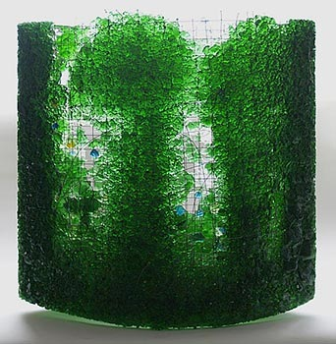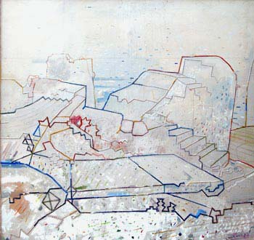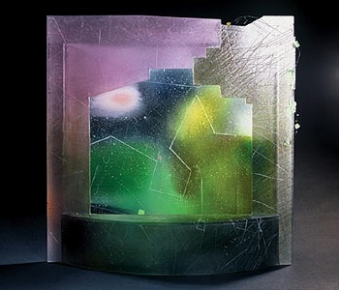
Jaroslav Matous

Among Libensky’s students are also Milan Handl and Jirí Nekovár.. With a distinctive aesthetic expression they master the technique of casting glass in combination with cutting and generally choose abstract forms. Others seem to concentrate more on structures in the glass surface and find inspiration in the organic world, as for instance Ivan Mares.

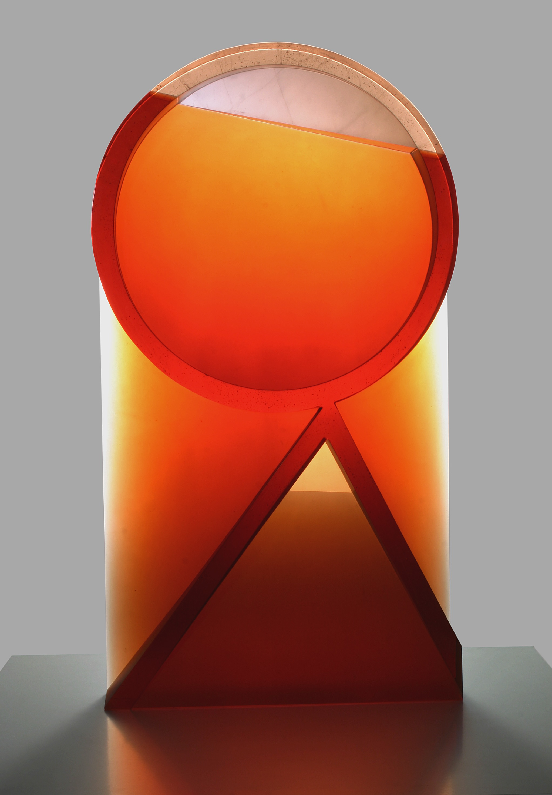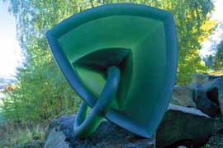
Milan Handl Jiri Nekovár
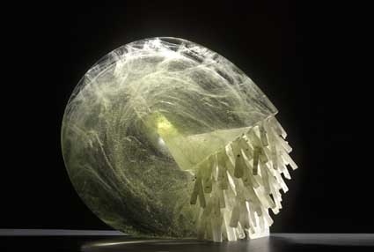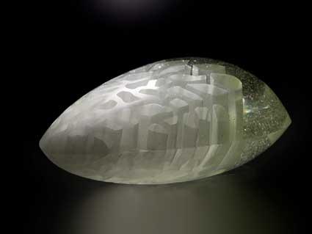
Ivan Mares

The combination of glass with other materials such as stone or metal is gaining ground. This line of work is represented in a grotesque world of bizarre, submarine creatures and other monsters created by Jaromír Rybák and in figurative sculptures by Gizela Sabóková. The bronze part forms a whole with the sculpture and strikes a balance with the blown – and lately even cast – glass in the works of Dana Vachtová. Although she constantly belongs to the older generation of sculptors, she manages to find new ways of expression constantly.

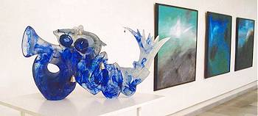
Jaromír Rybák

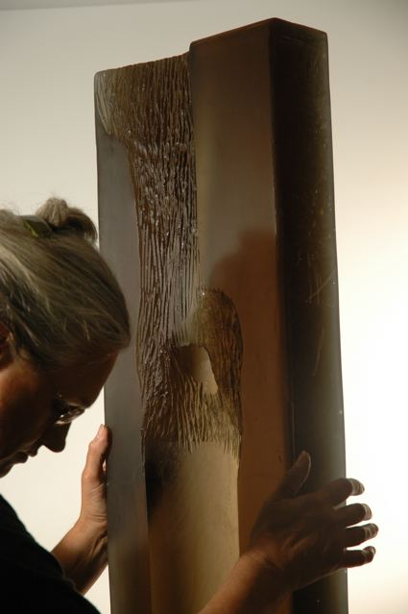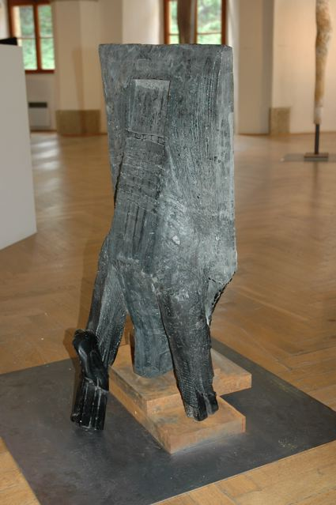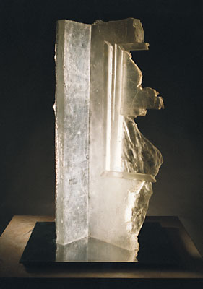
Gizela Sabóková Gizela Sabóková Dana Vachtova

PAINTED GLASS WITH A DIFFERENCE

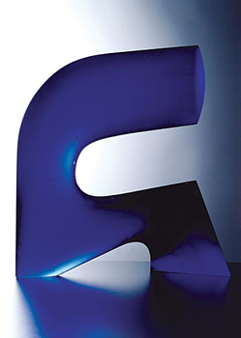
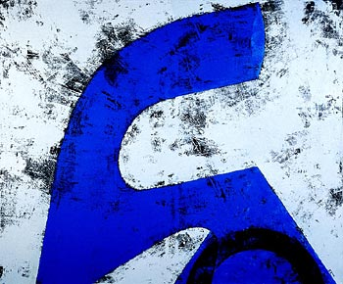
Stained glass is generally thought of as leaded panes, predominantly in churches. However, a number of artists make a different use of this technique, among them Jan Exnar. In his works too, the transition between glass and classical painting on canvas is very gradual. The themes may be the same, but they are always adapted to the specific potential of the material. Exnar uses glass colours, which are burnt. This affords an almost unlimited scale of nuances and shades, and the transparency of the glass is preserved. Bands of lead are used as a graphic idiom and not just as a functional framework. Cast and cut glass form another sphere of Exnar’s works.

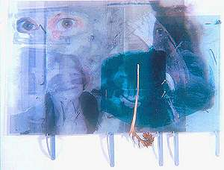
Dana Zámecníková has a background as a scenographer and architect. This appears clearly in her compositions, which are sort of digital collages, transferred onto sheet glass on which she then paints, sandblows or etches. Realistic, often figurative motifs are staged in a visually powerful, dream-like reality. The perspective is stressed by stacking the sheets vertically.

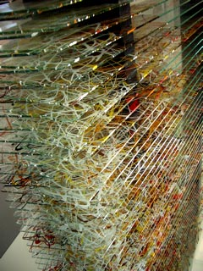

A selection of Jirina Zertová’s objects will
be displayed: horizontally stacked sheet glass, painted in the style of ”action painting”
as are her paintings (on canvas).

Also on show are Marian Volráb’s rather sombre painted glass pictures of cast, slumped sheet glass in dark shades, in which engravings and cuttings make ”openings” for the light to shine through.

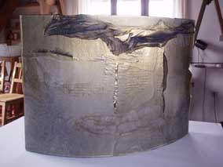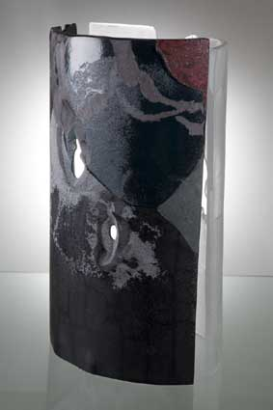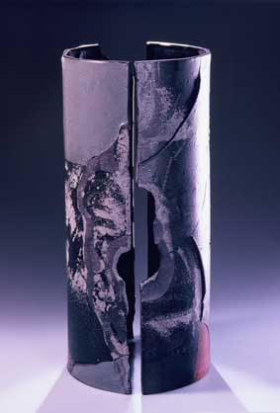

Marian Volráb

RELATIONS BETWEEN SHAPE, LIGHT AND COLOUR
Works by Václav Cigler are evidence that the theme of his artistic life is the exploration of relations between glass and its environment. Because of the prismatic cutting, the purist shapes reflect the surroundings and keep changing with the position of the spectator, thus producing a kinetic effect.

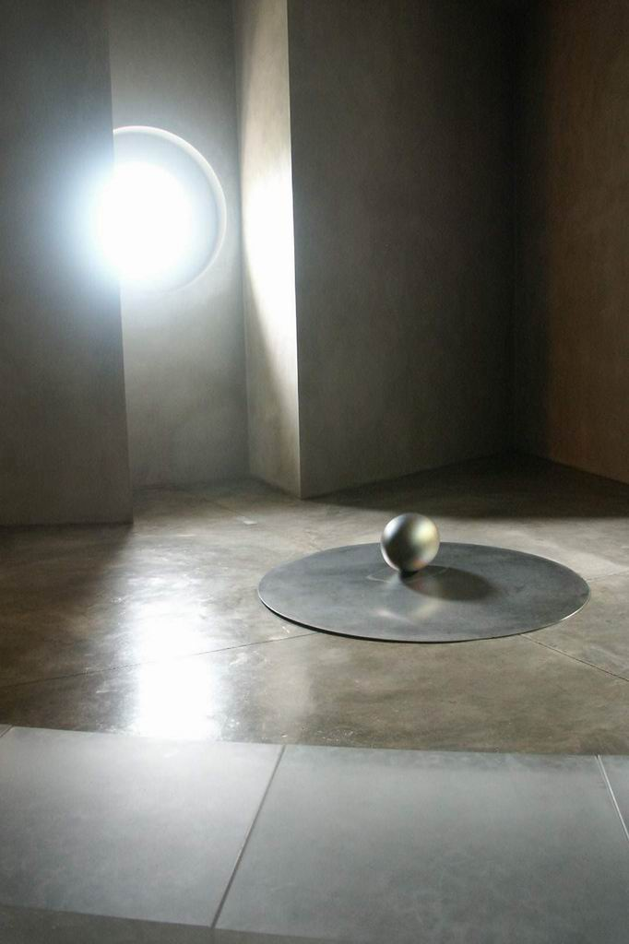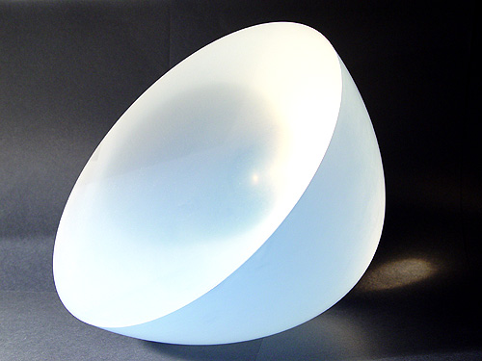
Václav Cigler

Ivo Rozsypal transforms Cigler’s constructivist compositions into architectural visions and fictional landscapes, in which colour and elements of blown glass add an expressionist effect to his mostly black-and-white geometric elements. Similar contrasts between the rational and the imaginary are explored in some of Rozsypal’s paintings.

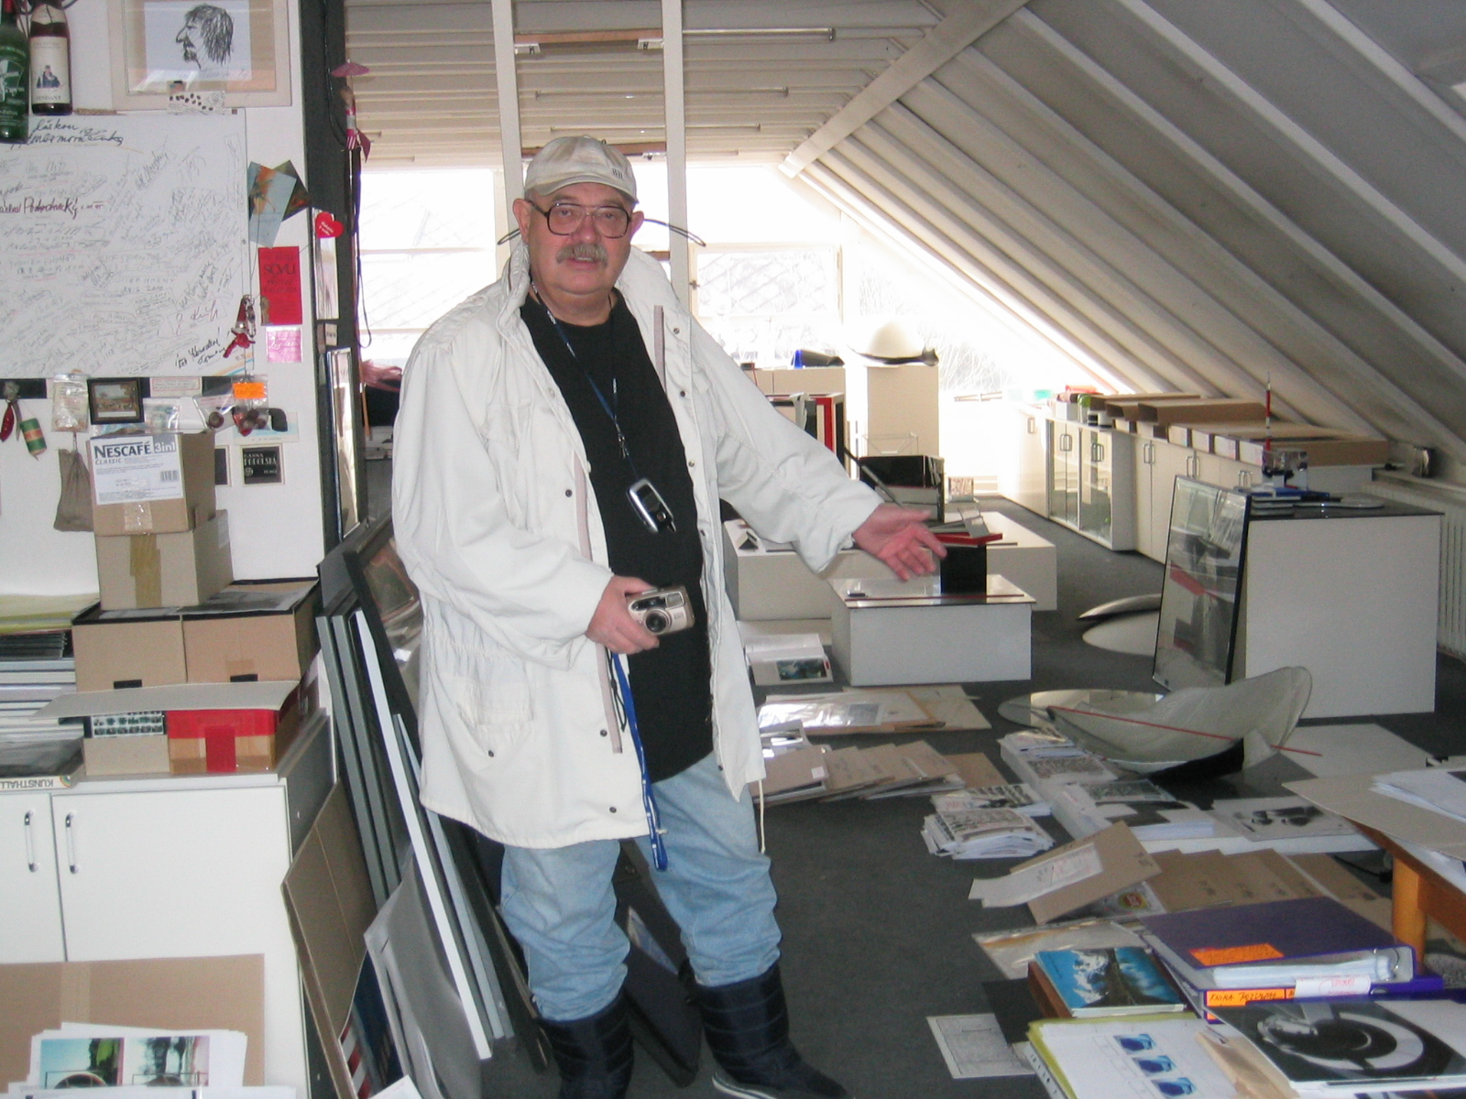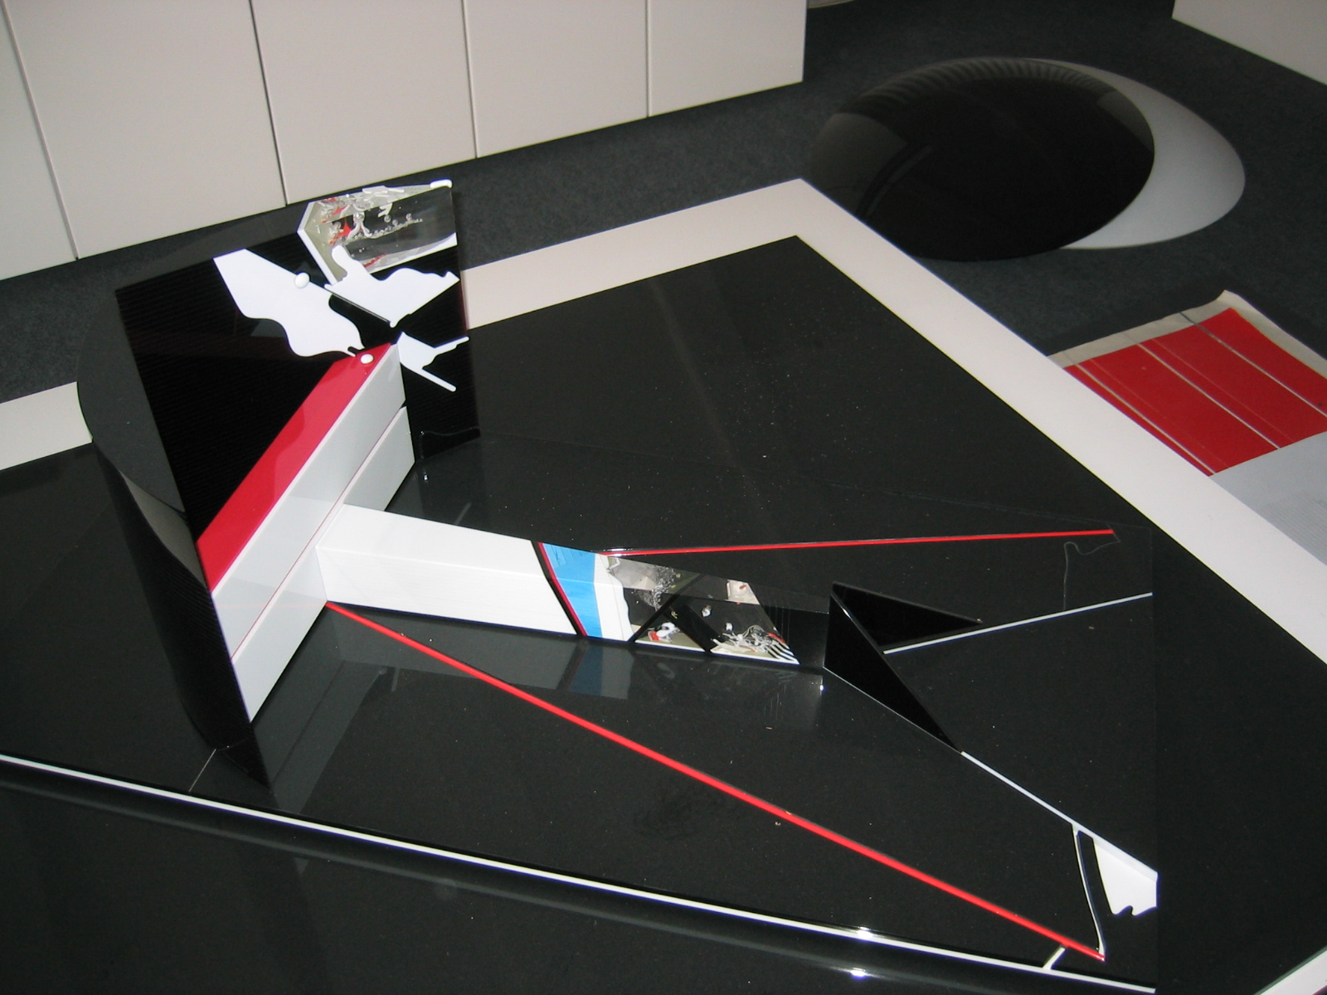

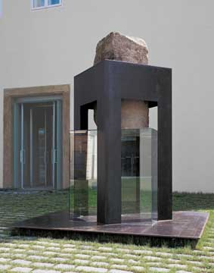
Among the first to discover the optical potential of cut glass was Marian Karel. From geometrical objects he soon moved to out-door installations made of sheet glass in combination with other materials, which reflect and multiply the surroundings. Most often he is preoccupied with the frenzied life of modern cities, but he also ”turns the glass” toward historic architecture.

Karel is the dean of the department ”Glass in Architecture” at the AAAD and like him, his students make a point of relating their projects to a certain architectural space and thus create various installations.

A similar point of departure may be seen in the works of Jan Ambruz. At times he builds up his glass ”environments” out-doors, at other times he is inspired
by a specific interior.

THE PERSISTENT ONES – THE BORDER IS CROSSED ONCE MORE
To the young artists the widely accepted glass aesthetics suddenly began to seem like a sacred dogma, not to be touched. 15 years ago, a group of students arranged a provocative exhibition. They demonstrated that there are no tabus in glass: ”Sex and porn, kitsch and bad taste are all part of our daily life and culture. Therefore it also belongs in art.”

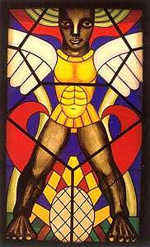
This generation, born in the sixties, called themselves ”The Persistent Ones”. Much more than they used to, they now worked in other media than glass. Some found careers in book illustration, graphic lay-out, photography or ceramics.

This group, now dissolved, is represented by Jaroslav Róna and Michal Machat. Although Róna’s works are sculpted, picturesque, figurative motifs, and Machat expresses himself predominantly in computer painting and only periodically in glass, their common features are humour, irony, erotic provocation and primitivistic modes of expression.
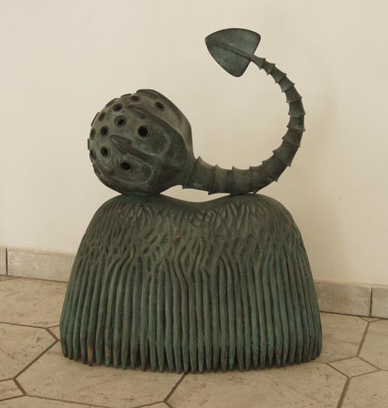
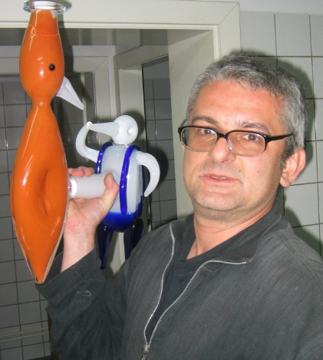
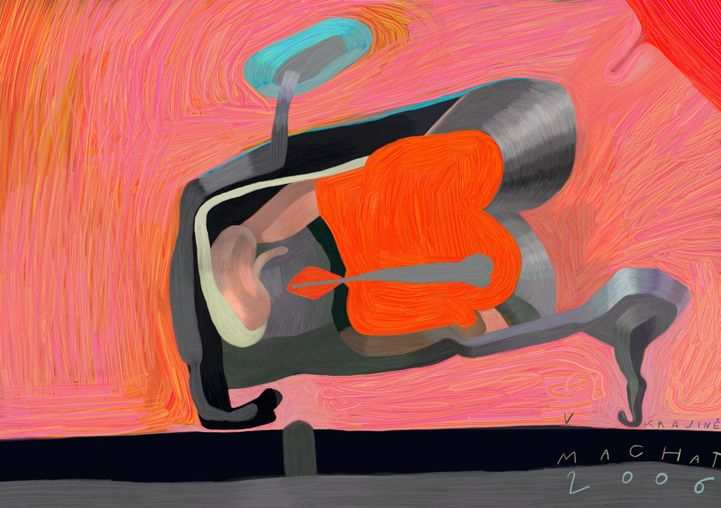

Jaroslav Róna

Michal Machat
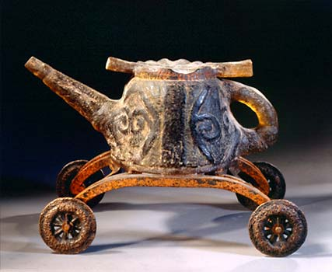
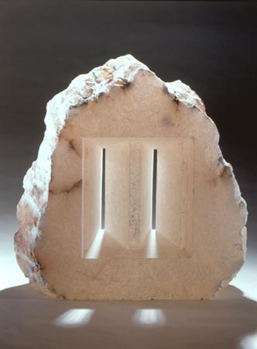
Alena Matejková sometimes produces trivia, albeit with technological perfectionism, at other times she quotes freely from historical styles and genres. She works in glass and stone and occasionally in ice sculpture.

Classical values are reflected in the glass sculptures and paintings by Anna Matousková, another representative of the sixties generation. In the construction of her works she draws parallels to musical composition as well as architecture.

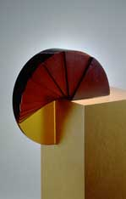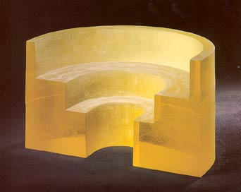

VLADIMÍR KOPECKY AND HIS SCHOOL
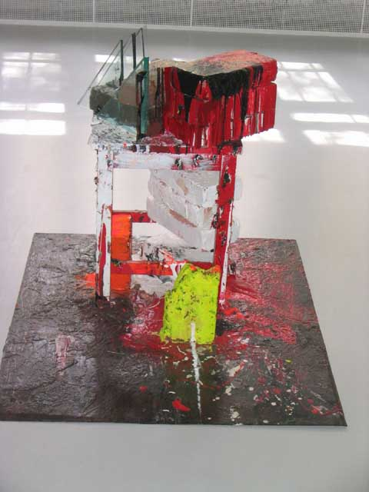
All the way through his entire artistic activities, Vladimír Kopecky has oscillated between a very expressive, colourful form and a severe, almost monochromatic one. He should probably be considered as much a painter as a glass artist. As early as the sixties he created the concept of ”ugly glass”, thus posing the question whether it might not be too easy just to rely on the decorative effect of the material. His installations seem like casual groupings of broken glass, wood waste, and various kinds of building material, all sprinkled with acrylic paint in gaudy colours. This anarchy and negative destruction he compensates through his contemplative glass sculptures of sand-blasted plane glass.
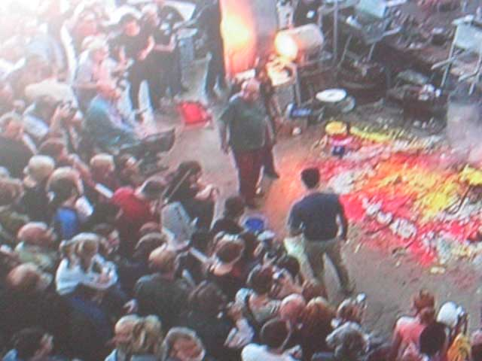
His open-minded approach to glass is reflected in his students at the AAAD. They are invited to express their artistic ideas, whether in glass or other media. The artistic concept is crucial and determines the choice of media.

Kopecky’s school is represented by Lada Semecká. Her works are almost minimalistically severe. She redefines the concept of ”picture-painting”. Sheet glass in several layers fused together with sand are ”framed” and hung floating in space. A through-going shaft of light forms part of the contents. Her horizontally placed glass plates also express a feeling of nature, eg. melting ice, landscape in the rain.

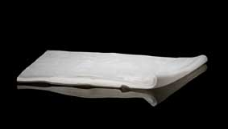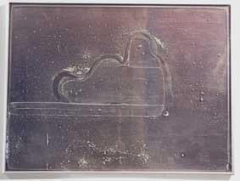
Lada Semecká

In the spirit of Kopecky, Klara Horácková chooses as her starting point organic shapes, or she explores space. Her constructions are cubes of mirror glass, and the spectator is soon captured by his or her infinite reflections. Born in the eighties, Horácková is among the youngest participants, and many of her contemporaries are still students. It’s hard to say how their artistic careers will turn out, or whether they will continue developing the idea of ”The Czech Glass School”.

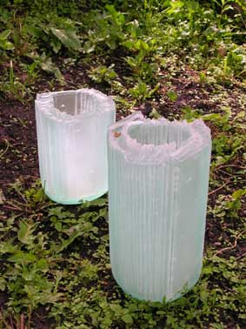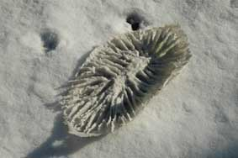
Klara Horácková
It is difficult to predict how their artistic careers will develop and if they can manage to continue to develop the so-called “Czech glass school”. Perhaps it may be of less importance at a time when globalization and fast communication of information make themselves felt even in art. The most important issue is probably that the coming generation may sustain an open-minded approach to glass, without ”pomp and circumstance”, yet with respect, and that they can find their own ways to cross borders.

With the exhibition “Crossing Borders”, Glasmuseet Ebeltoft would like to show how much effect the break down of the physical borders in the Czech Republic has had, but also illustrate how the Czech artists themselves have crossed boundaries both mentally and artistically – and continue to do so with great commitment.

The exhibition has been put together in collaboration with Czech born Pavla Rossini, who has studied philosophy and gained a PHD in aesthetics in Prague. Rossini has also studied Architecture at the Royal Academy of Art in Denmark. She is a freelance art critic and has curated a number of exhibitions in Denmark and other European countries.

Dagmar Brendstrup
2008

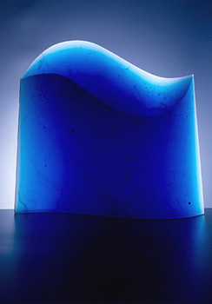
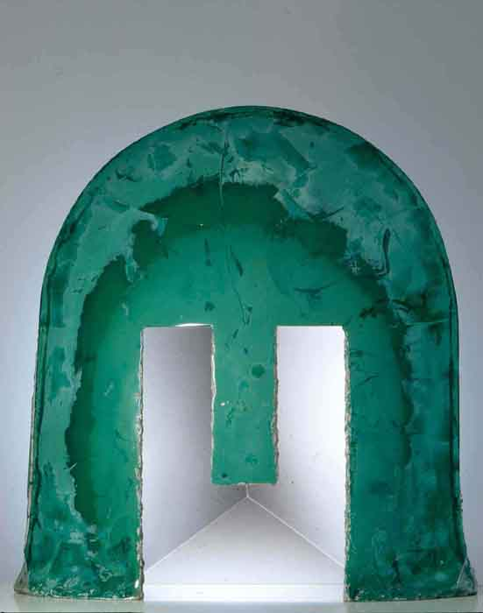
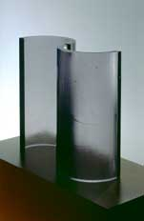

Jan Exnar Milan Handl Anna Matousková

