INVITATION

The Embassy of the Czech Republic cordially invites you to the literary evening

“Czech Illustrations of Greenlandic Myths and Legends
by Knud Rasmussen”
A Talk by
Mr. Zdeněk Lyčka

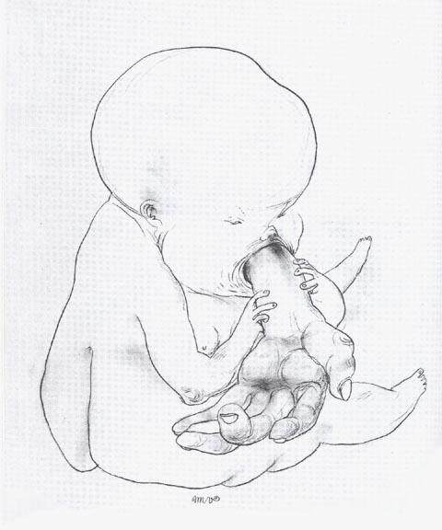

on Thursday 3 December 2009 at 5 pm.
at the Embassy of the Czech Republic in Copenhagen,
Ryvangs Allé 14-16, 2100 Copenhagen Ø.

The Czech Ambassador to Denmark, Mr. Zdeněk Lyčka, will speak about the translation of Greenlandic national literary heritage into a language as far away as Czech. The Czech edition of Knud Rasmussen’s Greenlandic Myths and Legends has been translated by Viola and Zdeněk Lyčka and illustrated by Martin Velíšek, an academic art painter. We will have a closer look at these illustrations. Be aware of the fact that they are not for the faint hearted. You may find them shocking, grotesque, amazing or just unbelievable – but such was life in the harsh nature of the far North. As part of original Inuit literature, the myths and legends bring the readers to the very roots of being. That is why Zdeněk Lyčka has devoted a lot of time and energy to intermediate the Inuit message to the public.

Due to limited capacity of the hall we kindly ask you to confirm your attendance
no later than 25 November 2009 by e-mail: copenhagen@embassy.mzv.cz
or telephone: 3910 1819. For security reasons, the entrance to the residence will be open between 16:45 - 17:15 only.

